Subject | Workbook | Online
Art | Continuing with the theme Human Figure:  An envelope will arrive through your door.  Follow the instructions.  We are shrinking objects down whilst thinking big. | https://classroom.google.com
Business | Using your revision guide, focus on pg. 14 - 16. Turn the key terms into flash cards, create a revision clock for Franchises; create a revision clock for PLC’s; create a revision clock for Co-Operatives. Create a revision mind-map about the advantages and disadvantages of those three types of ownership. | https://classroom.google.com  Look at the Topic “28th Jan - Legal Structures Part 2” and watch the video. As you watch the video, pause it and complete the other tasks as directed. Use the Golden Task Plan to help you tick off the tasks as you complete them.
Digital Technologies | Use your revision guide, focus on pg. 14 - 22. Turn the key terms into flash cards, create a revision clock each type of law. Create a revision mind-map about the advantages and disadvantages of the laws. | https://classroom.google.com  Under the topic 27th Jan - Legal Considerations, there is a Golden Task Plan which will take you through the range of tasks for our lessons. There is also a video for you to watch which explains the topic.  Also, where possible, continue working on Progress Cakes.
English |  | https://classroom.google.com
Geography | Using your revision guide on page 42 answer the questions on the question sheet provided from school.  Using the information sheet provided from school answer the questions about causes of deforestation from the question sheet provided from school. | Using the work for 25th January week, watch the loom video and read the powerpoint. Using the powerpoint complete the google document Causes of Deforestation, then complete the Tropical Rainforest Deforestation google document and googleform.  https://classroom.google.com
History | GQ: What was education like in Elizabethan England?  GQ; What did Elizabethans do for fun?  Using the Golden task plan follow the printed powerpoint and complete all tasks in both powerpoints. | https://classroom.google.com  GQ: What was education like in Elizabethan England?  GQ; What did Elizabethans do for fun?  Using the Golden task plan and the live lesson instructions complete all tasks.
Maths | Complete term 2 review section of the booklet | https://classroom.google.com
MFL | In your workbook  Unhealthy living  1 Using your notes from pages 83-84 create a leaflet in French promoting a healthy lifestyle | https://classroom.google.com  Complete the tasks under ‘Remote Learning Week Beginning 25th January’
Performing Arts | Work on your component 1 presentations for West Side Story. | https://classroom.google.com  Work on your component 1 presentations for West Side Story.
Health and Fitness | If you are working on paper you need the revision booklet that you were all given. If you don’t have it then contact the school and we will get another one to you.  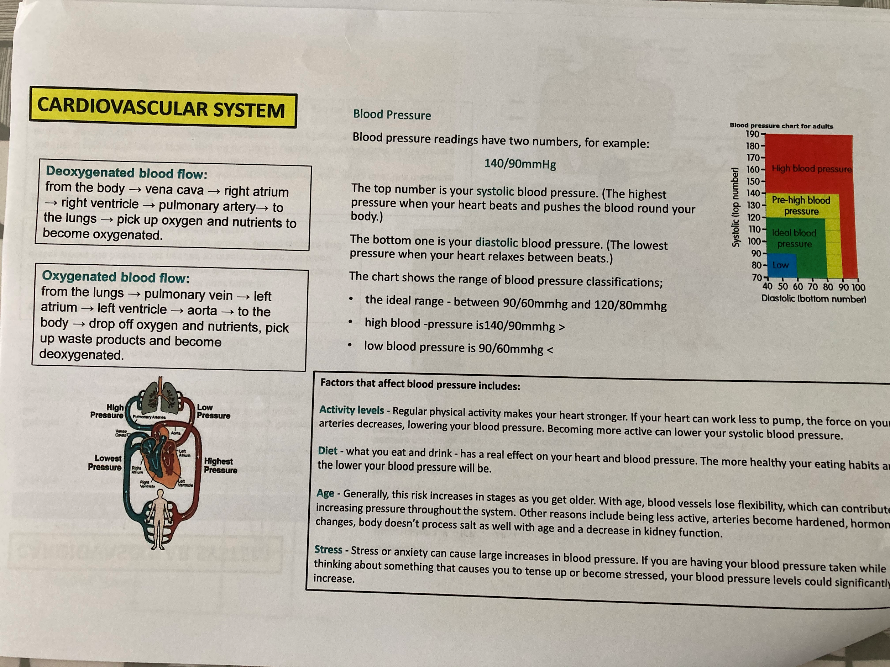  Your task Read through the information on each section of the page. Take notes on each and try to remember all key facts and labels.  Try the following techniques to help you learn:-  - Look, cover, remember and write on a note.  - Create small flash cards with bits of information on them.  - Get someone in your house to come in and test you on it.  - Try to draw the diagram from memory on some paper. | https://classroom.google.com  Open up my loom video and play it as you work through the Google Slides presentation that goes with it.  After you have completed the slides, use the knowledge that you have gained to attempt the quiz.
PE | Complete the following circuit programme  Warm up  30 seconds jogging on the spot  Heal flicks (30 seconds)  Stretches (1 minute)  Main workout  20-star jumps  20 squats  30 walking lunges  15 press ups  50 seconds Arm circles  30 mountain climbers  Plank (40 seconds)  25 Air punches  Cool down  Light stretches | https://classroom.google.com  There will be a number of tasks set in the google classroom this week.  1.Remote Learning workout – week 4  2. Teacher Challenge  3. Remote learning quiz – week 4  Don’t forget you could also do the Joe Wicks workouts (Monday/Wednesday/Friday) as an extra too.
RE | Using pages 28 to 41of the revision guide answers the questions on page 6 to page 23 in the Christianity practices booklet. (GCSE option only) | https://classroom.google.com  Be ready for the live session. Complete the work on google docs.
Science | Use the AQA GCSE 9-1 Combined science trilogy to complete the following:  - Read through pages 158 to 169  - Complete the practise questions on pages 178 - 180  - Complete the questions on pages 198-190  Create a fact file about Newton’s Laws of Motion.  Complete the exam questions and mark them using the mark scheme. | https://classroom.google.com  Combined science:  https://senecalearning.com/en-GB/ Class code: s7ldbd0c7b  Separates science:  https://senecalearning.com/en-GB/ Class code: pyzonq00f6
Hospitality & Catering | Complete the following pages in the WJEC Catering revision book:  - Types of food service  - Exam questions  - HACCP  - Exam questions  - Food poisoning  - Hygiene and food safety  - Exam questions | https://classroom.google.com
PHSE | PSHE to begin after Feb half term. | https://classroom.google.com

