Subject | Workbook | Online
Alternate Provision | English – Purple Language Workbook. Read and complete notes on section- writing essays. pg 60 onwards  Science - Read pg. 90; answer the questions on pg. 110 and 128.  Maths - Pg 19 - P26 of the Revision Guide and answer the questions in the Workbook on the same pages. | Maths: Maths – Log into Google Classroom and complete the tasks on Algebra. Watch the video, do the worksheet and complete the Quiz.  English: https://www.bbc.co.uk/bitesize/examspecs/zcbchv4  https://classroom.thenational.academy/units/language-skills-fiction-reading-52c6 All lessons on reading fiction texts. Watch the videos and complete tasks.  Science: Science – Log into Google Classroom and complete the tasks. Watch the video, do the worksheet & complete the Quiz.
Art | ART  Yr. 11 Remote Learning  WB 1st March  Final Project Stage 2  As in last week’s tasks, only do the task which is on your selected approach. Either Graphics or 3D Modelling. Do not go changing your approach.  Graphics: Now that you are familiar with what LOGOS are and have looked at how companies develop their identity to advertise or promote themselves we now have to look at creating a LOGO for our own topic.  Divide a sheet of paper into 8 boxes.  In box 1, Draw out an image from one of your projects. This should be quite realistic. Now in the next box, start to simplify it into a graphic or a symbol. (a basic LOGO design) No text, only a symbol. You have four attempts at this (you can change the object each time) and the objective is to create four different symbols and then next week we can take the best one and develop this using colour and other graphic techniques. Look at the examples below of the logo design sheets done by real designers.  3D Modelling: You should have collected card last week and looked at ideas or examples on card modelling. You will now be asked to make some sketches of what you might want to create as a 3D model. Remember that you can use any of your existing project from Yr.9 to Yr. 11. The cubist one is probably the best one as you may have seen in the examples from last week.  Think carefully about how the model will be constructed. Using flat pieces of card slotted together is a really good technique and it will give you lots of flat sides that you can later paint or decorate with images taken from your selected project topic.  You only have to look at the resources for your approach - either Graphics or 3D Modelling.  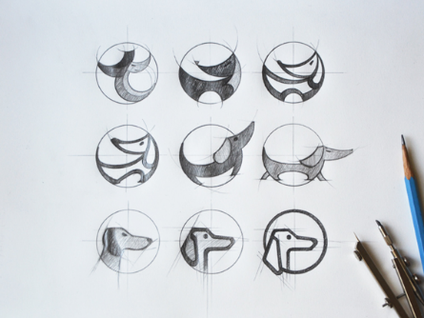  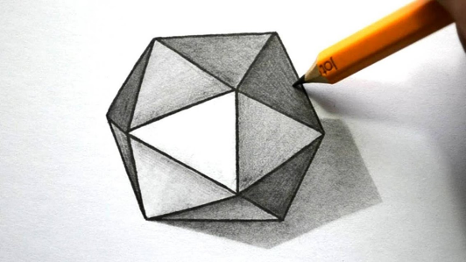 | Go to Google Classroom and look up your class, make sure you are doing the right task for this week.  https://classroom.google.com
Business | Use the information on Plegg’s Ltd and complete the People & Operations. Make sure you also complete the Learner Log. | https://classroom.google.com  Use the information on Plegg’s Ltd and complete the the next section – People & Operations. Make sure you also complete the Learner Log. Use the Checklist to help you. Also make any necessary changes to your first section.
Digital Technologies | Read page 70 – 74 about using technology to present information. Make flashcards covering the key terms; a mind map explaining the different methods and how they work and answer the exam questions. | https://classroom.google.com  Under the topic 3rd March – Skill building, watch the video which guides you through the learning and complete each of the tasks.
English | English –  Purple Language Workbook.  Read and complete notes on section- writing essays. pg 6o onwards  Workpack: Read through powerpoints and complete activities on rhetoric.  Read articles on parenting and write essay on overprotective parents | hhttps://classroom.google.com see individual class codes  https://senecalearning.com Class code: 7s1feo22nx  Macbeth Revision on Macbeth and Lady Macbeth  https://classroom.thenational.academy/units/revisiting-macbeth-91c7  Revisiting Macbeth All lessons  Revisiting Macbeth: Lesson 7 and Lesson 8 on Macbeth and Lady Macbeth  https://classroom.thenational.academy/units/revisiting-a-christmas-carol-2c27  Revisiting A Christmas Carol: All lessons  https://classroom.thenational.academy/units/revisiting-an-inspector-calls-d1f4  Revisiting An Inspector Calls: All lessonsttps://classroom.google.com
Geography | Use the ‘UK Economy’ revision guide to create your bank of notes. Complete the questions in the workbook. | https://classroom.google.com
History | Read the photocopies of pages 44-45. Complete tasks 1-3 from the blue box on page 45.  Read the photocopies of pages 46-49. Complete all tasks from the blue boxes | https://classroom.google.com
Maths | Complete the new booklet of work that needs to be collected this week  Higher set 1,2  foundation set 3,4,5,6,7 | https://classroom.google.com
MFL | In your workbook  1 p111 Complete the listening questions using your CD  2 p114. Complete the writing questions, using your notes and pages 107-110 for support. | https://classroom.google.com  Complete the lesson under the topic week beginning 22 February
Performing Arts | You should have completed your Component 1 Presentation by now. I will be marking this week. If you have feedback to work on, you must complete this as a priority.  If you have done this, you can have a go at finding a monologue or a song that you would like to learn and perform. | https://classroom.google.com  You should have completed your Component 1 Presentation by now. I will be marking this week. If you have feedback to work on, you must complete this as a priority.  If you have done this, you can have a go at finding a monologue or a song that you would like to learn and perform.
PE - Health and Fitness | Create the second week of your training programme for your client.  This must include the following:  Session 1  Warm up  Circuit training session including 8 stations and low weights/ high reps  Cool down  Session 2  Warm up  Resistance speed training session including at least 4 exercises. High intensity/ low reps  Cool down  Session 3  Warm up  Weight training session including 8 stations and low weights/ high reps. Increase your weight and reps from last week.  Cool down | https://classroom.google.com  This week you will be completing week 1 of your training programme on the google classroom. You will need to produce a training session focused on weight and plyometric training. Please join the live lessons on Monday at 11.30am for option A students and Wednesday at 11.30am for option C students.
PE - Core | Complete the following circuit programme  Warm up  30 seconds jogging on the spot  Heel flicks (30 seconds)  Stretches (1 minute)  Main workout  25-star jumps  20 squats  30 walking lunges  18 press ups  45 seconds Arm circles  30 mountain climbers  Plank (35 seconds)  25 Air punches  Cool down  Light stretches | https://classroom.google.com  There will be a number of tasks set in the google classroom this week.  1.Remote Learning workout  2. Remote learning quiz  Don’t forget you could also complete the Joe Wicks workouts (Monday/Wednesday/Friday) if you wish to be more active.
RE | Using pages 46 to 55 of the revision guide answers the questions on page7 to page 27 in the Islamic practices booklet. | https://classroom.google.com  Complete the work set on google classrooms The nature of God. Make sure you take part in the live lessons and watch the loom video’s for extra help.
Science | Science - Combined  Using the combined science textbook, read through pages 40 - 44 and answer the quick test questions at the bottom of each section.  Once complete, answer the practise (p60) and review (p80, 81,82) questions. | https://classroom.google.com  Seneca assignments set for Biology, Chemistry and Physics Paper 2  Code: z9wdyoqit6
Science | Separate Science  Using the Biology textbook, read through pages 34 - 41. Answer the quick test section at the bottom of each page.  Once completed, complete the practise (p64,66,67) and review questions (p94,95,97) | https://classroom.google.com  Seneca assignments set for Biology, Chemistry and Physics Paper 2  Code: z9wdyoqit6
Hospitality & Catering | Complete the task provided from the home learning resources pack. | https://classroom.google.com  Seneca Class code: mek5xdbddn
PHSE | Read through the work sheets on ‘stalking and sexual harassment’.  Read through the information sheet and then complete the definition table with examples.  Send a picture of your completed work to your class teacher. | https://classroom.google.com

