Free* boiler service, replacements or repairs available for homeowners

The Importance of Getting Your Boiler Serviced
- Safety - all appliances that burn wood or fossil fuels (such as natural gas) could produce poisonous carbon monoxide (CO) if they are not working properly, so to keep your family safe, your Gas Safe registered engineer will check your boiler for CO.
- Keep your warranty valid - our warranties require that your boiler is annually serviced by a Gas Safe registered engineer. Failure to do so could invalidate your warranty, resulting in expensive repair bills, should your boiler break down.
- Fewer breakdowns - as you would expect when you take your car for its MOT, when you have your boiler serviced, all the main components are checked for wear and tear, and replaced if necessary. That means that it is less likely to breakdown when you need it the most, particularly in the cold winter months.
- Efficiency - a well-maintained and regularly serviced boiler will work more efficiently. This means you are using less fuel and reducing your energy bills.
01253 476646
care&repair@bch.co.uk
*Free servicing repairs or replacements are subject to individual circumstances and proof of finances may be required.
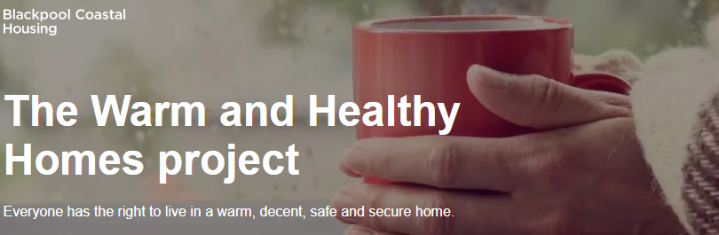
The Warm and Healthy Homes project launched on 1st December 2021, in partnership with Cadent and Cadent Foundation.
Supporting households of all tenures, Care & Repair's free service will run for two years to help ensure Blackpool residents can save money and stay warm at home.
Clients will receive an assessment of their needs by a Caseworker and the following support can be provided, tailored to each individual:
Affordable warmth advice and assistance, including; warm homes discount, priority services register, understanding and reducing fuel bills, energy efficiency, budgeting money, dealing with fuel debt, fuel incentives, tariff differences, switching, smart meters, green measures, addressing damp and more.
Support to access funding for various measures as required, including; boiler servicing, repairs, replacements, green measures, emergency heaters, double glazing, draught excluders, winter warm packs, fuel top-ups, essential household goods, food parcels and more.
Support to access broader health and wellbeing services, including; befriending, community activities, employment support, volunteering, mental health services, advocacy, adult learning and more.
A discretionary emergency fund is available which will be used in conjunction with any other funding available, to assist homeowners on a low income and/with a medical condition/disability to repair or replace their heating, gas and electrical appliances.

Tel: 01253 476646 Email: care&repair@bch.co.uk

