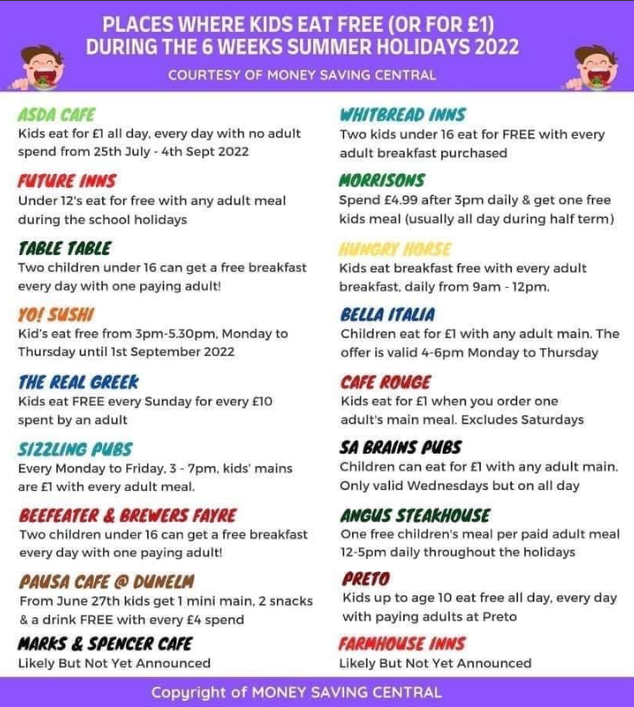
Support with food - Food banks, cheap food & meals:
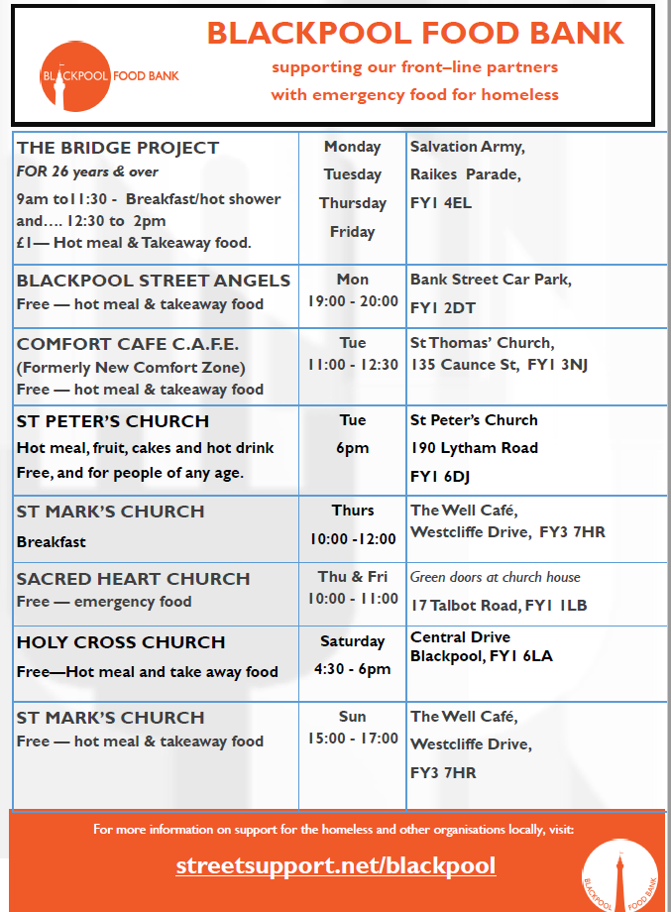
HIS COMMUNITY FOOD PANTRY (HIS PROVISION):
Did you know that our food pantry/mobile unit is open for anyone to use?
How it works is you pay £5-10 and choose tinned/packet food items from our shelves. We then top up your shopping with a further £15+ of extra food items for FREE.
Below is a list of all our collection points and addresses. If you need any more information simply message us (Facebook page: His Community Food Pantry).
- Wednesday: 11-12.30 - His Community Food Pantry. 1 Raikes Parade.
- Wednesday: 11.30-1 - His on Central Drive. 272-274 Central Drive.
- Thursday: 9.30-11.30 - His mobile food pantry. Outside the Argosy Centre on Forshaw Ave, Grange Park.

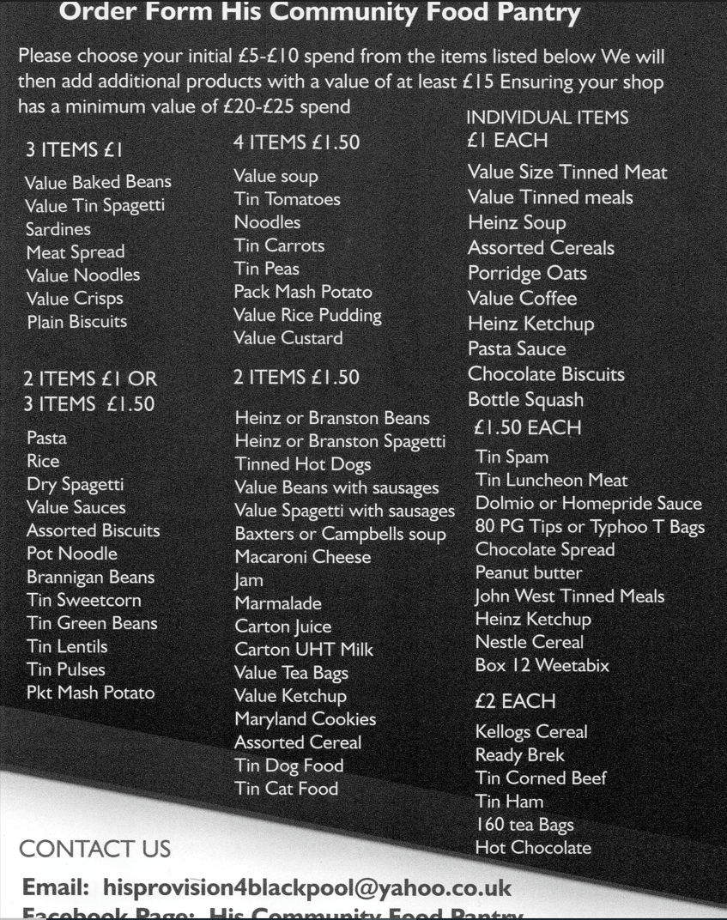

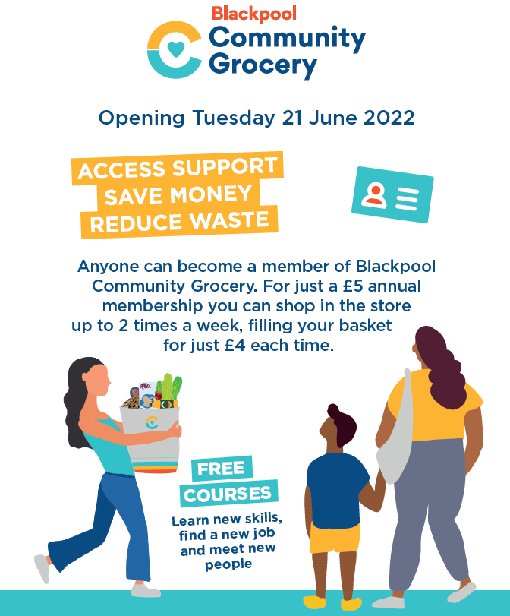
Blackpool Community Grocery:

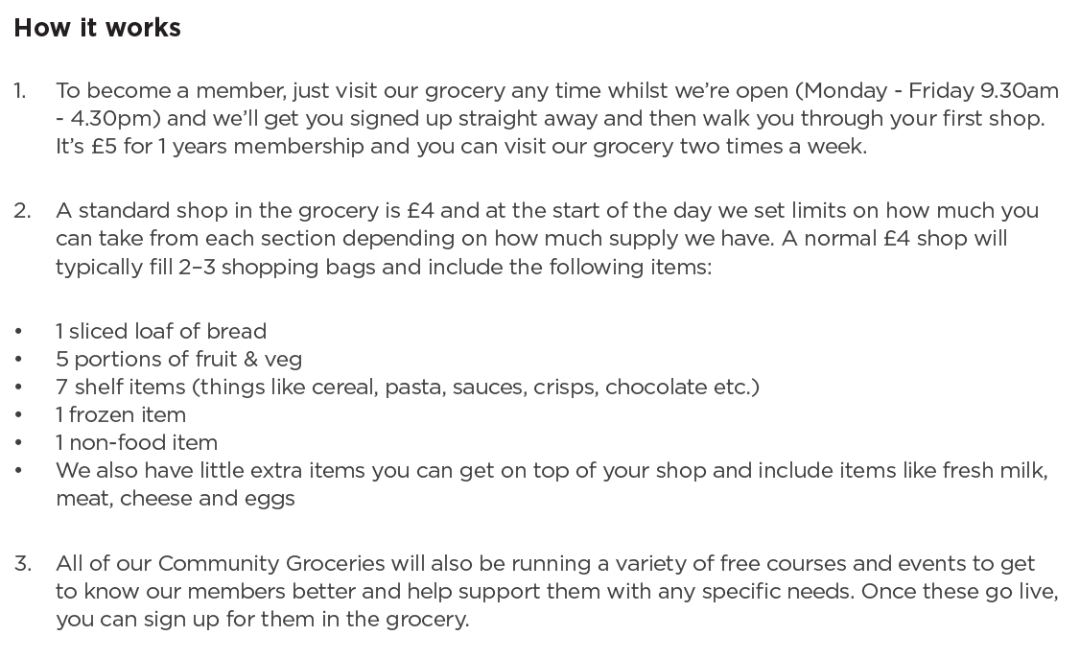
https://communitygrocery.org.uk/blackpool/

Blackpool discretionary scheme:
The Blackpool discretionary support scheme can provide assistance to vulnerable people who need:
- Short term emergency support (Food parcel, gas & electricity – if your energy provider is unable to offer support)
- Help to become established or maintain independence in the community
We are unable to give cash.
How to apply: https://www.blackpool.gov.uk/Residents/Advice-and-support/Discretionary-support-scheme.aspx

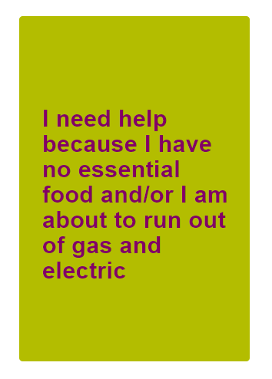

- Complete all the questions on the online form and enter personal details regarding your circumstances

