Aspiring
Apprentices

APPRENTICESHIP VACANCIES  – Fylde area | APPRENTICESHIP VACANCIES  – Wider area
Closing date: 28th September 2023  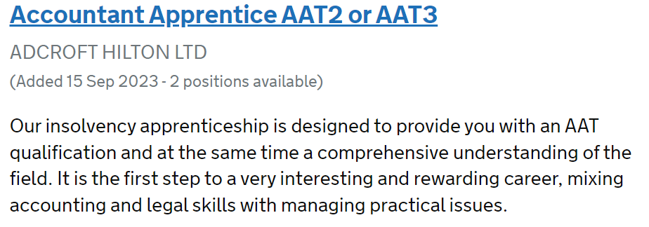  Closing date: 30th September 2023  Closing date: 1st October 2023  Closing date: 2nd October 2023  Closing date: 5th October 2023  Closing date: 6th October 2023  Closing date: 7th October 2023  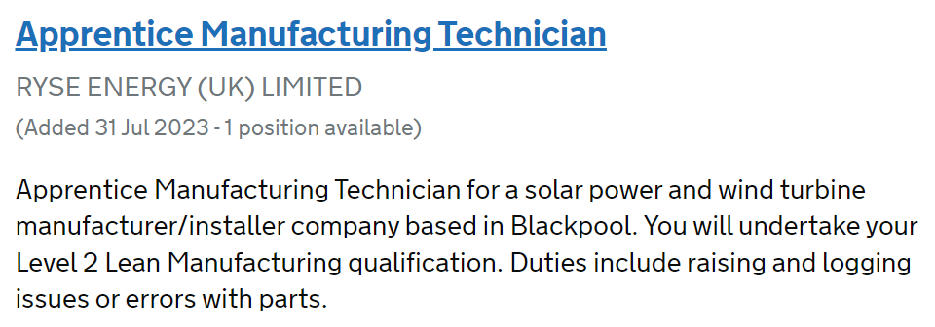  Closing date: 10th October 2023  Closing date: 12th October 2023 | 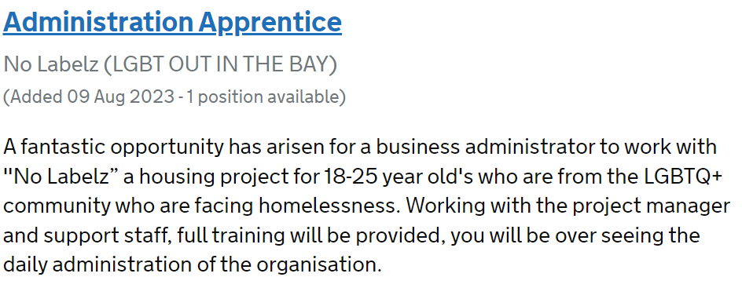  Morecambe  Closing date: 26th September 2023  Lancaster  Closing date: 1st October 2023  Preston  Closing date: 26th September 2023  Preston  Closing date: 29th September 2023  Preston  Closing date: 29th September 2023  Preston  Closing date: 29th September 2023  Liverpool  Closing date: 26th September 2023  Liverpool  Closing date: 29th September 2023  Manchester  Closing date: 26th September 2023

