Accessing Google Classroom and Submitting Work

- You can find Google Classroom using a search engine.

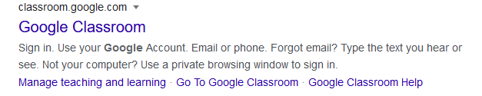
- Click on the result that looks like this, or just go straight to: classroom.google.com

- Click ‘Go to Classroom’ in the middle of the screen.
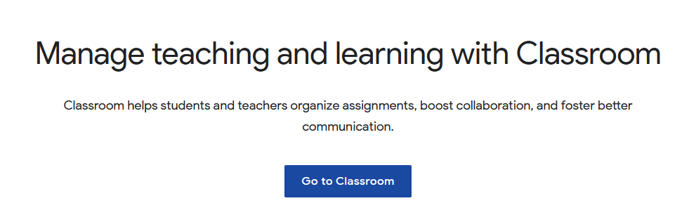

- You must now sign in with your school email account, this looks like below. Your password is the same as the one you use for the computers at school.

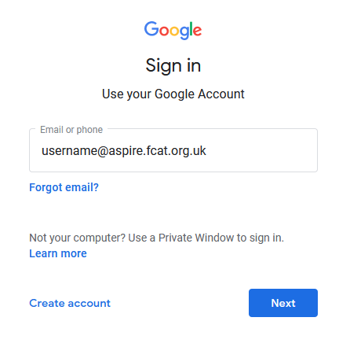
Your username is:
A number – Your surname – First letter of first name
Numbers:
Y7: 24
Y8: 23
Y9: 22
Y10: 21
Y11: 20
So, a year 7 student named James Smith will have the email address 24smithj@aspire.fcat.org.uk

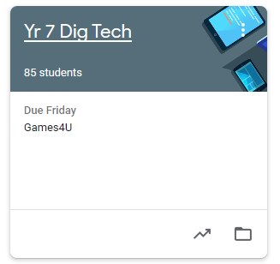
- Once signed in, you will see your classes on the home page. Click on a class to find your work.

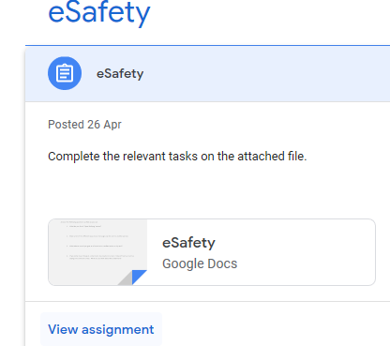
- You can now see what work has been set, click on a task to start working on it. Instructions are provided for each activity.

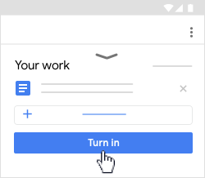

- When you have finished your work, select ‘Turn in’. This will submit your work to your teacher to mark.

For guidance when working on tablet devices –
https://www.blackpoolaspireacademy.co.uk/guide-to-home-learning

