

*Success Nothing Less*

**Candidate Examinations Handbook**

*Guidance for Students, Parents and Guardians*

GCSE Examinations

2023 / 2024



***Success Nothing Less***

**Centre Number 46409**

**Introduction Summer 2024**

Blackpool Aspire Academy is committed to ensuring that candidates are fully briefed on the exam and assessment process in place at Blackpool Aspire Academy and you are made aware of the required JCQ awarding body and GCSE instructions and information for candidates.

**Candidate Details**

|  |
| --- |
| **Candidate Name**  Candidates are registered using legal names, not preferred names and should be the same as birth certificates and passports.  **Candidate Number**  Each candidate has a four-digit candidate number. This is the number you will enter on examination papers. (example: 7321)  **Unique Candidate Identifier (UCI):**  In addition to a candidate number, each candidate has a Unique Candidate Identifier (12 numbers and 1 letter), which is shown on your provisional timetable. This number will usually begin with the Centre Number (48101) unless you have transferred from another school that had already issued your UCI.  Your UCI is used for administration purposes and it is not necessary for you to remember it. |

**Exam Timetable**

|  |
| --- |
| Candidate Timetable – On receiving your Exam Timetable please check that all levels of entry and exam information is correct. Paying particular attention to all your personal details, date of birth, spelling of names are accurate as these will appear on certificates and it may be difficult to change them once certificates are awarded. Please contact Miss Young (Examinations Officer) immediately if you discover any omissions or errors on s.young@aspire.fcat.org.uk  (01253) 353155 |

**Contingency Day**

|  |
| --- |
| The awarding bodies will designate a date in June as a ‘contingency day’ for examinations. This is consistent with the qualification regulators’ document exam system contingency plan: England, Wales and Northern Ireland.  The designation of a ‘contingency day’ within the common examination timetable is in the event of national or local disruption to examinations. It is part of the awarding bodies’ standard contingency planning for examinations.  We must remind candidates that they must remain available until the end of the academic year until advised otherwise by Ofqual / JCQ should the awarding bodies need to invoke its contingency plan. |

**Exam Clashes**

|  |
| --- |
| If you have an exam clash we will write to you letting you know how that clash will be resolved. An exam clash is when you have two exams in the same subject or different subjects scheduled for the same time.  If you have a clash the following information explains what will happen.   * You will be kept under supervision in between your two exams * During this time, you can revise, however you must not have access or have on your possession any electronic communication/storage devices or have access to the internet. (All revision material should be left with an Invigilator at the beginning of your first exam.) * during this time, you cannot have contact with other pupils, except those pupils who are being supervised in the same room as you * It is advisable to bring a snack and a drink (please hand this to your Invigilators at the beginning of your first exam). * You will be collected from your first exam by an invigilator and taken to another classroom where you will begin your next exam.   If you do not understand your clash instructions please speak to Mr Buchanan or Miss Young. |

**Exam Venues**

|  |
| --- |
| Exam venue / classroom information will be posted on the canteen doors the day before your exam, please check this daily as changes may occur. The main cohort of examinations will be held in the Sports Hall. |

**Exam Invigilation**

|  |
| --- |
| Exams are supervised by a team of experienced external invigilators. Our Invigilators must follow the strict guidelines set by JCQ. Please note that invigilators cannot discuss the examination paper with candidates or explain the questions during the exam. |

**Exam Start Time**

|  |
| --- |
| The start time for exams at Blackpool Aspire Academy are:   * 09:00 am for morning exams * 13:30 pm for afternoon exams   You should aim to arrive at school at least 20 minutes before the start of your exam, once you have registered, and checked the exam board make your way to the yard to line up.  You must remain seated and in silence until the end of your exam  If you are entitled to extra time you will not be allowed to leave the exam room until the end of your scheduled exam time. (Unless this is part of your Exam Arrangements)  ***School Bus – If you have an exam scheduled to finish after the scheduled school transport collection times, you will need to arrange alternative transport home.*** |

**Exam Conditions**

|  |
| --- |
| Candidates must not enter the exam room until directed to do so by the Examination Officer, Headmaster or Senior Leadership Team.  An exam briefing for all candidates will be given by an Examination Officer or Senior Leadership Team in the exam venue before the exam begins  Remember:   * You are under exam conditions from the moment you enter the exam room until you are given permission to leave * Candidates must listen to and follow the instructions of the invigilator at all times in the exam room * Candidates must not talk to, attempt to communicate with or disturb other candidates once you have entered the exam room. * You should write clearly and legibly * The Centre Name is Blackpool Aspire Academy and Centre Number is 46409 this will be displayed on the white board at the front of the exam room. * Exam board, subject title, tier, paper number; and the actual starting and finishing times (AM or PM), and the date of each exam will be displayed on the guidance board. * We will announce clearly to the candidates when to complete the details on their answer booklet, and an announce any additional information. * We will announce clearly to the candidates when you can start your examination, your exam will formally start at this point. * We will specify the time allowed for your exam. |

**Where Will You Sit in an Exam Room?**

|  |
| --- |
| * There will be a room seating plan displayed on the exam notice board the day before your exam for you to familiarise yourself with. * There will be a seating plan outside of your exam venue, with your name, seat number and candidate number, please arrive 10 minutes before the start time. * Please find your desk as quickly and quietly and stand behind your seat, once you enter an exam room you are under strict exam conditions (please refer to JCQ Warning to Candidates) * If you require assistance, put up your hand and an invigilator will attend to you, do not communicate or disturb any other candidate. |

**Exam Papers and Answer Booklets**

|  |
| --- |
| Please remember it is your responsibility to check you have the correct question paper and you are sitting the correct exam – check the day, date, subject, unit/component and tier of entry (if appropriate)  If you think you have been given the wrong exam paper, please raise your hand and notify an Invigilator immediately. |

**At the End of the Exam**

|  |
| --- |
| An invigilator will make an announcement informing you to stop writing or stop working and put down your pens, this will be end of your exam   * No candidate will be allowed to leave the room until the end of the published exam time. * If you are entitled to extra time you will not be allowed to leave until the end of your extra time. * Candidates must remain seated until all papers have been collected and the Senior Invigilator instructs you to leave. * When you leave the exam venue you should walk out in complete silence, and refrain from talking until you are well away from the exam room so that you do not disturb your fellow-students who are still working. |

**Equipment**

|  |
| --- |
| Only authorised material can be brought into the exam room: Black Pens, pencils, pencil sharpener, eraser, compass, ruler, protractor, highlighter and a calculator. You must bring all your equipment to every exam, if you are not allowed to use a particular item you will be informed in the briefing before your exam starts, you must hand in all unauthorised equipment to the Invigilator.   * Remember that you need to write in black ink (Please bring spare pens) * Do not use any of the following:   + Correcting pens, fluid or tape   + Erasable pens   + Highlighters can only be used on Question Papers and Must Not be used on your answers.   + Gel Pens * You must have a clear pencil case containing authorised equipment only * Your water bottle must be clear / transparent and have no label or writing on it   You may use coloured pens or inks for diagrams, maps, charts etc. only if your exam allows them, instructions and information will be given to you in the briefing. |

**Using Calculators**

You must be aware of awarding body instructions regarding the use of calculators in your exams which state:

|  |
| --- |
| Candidates may use a calculator in an examination unless prohibited by the awarding body’s specification. Where the use of a calculator is allowed, candidates are responsible for making sure that their calculators meet the awarding bodies’ regulations  We will provide a calculator to every exam, you will be asked to put it under your desk it the calculator is not allowed in an exam.  • Please seek further advice from Mr Thompson, Head of Maths for additional guidance.  Calculators must be:  1. Of a size suitable for use on the desk  2. Either battery or solar powered  3. Free of lids, cases and covers which have printed instructions or formulae  Calculators must not:  Be designed or adapted to offer any of these facilities:  1. Language translators  2. Symbolic algebra manipulation  3. Symbolic differentiation or integration  4. Communication with other machines or the internet  5. Be borrowed from another candidate during an exam for any reason  6. Have retrievable information stored in them. This includes:   * Databanks * Dictionaries * Mathematical formulae * Text   Candidates are responsible for the following:   * The calculators power supply * The calculators working condition * Clearing anything stored in the calculator |

**Food and Drink in Exam Rooms**

|  |
| --- |
| * A clear / transparent plastic bottle of water (Juice is not permitted) is allowed in the exam room, all labels must be removed before entering the room. * NO other drinks of food will be allowed in the exam room unless you have a medical need that has been discussed with Miss Young, Examinations Officer. |

**What Should You Wear**

|  |
| --- |
| It is a requirement that you wear your full Blackpool Aspire Academy Uniform for all your exams. There will be no exceptions made.  Writing should be removed from your bare skin. |

**What to Do If You Arrive Late For an Exam**

|  |
| --- |
| It sounds obvious, but...ensure that you know the scheduled date your exam will take place and whether they are morning or afternoon exams.   * A register is taken at the start of each exam to check that all candidates are present if you are running late for your exam, you or your parents/carers must call the School Office on 01253 35155 requesting to urgently speak to Miss Young, Exams Officer, or Mr Buchanan, Assistant Head so that we are aware of your position. * If you find that you are running late don’t panic! When you arrive at school you should report to the Attendance Office Entrance and a member of the school office staff will contact either Miss Young or Mr Buchanan. * If you arrive for your exam within an hour of the PUBLISHED START TIMES you will be allowed to take your seat and begin your exam, you will be given the full amount of time for that exam.   If you are going to be “VERY LATE” for an exam – i.e. more than an hour after the published start times – you must call us as early as possible.  Even though we will allow you to sit the exam, and give you the full time for the exam, you should be aware that the exam board may not accept your completed paper.  You will need to prove that you have not had access to the internet whilst making your way into school.  The best way to do this is:   * Avoid public transport * Ask your parent/carer to drive you to School and ensure you give them all internet enabled devices you may be carrying e.g. mobile phone, smartwatch etc. * You and your parent/carer will be asked to sign a letter confirming that you have not had internet access * You and your parent/carer will be asked to make a written statement giving the details of your movements pre-your exam * The decision about whether to accept your script is at the discretion of the exam board |

**If You Fail to Attend Your GCSE Exam**

|  |
| --- |
| If you fail to attend your GCSE exams or fail to complete your NEA/Coursework element of your GCSE, you will be invoiced for the full cost of the exam and refused attendance for Prom. There will be no exceptions made. |

**What to Do If You Are Unwell on The Day of an Exam**

|  |
| --- |
| If you feel unwell on the day of your exam:   * You or your parent/carer should call ahead to the School Office and let us know so that we can help you as best we can when you arrive * Once you are here, speak to Miss Young (Examination Officer) or Mr Buchanan before your exam and update us on how you are feeling * We will do what we can to help you – for example seat you close to an exit in case you need to leave the room or place a sick bucket next to your desk * If you feel unwell during an exam: Let the invigilating team know as soon as possible what is wrong so that they can take any measures possible to assist you |

**What Happens In The Event Of an Emergency in the Exam Room**

|  |
| --- |
| In the event of the emergency bell sounding the following will happen:   * The invigilator will ask you to stop writing, close your answer booklet and put your pen down/stop working * The invigilator /Examination Officer/ SLT will evacuate the room if there is clear danger * If there is no clear danger to candidates the invigilator will await instructions from SLT, who will be with you very quickly   In the event of a false alarm:   * You will be given a few minutes to compose yourself and get ready to start * The amount of time lost will be added on to your exam time. The new finish time will be clearly written on the board at the front of the room   If an evacuation is necessary:   * The invigilator will ask you to line up in complete silence and leave the exam venue, you must not communicate with any candidate during the evacuation as this may compromise the exam security and will mean that the exam may have to be abandoned, or you will be disqualified from the exam due to malpractice. * Once you have returned to the exam room your new finish time will be calculated and you will be given time to compose yourself before the exam is re-started. |

**Results**

|  |
| --- |
| GCSE results will take place in August, between 10:00am and 11:00am 22nd August  We strongly advise students to attend with their parents/carers to collect results, where we will have a Blackpool Aspire Academy team, consisting of Head Teacher, Deputy Head Teacher, Heads of Departments to offer you guidance and support.  No results will be given out by telephone or via email under any circumstances  If you are unable to attend results day, you are required to complete a candidate permission form and provide the exam office with a self-addressed envelope. Your results may be collected from the main reception upon schools reopening in September by either yourself or someone on your behalf provided you have given written or email permission for them to do so. Those collecting on your behalf will be asked for ID. |

**Post Results**

|  |
| --- |
| If your results are not as you expected there are various options available within the Post Results Services you can find additional Information by following this link: <https://www.jcq.org.uk/examsoffice/post-results-services>  It is important that you discuss any review options with your subject teacher before applying – as marks can go up or down and there is no option to revert to a previous, higher mark.  Please note that these services only apply to exams taken in the 2024 Summer Season. The deadlines for applications are final and it should be noted that scripts are destroyed after a certain time so these services must be applied for immediately after receiving your results.  There will be a fee for all Post Results Services as outlined by the Exam Boards.  Applications will not be submitted to the Board without payment having been received. If you require a review of a subject involving more than one unit, the review fee is payable for each unit.  It is most important that you consult with a relevant subject teacher / (Deputy) Head Teacher before applying for Post Review Services.  Further Details will be sent to you nearer the time showing you the options and fees. |

**Certificates**

|  |
| --- |
| Issue:  • GCSE Certificates will arrive in school in the autumn term, and will be presented at Blackpool Aspire Academy GCSE Certificate Collection Evening. (November 2024).  • Date to be confirmed.  Collection:  • If you are unable to make Certificate Collection there will be the opportunity to collect your certificates from the school Reception after this evening. When collecting you will need to bring your ID, if you send someone else to collect them on your behalf they will require a letter of authorisation from you and provide ID.  Unclaimed:  • Awarding bodies prescribe that unclaimed certificates may be destroyed after they are held for a period of 12 months from the date of issue. If you do not collect your certificates within this period, they may no longer be available to you. After this period, awarding bodies will be able to issue you a statement of your results (not a full certificate as originally issued) and will charge you for this service. You should apply directly to the awarding body for this service. |

**Contact Details**

|  |
| --- |
| Blackpool Aspire Academy Main Office (01253) 353 155  Head Teacher: Mr J Woods – [j.woods@aspire.fcat.org.uk](mailto:j.woods@aspire.fcat.org.uk)  Assistant Headteacher: Mr W Buchanan – [w.buchanan@aspire.fcat.org.uk](mailto:w.buchanan@aspire.fcat.org.uk)  Examinations Officer: Miss S Young – [s.young@aspire.fcat.org.uk](mailto:s.young@aspire.fcat.org.uk) |



***Success Nothing Less***

**Examples of Approved Water Bottles**

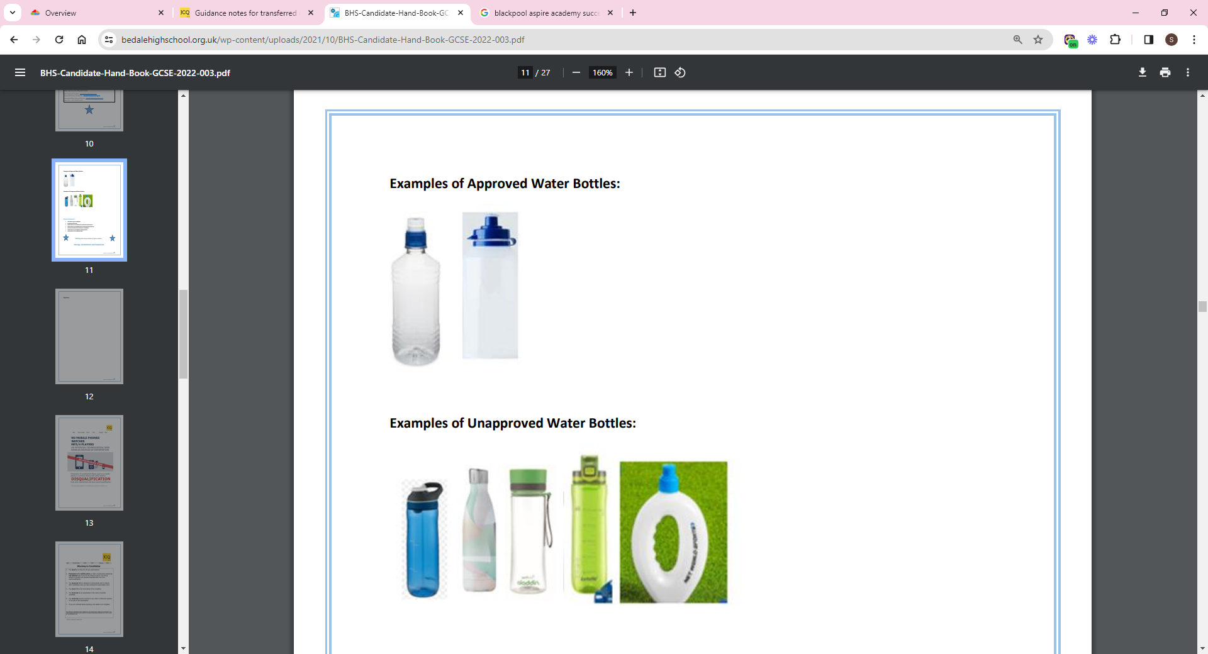

**Examples of Unapproved Water Bottles**



**Attached Documents:**

* JCQ Warning to Candidates
* Unauthorised Items
* Information for Candidates for Written Examinations
* Information for Candidates for On-Screen Examinations
* JCQ Social Media Information for Candidates
* Information for Candidates Privacy Notice
* Information for Candidates NEA
* Information for Candidates Coursework Assessments
* Preparing to sit exams

**Wishing you every success in your exams.**



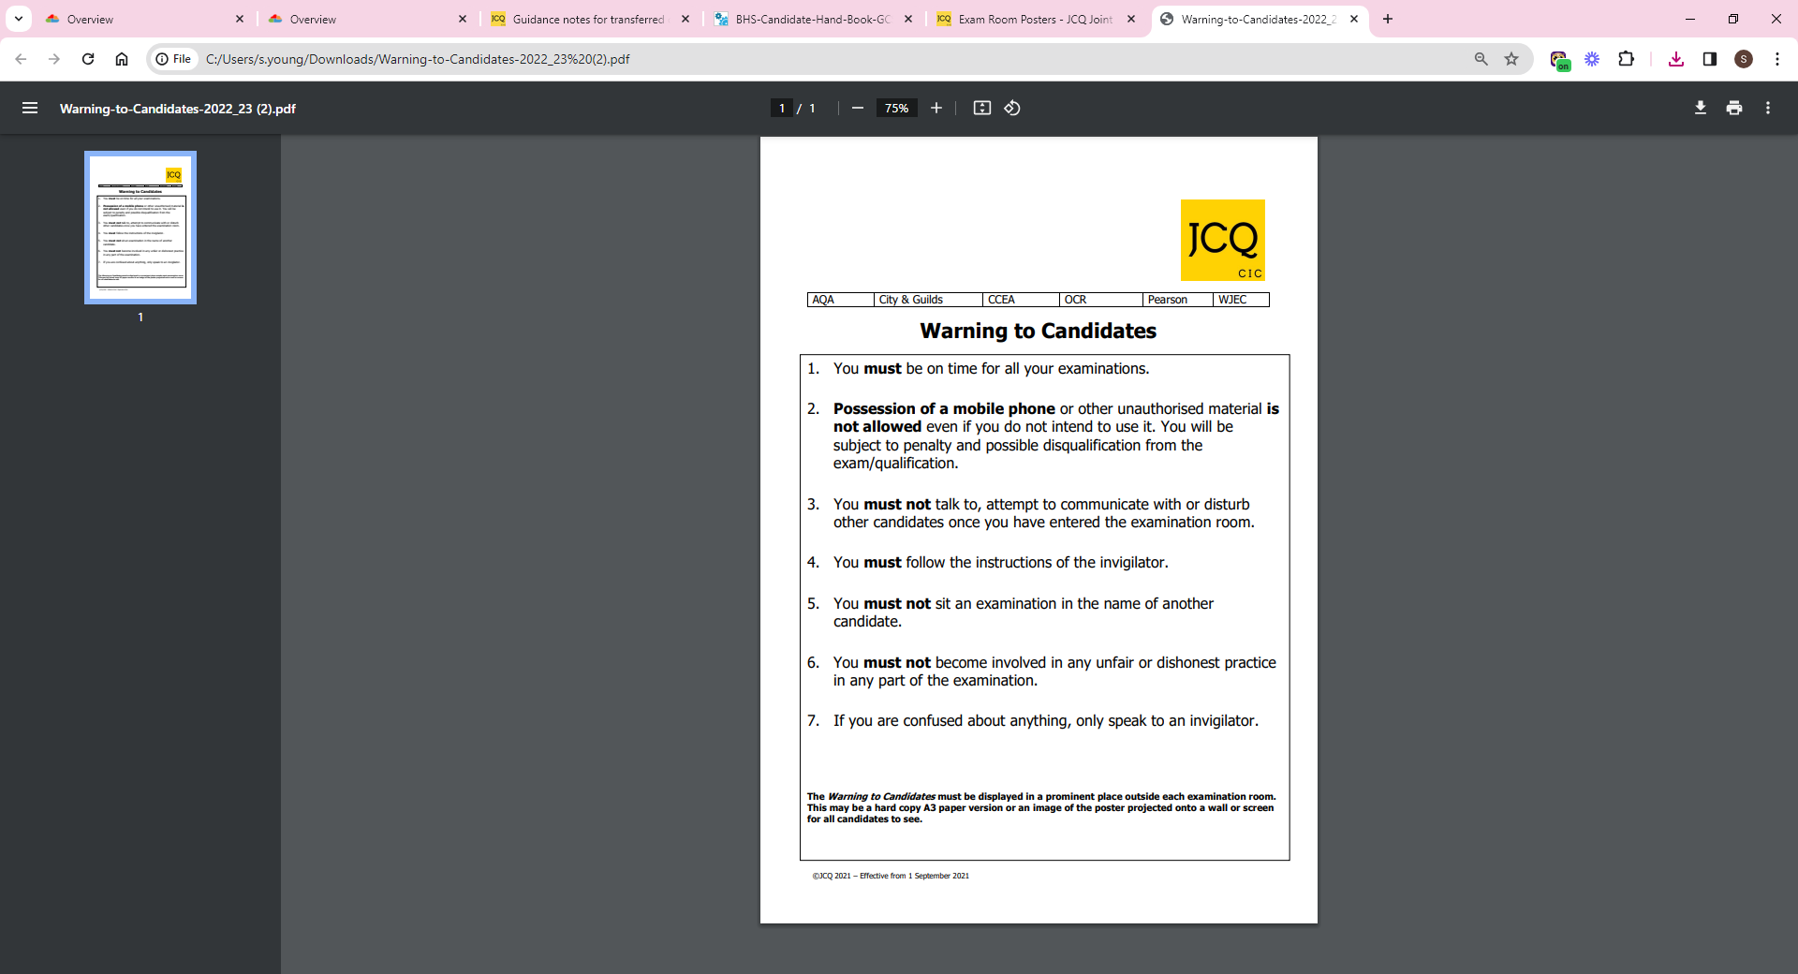



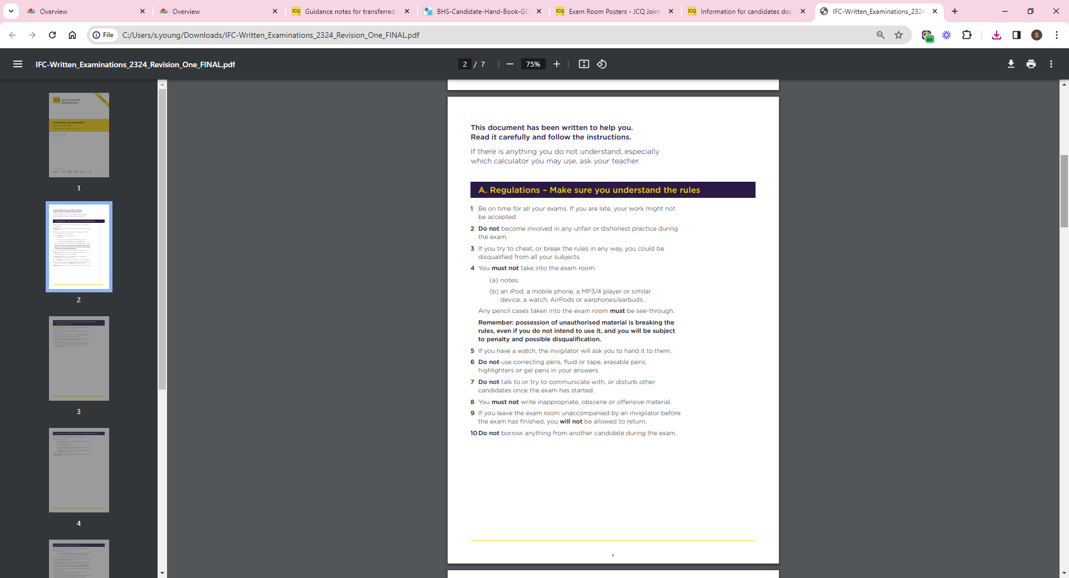

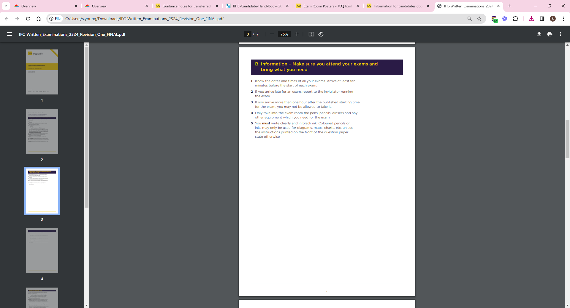

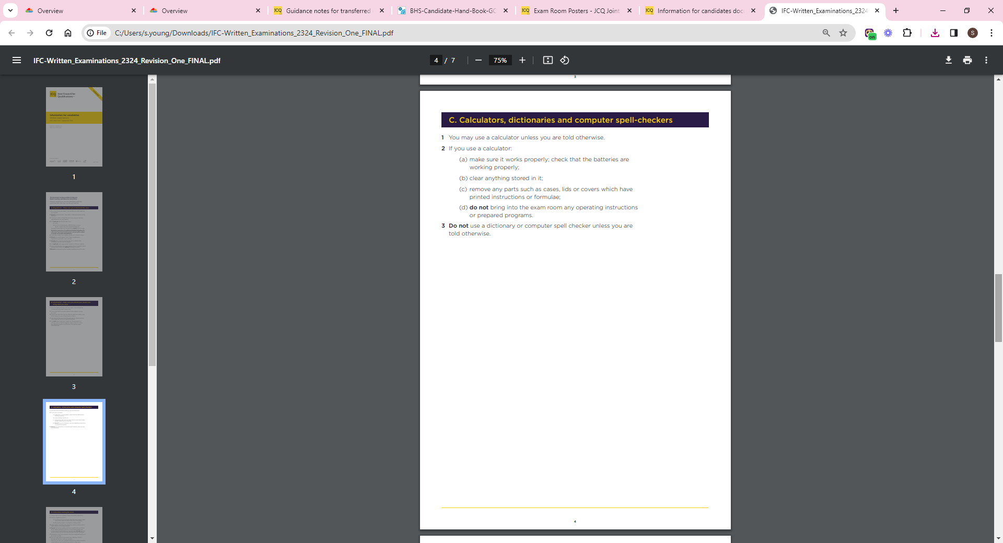

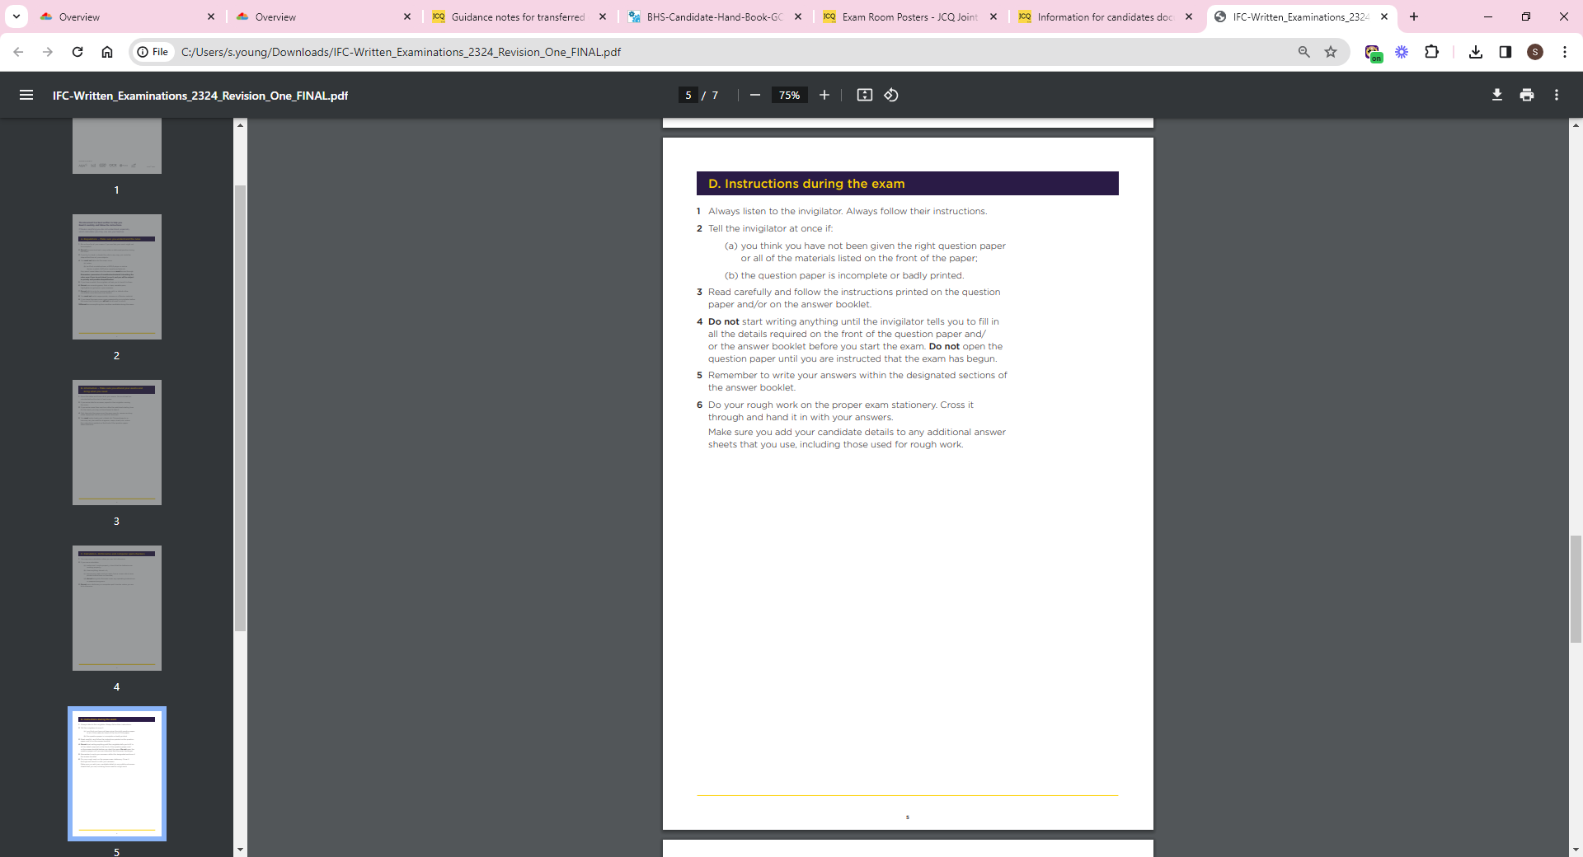

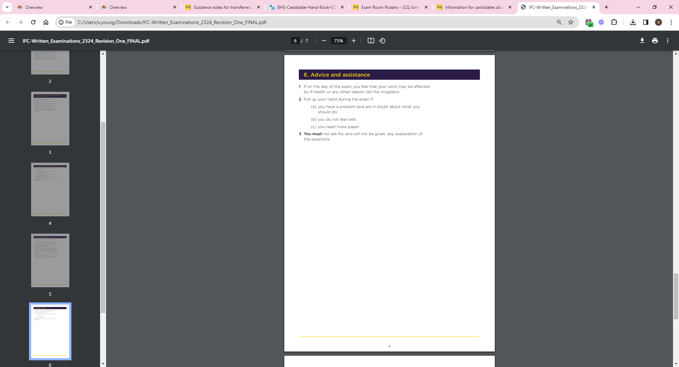

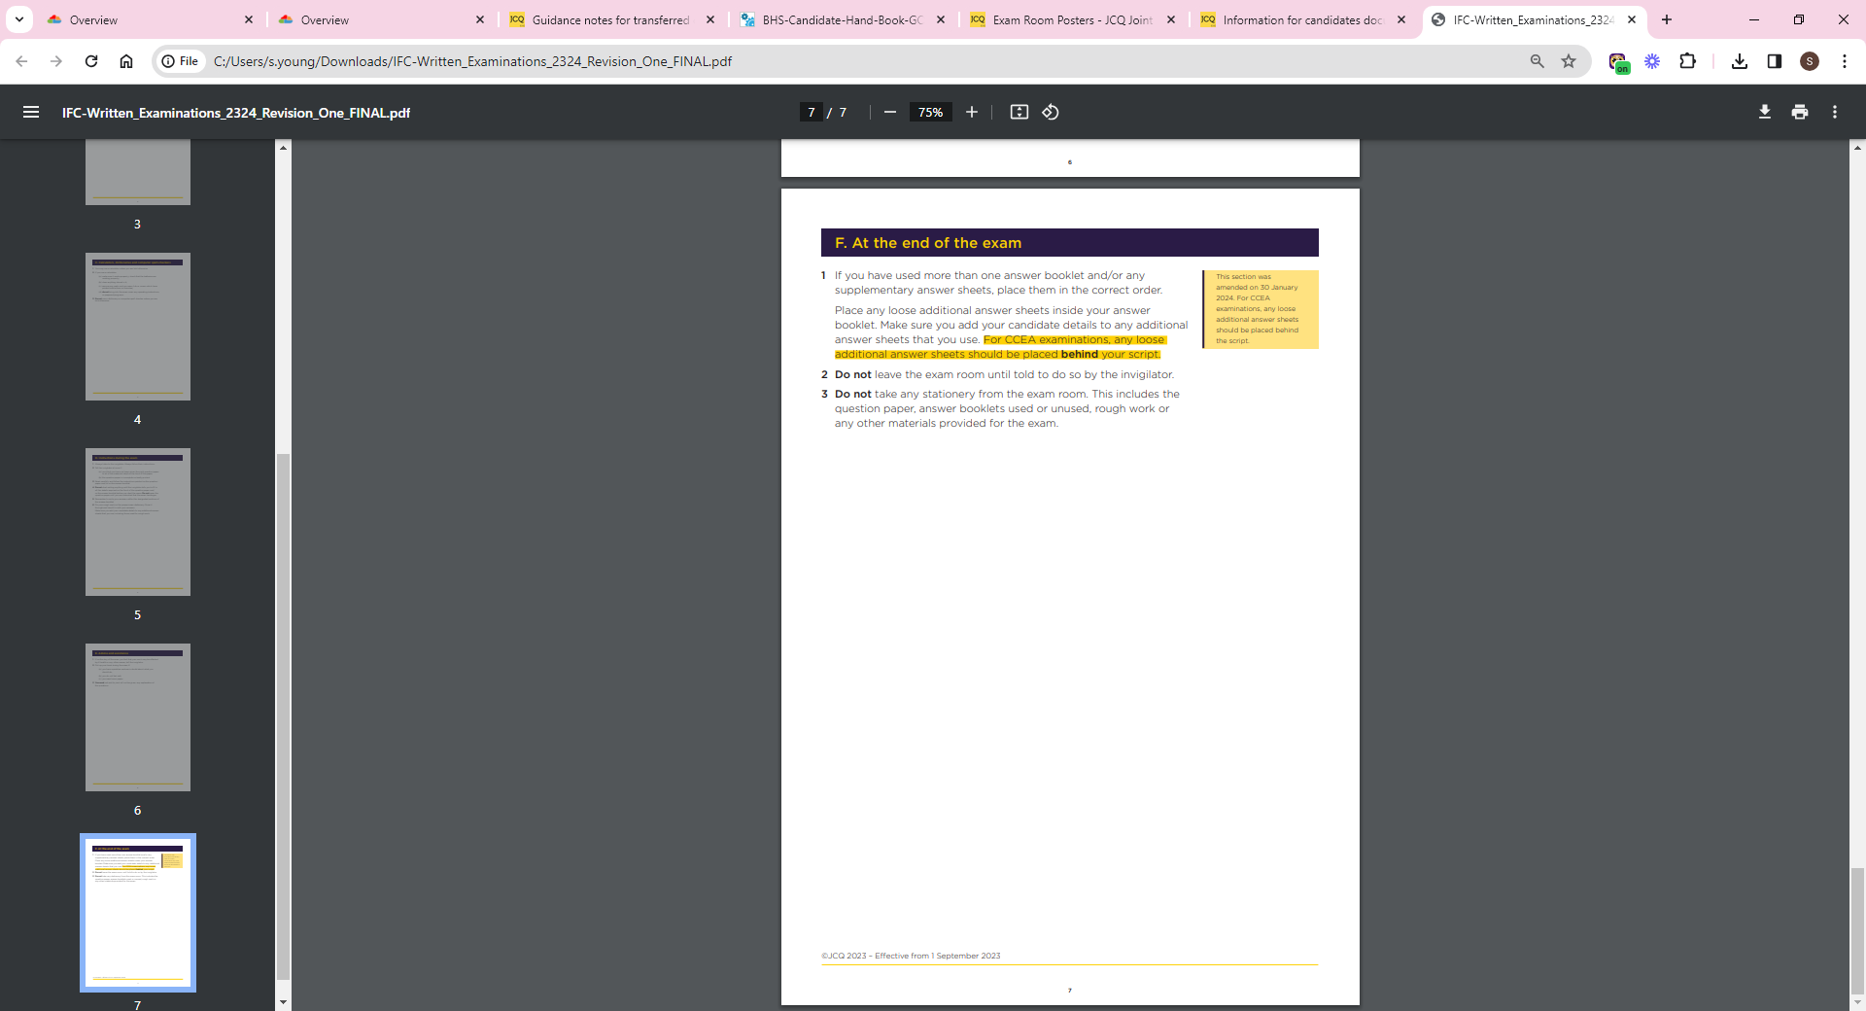

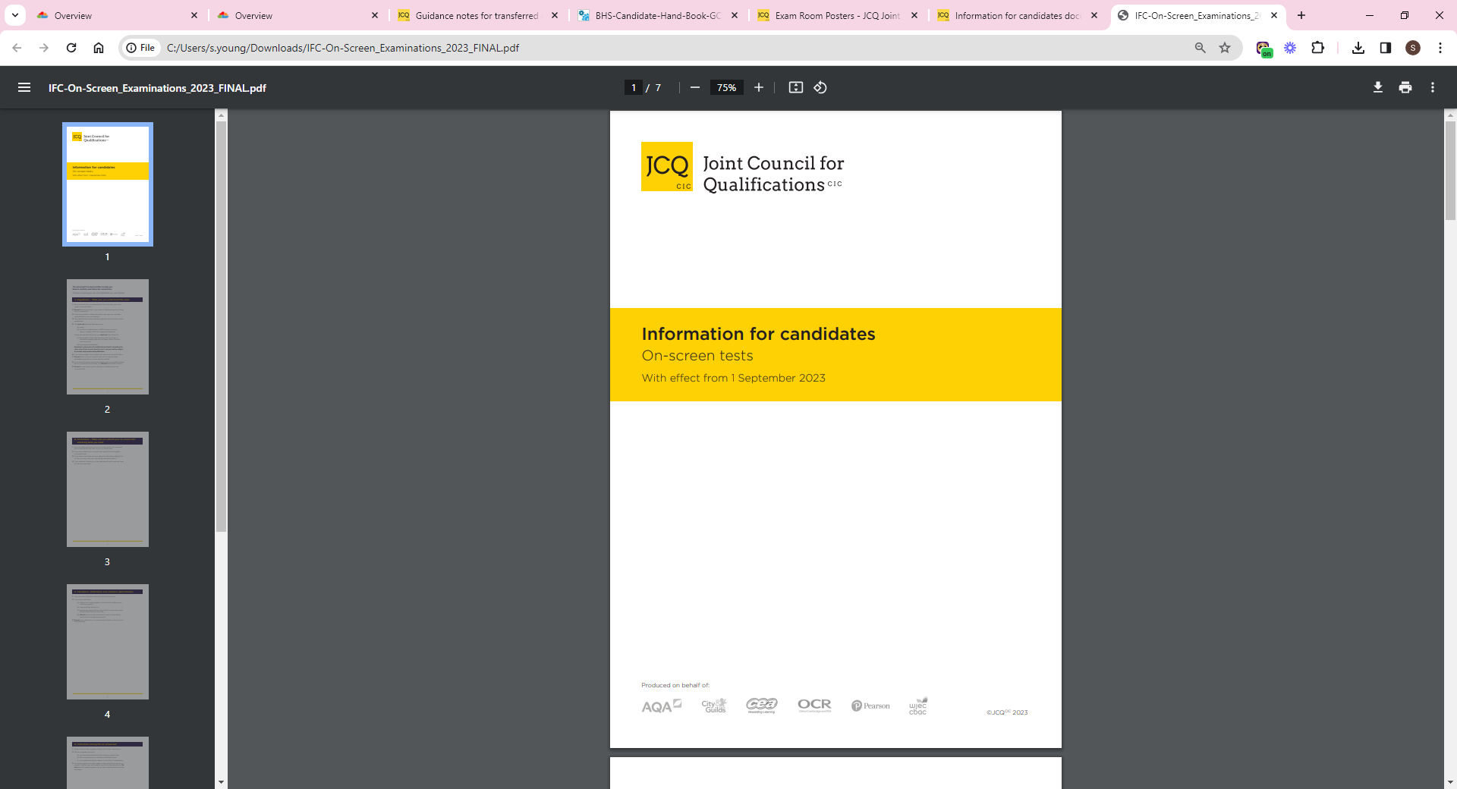

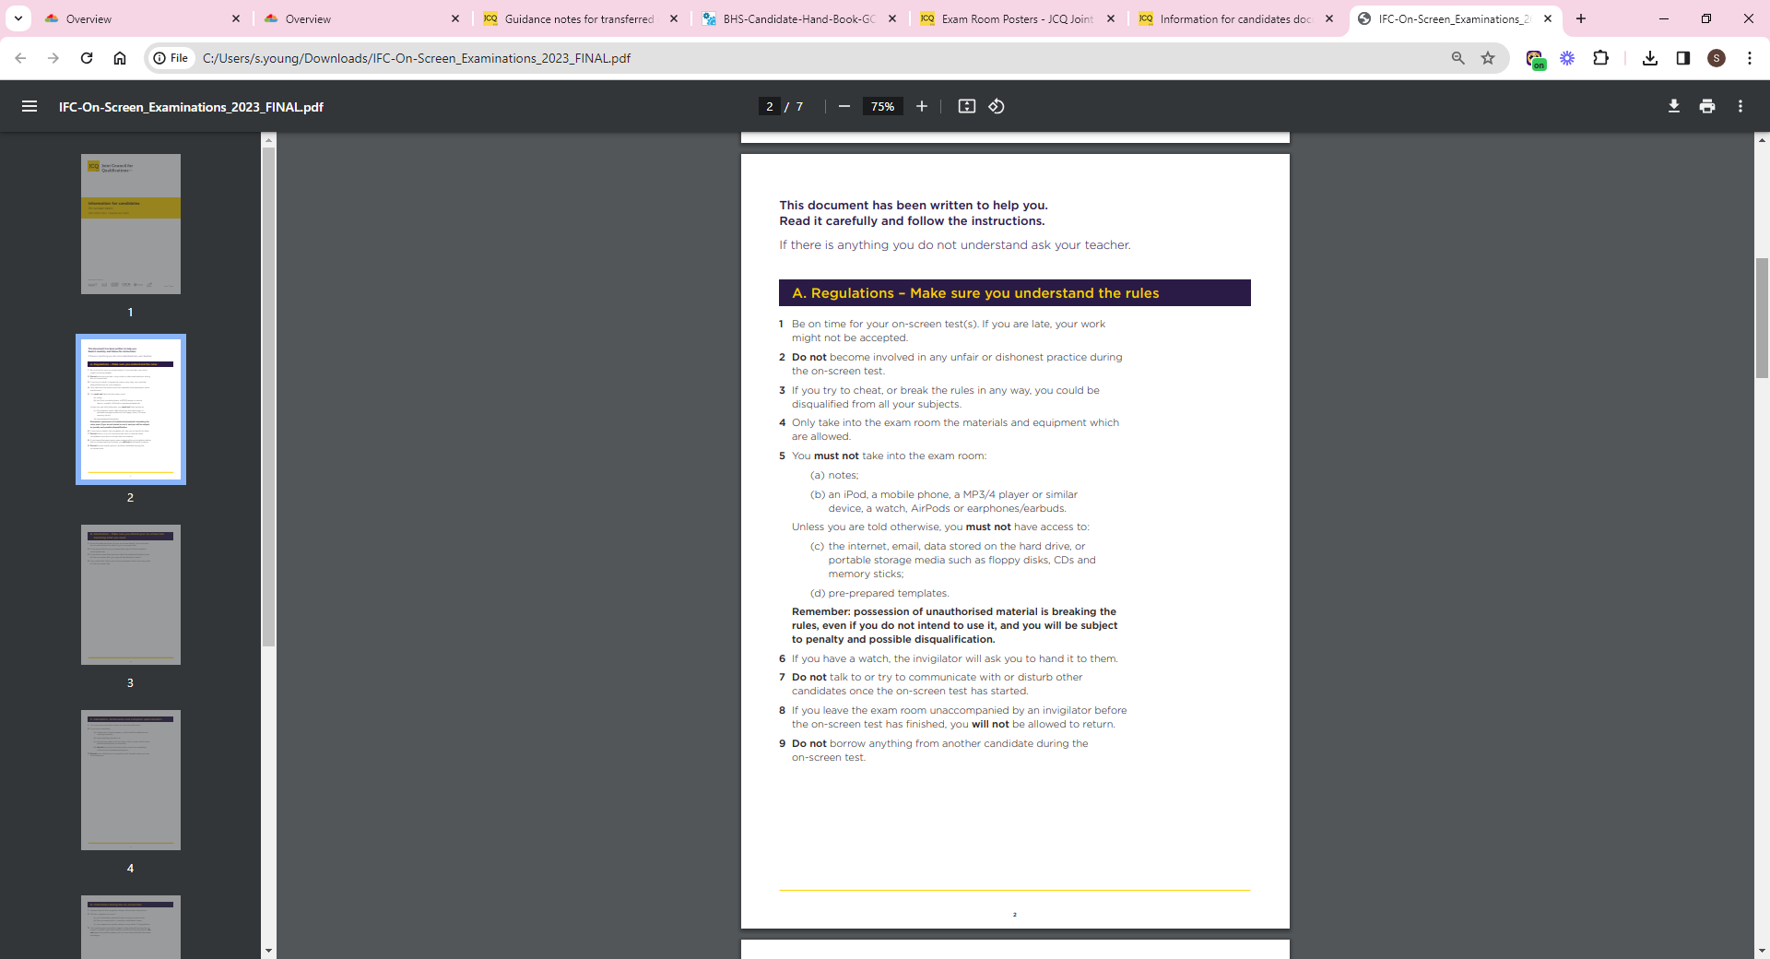

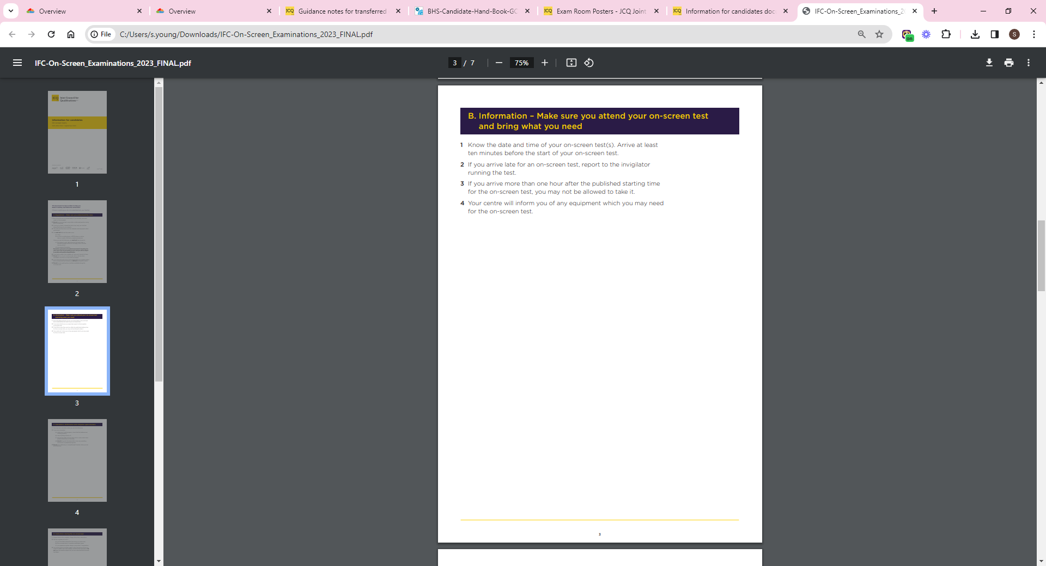

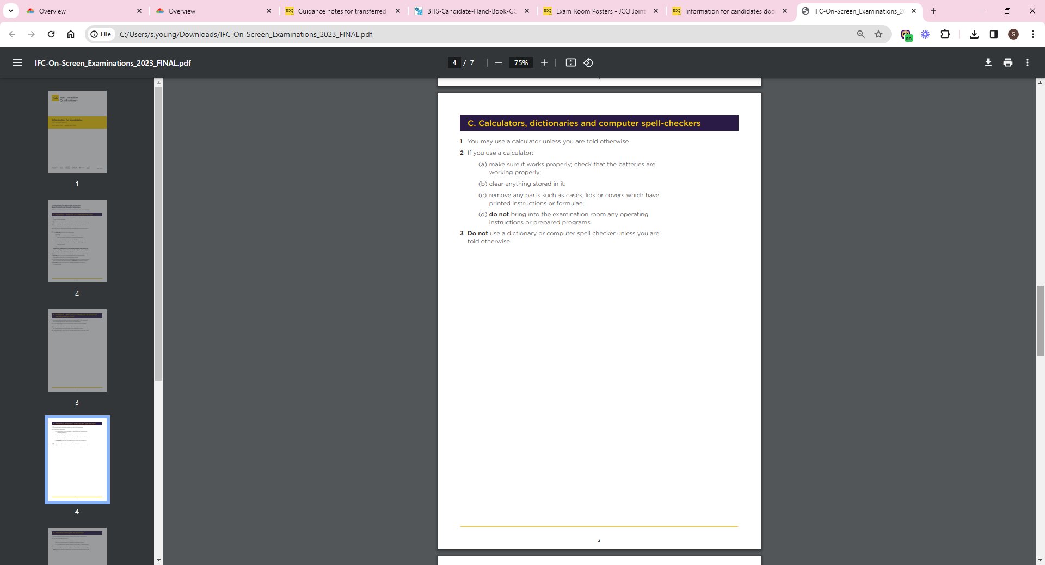

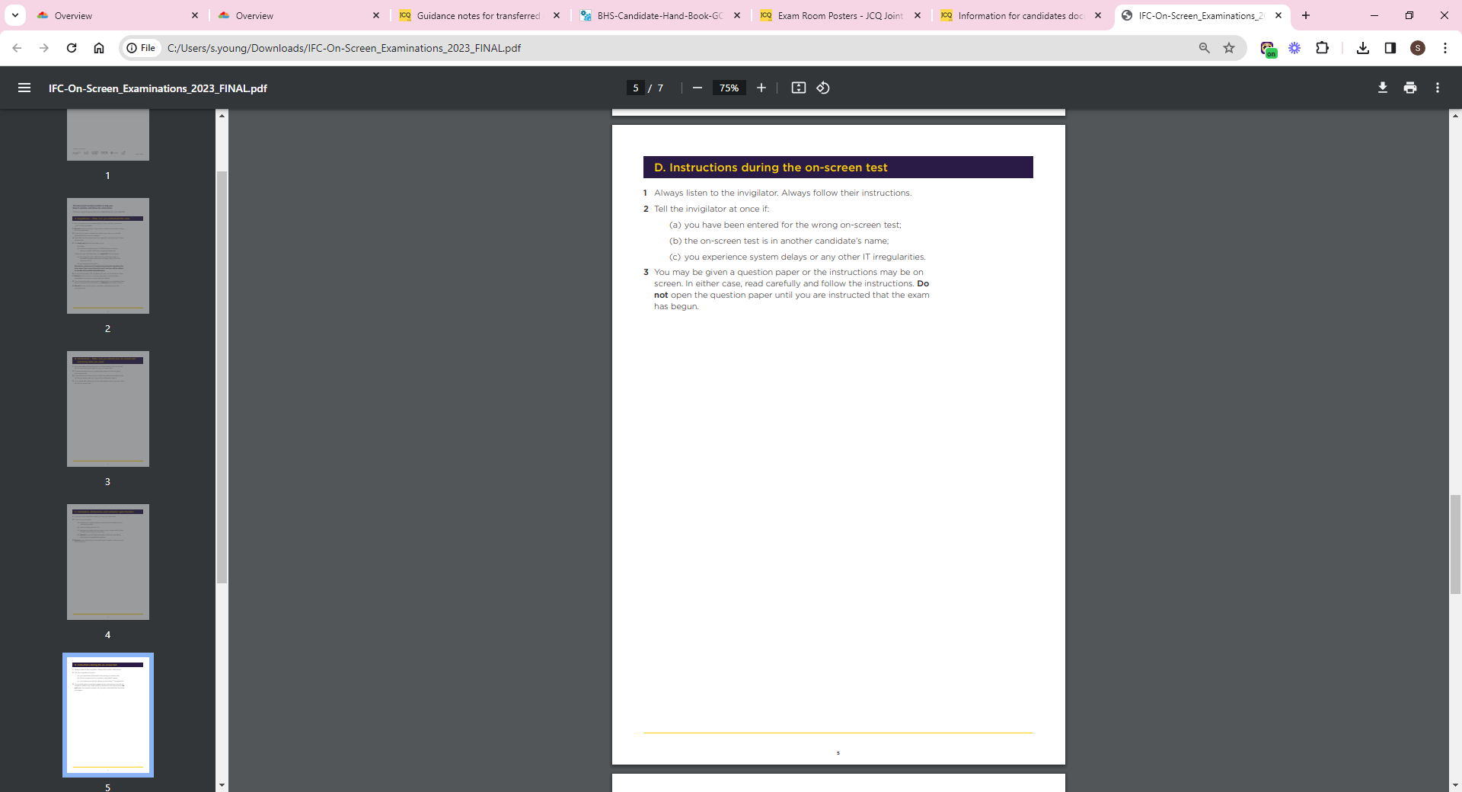

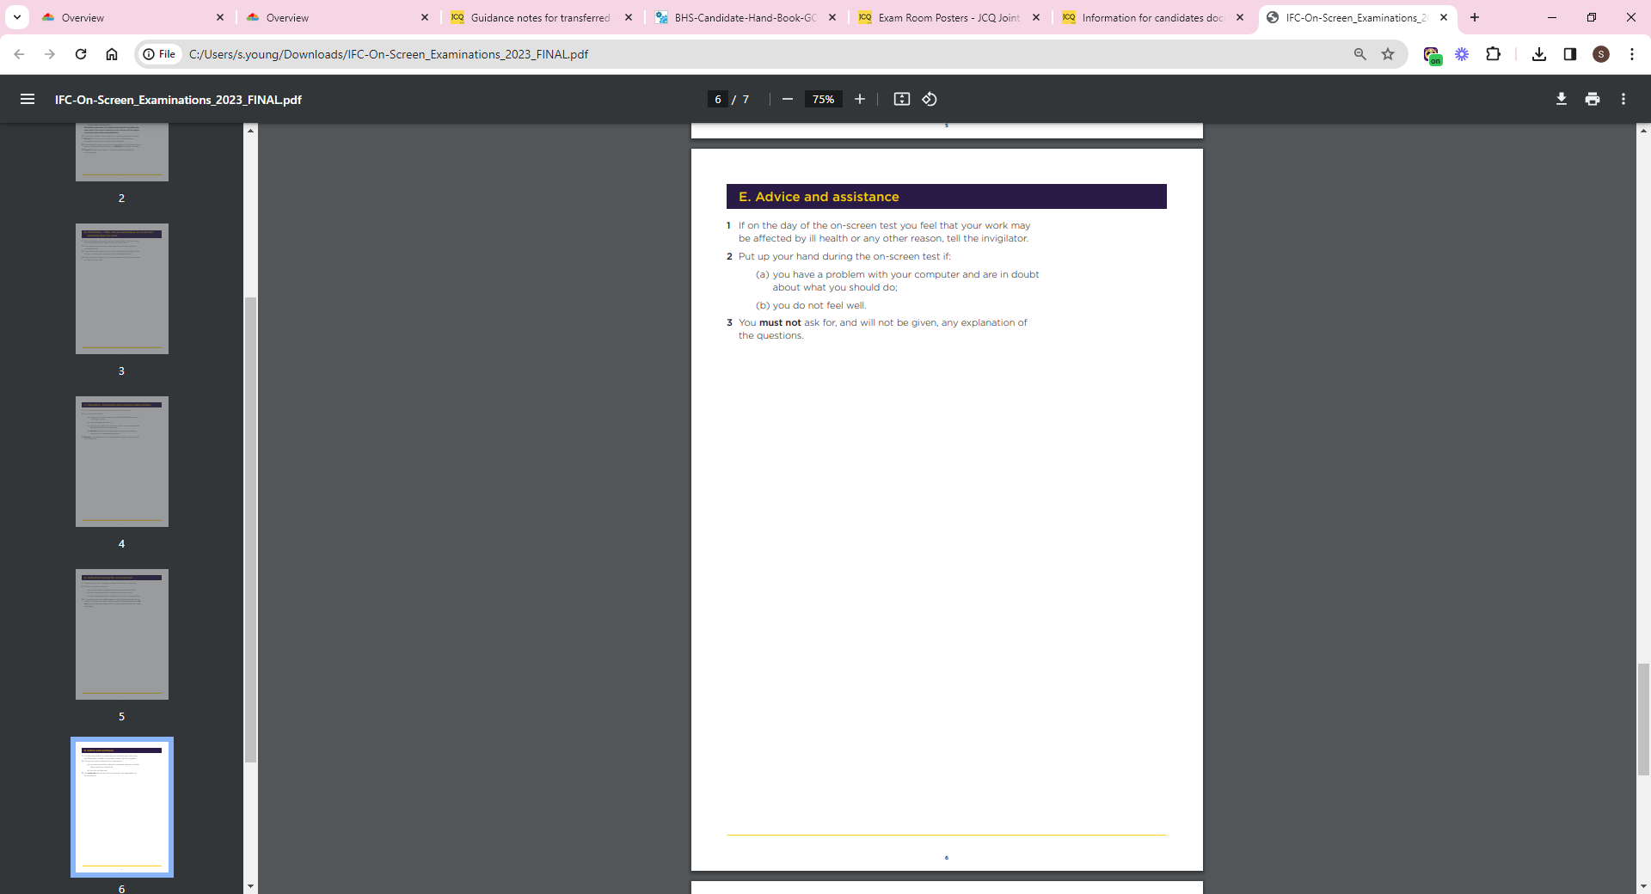

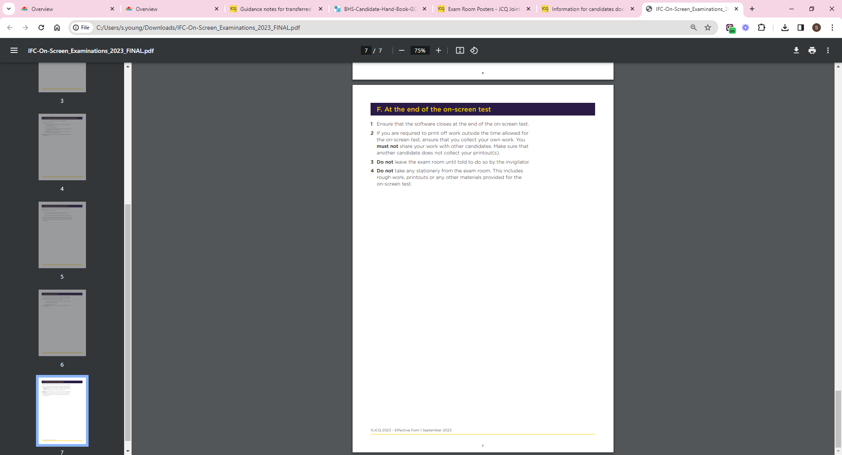

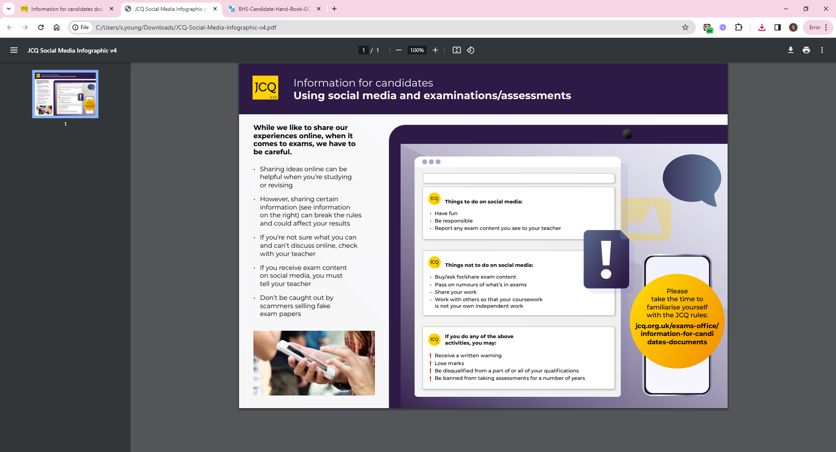

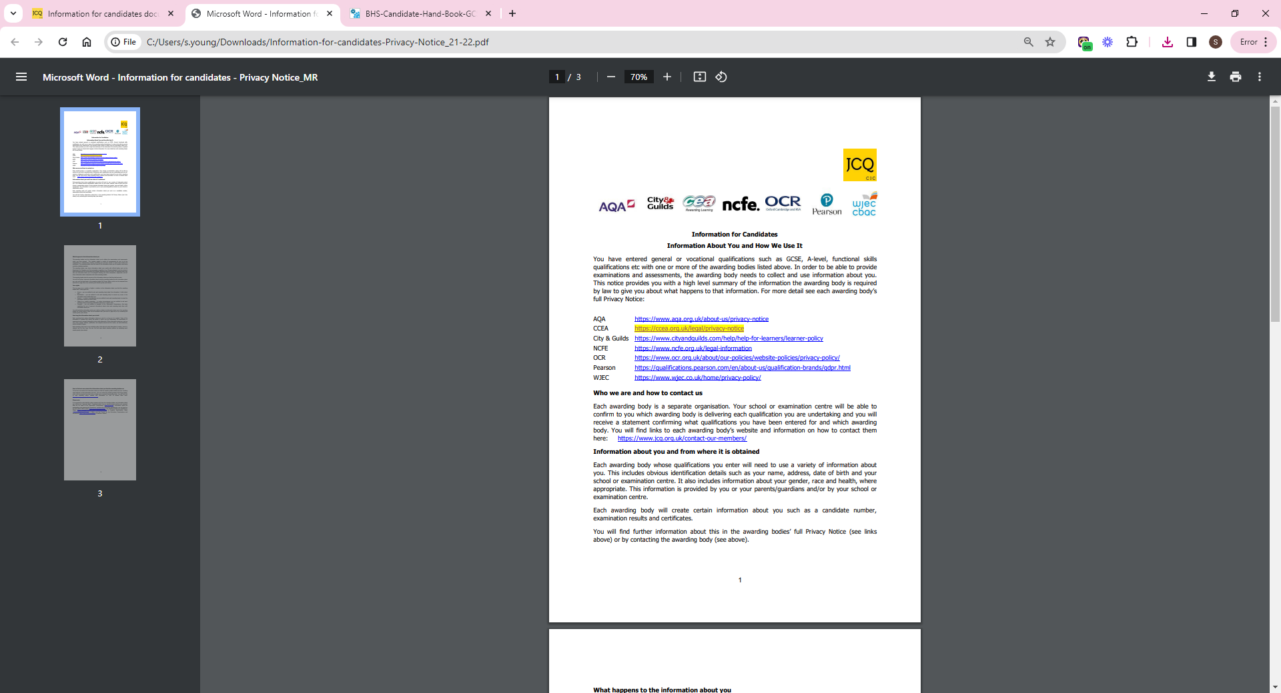

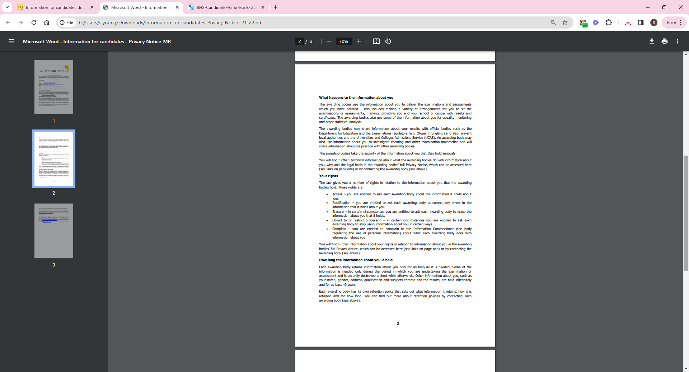

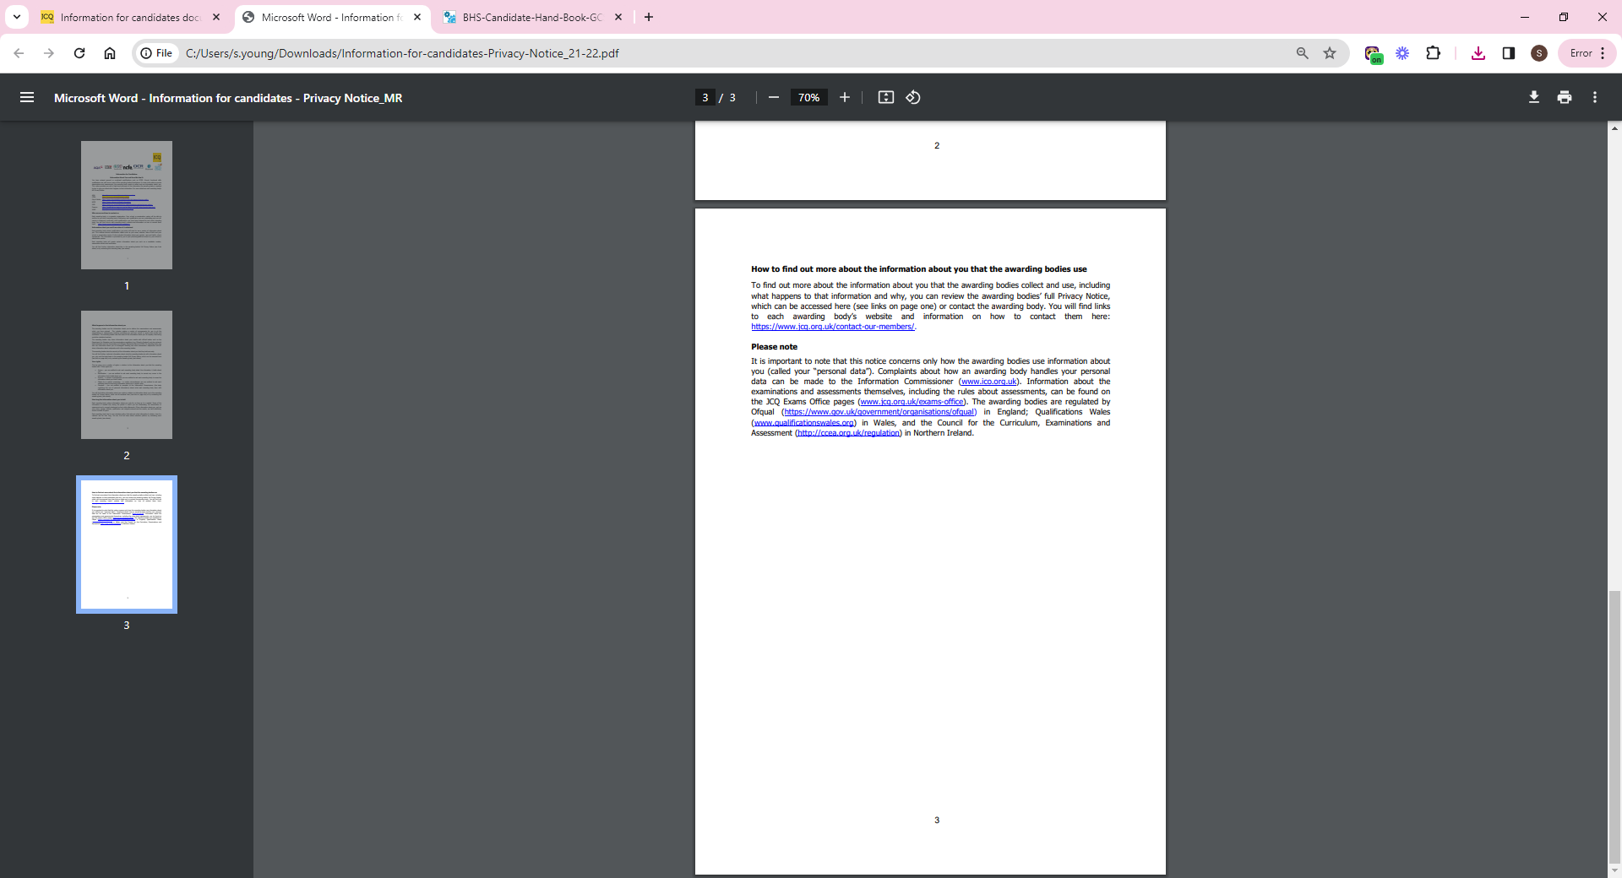



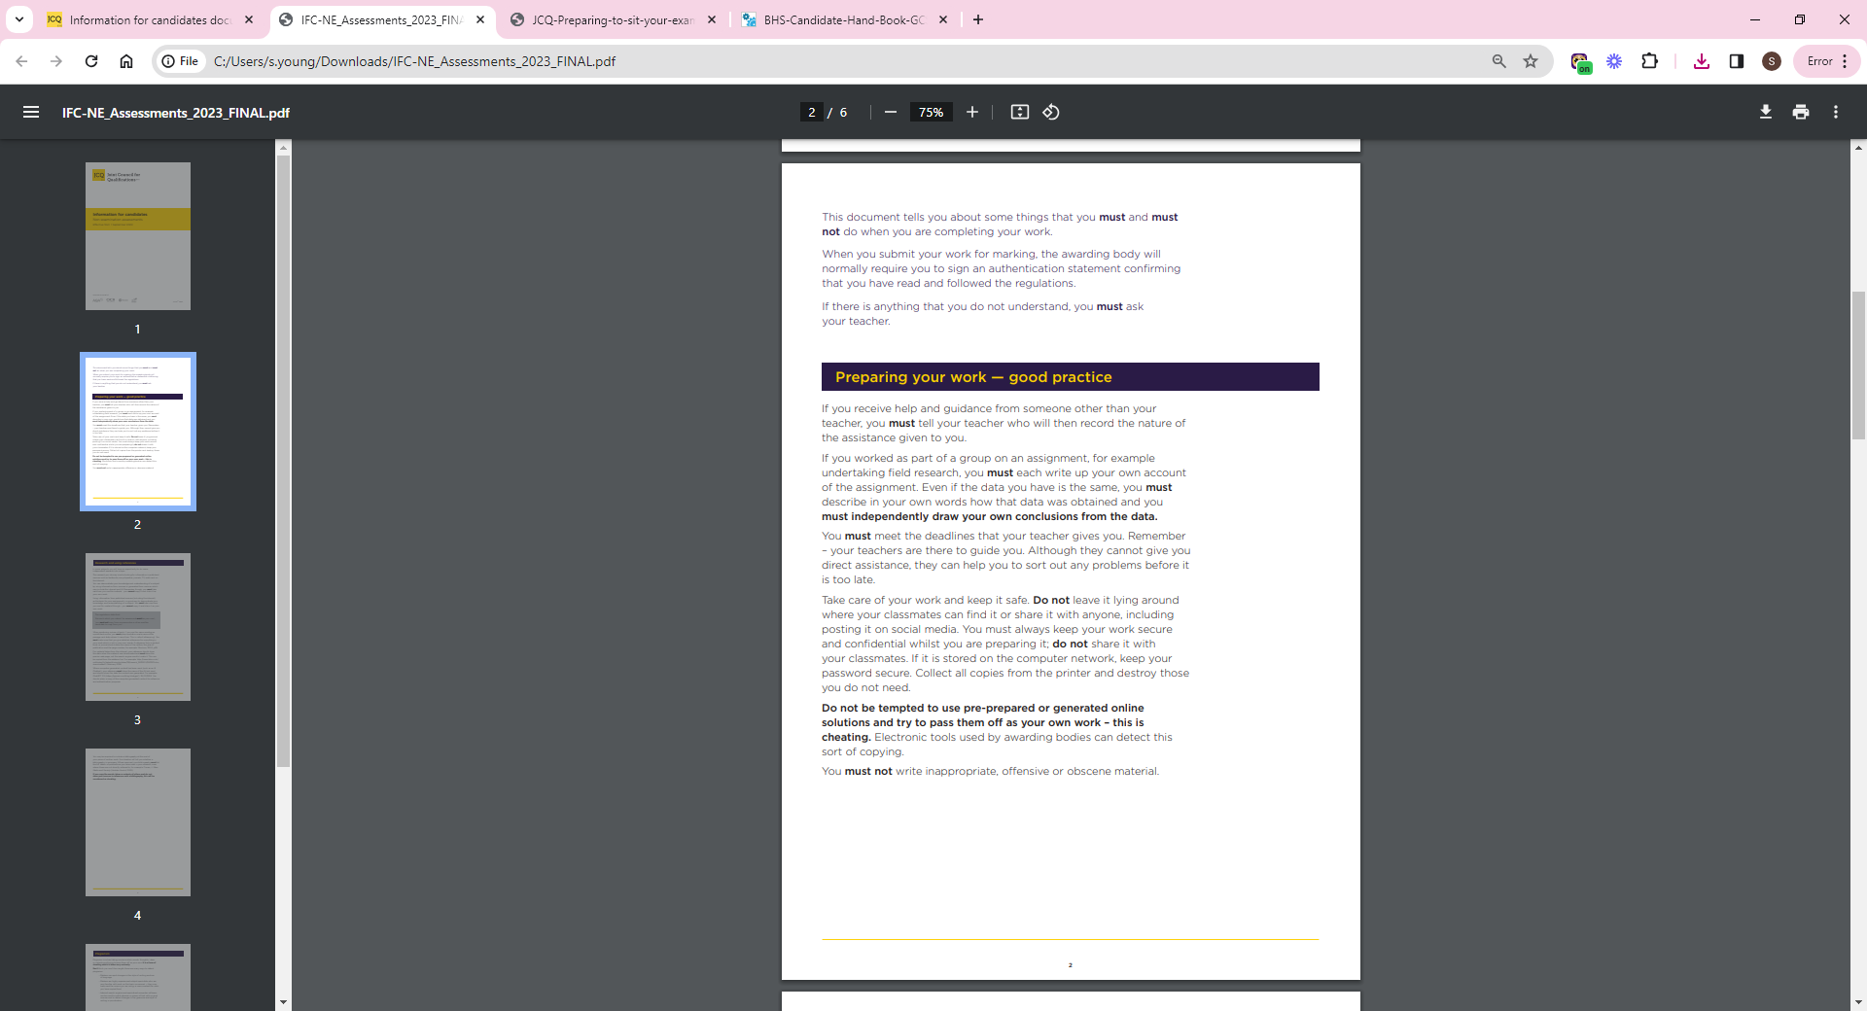

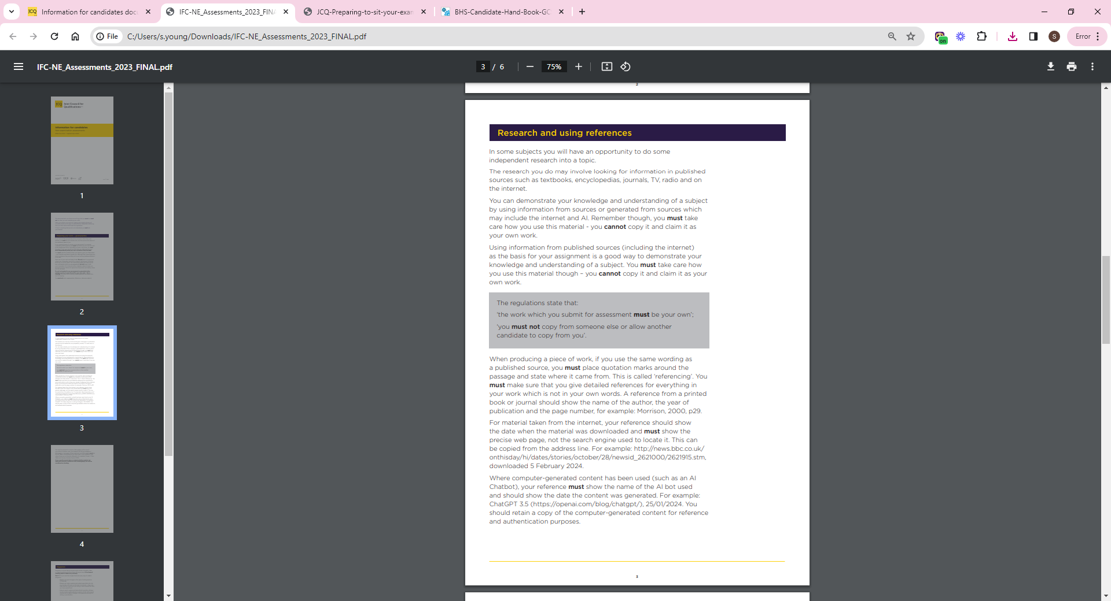

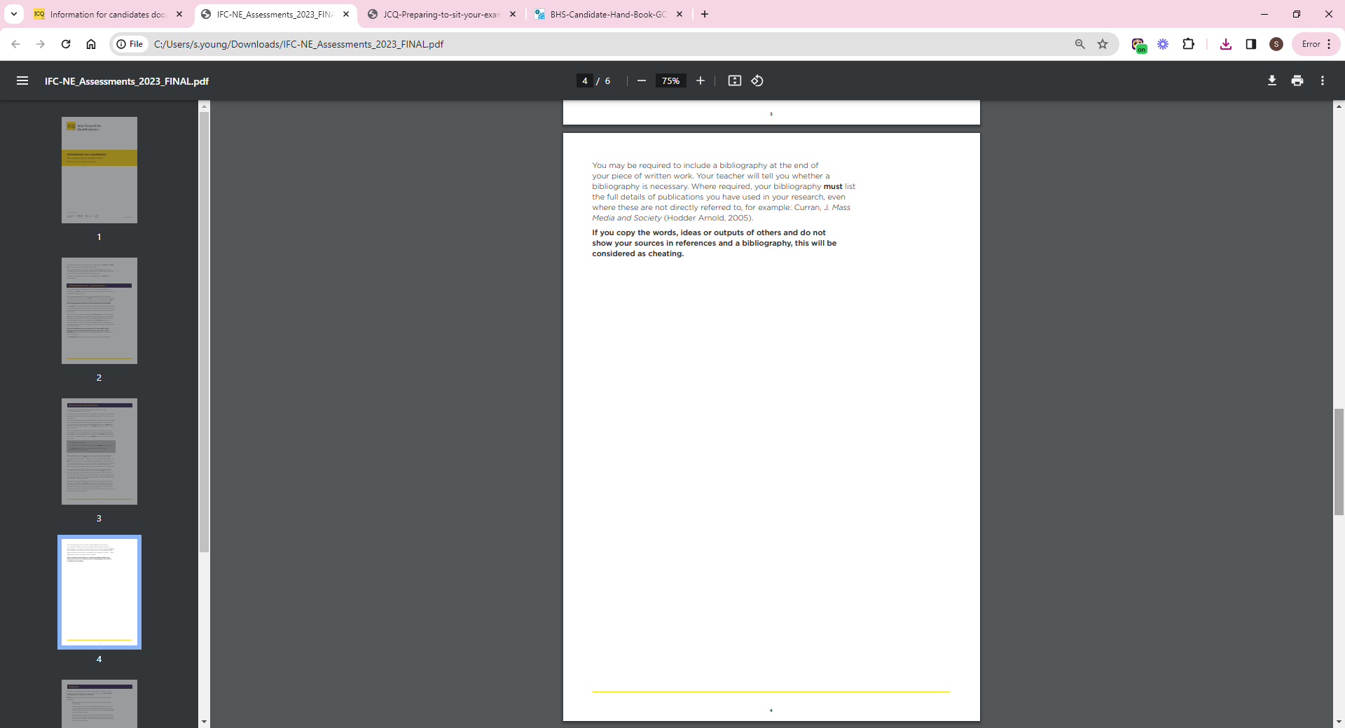

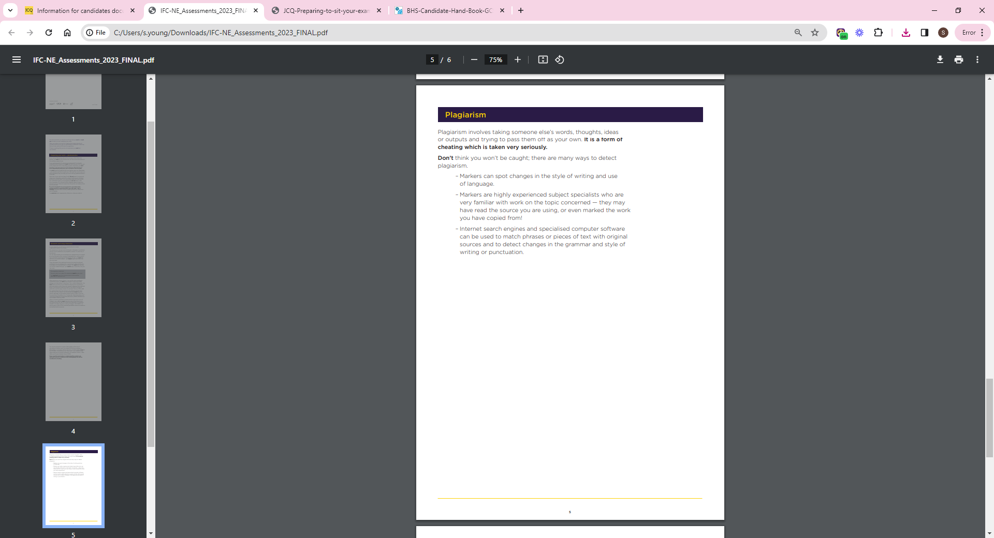

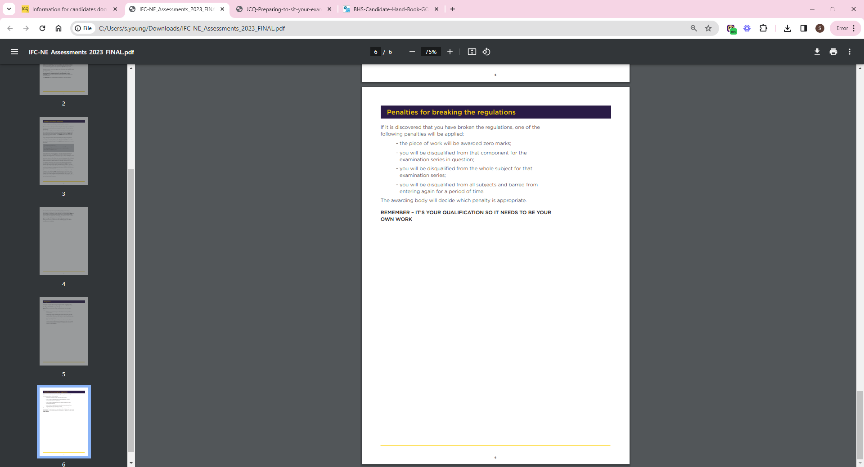



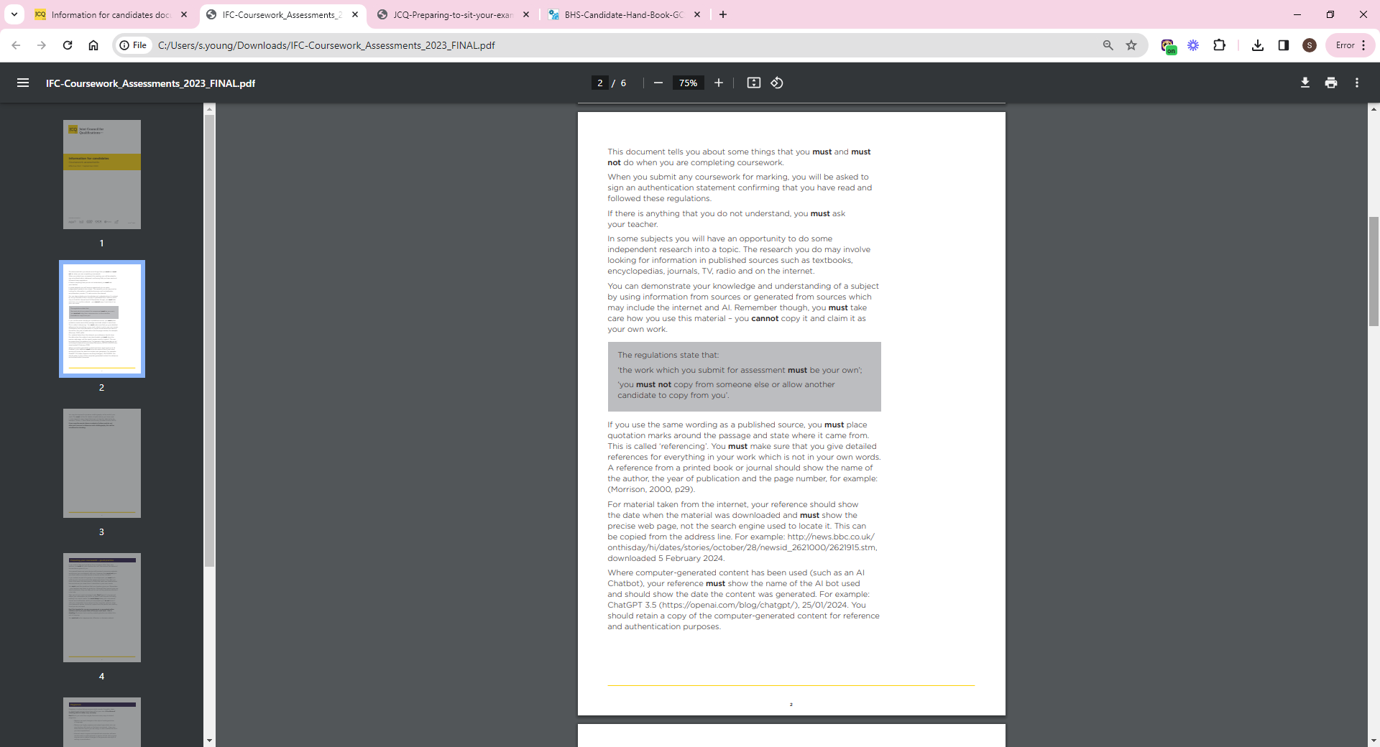

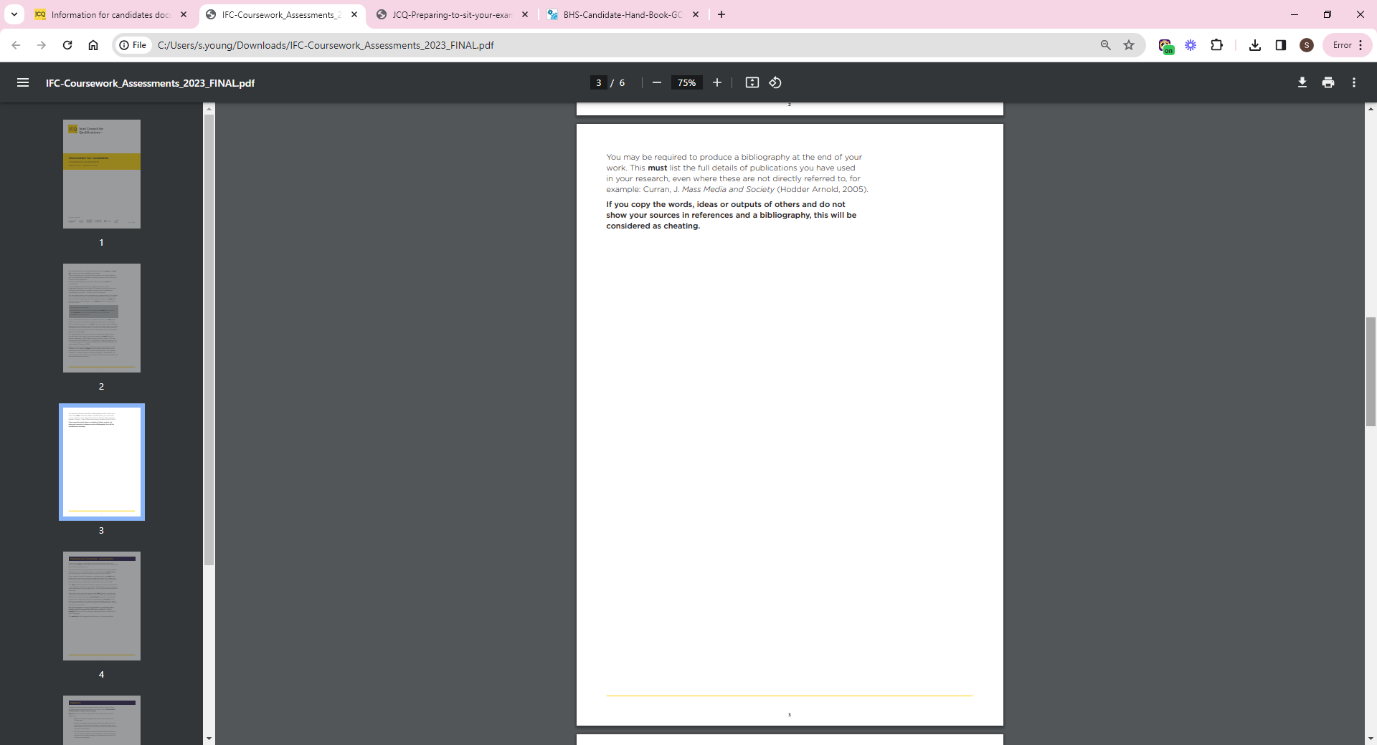

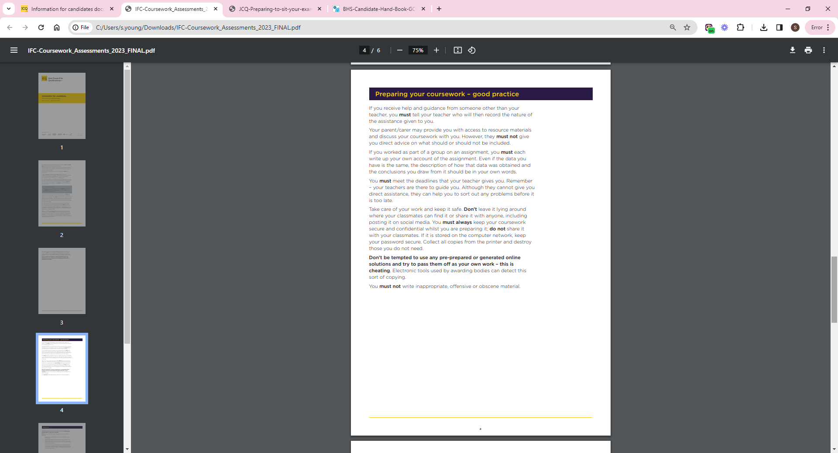

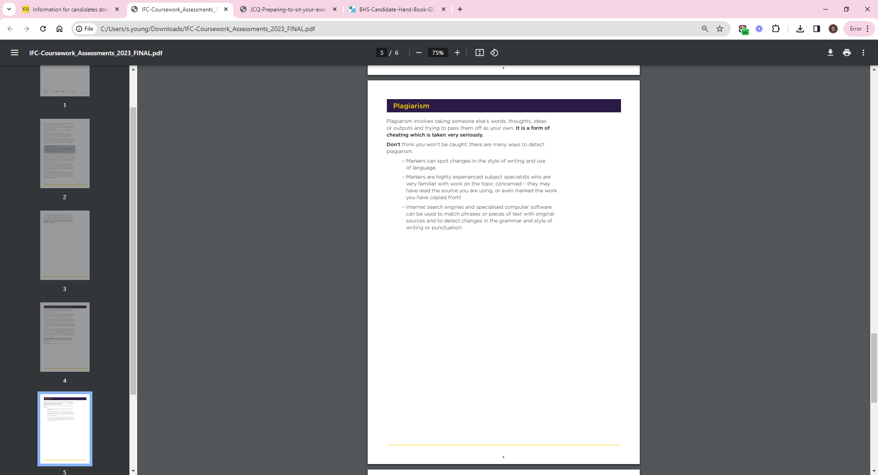

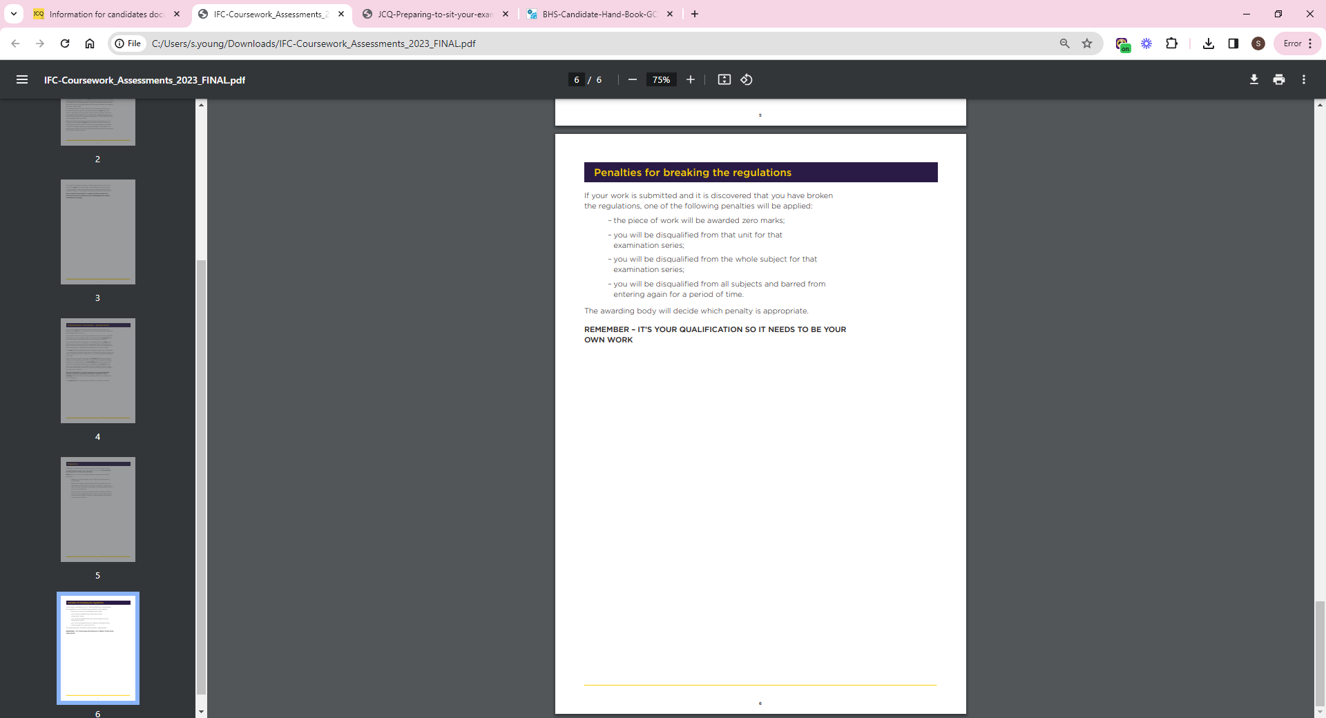

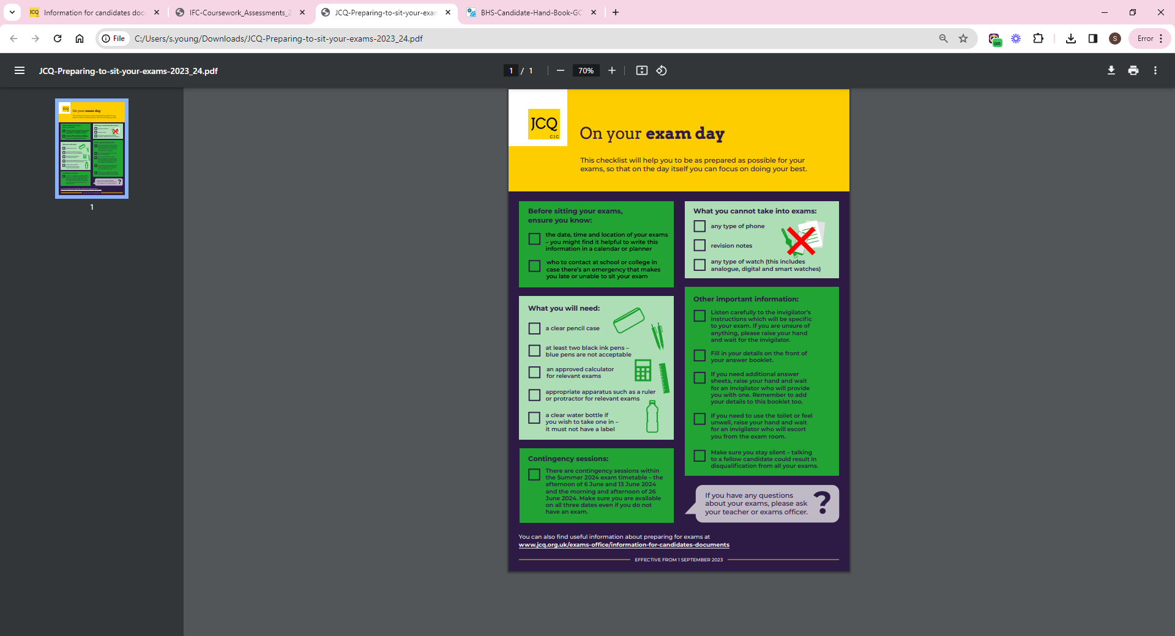

**Further Examination Policies**

* Complaints Policy
* Internal Appeals Procedure – Access Arrangements, Special Considerations and other administrative issues
* Internal Appeals Procedure – Internal Assessment Decisions
* Internal Appeals Procedure – Review of Results and Appeals

All the policies listed about are available from Miss Young, Examinations Officer, and on Blackpool Aspire Academy Website by following the below link: