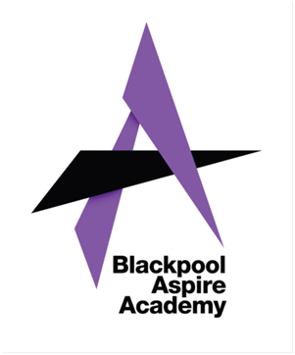
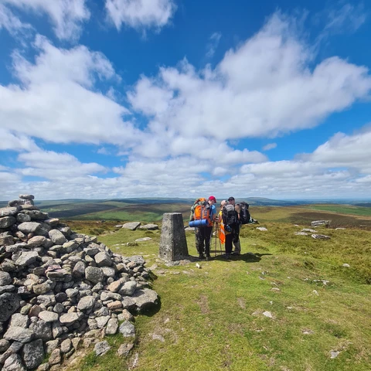
Success nothing less

Introduction to
The Duke of Edinburgh’s Award

For Parents and Guardians
Blackpool Aspire Academy

What is the Duke of Edinburgh’s Award?

The Duke of Edinburgh’s Award is the world’s leading achievement based award; recognised and valued by universities and employers.
It is valued because of the breadth of involvement and the commitment young people need to show to achieve the award.
Whilst the onus is on young people to complete their Award, they will need support from parents/guardians. This leaflet outlines the structure of the Award and how you can support your son/daughter.

Levels and Sections
The Award is organised into 3 levels:

Bronze | Silver | Gold

Each level builds on the previous one; using the skills learnt to meet new challenges.

Each level has 4 elements (known as sections). These are:
Volunteering, Physical, Skills and an Expedition.
The sections provide a broad selection of challenges to help develop a wide range essential skills for life and work.

Individual Commitment
Young people normally start their Duke of Edinburgh’s experience at Bronze level. They can begin working on all their sections as soon as they have enrolled.
They must choose the activities they want to undertake for each section. With a wide range of activities available, they will be able to find activities that match their interests. Normally young people can use activities that they already enjoy, such as attending youth organisations, playing a sport or learning to play a musical instrument.
At Bronze level, each section requires a commitment of one hour per week which must be sustained for a minimum of 3 months (plus an additional 3 months on one section)

For the expedition section young people need to complete a training package, a practice expedition and a qualifying expedition. The training and the expeditions can be tailored to suit the level of the award and the needs of the young people taking part. For Bronze, the expeditions must include two days walking and an overnight camp.
More information on the levels and sections of the Award can be found at https://www.dofe.org

Parental Support
Whilst the emphasis is on the young people giving time and commitment to achieve the Award, your child/ward will need support.

For example your child may need lifts to and from attending sessions for their Volunteering, Physical and Skills sections or to take part in expedition training. These activities may be carried out in school, sports club, community centre or another location.

Cost
There is a £22 enrolment fee for Bronze and Silver (£29 for Gold) which helps the DofE team pay for administrating the Award and provide a welcome pack and certificate. The school will take charge of this for the duration of the award.
The pack will help the young person record their progress through the Award.

Making Sure Your Child is Properly Supervised
The school will provide DBS cleared staff and volunteers to support expedition training and supervise your child whilst on their expeditions. Activities for the other sections may also be carried out by teaching staff or other volunteers already DBS cleared.

However, if your child wishes to take part in an activity run by other agencies such as voluntary clubs, commercial organisations or local groups, eg: a sports club, a dance class or a guitar tutor, then it is your responsibility to ensure that the adult supervising that session is trustworthy. The school does not vet these agencies, their staff or volunteers, or the standards of work that they provide.

