How to help your child with Maths
- Talk through the question.

- Draw the Problem- use images instead of numbers.

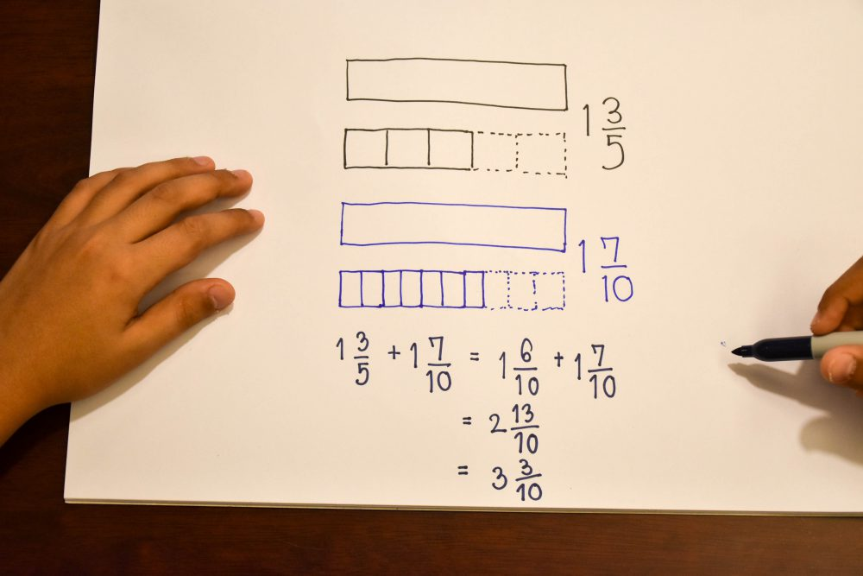
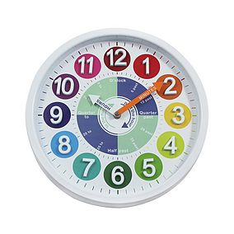
- Break Tasks Down into small chunks.

- Use “Real-Life” Physical Objects- clocks, counters etc.

- Go over what you’ve learnt and understand that children may forget.

6. If you have internet access use the Maths websites. Times table games, interactive clock, counting games etc.

7. Use lots of praise and rewards.

