Islam
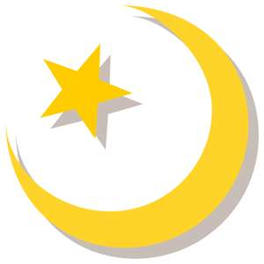
- Find the missing words

- Islam is one of many kinds of .
- People who follow Islam are called .
- The Prophet was the man who spread the word of Islam to the people.
- Mohammed was born in the city of .
- Muslims call God .
Mohammed Allah religion Mecca Muslims

- Mohammed is an important person to Muslims. Who is important to you? Draw a picture of them.

