Information About Judaism
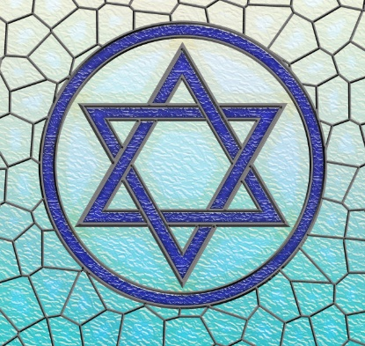
Judaism is the original of the three Abrahamic faiths, which also includes Christianity and Islam. According to information published by The Jewish People Policy Planning Institute, there were around 13.1 million Jewish people in the world in 2007, most residing in the USA and Israel. According to the 2001 census 267,000 people in the UK said that their religious identity was Jewish, about 0.5% of the population.
- Judaism originated in the Middle East over 3500 years ago. The centre of Jewish worship was Jerusalem where the Jewish temple was located. The temple was destroyed by the Romans in 70CE after a Jewish revolt. After this point Judaism expanded beyond the Middle East and into Europe, Africa and Asia.
- Judaism was founded by Moses, although Jews trace their history back to Abraham.
- Jews believe that there is only one G-d with whom they have a covenant. A covenant is an agreement between G-d and humans. In exchange for all the good that G-d has done for the Jewish people, Jewish people keep G-d’s laws and try to bring holiness into every aspect of their lives.
- Judaism has a rich history of religious text, but the central and most important religious document is the Torah, which Jews believe was written by Moses.
- The Torah is still written on scrolls and is treated with respect and Torah scrolls are kept in an ark at the synagogue. Jews do not directly touch the scrolls but use pointers instead, which are called Bimah.
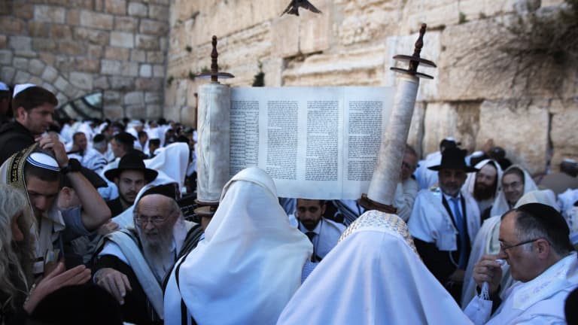
- The Torah contains 613 commandments or mitzvot that Jews must keep in order to maintain the covenant with God. These include not working on the Sabbath which runs from sunset on a Friday to sunset on a Saturday.
- Jewish traditional or oral law, the interpretation of the laws of the Torah, is called halakhah.
- Spiritual leaders are called Rabbis and Jews worship in Synagogues.

