Blackpool Old Rd, Blackpool  FY3 7LS |  |  |  |  | Mindfulness  - Guidance for parents/ carers  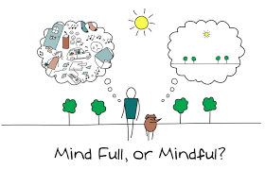  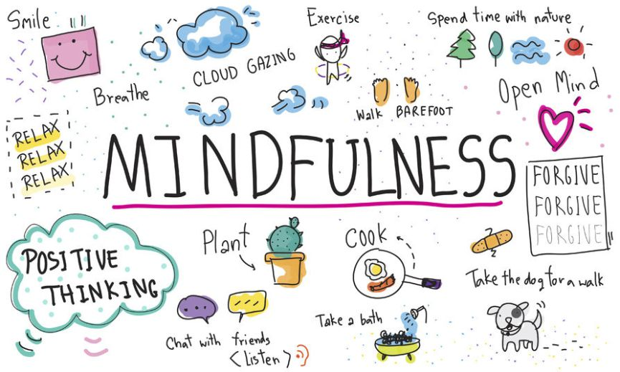

“an awareness that arises, by paying attention on purpose, in the present moment and non-judgmentally”  Jon Kabat-Zinn  What is Mindfulness?  Mindfulness is about focusing on the present moment and not judging ourselves for any thoughts that pop into our heads. Mindfulness teaches us to acknowledge our thoughts and put them to one side, to enjoy being in the present moment.  Mindfulness helps us deal with our thoughts by focusing our attention on one point (anchor), when thoughts come we acknowledge them, then return to the anchor. | Body scan  Breathing meditation  Small daily practices  Applying knowledge  How can it help?  Research has shown that Mindfulness can show improvements for several conditions, such as:  - Depression  - Anxiety  - Stress  - Chronic pain  Mindfulness can also help us in a number for other ways. For example:  - Increase mood and well being  - Decrease emotional reactivity  - Increase immune functioning  - Increase focus and flexibility in our thinking  - Boost working memory  - Increase information processing speed | How does it work?  Most individuals in the western world are dominated by the left side of their brain, which can cause too much thinking.  Practicing mindfulness can help bring abut a calmness, stilling the brain chatter and helping to engage the right side of our brain. This reduces stress and improves our health.  Mindfulness often goes against many of our automatic behavioural responses such as:  - Rushing through activities without being attentive to them  - Acting clumsily due to thinking of other things  - Lashing out when angry  - Snacking without being aware  Please see Mrs. Gregory for more information on Mindfulness or attend one of her work shops.  L.gregory@aspire.fcat.org.uk

