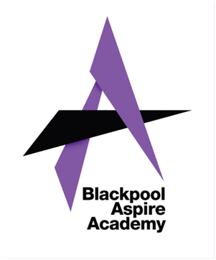
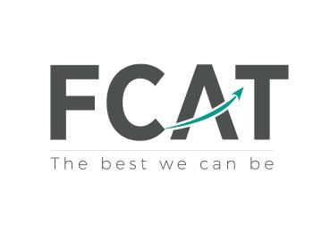

Success nothing less

13th November 2023

Year 10 WORK EXPERIENCE - April 2024

Dear Parent/Carer,

As part of Blackpool Aspire academy’s Career curriculum, we are offering students in Year 10 the opportunity to participate in a work experience placement in April 2024.
It is a great opportunity for all Year 10 students to spend some time with an employer or other organisation, allowing them to experience as far as possible the hours, working conditions and regulations they may encounter when they go to work themselves. Placements are defined as experience in which students carry out a range of tasks and duties more or less as would regular employees but with emphasis on the learning aspect of the experience. It is not intended to be training for a student's chosen career.
The dates of the one-week placement for this academic year will be from 29th April to 3rd May 2024.
Students will work normal business hours and could be asked by the employer to visit the placement before starting work.
Year 10 students have had their launch assembly which detailed what the programme entails, how to complete the required forms and ask questions to our school’s working partner, the Education Business partnership (NW), EBP(NW) Ltd, which specialises in work placements in the Blackpool, Fylde and Wyre areas. EBP(NW) will join us again in December for a further information session.
We encourage students to find their own placement to ensure that they have an enjoyable and rewarding week, and if they do so, they must complete a ‘self placement’ form and hand this in to me by Thursday 21st December 2023. Copies of this form are also available on the school website. If students are unable to find their own placement, details of the online system used to support with choosing a placement will follow.
Yours sincerely,

Mrs L Barnhurst
Careers Lead

