

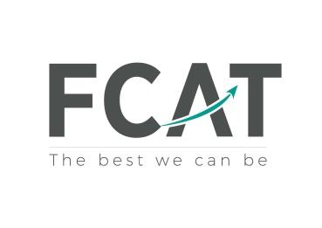

Success nothing less

10th November 2025

Year 10 WORK EXPERIENCE – Monday 11th May 2026 to Friday 15th May 2026

Dear Parent/Carer,

As part of Blackpool Aspire academy’s Career curriculum, we are offering students in Year 10 the opportunity to participate in a work experience placement from Monday 11th May 2026 to Friday 15th May 2026

It is a great opportunity for all Year 10 students to spend some time with an employer or other organisation, allowing them to experience as far as possible the hours, working conditions and regulations they may encounter when they go to work themselves. Placements are defined as experience in which students carry out a range of tasks and duties more or less as would regular employees but with emphasis on the learning aspect of the experience. It is not intended to be training for a student's chosen career.
Students will work normal business hours and will be asked by the employer to visit the placement before starting work and attend an interview
The dates of the one-week placement for this academic year will be from Monday 11th May 2026 to Friday 15th May 2026

The assembly on Monday 10th November allowed students to understand what the programme entails, how to complete the required forms and ask questions to our school’s working partner, the Education Business partnership (NW), EBP(NW) Ltd, which specialises in work placements in the Blackpool, Fylde and Wyre areas.
Students are invited to find their own quality placement. All placements are required to complete a work experience placement form, which was given to students at the end of the assembly (they are still available on the website under Curriculum/Careers/work experience) and will be sent over to you by text. The forms will need to be brought back to Miss Plancke no later than Monday 12th January 2026

All placements are checked for their suitability by EBP(NW) Ltd. Please note that placements need to be within the Blackpool, Fylde and Wyre areas. On the run-up to your child's work experience please could you update school with any new medical information that you believe would be relevant for their work experience placement.
Please note that we cannot authorise any placement that does not hold Employers Liability Insurance, this is the insurance that covers students whilst on work experience. A copy of this certificate is required in order to process a Placement Request. Students were asked to ensure a copy was delivered to Miss Plancke at the earliest convenience.
If students are unable to find a self-placement before the December deadline, they will be directed to the students’ work experience portal, which will be made available to them in January 2025. A list of already agreed work placements with employers will be available and students will be able to choose their preferred options. The system will then allocate students at random. All students will receive a letter explaining what their work placement entails, where it will be located and which employer to contact.
If your child is absent, due to illness, it will be the parent/carer responsibility to inform the employer as well as informing the school.
If you have any questions or concerns or would like further information at this time, please do not hesitate to contact Miss Plancke at p.plancke@aspire.fcat.org.uk. We appreciate your support and cooperation during the Work Experience process.

Yours sincerely,

Miss Plancke
Science and MFL teacher
STEM and Entitlement Curriculum Coordinator
DofE Manager
Careers coordinator (temporary)

