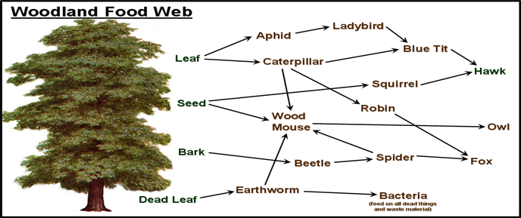
1 Name a producer: plants (such as leaf, seed, bark, dead leaf)
2 Name three consumers: insects caterpillars beetles
3 Name a decomposer: fungi
4 What would happen if the Robin died out? (What would happen to the Fox, the Caterpillar, the leaves, the tree? Think amount numbers, food supply…)
Type answer here: There would be more caterpillars due to less robins eating them which would then mean more leaves are getting eaten due to the increase of caterpillars. The number of foxes may decrease due to them having less food options, whereas the blue tit and wood mouse may increase in numbers due to them having an increase in their prey. Well understood, also the tree may struggle to grow more leaves as they are being eaten.

4 How are nutrients recycled in a woodland ecosystem?
Type answer here: Trees and plants in the ecosystem receive nutrients from the soil through their roots which are stored in the leaves. These nutrients are then passed on to animals or decomposed back in the soil. Animals retrieve these nutrients when they eat these leaves. However if the leaves are not eaten then the bacteria in the soil will break down these leaves and restore the nutrients back into the soil. Great Answer!
How do leaves get their energy?
Oak Tree Photosynthesis light warmth Autumn Spring decomposition decay growth leaves/litter soil nutrients fungi/bacteria

5. Impacts on a small ecosystem
Natural Changes
What could drought do to the pond?
A drought could lead to the ecosystem of fish which would then cause problems for the fishes predators. The fish would die as there is not enough water
What may happen if there are no plants in the pond (what do the plants produce for the fish)?
Plants provide shelter and cover for the fish which they can use as camouflage and hide from predators so without this it would mean a decrease in fish. Plants also provide oxygen and food for the fish. Good, they also provide oxygen for the fish
Human Changes
What can Humans do to the pond?
To help the pond humans could do many things such as introducing more fish in the pond, control water levels by altering the drainage of the land around the pond and changing the ph level Good

What is the problem with wood being cut down?
Deforestation would mean ecosystems would be destroyed and would lead to greenhouse gasses in the air such as carbon dioxide Good

Global Circulation:
6a Where is the most heat concentrated on our planet?
Core x The sun’s heat - the equator
6b Where is the least heat concentrated on our planet?
Crust x the polar regions
6c What cells circulate the heat?
Hadley cell, ferrel cell, polar cell Good

6d What happens when air rises?
When air rises the temperature cools down and causes low pressure. Good
6e What happens when air falls/sinks?
Sinking air creates high pressure and dry weather

7. Tropical Rainforests
Which latitude are the tropical rainforests found?
In Between tropic of cancer and tropic of capricorn

Why are the tropical rainforests wet?
They are wet because they are located near the equator which has a low air pressure which means they are typically hot, humid and wet. Good

8. Hot Deserts
Which latitude are the tropical rainforests found?
Mainly found around the tropics of cancer and capricorn
Why are the tropical rainforests dry
They are dry because they are found in an area of high air pressure where the air sinks. There is also a lack of moisture due to large amounts of sun. Good
9. UK Climate
Which latitude is the UK found?
55.3781 N,3.4360 W

Why is the UK climate unstable?
The UK is complicated because we gets loads of rainfall because we are near a low pressure air mass, we also get warm and wet surface winds in summer from the south west caribbean but then we get cold surface winds from the arctic in winter . Good

