Mathematics (Visual learning)

When we learn Mathematics, we develop understanding through visual models - these are specific "mental pictures" that explain a particular idea or concept. A ‘Visual model’ can be anything from cake or pie to a simple number line. These different items can help us with concepts to do with Fraction, Percentages, Algebra and so many more.
Here are a few different activities that you could do, which involve the use of Mathematics:
- Using ARRAYS
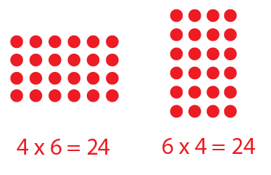
Arrays are what we call counters in reality.
These counters are always useful in portraying
general calculations involving:
- Addition
- Subtraction
- Multiplication
- Division
- Fractions
- Ratio
Above is an image of multiplication with counters. This is a simple concept and always works with students who prefer to play with something while learning. As parents/carers the ideas with counters are limitless. There are many different activities you could make with arrays. One example, could be that you have three different coloured counters (nine of each: green, red and yellow). For this we could have the green counters representing hundreds, red counters representing tens and yellow counters representing units. This will be a perfect activity to help your child understand the theory of “Place value”.
- Baking or cooking
Obviously, this activity is a lot more exciting but will cost a bit more money to do. Below are the different things Baking and cooking can teach children:
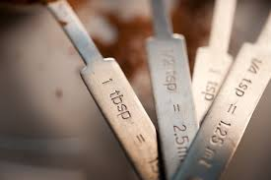
- Basic numeracy
- Weight (grams and millilitres)
- Ratios
- Percentages
- Money and finance

These five topics are key areas of maths in cooking. However, the last component ‘Money and finance’ is something more viable before you start actually baking or cooking. Allowing your child to help with the shopping is something as parents/carers, can start doing more often. Something like this can help your child understand the concept of money alone but as time goes on they’ll manage the calculations in their head when buying a set array of produce.
Whilst baking it’s maybe worth taking a step back when you feel comfortable for your child to follow the instructions by themselves but obviously you can help out when it comes to using any dangerous items like knives and the hot oven. This allows them to work it out for themselves, leaves it to them to get the measurements correct and you as a parent/carer can monitor if they are doing the things correctly.
On the whole this will be a very rewarding task and the final conclusion will be an edible item for their efforts.
- Maths dice
Dice can be used to help with general numeracy skills. Clearly, we can use the dice in just general boardgames like snakes and ladders. So, it’s good to maybe check what boardgames you have to hand and use these.
However, we do have something called maths dice. These have mathematical symbols on them to go through gradual calculations. This is a straight forward method that adds a simple die to get your child playing and doing quick sums in their heads. For this all you need is one maths die and one regular die, with numbers on it. These you can either buy or create. If you are wanting to create the dice, you can visit the site:
https://www.twinkl.co.uk/resource/t2-m-387-cube-net
Making Slime
Making slime is a really fun activity that involves making a mess, which every child loves to do at some point in their lives. Making slime involves science and obviously English in the recipe but it also clearly includes mathematics (Measurements). Now who said that maths had to be boring! Below are the ingredients and instructions on how to make the slime:
(READ ON IF YOU ARE HAPPY TO LET YOUR CHILD GET MESSY!!!)
- 100ml PVA white glue (children’s craft glue or CE marked glue)
- ½ tsp bicarbonate of soda
- gel food colouring
- 1 tsp contact lens cleaning solution
- glitter (optional)
Website: https://www.bbcgoodfood.com/howto/guide/how-make-slime
There are so many more activities to help online with mathematics. Below are a few websites to help start you off:
- YouTube
- https://thirdspacelearning.com/blog/fun-maths-games-activities-for-kids/

