Subject | Workbook | Online
Alternate Provision | Maths - Pg 19 - P26 of the Revision Guide and answer the questions in the Workbook on the same pages.  English – Purple Language Workbook. Read and complete notes on section- writing speeches. pg 64  Science - Read pg. 90; answer the questions on pg. 110 and 128. | Maths: Maths – Log into Google Classroom and complete the tasks on Fractions. Watch the video, do the worksheet and complete the Quiz.  English: English – English: English: https://www.bbc.co.uk/bitesize/examspecs/zcbchv4  https://classroom.thenational.academy/units/language-skills-fiction-reading-52c6 All lessons on reading fiction texts. Watch the videos and complete tasks.  Science: Science – Log into Google Classroom and complete the task on Separation by Distillation. Watch the video, do the worksheet & complete the Quiz.
Art | Wk. 6  Year 11 Art  Remote Learning Jan / Feb  Completing your Final Piece.  Last week you were drawing out your final outcome, composing it. This is where you sketched out the picture. You looked at size, position of objects, adjusted and moved things around that didn't work etc. You should have a layout and daring on the final piece of paper or canvas now.  This week, start adding your colour, paint, pencil crayon, textiles, ink, collage. Whatever you are going to use and have experimented with.  You are finishing the piece now. It must be completed by the end of half term, and you will need to photograph it and send us a picture of it. We will need this as part of your final grade assessment.  I attached a lot of images last week on Task 5. Here are some more to give you an idea of the quality we are expecting.  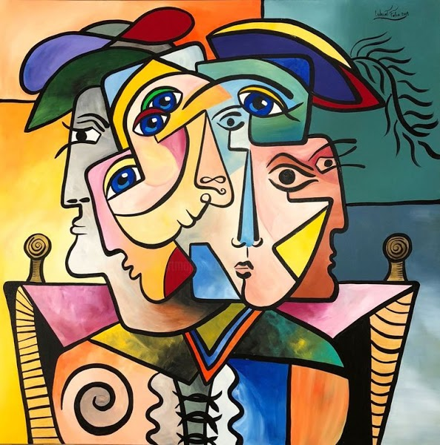 | https://classroom.google.com
Business | Use the information on Plegg’s Ltd and complete the Marketing Analysis. Make sure you also complete the Learner Log. | https://classroom.google.com  Use the information on Plegg’s Ltd and complete the the next section – Market Analysis using the preparation we did in the first week to help you. Make sure you also complete the Learner Log. Use the Checklist to help you. Also make any necessary changes to your first section.
Digital Technologies | Ms Matthews Class:  Read pg 27 – 30 about collecting. Make flashcards covering the key terms; a mind map explaining the different methods of collecting data and the advantages/ disadvantages and answer the exam questions.  Mr Brown’s Class:  We are focusing on Data and Information. Please read pages 22-26.  What is the difference between data and information, how does data become information? Continue to work on researching and revising these. | https://classroom.google.com  Ms Matthews Class:  Under the topic 3rd Feb – Data vs Information, watch the video about the learning. Then using the Golden Task Plan to help, work through the range of tasks.  If you can, continue working on Progress Cakes so that it is finished.  Mr Brown’s Class:  Log onto Google Classroom, watch the video and follow the instructions. Ensure to read the Golden Task Plan for clear instructions.
English | English –  Purple Language Workbook.  Read and complete notes on section- writing speeches. pg 64  Write a speech on ‘How to Surive Lockdown’. | https://classroom.google.com see individual class codes  https://senecalearning.com Class code: 7s1feo22nx  Macbeth Revision on Macbeth and Lady Macbeth  https://classroom.thenational.academy/units/revisiting-macbeth-91c7  Revisiting Macbeth All lessons  Revisiting Macbeth: Lesson 7 and Lesson 8 on Macbeth and Lady Macbeth  https://classroom.thenational.academy/units/revisiting-a-christmas-carol-2c27  Revisiting A Christmas Carol: All lessons  https://classroom.thenational.academy/units/revisiting-an-inspector-calls-d1f4  Revisiting An Inspector Calls: All lessons
Geography | - Make detailed notes from the ‘Economic Development – Nigeria’ revision guide that you should have received.  - Make detailed notes from the ‘Economic Development – UK’ revision guide that you should have received. This is brand new learning, so it will take time to create your own set of notes. You should ensure that you understood everything you write down!  - Complete the work booklet (with past paper questions) called ‘GCSE Geography’  - Try to return the work book back to school so that I can mark your work.  Miss Stevenson | https://classroom.google.com
History | Use the photocopies of pages 30-33  Read the information and make notes. Complete the tasks from the blue boxes on each of these pages. | https://classroom.google.com  Complete the tasks under ‘Week Beginning 8th February’  Follow the instructions on the loom video and on the Golden Task Plan.
Maths | There is a new work booklet to be collected from school, please complete complete part 1. | https://classroom.google.com
MFL | In your workbook  1 Complete the listening questions on page 78 using the CD at the back of the book  2 Complete the reading and writing questions on pages 80-81 in your workbook | https://classroom.google.com  Complete the tasks under ‘Remote Learning Week Beginning 8 February
Performing Arts | Work on your ideas and character for Component 3 - working from a brief. Log all ideas you have. | Work on your ideas and character for Component 3 - working from a brief. Log all ideas you have on the Google Doc provided
PE - Health and Fitness | Research the 4 fitness tests explaining what equipment is needed and the method for the press up test, sit up test, vertical jump test and standing long jump test. What components do these improve? | https://classroom.google.com  Please go onto google classroom and complete Task 3 of your controlled assessment. The live lessons are 11.30am on Monday for Option A pupils and 11.30am on Wednesday for Option C pupils.
PE - Core | Complete the following circuit programme  Warm up  30 seconds jogging on the spot  Heel flicks (30 seconds)  Stretches (1 minute)  Main workout  20-star jumps  15 squats  25 walking lunges  15 press ups  40 seconds Arm circles  25 mountain climbers  Plank (30 seconds)  20 Air punches  Cool down  Light stretches | https://classroom.google.com  There will be a number of tasks set in the google classroom this week.  1.Remote Learning workout – week 5  2. Teacher Challenge  3. Remote learning quiz – week 5  Don’t forget you could also complete the Joe Wicks workouts (Monday/Wednesday/Friday)
RE | Using pages 28 to 41of the revision guide answers the questions on page 6 to page 23 in the Christianity practices booklet. | https://classroom.google.com  Read through the google slides on Pacifism . Answer the questions on google slides. Watch the loom video. Log onto the live lesson.
Combined Science | Infection - Read through pages 40 - 48 and answer any quick test questions on any of the pages. Once you have done, complete the practice and review questions.  Practice pages: 60 and 61  Review pages: 80, 81 and 82 | https://classroom.google.com  Seneca assignments set for Biology, Chemistry and Physics Paper 2  Email: science@aspire.fcat.org.uk for the codes for the new Google Classrooms. You should have been invited to each class
Separate Science | Infection - Read through pages 34 - 40 and answer any quick test questions on any of the pages. Once you have done, complete the practise and review questions.  Practise pages: 64, 66 and 67  Review pages: 94, 95 ,97 | https://classroom.google.com  Seneca assignments set for Biology, Chemistry and Physics Paper 2  Email: science@aspire.fcat.org.uk for the codes for the new Google Classrooms. You should have been invited to each class
Hospitality & Catering | Complete the following pages in the WJEC Catering revision book:  - Nutrition  - Healthy eating  - Exam questions  - Dietary needs  - Exam questions | https://classroom.google.com  Seneca Class code: mek5xdbddn
PHSE | Work through the booklet on breathing . Take a photo of the completed document and send to your class teacher. | https://classroom.google.com

