Atomic structure and the periodic table
The periodic table provides chemists with a structured organisation of the known chemical elements from which they can make sense of their physical and chemical properties. The historical development of the periodic table and models of atomic structure provide good examples of how scientific ideas and explanations develop over time as new evidence emerges. The arrangement of elements in the modern periodic table can be explained in terms of atomic structure which provides evidence for the model of a nuclear atom with electrons in energy levels.

A simple model of the atom, symbols, relative atomic mass, electronic charge and isotopes
      - Atoms, elements and compounds

Content | Key opportunities for skills development
All substances are made of atoms. An atom is the smallest part of an element that can exist.
Atoms of each element are represented by a chemical symbol, eg O represents an atom of oxygen, Na represents an atom of sodium.
There are about 100 different elements. Elements are shown in the periodic table.
Compounds are formed from elements by chemical reactions. Chemical reactions always involve the formation of one or more new substances, and often involve a detectable energy change. Compounds contain two or more elements chemically combined in fixed proportions and can be represented by formulae using the symbols of the atoms from which they were formed. Compounds can only be separated into elements by chemical reactions.
Chemical reactions can be represented by word equations or equations using symbols and formulae.
Students will be supplied with a periodic table for the exam and should be able to:
- use the names and symbols of the first 20 elements in the periodic table, the elements in Groups 1 and 7, and other elements in this specification
- name compounds of these elements from given formulae or symbol equations
- write word equations for the reactions in this specification
- write formulae and balanced chemical equations for the reactions in this specification.

      - Mixtures

Content | Key opportunities for skills development
A mixture consists of two or more elements or compounds not chemically combined together. The chemical properties of each substance in the mixture are unchanged. | WS 2.2, 2.3  AT 4
Mixtures can be separated by physical processes such as filtration, crystallisation, simple distillation, fractional distillation and chromatography. These physical processes do not involve chemical reactions and no new substances are made. | Safe use of a range of equipment to separate chemical mixtures.
Students should be able to:
- describe, explain and give examples of the specified processes of separation
- suggest suitable separation and purification techniques for mixtures when given appropriate information.
      - The development of the model of the atom (common content with physics)

Content | Key opportunities for skills development
New experimental evidence may lead to a scientific model being changed or replaced.  Before the discovery of the electron, atoms were thought to be tiny spheres that could not be divided.  The discovery of the electron led to the plum pudding model of the atom. The plum pudding model suggested that the atom is a ball of positive charge with negative electrons embedded in it.  The results from the alpha particle scattering experiment led to the conclusion that the mass of an atom was concentrated at the centre (nucleus) and that the nucleus was charged. This nuclear model replaced the plum pudding model.  Niels Bohr adapted the nuclear model by suggesting that electrons orbit the nucleus at specific distances. The theoretical calculations of Bohr agreed with experimental observations.  Later experiments led to the idea that the positive charge of any nucleus could be subdivided into a whole number of smaller particles, each particle having the same amount of positive charge. The name proton was given to these particles.  The experimental work of James Chadwick provided the evidence to show the existence of neutrons within the nucleus. This was about 20 years after the nucleus became an accepted scientific idea.  Students should be able to describe: | WS 1.1, 1.6  This historical context provides an opportunity for students to show an understanding of why and describe how scientific methods and theories develop over time.  WS 1.2

Content | Key opportunities for skills development
- why the new evidence from the scattering experiment led to a change in the atomic model | WS 1.1
- the difference between the plum pudding model of the atom and the nuclear model of the atom. | WS 1.2
Details of experimental work supporting the Bohr model are not required.
Details of Chadwick’s experimental work are not required.

      - Relative electrical charges of subatomic particles

Content | Key opportunities for skills development
The relative electrical charges of the particles in atoms are:

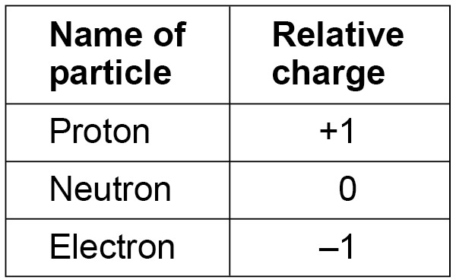
In an atom, the number of electrons is equal to the number of protons in the nucleus. Atoms have no overall electrical charge.
The number of protons in an atom of an element is its atomic number. All atoms of a particular element have the same number of protons. Atoms of different elements have different numbers of protons.
Students should be able to use the nuclear model to describe atoms. | WS 1.2

      - Size and mass of atoms

Content | Key opportunities for skills development
Atoms are very small, having a radius of about 0.1 nm (1 x 10-10 m). | WS 4.3, 4
The radius of a nucleus is less than 1/10 000 of that of the atom (about 1 x 10-14 m). | Use SI units and the prefix nano.
Almost all of the mass of an atom is in the nucleus. | MS 1b
The relative masses of protons, neutrons and electrons are:  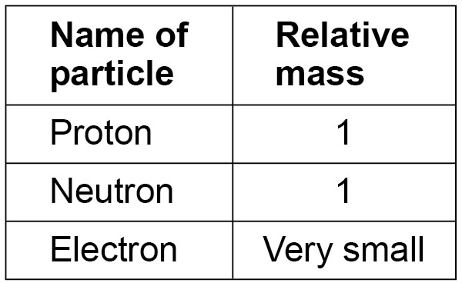 | Recognise expressions in standard form.
The sum of the protons and neutrons in an atom is its mass number.
Atoms of the same element can have different numbers of neutrons; these atoms are called isotopes of that element.
Atoms can be represented as shown in this example:
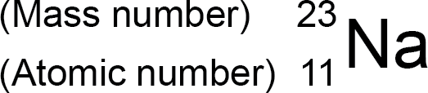
Students should be able to calculate the numbers of protons, neutrons and electrons in an atom or ion, given its atomic number and mass number.
Students should be able to relate size and scale of atoms to objects in the physical world. | MS 1d
      - Relative atomic mass

Content | Key opportunities for skills development
The relative atomic mass of an element is an average value that takes account of the abundance of the isotopes of the element.
Students should be able to calculate the relative atomic mass of an element given the percentage abundance of its isotopes.

      - Electronic structure

Content | Key opportunities for skills development
The electrons in an atom occupy the lowest available energy levels (innermost available shells). The electronic structure of an atom can be represented by numbers or by a diagram. For example, the electronic structure of sodium is 2,8,1 or  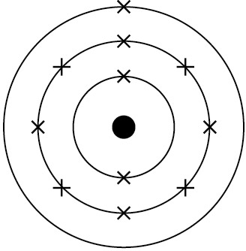  showing two electrons in the lowest energy level, eight in the second energy level and one in the third energy level.  Students may answer questions in terms of either energy levels or shells. | WS 1.2  Students should be able to represent the electronic structures of the first twenty elements of the periodic table in both forms.  MS 5b  Visualise and represent 2D and 3D forms including two- dimensional representations of 3D objects.

The periodic table
      - The periodic table

Content | Key opportunities for skills development
The elements in the periodic table are arranged in order of atomic (proton) number and so that elements with similar properties are in columns, known as groups. The table is called a periodic table because similar properties occur at regular intervals.
Elements in the same group in the periodic table have the same number of electrons in their outer shell (outer electrons) and this gives them similar chemical properties.
Students should be able to:  - explain how the position of an element in the periodic table is related to the arrangement of electrons in its atoms and hence to its atomic number  - predict possible reactions and probable reactivity of elements from their positions in the periodic table. | WS 1.2

      - Development of the periodic table

Content | Key opportunities for skills development
Before the discovery of protons, neutrons and electrons, scientists attempted to classify the elements by arranging them in order of their atomic weights.  The early periodic tables were incomplete and some elements were placed in inappropriate groups if the strict order of atomic weights was followed.  Mendeleev overcame some of the problems by leaving gaps for elements that he thought had not been discovered and in some places changed the order based on atomic weights.  Elements with properties predicted by Mendeleev were discovered and filled the gaps. Knowledge of isotopes made it possible to explain why the order based on atomic weights was not always correct.  Students should be able to describe these steps in the development of the periodic table. | WS 1.1, 1.6  Explain how testing a prediction can support or refute a new scientific idea.
      - Metals and non-metals

Content | Key opportunities for skills development
Elements that react to form positive ions are metals. Elements that do not form positive ions are non-metals.
The majority of elements are metals. Metals are found to the left and towards the bottom of the periodic table. Non-metals are found towards the right and top of the periodic table.
Students should be able to:
- explain the differences between metals and non-metals on the basis of their characteristic physical and chemical properties. This links to Group 0 (page 74), Group 1 (page 74), Group
7 (page 75) and Bonding, structure and the properties of matter (page 75)
- explain how the atomic structure of metals and non-metals relates to their position in the periodic table
- explain how the reactions of elements are related to the arrangement of electrons in their atoms and hence to their atomic number.

      - Group 0

Content | Key opportunities for skills development
The elements in Group 0 of the periodic table are called the noble gases. They are unreactive and do not easily form molecules because their atoms have stable arrangements of electrons. The noble gases have eight electrons in their outer shell, except for helium, which has only two electrons.
The boiling points of the noble gases increase with increasing relative atomic mass (going down the group).
Students should be able to:  - explain how properties of the elements in Group 0 depend on the outer shell of electrons of the atoms  - predict properties from given trends down the group. | WS 1.2
      - Group 1

Content | Key opportunities for skills development
The elements in Group 1 of the periodic table are known as the alkali metals and have characteristic properties because of the single electron in their outer shell.
Students should be able to describe the reactions of the first three alkali metals with oxygen, chlorine and water.
In Group 1, the reactivity of the elements increases going down the group.
Students should be able to:  - explain how properties of the elements in Group 1 depend on the outer shell of electrons of the atoms  - predict properties from given trends down the group. | WS 1.2

      - Group 7

Content | Key opportunities for skills development
The elements in Group 7 of the periodic table are known as the halogens and have similar reactions because they all have seven electrons in their outer shell. The halogens are non-metals and consist of molecules made of pairs of atoms.  Students should be able to describe the nature of the compounds formed when chlorine, bromine and iodine react with metals and non-metals.  In Group 7, the further down the group an element is the higher its relative molecular mass, melting point and boiling point.  In Group 7, the reactivity of the elements decreases going down the group.  A more reactive halogen can displace a less reactive halogen from an aqueous solution of its salt. | AT 6  Offers an opportunity within displacement reactions of halogens.
Students should be able to:  - explain how properties of the elements in Group 7 depend on the outer shell of electrons of the atoms  - predict properties from given trends down the group. | WS 1.2

Bonding, structure, and the properties of matter
Chemists use theories of structure and bonding to explain the physical and chemical properties of materials. Analysis of structures shows that atoms can be arranged in a variety of ways, some of which are molecular while others are giant structures. Theories of bonding explain how atoms are held together in these structures. Scientists use this knowledge of structure and bonding to engineer new materials with desirable properties. The properties of these materials may offer new applications in a range of different technologies.

Chemical bonds, ionic, covalent and metallic
      - Chemical bonds

Content | Key opportunities for skills development
There are three types of strong chemical bonds: ionic, covalent and metallic. For ionic bonding the particles are oppositely charged ions. For covalent bonding the particles are atoms which share pairs of electrons. For metallic bonding the particles are atoms which share delocalised electrons.
Ionic bonding occurs in compounds formed from metals combined with non-metals.
Covalent bonding occurs in most non-metallic elements and in compounds of non-metals.
Metallic bonding occurs in metallic elements and alloys.
Students should be able to explain chemical bonding in terms of electrostatic forces and the transfer or sharing of electrons.
      - Ionic bonding

Content | Key opportunities for skills development
When a metal atom reacts with a non-metal atom electrons in the outer shell of the metal atom are transferred. Metal atoms lose electrons to become positively charged ions. Non-metal atoms gain electrons to become negatively charged ions. The ions produced by metals in Groups 1 and 2 and by non-metals in Groups 6 and 7 have the electronic structure of a noble gas (Group 0).  The electron transfer during the formation of an ionic compound can be represented by a dot and cross diagram, eg for sodium chloride  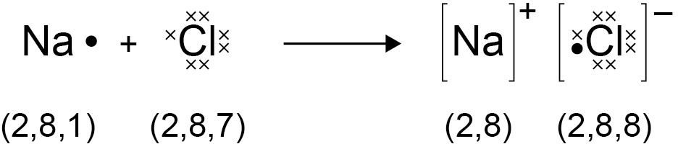 | MS 5b  Visualise and represent 2D and 3D forms including two- dimensional representations of 3D objects.
Students should be able to draw dot and cross diagrams for ionic compounds formed by metals in Groups 1 and 2 with non-metals in Groups 6 and 7.  The charge on the ions produced by metals in Groups 1 and 2 and by non-metals in Groups 6 and 7 relates to the group number of the element in the periodic table.  Students should be able to work out the charge on the ions of metals and non-metals from the group number of the element, limited to the metals in Groups 1 and 2, and non-metals in Groups 6 and 7. | WS 1.2

      - Ionic compounds

Content | Key opportunities for skills development
An ionic compound is a giant structure of ions. Ionic compounds are held together by strong electrostatic forces of attraction between oppositely charged ions. These forces act in all directions in the lattice and this is called ionic bonding.  The structure of sodium chloride can be represented in the following forms:  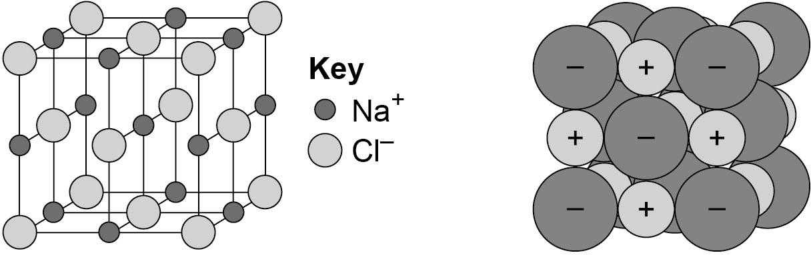 | MS 5b  Visualise and represent 2D and 3D forms including two- dimensional representations of 3D objects.
Students should be able to:  - deduce that a compound is ionic from a diagram of its structure in one of the specified forms  - describe the limitations of using dot and cross, ball and stick, two and three-dimensional diagrams to represent a giant ionic structure  - work out the empirical formula of an ionic compound from a given model or diagram that shows the ions in the structure.  Students should be familiar with the structure of sodium chloride but do not need to know the structures of other ionic compounds. | WS 1.2 MS 4a MS 1a, 1c

      - Covalent bonding

Content | Key opportunities for skills development
When atoms share pairs of electrons, they form covalent bonds. These bonds between atoms are strong.  Covalently bonded substances may consist of small molecules.  Students should be able to recognise common substances that consist of small molecules from their chemical formula. | WS 1.2  Recognise substances as small molecules, polymers or giant structures from diagrams showing their bonding.
Some covalently bonded substances have very large molecules, such as polymers.
Some covalently bonded substances have giant covalent structures, such as diamond and silicon dioxide.
The covalent bonds in molecules and giant structures can be represented in the following forms:
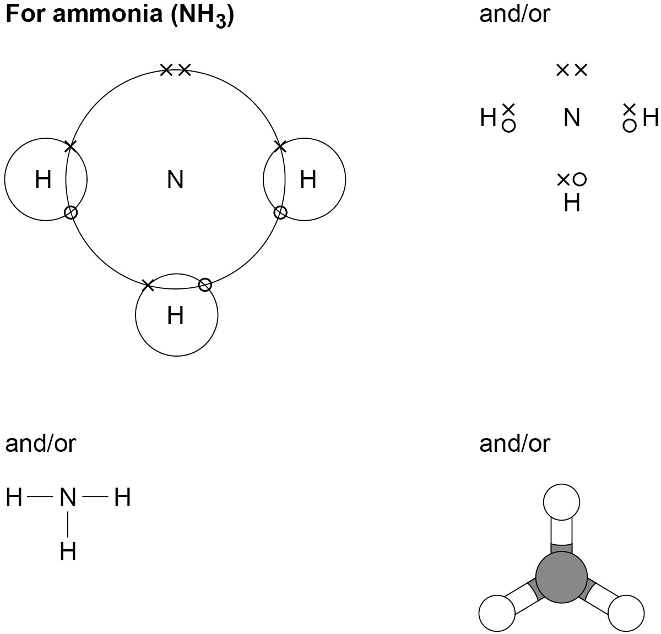
Polymers can be represented in the form:
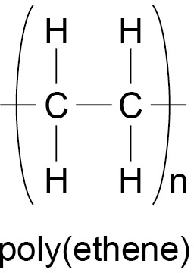
where n is a large number.

Content | Key opportunities for skills development
Students should be able to:  - draw dot and cross diagrams for the molecules of hydrogen, chlorine, oxygen, nitrogen, hydrogen chloride, water, ammonia and methane  - represent the covalent bonds in small molecules, in the repeating units of polymers and in part of giant covalent structures, using a line to represent a single bond  - describe the limitations of using dot and cross, ball and stick, two and three-dimensional diagrams to represent molecules or giant structures  - deduce the molecular formula of a substance from a given model or diagram in these forms showing the atoms and bonds in the molecule. | MS 5b

      - Metallic bonding

Content | Key opportunities for skills development
Metals consist of giant structures of atoms arranged in a regular pattern.  The electrons in the outer shell of metal atoms are delocalised and so are free to move through the whole structure. The sharing of delocalised electrons gives rise to strong metallic bonds. The bonding in metals may be represented in the following form:  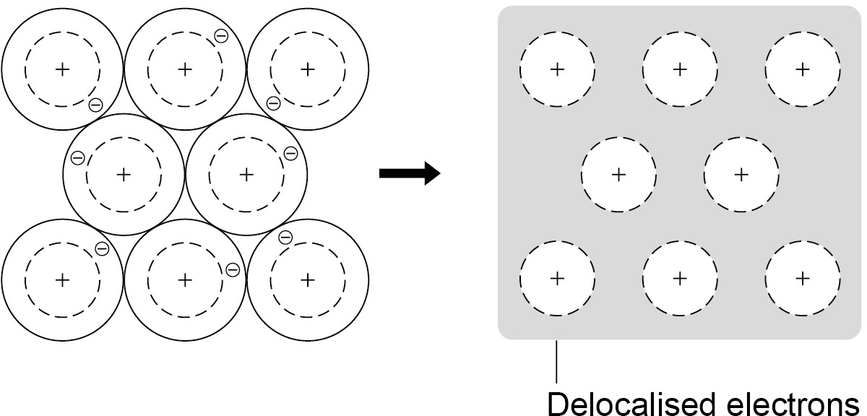 | WS 1.2  Recognise substances as metallic giant structures from diagrams showing their bonding.  MS 5b  Visualise and represent 2D and 3D forms including two- dimensional representations of 3D objects.

How bonding and structure are related to the properties of substances
      - The three states of matter

Content | Key opportunities for skills development
The three states of matter are solid, liquid and gas. Melting and freezing take place at the melting point, boiling and condensing take place at the boiling point.  The three states of matter can be represented by a simple model. In this model, particles are represented by small solid spheres.  Particle theory can help to explain melting, boiling, freezing and condensing.  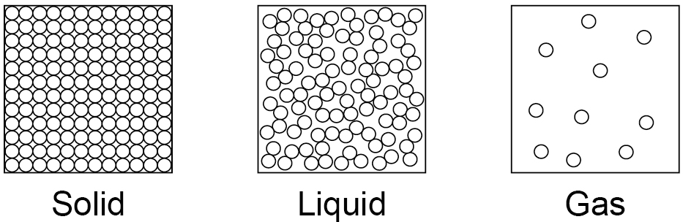  The amount of energy needed to change state from solid to liquid and from liquid to gas depends on the strength of the forces between the particles of the substance. The nature of the particles involved depends on the type of bonding and the structure of the substance. The stronger the forces between the particles the higher the melting point and boiling point of the substance. | MS 5b  Visualise and represent 2D and 3D forms including two- dimensional representations of 3D objects.
Students should be able to:  - predict the states of substances at different temperatures given appropriate data  - explain the different temperatures at which changes of state occur in terms of energy transfers and types of bonding  - recognise that atoms themselves do not have the bulk properties of materials | WS 1.2

      - State symbols

Content | Key opportunities for skills development
In chemical equations, the three states of matter are shown as (s),
(l) and (g), with (aq) for aqueous solutions.
Students should be able to include appropriate state symbols in chemical equations for the reactions in this specification.
      - Properties of ionic compounds

Content | Key opportunities for skills development
Ionic compounds have regular structures (giant ionic lattices) in which there are strong electrostatic forces of attraction in all directions between oppositely charged ions.
These compounds have high melting points and high boiling points because of the large amounts of energy needed to break the many strong bonds.
When melted or dissolved in water, ionic compounds conduct electricity because the ions are free to move and so charge can flow.
Knowledge of the structures of specific ionic compounds other than sodium chloride is not required.
      - Properties of small molecules

Content | Key opportunities for skills development
Substances that consist of small molecules are usually gases or liquids that have relatively low melting points and boiling points.  These substances have only weak forces between the molecules (intermolecular forces). It is these intermolecular forces that are overcome, not the covalent bonds, when the substance melts or boils.  The intermolecular forces increase with the size of the molecules, so larger molecules have higher melting and boiling points.  These substances do not conduct electricity because the molecules do not have an overall electric charge.  Students should be able to use the idea that intermolecular forces are weak compared with covalent bonds to explain the bulk properties of molecular substances. | WS 1.2

      - Polymers

Content | Key opportunities for skills development
Polymers have very large molecules. The atoms in the polymer molecules are linked to other atoms by strong covalent bonds. The intermolecular forces between polymer molecules are relatively strong and so these substances are solids at room temperature.
Students should be able to recognise polymers from diagrams showing their bonding and structure.
      - Giant covalent structures

Content | Key opportunities for skills development
Substances that consist of giant covalent structures are solids with very high melting points. All of the atoms in these structures are linked to other atoms by strong covalent bonds. These bonds must be overcome to melt or boil these substances. Diamond and graphite (forms of carbon) and silicon dioxide (silica) are examples of giant covalent structures.  Students should be able to recognise giant covalent structures from diagrams showing their bonding and structure. | MS 5b  Visualise and represent 2D and 3D forms including two- dimensional representations of 3D objects.  WS 1.2
      - Properties of metals and alloys

Content | Key opportunities for skills development
Metals have giant structures of atoms with strong metallic bonding. This means that most metals have high melting and boiling points.
In pure metals, atoms are arranged in layers, which allows metals to be bent and shaped. Pure metals are too soft for many uses and so are mixed with other metals to make alloys which are harder.
Students should be able to explain why alloys are harder than pure metals in terms of distortion of the layers of atoms in the structure of a pure metal. | WS 1.2
      - Metals as conductors

Content | Key opportunities for skills development
Metals are good conductors of electricity because the delocalised electrons in the metal carry electrical charge through the metal.
Metals are good conductors of thermal energy because energy is transferred by the delocalised electrons.

Structure and bonding of carbon
      - Diamond

Content | Key opportunities for skills development
In diamond, each carbon atom forms four covalent bonds with other carbon atoms in a giant covalent structure, so diamond is very hard, has a very high melting point and does not conduct electricity. | MS 5b  Visualise and represent 2D and 3D forms including two- dimensional representations of 3D objects.
Students should be able to explain the properties of diamond in terms of its structure and bonding. | WS 1.2
      - Graphite

Content | Key opportunities for skills development
In graphite, each carbon atom forms three covalent bonds with three other carbon atoms, forming layers of hexagonal rings which have no covalent bonds between the layers.  In graphite, one electron from each carbon atom is delocalised.  Students should be able to explain the properties of graphite in terms of its structure and bonding.  Students should know that graphite is similar to metals in that it has delocalised electrons. | WS 1.2

      - Graphene and fullerenes

Content | Key opportunities for skills development
Graphene is a single layer of graphite and has properties that make it useful in electronics and composites.  Students should be able to explain the properties of graphene in terms of its structure and bonding.  Fullerenes are molecules of carbon atoms with hollow shapes. The structure of fullerenes is based on hexagonal rings of carbon atoms but they may also contain rings with five or seven carbon atoms.  The first fullerene to be discovered was Buckminsterfullerene (C₆₀) which has a spherical shape.  Carbon nanotubes are cylindrical fullerenes with very high length to diameter ratios. Their properties make them useful for nanotechnology, electronics and materials.  Students should be able to:  - recognise graphene and fullerenes from diagrams and descriptions of their bonding and structure  - give examples of the uses of fullerenes, including carbon nanotubes. | WS 1.2, 1.4 MS 5b  Visualise and represent 2D and 3D forms including two- dimensional representations of 3D objects.

Quantitative chemistry
Chemists use quantitative analysis to determine the formulae of compounds and the equations for reactions. Given this information, analysts can then use quantitative methods to determine the purity of chemical samples and to monitor the yield from chemical reactions.
Chemical reactions can be classified in various ways. Identifying different types of chemical reaction allows chemists to make sense of how different chemicals react together, to establish patterns and to make predictions about the behaviour of other chemicals. Chemical equations provide a means of representing chemical reactions and are a key way for chemists to communicate chemical ideas.

Chemical measurements, conservation of mass and the quantitative interpretation of chemical equations
      - Conservation of mass and balanced chemical equations

Content | Key opportunities for skills development
The law of conservation of mass states that no atoms are lost or made during a chemical reaction so the mass of the products equals the mass of the reactants.  This means that chemical reactions can be represented by symbol equations which are balanced in terms of the numbers of atoms of each element involved on both sides of the equation.  Students should understand the use of the multipliers in equations in normal script before a formula and in subscript within a formula. | WS 1.2
      - Relative formula mass

Content | Key opportunities for skills development
The relative formula mass (M_{r}) of a compound is the sum of the relative atomic masses of the atoms in the numbers shown in the formula.
In a balanced chemical equation, the sum of the relative formula masses of the reactants in the quantities shown equals the sum of the relative formula masses of the products in the quantities shown.
Students should be able to calculate the percentage by mass in a compound given the relative formula mass and the relative atomic masses.
      - Mass changes when a reactant or product is a gas

Content | Key opportunities for skills development
Some reactions may appear to involve a change in mass but this can usually be explained because a reactant or product is a gas and its mass has not been taken into account. For example: when a metal reacts with oxygen the mass of the oxide produced is greater than the mass of the metal or in thermal decompositions of metal carbonates carbon dioxide is produced and escapes into the atmosphere leaving the metal oxide as the only solid product. | AT 1, 2,6  Opportunities within investigation of mass changes using various apparatus.
Students should be able to explain any observed changes in mass in non-enclosed systems during a chemical reaction given the balanced symbol equation for the reaction and explain these changes in terms of the particle model.

      - Chemical measurements

Content | Key opportunities for skills development
Whenever a measurement is made there is always some uncertainty about the result obtained.  Students should be able to:  - represent the distribution of results and make estimations of uncertainty  - use the range of a set of measurements about the mean as a measure of uncertainty. | WS 3.4

Use of amount of substance in relation to masses of pure substances
      - Concentration of solutions

Content | Key opportunities for skills development
Many chemical reactions take place in solutions. The concentration of a solution can be measured in mass per given volume of solution, eg grams per dm3 (g/dm3).  Students should be able to:  - calculate the mass of solute in a given volume of solution of known concentration in terms of mass per given volume of solution  - (HT only) explain how the mass of a solute and the volume of a solution is related to the concentration of the solution. | MS 1c  Use ratios, fractions and percentages.  MS 3b  Change the subject of an equation.

Chemical changes
Understanding of chemical changes began when people began experimenting with chemical reactions in a systematic way and organizing their results logically. Knowing about these different chemical changes meant that scientists could begin to predict exactly what new substances would be formed and use this knowledge to develop a wide range of different materials and processes. It also helped biochemists to understand the complex reactions that take place in living organisms. The extraction of important resources from the earth makes use of the way that some elements and compounds react with each other and how easily they can be ‘pulled apart’.

Reactivity of metals
      - Metal oxides

Content | Key opportunities for skills development
Metals react with oxygen to produce metal oxides. The reactions are oxidation reactions because the metals gain oxygen.
Students should be able to explain reduction and oxidation in terms of loss or gain of oxygen.
      - The reactivity series

Content | Key opportunities for skills development
When metals react with other substances the metal atoms form positive ions. The reactivity of a metal is related to its tendency to form positive ions. Metals can be arranged in order of their reactivity in a reactivity series. The metals potassium, sodium, lithium, calcium, magnesium, zinc, iron and copper can be put in order of their reactivity from their reactions with water and dilute acids. | AT 6  Mixing of reagents to explore chemical changes and/or products.
The non-metals hydrogen and carbon are often included in the reactivity series.
A more reactive metal can displace a less reactive metal from a compound.
Students should be able to:
- recall and describe the reactions, if any, of potassium, sodium, lithium, calcium, magnesium, zinc, iron and copper with water or dilute acids and where appropriate, to place these metals in order of reactivity
- explain how the reactivity of metals with water or dilute acids is related to the tendency of the metal to form its positive ion
- deduce an order of reactivity of metals based on experimental results.
The reactions of metals with water and acids are limited to room temperature and do not include reactions with steam.

      - Extraction of metals and reduction

Content | Key opportunities for skills development
Unreactive metals such as gold are found in the Earth as the metal itself but most metals are found as compounds that require chemical reactions to extract the metal.
Metals less reactive than carbon can be extracted from their oxides by reduction with carbon.
Reduction involves the loss of oxygen.
Knowledge and understanding are limited to the reduction of oxides using carbon.
Knowledge of the details of processes used in the extraction of metals is not required.
Students should be able to:
- interpret or evaluate specific metal extraction processes when given appropriate information
- identify the substances which are oxidised or reduced in terms of gain or loss of oxygen.

Reactions of acids
      - Reactions of acids with metals

Content | Key opportunities for skills development
Acids react with some metals to produce salts and hydrogen. (HT only) Students should be able to:
- explain in terms of gain or loss of electrons, that these are redox reactions
- identify which species are oxidised and which are reduced in given chemical equations.

Knowledge of reactions limited to those of magnesium, zinc and iron with hydrochloric and sulfuric acids.
      - Neutralisation of acids and salt production

Content | Key opportunities for skills development
Acids are neutralised by alkalis (eg soluble metal hydroxides) and bases (eg insoluble metal hydroxides and metal oxides) to produce salts and water, and by metal carbonates to produce salts, water and carbon dioxide.
The particular salt produced in any reaction between an acid and a base or alkali depends on:
- the acid used (hydrochloric acid produces chlorides, nitric acid produces nitrates, sulfuric acid produces sulfates)
- the positive ions in the base, alkali or carbonate. Students should be able to:
- predict products from given reactants
- use the formulae of common ions to deduce the formulae of salts.

      - Soluble salts

Content | Key opportunities for skills development
Soluble salts can be made from acids by reacting them with solid insoluble substances, such as metals, metal oxides, hydroxides or carbonates. The solid is added to the acid until no more reacts and the excess solid is filtered off to produce a solution of the salt.
Salt solutions can be crystallised to produce solid salts.
Students should be able to describe how to make pure, dry samples of named soluble salts from information provided.
Required practical activity 8: preparation of a pure, dry sample of a soluble salt from an insoluble oxide or carbonate, using a Bunsen burner to heat dilute acid and a water bath or electric heater to evaporate the solution.
AT skills covered by this practical activity: chemistry AT 2, 3, 4 and 6.
This practical activity also provides opportunities to develop WS and MS. Details of all skills are given in Key opportunities for skills development (page 180).

      - The pH scale and neutralisation

Content | Key opportunities for skills development
Acids produce hydrogen ions (H+) in aqueous solutions. Aqueous solutions of alkalis contain hydroxide ions (OH–).  The pH scale, from 0 to 14, is a measure of the acidity or alkalinity of a solution, and can be measured using universal indicator or a pH probe.  A solution with pH 7 is neutral. Aqueous solutions of acids have pH values of less than 7 and aqueous solutions of alkalis have pH values greater than 7.  In neutralisation reactions between an acid and an alkali, hydrogen ions react with hydroxide ions to produce water.  This reaction can be represented by the equation:  Students should be able to:  - describe the use of universal indicator or a wide range indicator to measure the approximate pH of a solution  - use the pH scale to identify acidic or alkaline solutions. | AT 3  This is an opportunity to investigate pH changes when a strong acid neutralises a strong alkali.

Electrolysis
      - The process of electrolysis

Content | Key opportunities for skills development
When an ionic compound is melted or dissolved in water, the ions are free to move about within the liquid or solution. These liquids and solutions are able to conduct electricity and are called electrolytes.
Passing an electric current through electrolytes causes the ions to move to the electrodes. Positively charged ions move to the negative electrode (the cathode), and negatively charged ions move to the positive electrode (the anode). Ions are discharged at the electrodes producing elements. This process is called electrolysis.

      - Electrolysis of molten ionic compounds

Content | Key opportunities for skills development
When a simple ionic compound (eg lead bromide) is electrolysed in the molten state using inert electrodes, the metal (lead) is produced at the cathode and the non-metal (bromine) is produced at the anode.  Students should be able to predict the products of the electrolysis of binary ionic compounds in the molten state. | A safer alternative for practical work is anhydrous zinc chloride.
      - Using electrolysis to extract metals

Content | Key opportunities for skills development
Metals can be extracted from molten compounds using electrolysis. Electrolysis is used if the metal is too reactive to be extracted by reduction with carbon or if the metal reacts with carbon. Large amounts of energy are used in the extraction process to melt the compounds and to produce the electrical current.
Aluminium is manufactured by the electrolysis of a molten mixture of aluminium oxide and cryolite using carbon as the positive electrode (anode).
Students should be able to:
- explain why a mixture is used as the electrolyte
- explain why the positive electrode must be continually replaced.
      - Electrolysis of aqueous solutions

Content | Key opportunities for skills development
The ions discharged when an aqueous solution is electrolysed using inert electrodes depend on the relative reactivity of the elements involved.
At the negative electrode (cathode), hydrogen is produced if the metal is more reactive than hydrogen.
At the positive electrode (anode), oxygen is produced unless the solution contains halide ions when the halogen is produced.
This happens because in the aqueous solution water molecules break down producing hydrogen ions and hydroxide ions that are discharged.
Students should be able to predict the products of the electrolysis of aqueous solutions containing a single ionic compound. | WS 1.2

Required practical activity 9: investigate what happens when aqueous solutions are electrolysed using inert electrodes. This should be an investigation involving developing a hypothesis.
AT skills covered by this practical activity: chemistry AT 3 and 7.
This practical activity also provides opportunities to develop WS and MS. Details of all skills are given in Key opportunities for skills development (page 180).

Energy changes
Energy changes are an important part of chemical reactions. The interaction of particles often involves transfers of energy due to the breaking and formation of bonds. Reactions in which energy is released to the surroundings are exothermic reactions, while those that take in thermal energy are endothermic. These interactions between particles can produce heating or cooling effects that are used in a range of everyday applications. Some interactions between ions in an electrolyte result in the production of electricity. Cells and batteries use these chemical reactions to provide electricity. Electricity can also be used to decompose ionic substances and is a useful means of producing elements that are too expensive to extract any other way.

Exothermic and endothermic reactions
      - Energy transfer during exothermic and endothermic reactions

Content | Key opportunities for skills development
Energy is conserved in chemical reactions. The amount of energy in the universe at the end of a chemical reaction is the same as before the reaction takes place. If a reaction transfers energy to the surroundings the product molecules must have less energy than the reactants, by the amount transferred. | AT 5  An opportunity to measure temperature changes when substances react or dissolve in water.
An exothermic reaction is one that transfers energy to the surroundings so the temperature of the surroundings increases.
Exothermic reactions include combustion, many oxidation reactions and neutralisation.
Everyday uses of exothermic reactions include self-heating cans and hand warmers.
An endothermic reaction is one that takes in energy from the surroundings so the temperature of the surroundings decreases.
Endothermic reactions include thermal decompositions and the reaction of citric acid and sodium hydrogencarbonate. Some sports injury packs are based on endothermic reactions.
Students should be able to:
- distinguish between exothermic and endothermic reactions on the basis of the temperature change of the surroundings
- evaluate uses and applications of exothermic and endothermic reactions given appropriate information.
Limited to measurement of temperature change. Calculation of energy changes or ΔH is not required.
Required practical activity 10: investigate the variables that affect temperature changes in reacting solutions such as, eg acid plus metals, acid plus carbonates, neutralisations, displacement of metals.
AT skills covered by this practical activity: chemistry AT 1, 3, 5 and 6.
This practical activity also provides opportunities to develop WS and MS. Details of all skills are given in Key opportunities for skills development (page 181).

      - Reaction profiles

Content | Key opportunities for skills development
Chemical reactions can occur only when reacting particles collide with each other and with sufficient energy. The minimum amount of energy that particles must have to react is called the activation energy.
Reaction profiles can be used to show the relative energies of reactants and products, the activation energy and the overall energy change of a reaction.
Students should be able to:
- draw simple reaction profiles (energy level diagrams) for exothermic and endothermic reactions showing the relative energies of reactants and products, the activation energy and the overall energy change, with a curved line to show the energy as the reaction proceeds
- use reaction profiles to identify reactions as exothermic or endothermic
- explain that the activation energy is the energy needed for a reaction to occur.

