The rate and extent of chemical change
Chemical reactions can occur at vastly different rates. Whilst the reactivity of chemicals is a significant factor in how fast chemical reactions proceed, there are many variables that can be manipulated in order to speed them up or slow them down. Chemical reactions may also be reversible and therefore the effect of different variables needs to be established in order to identify how to maximise the yield of desired product. Understanding energy changes that accompany chemical reactions is important for this process. In industry, chemists and chemical engineers determine the effect of different variables on reaction rate and yield of product. Whilst there may be compromises to be made, they carry out optimisation processes to ensure that enough product is produced within a sufficient time, and in an energy-efficient way.

Rate of reaction
      - Calculating rates of reactions

Content | Key opportunities for skills development
The rate of a chemical reaction can be found by measuring the quantity of a reactant used or the quantity of product formed over time:  mean rate o f reaction = quantity o f reactant used  time taken  mean rate o f reaction = quantity o f product f ormed  time taken  The quantity of reactant or product can be measured by the mass in grams or by a volume in cm3.  The units of rate of reaction may be given as g/s or cm3/s.  For the Higher Tier, students are also required to use quantity of reactants in terms of moles and units for rate of reaction in mol/s.  Students should be able to:  - calculate the mean rate of a reaction from given information about the quantity of a reactant used or the quantity of a product formed and the time taken  - draw, and interpret, graphs showing the quantity of product formed or quantity of reactant used up against time  - draw tangents to the curves on these graphs and use the slope of the tangent as a measure of the rate of reaction  - (HT only) calculate the gradient of a tangent to the curve on these graphs as a measure of rate of reaction at a specific time. | MS 1a  Recognise and use expressions in decimal form.  MS 1c  Use ratios, fractions and percentages.  MS 1d  Make estimates of the results of simple calculations.  MS 4a  Translate information between graphical and numeric form.  MS 4b  Drawing and interpreting appropriate graphs from data to determine rate of reaction.  MS 4c  Plot two variables from experimental or other data.  MS 4d  Determine the slope and intercept of a linear graph.  MS 4e  Draw and use the slope of a tangent to a curve as a measure of rate of change.

      - Factors which affect the rates of chemical reactions

Content | Key opportunities for skills development
Factors which affect the rates of chemical reactions include: the concentrations of reactants in solution, the pressure of reacting gases, the surface area of solid reactants, the temperature and the presence of catalysts.
Students should be able to recall how changing these factors affects the rate of chemical reactions. | This topic offers opportunities for practical work and investigations in addition to required practical 11.
Required practical activity 11: investigate how changes in concentration affect the rates of reactions by a method involving measuring the volume of a gas produced and a method involving a change in colour or turbidity.
This should be an investigation involving developing a hypothesis. AT skills covered by this practical activity: chemistry AT 1, 3, 5 and 6.
This practical activity also provides opportunities to develop WS and MS. Details of all skills are given in Key opportunities for skills development (page 182)

      - Collision theory and activation energy

Content | Key opportunities for skills development
Collision theory explains how various factors affect rates of reactions. According to this theory, chemical reactions can occur only when reacting particles collide with each other and with sufficient energy. The minimum amount of energy that particles must have to react is called the activation energy.
Increasing the concentration of reactants in solution, the pressure of reacting gases, and the surface area of solid reactants increases the frequency of collisions and so increases the rate of reaction.
Increasing the temperature increases the frequency of collisions and makes the collisions more energetic, and so increases the rate of reaction.
Students should be able to :  - predict and explain using collision theory the effects of changing conditions of concentration, pressure and temperature on the rate of a reaction | WS 1.2

Content | Key opportunities for skills development
- predict and explain the effects of changes in the size of pieces of a reacting solid in terms of surface area to volume ratio  - use simple ideas about proportionality when using collision theory to explain the effect of a factor on the rate of a reaction. | MS 5c MS 1c

      - Catalysts

Content | Key opportunities for skills development
Catalysts change the rate of chemical reactions but are not used up during the reaction. Different reactions need different catalysts.  Enzymes act as catalysts in biological systems.  Catalysts increase the rate of reaction by providing a different pathway for the reaction that has a lower activation energy.  A reaction profile for a catalysed reaction can be drawn in the following form: | AT 5  An opportunity to investigate the catalytic effect of adding different metal salts to a reaction such as the decomposition of hydrogen peroxide.
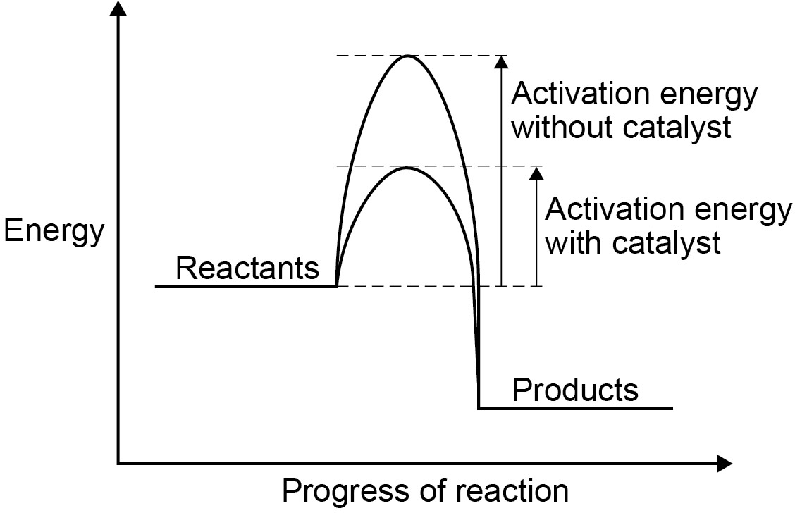
Students should be able to identify catalysts in reactions from their effect on the rate of reaction and because they are not included in the chemical equation for the reaction.
Students should be able to explain catalytic action in terms of activation energy.
Students do not need to know the names of catalysts other than those specified in the subject content.

Reversible reactions and dynamic equilibrium
      - Reversible reactions

Content | Key opportunities for skills development
In some chemical reactions, the products of the reaction can react to produce the original reactants. Such reactions are called reversible reactions and are represented:
A + B C + D
The direction of reversible reactions can be changed by changing the conditions.
For example:

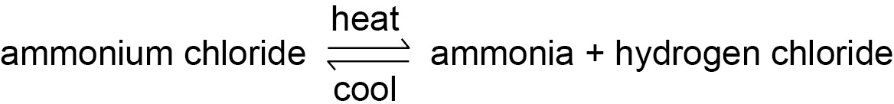
      - Energy changes and reversible reactions

Content | Key opportunities for skills development
If a reversible reaction is exothermic in one direction, it is endothermic in the opposite direction. The same amount of energy is transferred in each case. For example:

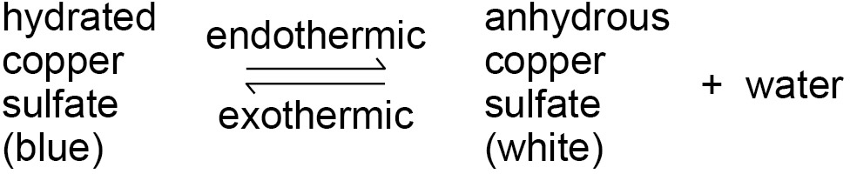
      - Equilibrium

Content | Key opportunities for skills development
When a reversible reaction occurs in apparatus which prevents the escape of reactants and products, equilibrium is reached when the forward and reverse reactions occur at exactly the same rate. | WS 1.2

      - The effect of changing conditions on equilibrium (HT only)

Content | Key opportunities for skills development
The relative amounts of all the reactants and products at equilibrium depend on the conditions of the reaction.
If a system is at equilibrium and a change is made to any of the conditions, then the system responds to counteract the change.
The effects of changing conditions on a system at equilibrium can be predicted using Le Chatelier’s Principle.
Students should be able to make qualitative predictions about the effect of changes on systems at equilibrium when given appropriate information.
      - The effect of changing concentration (HT only)

Content | Key opportunities for skills development
If the concentration of one of the reactants or products is changed, the system is no longer at equilibrium and the concentrations of all the substances will change until equilibrium is reached again.
If the concentration of a reactant is increased, more products will be formed until equilibrium is reached again.
If the concentration of a product is decreased, more reactants will react until equilibrium is reached again.
Students should be able to interpret appropriate given data to predict the effect of a change in concentration of a reactant or product on given reactions at equilibrium.

      - The effect of temperature changes on equilibrium (HT only)

Content | Key opportunities for skills development
If the temperature of a system at equilibrium is increased:
- the relative amount of products at equilibrium increases for an endothermic reaction
- the relative amount of products at equilibrium decreases for an exothermic reaction.
If the temperature of a system at equilibrium is decreased:
- the relative amount of products at equilibrium decreases for an endothermic reaction
- the relative amount of products at equilibrium increases for an exothermic reaction.
Students should be able to interpret appropriate given data to predict the effect of a change in temperature on given reactions at equilibrium.
      - The effect of pressure changes on equilibrium (HT only)

Content | Key opportunities for skills development
For gaseous reactions at equilibrium:
- an increase in pressure causes the equilibrium position to shift towards the side with the smaller number of molecules as shown by the symbol equation for that reaction
- a decrease in pressure causes the equilibrium position to shift towards the side with the larger number of molecules as shown by the symbol equation for that reaction.
Students should be able to interpret appropriate given data to predict the effect of pressure changes on given reactions at equilibrium.

Organic chemistry
The chemistry of carbon compounds is so important that it forms a separate branch of chemistry. A great variety of carbon compounds is possible because carbon atoms can form chains and rings linked by C-C bonds. This branch of chemistry gets its name from the fact that the main sources of organic compounds are living, or once-living materials from plants and animals. These sources include fossil fuels which are a major source of feedstock for the petrochemical industry. Chemists are able to take organic molecules and modify them in many ways to make new and useful materials such as polymers, pharmaceuticals, perfumes and flavourings, dyes and detergents.

Carbon compounds as fuels and feedstock
      - Crude oil, hydrocarbons and alkanes

Content | Key opportunities for skills development
Crude oil is a finite resource found in rocks. Crude oil is the remains of an ancient biomass consisting mainly of plankton that was buried in mud.  Crude oil is a mixture of a very large number of compounds. Most of the compounds in crude oil are hydrocarbons, which are molecules made up of hydrogen and carbon atoms only. | WS 1.2  Make models of alkane molecules using the molecular modelling kits.
Most of the hydrocarbons in crude oil are hydrocarbons called alkanes. The general formula for the homologous series of alkanes is CnH2n+2
The first four members of the alkanes are methane, ethane, propane and butane.
Alkane molecules can be represented in the following forms:
C₂H₆ or
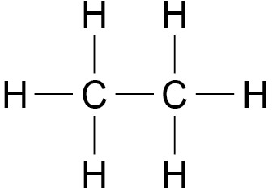
Students should be able to recognise substances as alkanes given their formulae in these forms.
Students do not need to know the names of specific alkanes other than methane, ethane, propane and butane.

      - Fractional distillation and petrochemicals

Content | Key opportunities for skills development
The many hydrocarbons in crude oil may be separated into fractions, each of which contains molecules with a similar number of carbon atoms, by fractional distillation.  The fractions can be processed to produce fuels and feedstock for the petrochemical industry.  Many of the fuels on which we depend for our modern lifestyle, such as petrol, diesel oil, kerosene, heavy fuel oil and liquefied petroleum gases, are produced from crude oil.  Many useful materials on which modern life depends are produced by the petrochemical industry, such as solvents, lubricants, polymers, detergents.  The vast array of natural and synthetic carbon compounds occur due to the ability of carbon atoms to form families of similar compounds.  Students should be able to explain how fractional distillation works in terms of evaporation and condensation.  Knowledge of the names of other specific fractions or fuels is not required. | WS 1.2
      - Properties of hydrocarbons

Content | Key opportunities for skills development
Some properties of hydrocarbons depend on the size of their molecules, including boiling point, viscosity and flammability. These properties influence how hydrocarbons are used as fuels.  Students should be able to recall how boiling point, viscosity and flammability change with increasing molecular size.  The combustion of hydrocarbon fuels releases energy. During combustion, the carbon and hydrogen in the fuels are oxidised. The complete combustion of a hydrocarbon produces carbon dioxide and water.  Students should be able to write balanced equations for the complete combustion of hydrocarbons with a given formula.  Knowledge of trends in properties of hydrocarbons is limited to:  - boiling points  - viscosity  - flammability. | WS 1.2, 4.1  Investigate the properties of different hydrocarbons.

      - Cracking and alkenes

Content | Key opportunities for skills development
Hydrocarbons can be broken down (cracked) to produce smaller, more useful molecules.  Cracking can be done by various methods including catalytic cracking and steam cracking.  Students should be able to describe in general terms the conditions used for catalytic cracking and steam cracking.  The products of cracking include alkanes and another type of hydrocarbon called alkenes.  Alkenes are more reactive than alkanes and react with bromine water, which is used as a test for alkenes.  Students should be able to recall the colour change when bromine water reacts with an alkene.  There is a high demand for fuels with small molecules and so some of the products of cracking are useful as fuels.  Alkenes are used to produce polymers and as starting materials for the production of many other chemicals.  Students should be able to balance chemical equations as examples of cracking given the formulae of the reactants and products.  Students should be able to give examples to illustrate the usefulness of cracking. They should also be able to explain how modern life depends on the uses of hydrocarbons.  (Students do not need to know the formulae or names of individual alkenes.) | WS 1.2

Chemical analysis
Analysts have developed a range of qualitative tests to detect specific chemicals. The tests are based on reactions that produce a gas with distinctive properties, or a colour change or an insoluble solid that appears as a precipitate.
Instrumental methods provide fast, sensitive and accurate means of analysing chemicals, and are particularly useful when the amount of chemical being analysed is small. Forensic scientists and drug control scientists rely on such instrumental methods in their work.

Purity, formulations and chromatography
      - Pure substances

Content | Key opportunities for skills development
In chemistry, a pure substance is a single element or compound, not mixed with any other substance.  Pure elements and compounds melt and boil at specific temperatures. Melting point and boiling point data can be used to distinguish pure substances from mixtures.  In everyday language, a pure substance can mean a substance that has had nothing added to it, so it is unadulterated and in its natural state, eg pure milk.  Students should be able to use melting point and boiling point data to distinguish pure from impure substances. | WS 2.2, 4.1
      - Formulations

Content | Key opportunities for skills development
A formulation is a mixture that has been designed as a useful product. Many products are complex mixtures in which each chemical has a particular purpose. Formulations are made by mixing the components in carefully measured quantities to ensure that the product has the required properties. Formulations include fuels, cleaning agents, paints, medicines, alloys, fertilisers and foods.  Students should be able to identify formulations given appropriate information.  Students do not need to know the names of components in proprietary products. | WS 1.4, 2.2

      - Chromatography

Content | Key opportunities for skills development
Chromatography can be used to separate mixtures and can give information to help identify substances. Chromatography involves a stationary phase and a mobile phase. Separation depends on the distribution of substances between the phases.  The ratio of the distance moved by a compound (centre of spot from origin) to the distance moved by the solvent can be expressed as its R_{f} value:  Rf = distance moved by substance distance moved by solvent  Different compounds have different R_{f} values in different solvents, which can be used to help identify the compounds. The compounds in a mixture may separate into different spots depending on the solvent but a pure compound will produce a single spot in all solvents.  Students should be able to:  - explain how paper chromatography separates mixtures  - suggest how chromatographic methods can be used for distinguishing pure substances from impure substances  - interpret chromatograms and determine R_{f} values from chromatograms | WS 2.2, 3.1, 2, 3 MS 1a  Recognise and use expressions in decimal form.  MS 1c  Use ratios, fractions and percentages.  MS 1d  Make estimates of the results of simple calculations.
- provide answers to an appropriate number of significant figures. | MS 2a
Required practical activity 12: investigate how paper chromatography can be used to separate and tell the difference between coloured substances. Students should calculate R_{f} values.
AT skills covered by this practical activity: chemistry AT 1 and 4.
This practical activity also provides opportunities to develop WS and MS. Details of all skills are given in Key opportunities for skills development (page 183).

Chemistry of the atmosphere
The Earth’s atmosphere is dynamic and forever changing. The causes of these changes are sometimes man-made and sometimes part of many natural cycles. Scientists use very complex software to predict weather and climate change as there are many variables that can influence this. The problems caused by increased levels of air pollutants require scientists and engineers to develop solutions that help to reduce the impact of human activity.

The composition and evolution of the Earth's atmosphere
      - The proportions of different gases in the atmosphere

Content | Key opportunities for skills development
For 200 million years, the proportions of different gases in the atmosphere have been much the same as they are today:  - about four-fifths (approximately 80%) nitrogen  - about one-fifth (approximately 20%) oxygen  - small proportions of various other gases, including carbon dioxide, water vapour and noble gases. | MS 1c  To use ratios, fractions and percentages.

      - The Earth's early atmosphere

Content | Key opportunities for skills development
Theories about what was in the Earth’s early atmosphere and how the atmosphere was formed have changed and developed over time. Evidence for the early atmosphere is limited because of the time scale of 4.6 billion years. | WS 1.1, 1.2, 1.3, 3.5, 3.6,  4.1
One theory suggests that during the first billion years of the Earth’s existence there was intense volcanic activity that released gases that formed the early atmosphere and water vapour that condensed to form the oceans. At the start of this period the Earth’s atmosphere may have been like the atmospheres of Mars and Venus today, consisting of mainly carbon dioxide with little or no oxygen gas.
Volcanoes also produced nitrogen which gradually built up in the atmosphere and there may have been small proportions of methane and ammonia.
When the oceans formed carbon dioxide dissolved in the water and carbonates were precipitated producing sediments, reducing the amount of carbon dioxide in the atmosphere. No knowledge of other theories is required.
Students should be able to, given appropriate information, interpret evidence and evaluate different theories about the Earth’s early atmosphere.
      - How oxygen increased

Content | Key opportunities for skills development
Algae and plants produced the oxygen that is now in the atmosphere by photosynthesis, which can be represented by the equation:  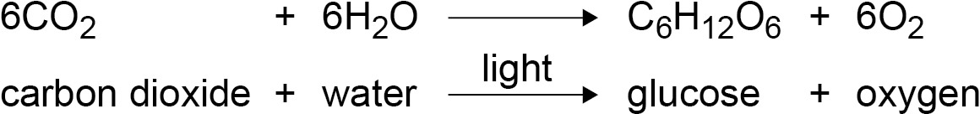 | WS 1.2  An opportunity to show that aquatic plants produce oxygen in daylight.
Algae first produced oxygen about 2.7 billion years ago and soon after this oxygen appeared in the atmosphere. Over the next billion years plants evolved and the percentage of oxygen gradually increased to a level that enabled animals to evolve.

      - How carbon dioxide decreased

Content | Key opportunities for skills development
Algae and plants decreased the percentage of carbon dioxide in the atmosphere by photosynthesis.
Carbon dioxide was also decreased by the formation of sedimentary rocks and fossil fuels that contain carbon.
Students should be able to:  - describe the main changes in the atmosphere over time and some of the likely causes of these changes  - describe and explain the formation of deposits of limestone, coal, crude oil and natural gas. | WS 1.2, 4.1

Carbon dioxide and methane as greenhouse gases
      - Greenhouse gases

Content | Key opportunities for skills development
Greenhouse gases in the atmosphere maintain temperatures on Earth high enough to support life. Water vapour, carbon dioxide and methane are greenhouse gases.  Students should be able to describe the greenhouse effect in terms of the interaction of short and long wavelength radiation with matter. | WS 1.2

      - Human activities which contribute to an increase in greenhouse gases in the atmosphere

Content | Key opportunities for skills development
Some human activities increase the amounts of greenhouse gases in the atmosphere. These include:
- carbon dioxide
- methane.
Students should be able to recall two human activities that increase the amounts of each of the greenhouse gases carbon dioxide and methane.
Based on peer-reviewed evidence, many scientists believe that human activities will cause the temperature of the Earth’s atmosphere to increase at the surface and that this will result in global climate change.
However, it is difficult to model such complex systems as global climate change. This leads to simplified models, speculation and opinions presented in the media that may be based on only parts of the evidence and which may be biased.
Students should be able to:  - evaluate the quality of evidence in a report about global climate change given appropriate information  - describe uncertainties in the evidence base  - recognise the importance of peer review of results and of communicating results to a wide range of audiences. | WS 1.2, 1.3, 1.6
      - Global climate change

Content | Key opportunities for skills development
An increase in average global temperature is a major cause of climate change.  There are several potential effects of global climate change. Students should be able to:  - describe briefly four potential effects of global climate change  - discuss the scale, risk and environmental implications of global climate change. | WS 1.5

      - The carbon footprint and its reduction

Content | Key opportunities for skills development
The carbon footprint is the total amount of carbon dioxide and other greenhouse gases emitted over the full life cycle of a product, service or event.  The carbon footprint can be reduced by reducing emissions of carbon dioxide and methane.  Students should be able to:  - describe actions to reduce emissions of carbon dioxide and methane  - give reasons why actions may be limited. | WS 1.3

Common atmospheric pollutants and their sources
      - Atmospheric pollutants from fuels

Content | Key opportunities for skills development
The combustion of fuels is a major source of atmospheric pollutants.
Most fuels, including coal, contain carbon and/or hydrogen and may also contain some sulfur.
The gases released into the atmosphere when a fuel is burned may include carbon dioxide, water vapour, carbon monoxide, sulfur dioxide and oxides of nitrogen. Solid particles and unburned hydrocarbons may also be released that form particulates in the atmosphere.
Students should be able to:
- describe how carbon monoxide, soot (carbon particles), sulfur dioxide and oxides of nitrogen are produced by burning fuels
- predict the products of combustion of a fuel given appropriate information about the composition of the fuel and the conditions in which it is used. | WS 1.2

      - Properties and effects of atmospheric pollutants

Content | Key opportunities for skills development
Carbon monoxide is a toxic gas. It is colourless and odourless and so is not easily detected.
Sulfur dioxide and oxides of nitrogen cause respiratory problems in humans and cause acid rain.
Particulates cause global dimming and health problems for humans.
Students should be able to describe and explain the problems caused by increased amounts of these pollutants in the air. | WS 1.4

Using resources
Industries use the Earth’s natural resources to manufacture useful products. In order to operate sustainably, chemists seek to minimise the use of limited resources, use of energy, waste and environmental impact in the manufacture of these products. Chemists also aim to develop ways of disposing of products at the end of their useful life in ways that ensure that materials and stored energy are utilised. Pollution, disposal of waste products and changing land use has a significant effect on the environment, and environmental chemists study how human activity has affected the Earth’s natural cycles, and how damaging effects can be minimised.

Using the Earth's resources and obtaining potable water
      - Using the Earth's resources and sustainable development

Content | Key opportunities for skills development
Humans use the Earth’s resources to provide warmth, shelter, food and transport.
Natural resources, supplemented by agriculture, provide food, timber, clothing and fuels.
Finite resources from the Earth, oceans and atmosphere are processed to provide energy and materials.
Chemistry plays an important role in improving agricultural and industrial processes to provide new products and in sustainable development, which is development that meets the needs of current generations without compromising the ability of future generations to meet their own needs.
Students should be able to:
- state examples of natural products that are supplemented or replaced by agricultural and synthetic products
- distinguish between finite and renewable resources given appropriate information.
Students should be able to:
- extract and interpret information about resources from charts, graphs and tables | WS 3.2 MS 2c, 4a
- use orders of magnitude to evaluate the significance of data. | MS 2h  Translate information between graphical and numeric form.

      - Potable water

Content | Key opportunities for skills development
Water of appropriate quality is essential for life. For humans, drinking water should have sufficiently low levels of dissolved salts and microbes. Water that is safe to drink is called potable water.
Potable water is not pure water in the chemical sense because it contains dissolved substances.
The methods used to produce potable water depend on available supplies of water and local conditions.
In the United Kingdom (UK), rain provides water with low levels of dissolved substances (fresh water) that collects in the ground and in lakes and rivers, and most potable water is produced by:
- choosing an appropriate source of fresh water
- passing the water through filter beds
- sterilising.
Sterilising agents used for potable water include chlorine, ozone or ultraviolet light.
If supplies of fresh water are limited, desalination of salty water or sea water may be required. Desalination can be done by distillation or by processes that use membranes such as reverse osmosis.
These processes require large amounts of energy. Students should be able to:
- distinguish between potable water and pure water
- describe the differences in treatment of ground water and salty water
- give reasons for the steps used to produce potable water.

      - Waste water treatment

Content | Key opportunities for skills development
Urban lifestyles and industrial processes produce large amounts of waste water that require treatment before being released into the environment. Sewage and agricultural waste water require removal of organic matter and harmful microbes. Industrial waste water may require removal of organic matter and harmful chemicals.
Sewage treatment includes:
- screening and grit removal
- sedimentation to produce sewage sludge and effluent
- anaerobic digestion of sewage sludge
- aerobic biological treatment of effluent.
Students should be able to comment on the relative ease of obtaining potable water from waste, ground and salt water.
      - Alternative methods of extracting metals (HT only)

Content | Key opportunities for skills development
The Earth’s resources of metal ores are limited.
Copper ores are becoming scarce and new ways of extracting copper from low-grade ores include phytomining, and bioleaching. These methods avoid traditional mining methods of digging, moving and disposing of large amounts of rock.
Phytomining uses plants to absorb metal compounds. The plants are harvested and then burned to produce ash that contains metal compounds.
Bioleaching uses bacteria to produce leachate solutions that contain metal compounds.
The metal compounds can be processed to obtain the metal. For example, copper can be obtained from solutions of copper compounds by displacement using scrap iron or by electrolysis.
Students should be able to evaluate alternative biological methods of metal extraction, given appropriate information.

Life cycle assessment and recycling
      - Life cycle assessment

Content | Key opportunities for skills development
Life cycle assessments (LCAs) are carried out to assess the environmental impact of products in each of these stages:  - extracting and processing raw materials  - manufacturing and packaging  - use and operation during its lifetime  - disposal at the end of its useful life, including transport and distribution at each stage.  Use of water, resources, energy sources and production of some wastes can be fairly easily quantified. Allocating numerical values to pollutant effects is less straightforward and requires value judgements, so LCA is not a purely objective process.  Selective or abbreviated LCAs can be devised to evaluate a product but these can be misused to reach pre-determined conclusions, eg in support of claims for advertising purposes.  Students should be able to carry out simple comparative LCAs for shopping bags made from plastic and paper. | WS 1.3, 4, 5  LCAs should be done as a comparison of the impact on the environment of the stages in the life of a product, and only quantified where data is readily available for energy, water, resources and wastes.  Interpret LCAs of materials or products given appropriate information.  MS 1a  Recognise and use expressions in decimal form.  MS 1c  Use ratios, fractions and percentages.  MS 1d  Make estimates of the results of simple calculations.  MS 2a  Use an appropriate number of significant figures.  MS 4a  Translate information between graphical and numeric form.

      - Ways of reducing the use of resources

Content | Key opportunities for skills development
The reduction in use, reuse and recycling of materials by end users reduces the use of limited resources, use of energy sources, waste and environmental impacts.
Metals, glass, building materials, clay ceramics and most plastics are produced from limited raw materials. Much of the energy for the processes comes from limited resources. Obtaining raw materials from the Earth by quarrying and mining causes environmental impacts.
Some products, such as glass bottles, can be reused. Glass bottles can be crushed and melted to make different glass products. Other products cannot be reused and so are recycled for a different use.
Metals can be recycled by melting and recasting or reforming into different products. The amount of separation required for recycling depends on the material and the properties required of the final product. For example, some scrap steel can be added to iron from a blast furnace to reduce the amount of iron that needs to be extracted from iron ore.
Students should be able to evaluate ways of reducing the use of limited resources, given appropriate information.

