Energy
The concept of energy emerged in the 19th century. The idea was used to explain the work output of steam engines and then generalised to understand other heat engines. It also became a key tool for understanding chemical reactions and biological systems.
Limits to the use of fossil fuels and global warming are critical problems for this century. Physicists and engineers are working hard to identify ways to reduce our energy usage.

Energy changes in a system, and the ways energy is stored before and after such changes
      - Energy stores and systems

Content | Key opportunities for skills development
A system is an object or group of objects.  There are changes in the way energy is stored when a system changes.  Students should be able to describe all the changes involved in the way energy is stored when a system changes, for common situations. For example: | The link between work done (energy transfer) and current flow in a circuit is covered in Work done and energy transfer (page 146).  WS 4.5
- an object projected upwards
- a moving object hitting an obstacle
- an object accelerated by a constant force
- a vehicle slowing down
- bringing water to a boil in an electric kettle.
Throughout this section on Energy students should be able to calculate the changes in energy involved when a system is changed by:
- heating
- work done by forces
- work done when a current flows
- use calculations to show on a common scale how the overall energy in a system is redistributed when the system is changed. | WS 1.2, 4.3, 4.5, 4.6  MS 1a, c, 3b, c
      - Changes in energy

Content | Key opportunities for skills development
Students should be able to calculate the amount of energy associated with a moving object, a stretched spring and an object raised above ground level. | WS 1.2, 4.3, 4.4, 4.6  MS 1a, c, 3b, c

Content | Key opportunities for skills development
The kinetic energy of a moving object can be calculated using the equation:  kinetic energy = 0.5 × mass × speed ²  E_{k} = ¹ m v²  2  kinetic energy, E_{k}, in joules, J mass, m, in kilograms, kg  speed, v, in metres per second, m/s  The amount of elastic potential energy stored in a stretched spring can be calculated using the equation: | MS 3b, c  Students should be able to recall and apply this equation.
elastic potential energy = 0.5 × spring constant × extension ²  E_{e} = ¹ k e²  2  (assuming the limit of proportionality has not been exceeded) elastic potential energy, E_{e}, in joules, J  spring constant, k, in newtons per metre, N/m extension, e, in metres, m  The amount of gravitational potential energy gained by an object raised above ground level can be calculated using the equation: | MS 3b, c  Students should be able to apply this equation which is given on the Physics equation sheet.
g . p . e . = mass × gravitational f ield strength × height  E_{p} = m g h  gravitational potential energy, E_{p}, in joules, J mass, m, in kilograms, kg  gravitational field strength, g, in newtons per kilogram, N/kg (In any calculation the value of the gravitational field strength (g) will be given).  height, h, in metres, m | MS 3b, c  Students should be able to recall and apply this equation.  AT 1  Investigate the transfer of energy from a gravitational potential energy store to a kinetic energy store.

      - Energy changes in systems

Content | Key opportunities for skills development
The amount of energy stored in or released from a system as its temperature changes can be calculated using the equation:

Content | Key opportunities for skills development
change in thermal energy = mass × speci f ic heat capacity  × temperature change  ∆ E = m c ∆ θ | MS 3b, c  Students should be able to apply this equation which is
change in thermal energy, ∆E, in joules, J | given on the Physics  equation sheet.
mass, m, in kilograms, kg | This equation and specific
specific heat capacity, c, in joules per kilogram per degree Celsius, | heat capacity are also
J/kg °C | included in Temperature
temperature change, ∆θ, in degrees Celsius, °C | changes in a system and  specific heat capacity (page
The specific heat capacity of a substance is the amount of energy | 137).
required to raise the temperature of one kilogram of the substance
by one degree Celsius.

Required practical activity 14: an investigation to determine the specific heat capacity of one or more materials. The investigation will involve linking the decrease of one energy store (or work done) to the increase in temperature and subsequent increase in thermal energy stored.
AT skills covered by this practical activity: physics AT 1 and 5.
This practical activity also provides opportunities to develop WS and MS. Details of all skills are given in Key opportunities for skills development (page 184).

      - Power

Content | Key opportunities for skills development
Power is defined as the rate at which energy is transferred or the rate at which work is done.  power = energy trans f erred  time  P = E  t  power = work done  time  P = W  t  power, P, in watts, W  energy transferred, E, in joules, J time, t, in seconds, s  work done, W, in joules, J  An energy transfer of 1 joule per second is equal to a power of 1 watt.  Students should be able to give examples that illustrate the definition of power eg comparing two electric motors that both lift the same weight through the same height but one does it faster than the other. | MS 3b, c  Students should be able to recall and apply both equations.

Conservation and dissipation of energy
      - Energy transfers in a system

Content | Key opportunities for skills development
Energy can be transferred usefully, stored or dissipated, but cannot be created or destroyed.
Students should be able to describe with examples where there are energy transfers in a closed system, that there is no net change to the total energy.
Students should be able to describe, with examples, how in all system changes energy is dissipated, so that it is stored in less useful ways. This energy is often described as being ‘wasted’.

Content | Key opportunities for skills development
Students should be able to explain ways of reducing unwanted energy transfers, for example through lubrication and the use of thermal insulation. | WS 1.4  AT 1, 5
The higher the thermal conductivity of a material the higher the rate of energy transfer by conduction across the material. | Investigate thermal conductivity using rods of  different materials.
Students should be able to describe how the rate of cooling of a building is affected by the thickness and thermal conductivity of its walls.
Students do not need to know the definition of thermal conductivity.

      - Efficiency

Content | Key opportunities for skills development
The energy efficiency for any energy transfer can be calculated using the equation:  e f f iciency = use f ul output energy trans f er  total input energy trans f er | MS 3b, c  Students should be able to recall and apply both equations.
Efficiency may also be calculated using the equation: | MS 1a, c, 3b, c
e f f iciency = use f ul power output  total power input | Students may be required to calculate or use efficiency values as a decimal or as a percentage.
(HT only) Students should be able to describe ways to increase the efficiency of an intended energy transfer. | (HT only) WS 1.4

    - National and global energy resources

Content | Key opportunities for skills development
The main energy resources available for use on Earth include: fossil fuels (coal, oil and gas), nuclear fuel, bio-fuel, wind, hydro- electricity, geothermal, the tides, the Sun and water waves.  A renewable energy resource is one that is being (or can be) replenished as it is used.  The uses of energy resources include: transport, electricity generation and heating.  Students should be able to:  - describe the main energy sources available  - distinguish between energy resources that are renewable and energy resources that are non-renewable  - compare ways that different energy resources are used, the uses to include transport, electricity generation and heating  - understand why some energy resources are more reliable than others | WS 4.4
- describe the environmental impact arising from the use of different energy resources | WS 1.3, 1.4
- explain patterns and trends in the use of energy resources. | WS 3.5
Descriptions of how energy resources are used to generate electricity are not required.
Students should be able to:  - consider the environmental issues that may arise from the use of different energy resources  - show that science has the ability to identify environmental issues arising from the use of energy resources but not always the power to deal with the issues because of political, social, ethical or economic considerations. | WS 1.3, 1.4, 4.4 MS 1c, 2c, 4a

Electricity
Electric charge is a fundamental property of matter everywhere. Understanding the difference in the microstructure of conductors, semiconductors and insulators makes it possible to design components and build electric circuits. Many circuits are powered with mains electricity, but portable electrical devices must use batteries of some kind.
Electrical power fills the modern world with artificial light and sound, information and entertainment, remote sensing and control. The fundamentals of electromagnetism were worked out by scientists of the 19th century. However, power stations, like all machines, have a limited lifetime. If we all

continue to demand more electricity this means building new power stations in every generation – but what mix of power stations can promise a sustainable future?

Current, potential difference and resistance
      - Standard circuit diagram symbols

Content | Key opportunities for skills development
Circuit diagrams use standard symbols.  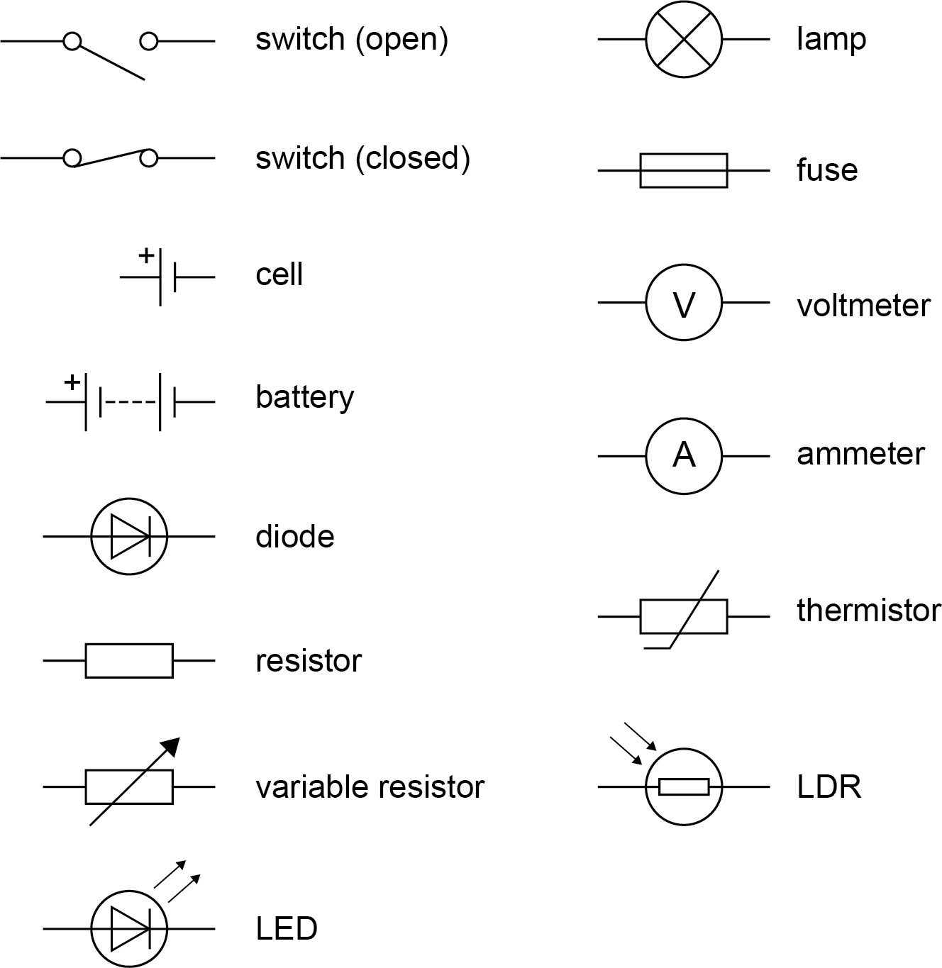  Students should be able to draw and interpret circuit diagrams. | WS 1.2
      - Electrical charge and current

Content | Key opportunities for skills development
For electrical charge to flow through a closed circuit the circuit must include a source of potential difference.

Content | Key opportunities for skills development
Electric current is a flow of electrical charge. The size of the electric current is the rate of flow of electrical charge. Charge flow, current and time are linked by the equation:  charge f low = current × time | MS 3b, c  Students should be able to recall and apply this equation.
Q = I t
charge flow, Q, in coulombs, C
current, I, in amperes, A (amp is acceptable for ampere)
time, t, in seconds, s
A current has the same value at any point in a single closed loop.

      - Current, resistance and potential difference

Content | Key opportunities for skills development
The current (I) through a component depends on both the resistance (R) of the component and the potential difference (V) across the component. The greater the resistance of the component the smaller the current for a given potential difference (pd) across the component.
Questions will be set using the term potential difference. Students will gain credit for the correct use of either potential difference or voltage.
Current, potential difference or resistance can be calculated using the equation:  potential di f f erence = current × resistance  V = I R | MS 3b, c  Students should be able to recall and apply this equation.
potential difference, V, in volts, V
current, I, in amperes, A (amp is acceptable for ampere)
resistance, R, in ohms, Ω

      - Resistors

Content | Key opportunities for skills development
Students should be able to explain that, for some resistors, the value of R remains constant but that in others it can change as the current changes.
The current through an ohmic conductor (at a constant temperature) is directly proportional to the potential difference across the resistor. This means that the resistance remains constant as the current changes.

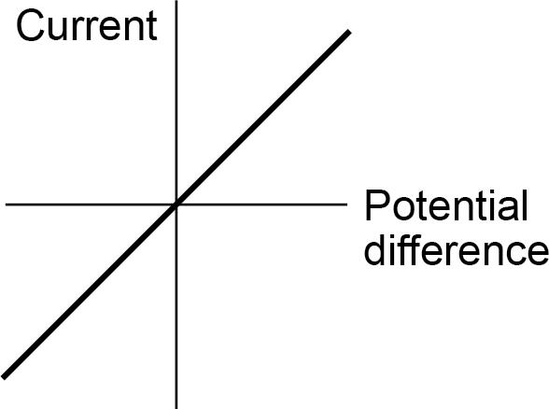

The resistance of components such as lamps, diodes, thermistors and LDRs is not constant; it changes with the current through the component.
The resistance of a filament lamp increases as the temperature of the filament increases.

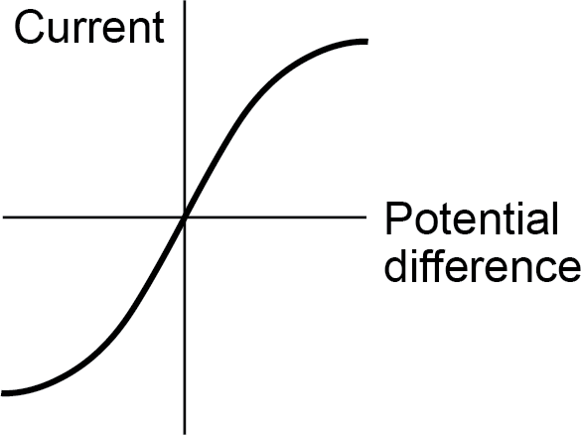

The current through a diode flows in one direction only. The diode has a very high resistance in the reverse direction.

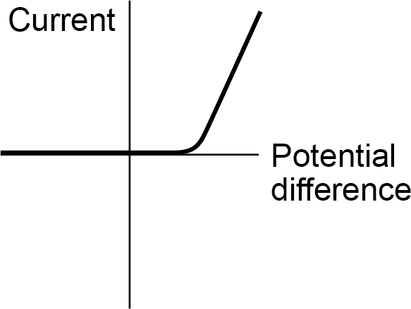

Content | Key opportunities for skills development
The resistance of a thermistor decreases as the temperature increases.
The applications of thermistors in circuits eg a thermostat is required.
The resistance of an LDR decreases as light intensity increases.
The application of LDRs in circuits eg switching lights on when it gets dark is required.  Students should be able to: | WS 1.2, 1.4
- explain the design and use of a circuit to measure the resistance of a component by measuring the current through, and potential difference across, the component  - draw an appropriate circuit diagram using correct circuit symbols. | AT 6  Investigate the relationship between the resistance of a thermistor and temperature.  Investigate the relationship between the resistance of an LDR and light intensity.
Students should be able to use graphs to explore whether circuit elements are linear or non-linear and relate the curves produced to their function and properties. | WS 1.2, 1.4 MS 4c, 4d, 4e

Required practical activity 16: use circuit diagrams to construct appropriate circuits to investigate the I–V characteristics of a variety of circuit elements, including a filament lamp, a diode and a resistor at constant temperature.
AT skills covered by this practical activity: physics AT 6 and 7.
This practical activity also provides opportunities to develop WS and MS. Details of all skills are given in Key opportunities for skills development (page 186).

Energy transfers

      - Power

Content | Key opportunities for skills development
Students should be able to explain how the power transfer in any circuit device is related to the potential difference across it and the current through it, and to the energy changes over time: | MS 3b, c WS 4.5
power = potential di f f erence × current  P = V I | Students should be able to recall and apply both equations.
power = current ² × resistance
P = I² R
power, P, in watts, W
potential difference, V, in volts, V
current, I, in amperes, A (amp is acceptable for ampere)
resistance, R, in ohms, Ω

      - Energy transfers in everyday appliances

Content | Key opportunities for skills development
Everyday electrical appliances are designed to bring about energy transfers.
The amount of energy an appliance transfers depends on how long the appliance is switched on for and the power of the appliance.
Students should be able to describe how different domestic appliances transfer energy from batteries or ac mains to the kinetic energy of electric motors or the energy of heating devices.
Work is done when charge flows in a circuit.
The amount of energy transferred by electrical work can be calculated using the equation:
energy trans f erred = power × time | MS 3b, c
E = P t  energy trans f erred = charge f low × potential di f f erence | Students should be able to recall and apply both equations.
E = Q V | WS 1.4
energy transferred, E, in joules, J
power, P, in watts, W
time, t, in seconds, s
charge flow, Q, in coulombs, C
potential difference, V, in volts, V
Students should be able to explain how the power of a circuit device is related to:  - the potential difference across it and the current through it  - the energy transferred over a given time.  Students should be able to describe, with examples, the relationship between the power ratings for domestic electrical appliances and the changes in stored energy when they are in use. | WS 1.2
      - The National Grid

Content | Key opportunities for skills development
The National Grid is a system of cables and transformers linking power stations to consumers.

Content | Key opportunities for skills development
Electrical power is transferred from power stations to consumers using the National Grid.  Step-up transformers are used to increase the potential difference from the power station to the transmission cables then step-down transformers are used to decrease, to a much lower value, the potential difference for domestic use.  Students should be able to explain why the National Grid system is an efficient way to transfer energy.  Higher tier only:  Students should be able to select and use the equation:  potential difference across primary coil x current in primary coil = potential difference across secondary coil x current in secondary coil  as given on the equation sheet. | WS 1.4  Detailed knowledge of the structure of a transformer is not required.

Particle model of matter
The particle model is widely used to predict the behaviour of solids, liquids and gases and this has many applications in everyday life. It helps us to explain a wide range of observations and engineers use these principles when designing vessels to withstand high pressures and temperatures, such as submarines and spacecraft. It also explains why it is difficult to make a good cup of tea high up a mountain!

Changes of state and the particle model

      - Density of materials

Content | Key opportunities for skills development
The density of a material is defined by the equation:  density = ^{mass}  volume  ρ = m  V  density, ρ, in kilograms per metre cubed, kg/m3 mass, m, in kilograms, kg  volume, V, in metres cubed, m3  The particle model can be used to explain  - the different states of matter  - differences in density. | MS 1a, b, c, 3b, c  Students should be able to recall and apply this equation to changes where mass is conserved.

Content | Key opportunities for skills development
Students should be able to recognise/draw simple diagrams to model the difference between solids, liquids and gases. | WS 1.2
Students should be able to explain the differences in density between the different states of matter in terms of the arrangement of atoms or molecules. | WS 1.2

      - Changes of state

Content | Key opportunities for skills development
Students should be able to describe how, when substances change state (melt, freeze, boil, evaporate, condense or sublimate), mass is conserved.
Changes of state are physical changes which differ from chemical changes because the material recovers its original properties if the change is reversed.

Particle model and pressure

      - Particle motion in gases

Content | Key opportunities for skills development
The molecules of a gas are in constant random motion. The temperature of the gas is related to the average kinetic energy of the molecules.  Changing the temperature of a gas, held at constant volume, changes the pressure exerted by the gas. | WS 1.2
Students should be able to:  - explain how the motion of the molecules in a gas is related to both its temperature and its pressure  - explain qualitatively the relation between the temperature of a gas and its pressure at constant volume. | WS 1.2

Atomic structure
Ionising radiation is hazardous but can be very useful. Although radioactivity was discovered over a century ago, it took many nuclear physicists several decades to understand the structure of atoms, nuclear forces and stability. Early researchers suffered from their exposure to ionising radiation. Rules for radiological protection were first introduced in the 1930s and subsequently

improved. Today radioactive materials are widely used in medicine, industry, agriculture and electrical power generation.

Atoms and isotopes

      - The structure of an atom

Content | Key opportunities for skills development
Atoms are very small, having a radius of about 1 × 10-10 metres. | MS 1b
The basic structure of an atom is a positively charged nucleus composed of both protons and neutrons surrounded by negatively charged electrons.  The radius of a nucleus is less than 1/10 000 of the radius of an atom. Most of the mass of an atom is concentrated in the nucleus. | WS 4.4  Students should be able to recognise expressions given in standard form.
The electrons are arranged at different distances from the nucleus (different energy levels). The electron arrangements may change with the absorption of electromagnetic radiation (move further from the nucleus; a higher energy level) or by the emission of electromagnetic radiation (move closer to the nucleus; a lower energy level).
      - Mass number, atomic number and isotopes

Content | Key opportunities for skills development
In an atom the number of electrons is equal to the number of protons in the nucleus. Atoms have no overall electrical charge.
All atoms of a particular element have the same number of protons. The number of protons in an atom of an element is called its atomic number.
The total number of protons and neutrons in an atom is called its mass number.
Atoms can be represented as shown in this example:

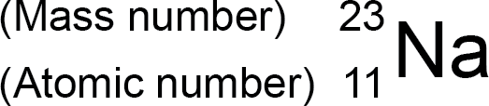

Atoms of the same element can have different numbers of neutrons; these atoms are called isotopes of that element.
Atoms turn into positive ions if they lose one or more outer electron(s).
Students should be able to relate differences between isotopes to differences in conventional representations of their identities, charges and masses. | WS 4.1

      - The development of the model of the atom (common content with chemistry)

Content | Key opportunities for skills development
New experimental evidence may lead to a scientific model being changed or replaced.  Before the discovery of the electron, atoms were thought to be tiny spheres that could not be divided.  The discovery of the electron led to the plum pudding model of the atom. The plum pudding model suggested that the atom is a ball of positive charge with negative electrons embedded in it.  The results from the alpha particle scattering experiment led to the conclusion that the mass of an atom was concentrated at the centre (nucleus) and that the nucleus was charged. This nuclear model replaced the plum pudding model.  Niels Bohr adapted the nuclear model by suggesting that electrons orbit the nucleus at specific distances. The theoretical calculations of Bohr agreed with experimental observations.  Later experiments led to the idea that the positive charge of any nucleus could be subdivided into a whole number of smaller particles, each particle having the same amount of positive charge. The name proton was given to these particles.  The experimental work of James Chadwick provided the evidence to show the existence of neutrons within the nucleus. This was about 20 years after the nucleus became an accepted scientific idea.  Students should be able to describe: | WS 1.1, 1.6  This historical context provides an opportunity for students to show an understanding of why and describe how scientific methods and theories develop over time.  WS 1.2
- why the new evidence from the scattering experiment led to a change in the atomic model | WS 1.1
- the difference between the plum pudding model of the atom and the nuclear model of the atom. | WS 1.2
Details of experimental work supporting the Bohr model are not required.
Details of Chadwick’s experimental work are not required.

Atoms and nuclear radiation
      - Radioactive decay and nuclear radiation

Content | Key opportunities for skills development
Some atomic nuclei are unstable. The nucleus gives out radiation as it changes to become more stable. This is a random process called radioactive decay.
Activity is the rate at which a source of unstable nuclei decays. Activity is measured in becquerel (Bq)
Count-rate is the number of decays recorded each second by a detector (eg Geiger-Muller tube).
The nuclear radiation emitted may be:
- an alpha particle (α) – this consists of two neutrons and two protons, it is the same as a helium nucleus
- a beta particle (β) – a high speed electron ejected from the nucleus as a neutron turns into a proton
- a gamma ray (γ) – electromagnetic radiation from the nucleus
- a neutron (n).
Required knowledge of the properties of alpha particles, beta particles and gamma rays is limited to their penetration through materials, their range in air and ionising power.  Students should be able to apply their knowledge to the uses of radiation and evaluate the best sources of radiation to use in a given situation. | WS 1.4, 1.5

      - Nuclear equations

Content | Key opportunities for skills development
Nuclear equations are used to represent radioactive decay.  In a nuclear equation an alpha particle may be represented by the symbol:  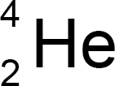  and a beta particle by the symbol:  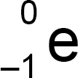  The emission of the different types of nuclear radiation may cause a change in the mass and /or the charge of the nucleus. For example:  So alpha decay causes both the mass and charge of the nucleus to decrease.  So beta decay does not cause the mass of the nucleus to change but does cause the charge of the nucleus to increase.  Students are not required to recall these two examples.  Students should be able to use the names and symbols of common nuclei and particles to write balanced equations that show single alpha (α) and beta (β) decay. This is limited to balancing the atomic numbers and mass numbers. The identification of daughter elements from such decays is not required.  The emission of a gamma ray does not cause the mass or the charge of the nucleus to change. | WS 1.2, 4.1  MS 1b, c, 3c
      - Half-lives and the random nature of radioactive decay

Content | Key opportunities for skills development
Radioactive decay is random.
The half-life of a radioactive isotope is the time it takes for the number of nuclei of the isotope in a sample to halve, or the time it takes for the count rate (or activity) from a sample containing the isotope to fall to half its initial level.

Content | Key opportunities for skills development
Students should be able to explain the concept of half-life and how it is related to the random nature of radioactive decay. | WS 1.2
Students should be able to determine the half-life of a radioactive isotope from given information. | MS 4a
(HT only) Students should be able to calculate the net decline, expressed as a ratio, in a radioactive emission after a given number of half-lives. | (HT only) MS 1c, 3d

      - Radioactive contamination

Content | Key opportunities for skills development
Radioactive contamination is the unwanted presence of materials containing radioactive atoms on other materials. The hazard from contamination is due to the decay of the contaminating atoms. The type of radiation emitted affects the level of hazard.  Irradiation is the process of exposing an object to nuclear radiation. The irradiated object does not become radioactive. | WS 1.5
Students should be able to compare the hazards associated with contamination and irradiation. | WS 1.5
Suitable precautions must be taken to protect against any hazard that the radioactive source used in the process of irradiation may present. | WS 1.5
Students should understand that it is important for the findings of studies into the effects of radiation on humans to be published and shared with other scientists so that the findings can be checked by peer review. | WS 1.6

