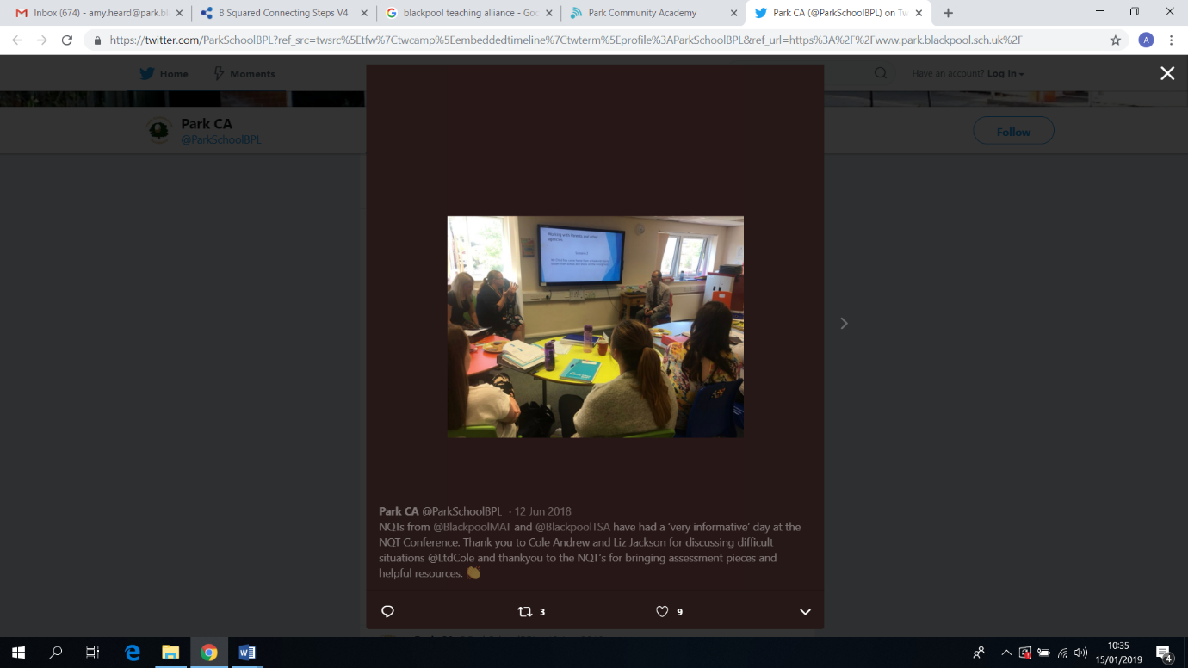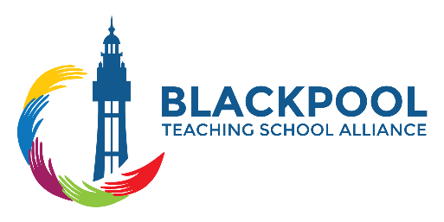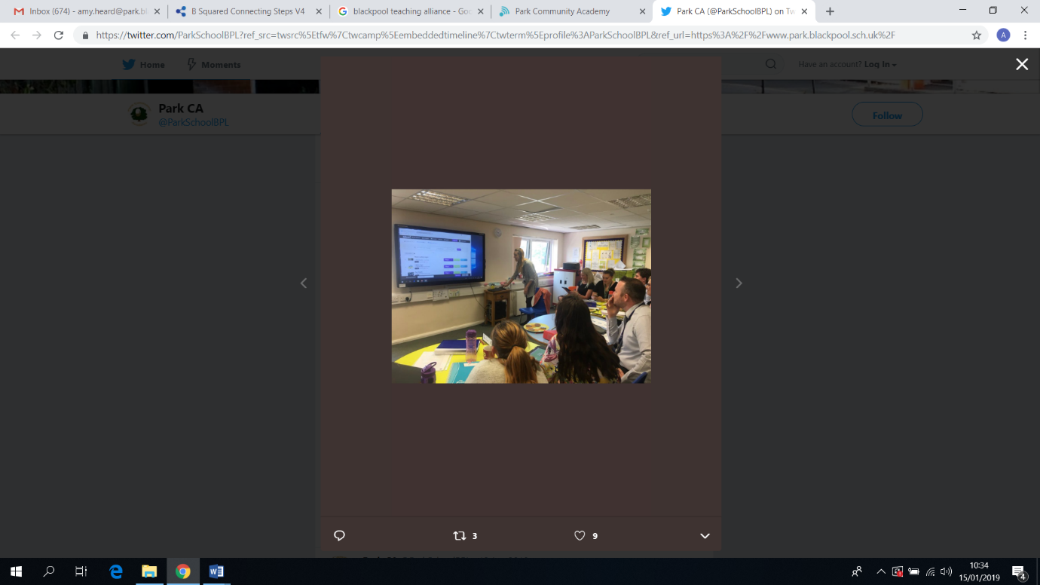

**OFSTED and Behaviour management**

Dave Parkes will be delivering two keynote sessions on;

* **Preparing for OFSTED and Learning Walks**
* **Behaviour management in the classroom**

Dave brings a wealth of experience, with a unique perspective and humour to his sessions. He has worked in Lancashire for 31 years in mainstream primary and special schools as a Class Teacher, Deputy Head and Head Teacher. He has also been an SEN and Primary School Adviser within Lancashire.

The session will include an opportunity for feedback and advice on your own classroom experiences so please bring them along with you.

**NQT standards**

The afternoon session will focus on the NQT guidelines and statutory requirements. This will give you the chance to ask questions and discuss evidence that can be used in your NQT files. Please bring your NQT files along so that we can share good practice.

The BTSA Spring NQT Conference will be held at

**Park Community Academy Westbury Sixth Form Centre on Tuesday 19th March, 2019.** (NQT’s -9.15am – 2.45pm RQT’s 9.15-12.30 )

**The cost of the conference is**

NQT’s-£50(BTSA members) £75 (Non-members) for the day including lunch and refreshments.

RQT’s-£30(BTSA members) £45 (Non-members) for the day including lunch and refreshments.

Please email Catherine.Cole@st-nicholas.blackpool.sch.uk to book your place!

**NQT/RQT**

**Conference**

**Preparing for your RQT year**

Hannah Kippax (RQT at Revoe and former BTSA School Direct student) will also be sharing key strategies for achieving a successful NQT year as well as giving advice in preparation for your RQT year.