DATE

EMPLOYEE:
POST:
SCHOOL:

I can confirm that the following pre-employment checks have been carried out and are complete.

Please keep this letter in the employee’s personnel file.

CHECK | RESULT | FURTHER DETAILS
ENHANCED DBS | Certificate no:  Issued:
CHILDREN’S BARRED LIST CHECK | Clear | Checked DATE
REFERENCES | 2 satisfactory received
ONLINE SEARCH | No risk identified | Report DATE
PHYSICAL AND MENTAL FITNESS | Fit to work | Report DATE
RIGHT TO WORK IN UK | British | Passport no:  Exp:
VERIFY QUALIFICATIONS | Certificates provided DATE
TEACHER STATUS | QTS: | DATE
TEACHER PROHIBITION CHECK | Clear | Checked DATE
CHILDCARE DISQUALIFICATION POLICY | Signed DATE
Yours sincerely,
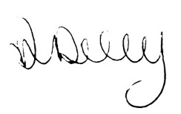
Ann Daly
HR Manager

