Date

Name
Address

Dear name,
We are writing to confirm receipt of notification of your resignation dated DATE from your post of POST at SCHOOL, part of the Blessed Edward Bamber Catholic Multi Academy Trust.
We can confirm that your final day of work will be DATE
You will receive your final pay on DATE
For staff on a 52 week contract: Your remaining annual leave will be calculated and any amount owing or owed will be paid in or deducted from your final wages.
We would be grateful if you could complete the Trust employee leaver’s questionnaire following this link: https://forms.gle/i76AgbzSKLwbJE1z7 . All responses are routinely shared with the school leaders unless you choose to opt out of this on the form.
We would like to take this opportunity to formally thank you for your service and wish you well for the future.

Yours sincerely,
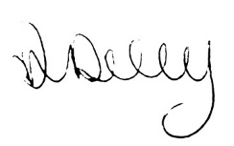
Ann Daly
HR Manager

