Boarshaw Primary School – Geography
Topic: Where would you prefer to live, England or Kenya? |  | Strand: Place Knowledge &  Human and Physical Geography |  | Year 2
What should I already know? |  | Countries on a world map. |  | Vocabulary
- The names of the four countries and capital cities of the UK.  - The geography of our school and the key human and physical features of Manchester.  - Where to find the hot and cold places of our world in relation to the North and South Poles and the Equator.  - That the weather and weather patterns in the UK are seasonal. |  | 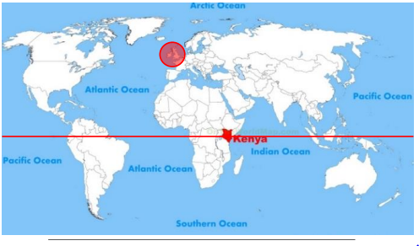  Equator |  | 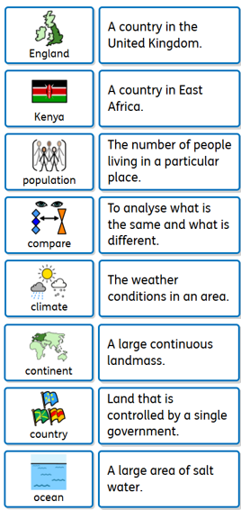
Key Knowledge |  | Key features of Kenya and England.
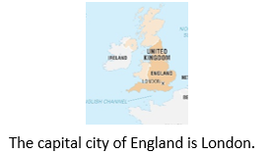  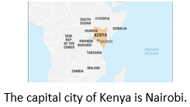  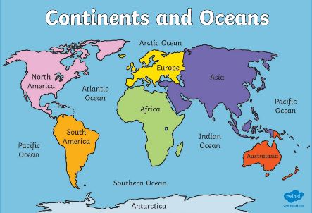 |  | Kenya England  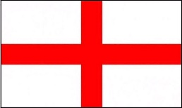  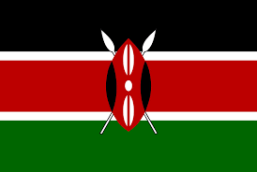  English flag  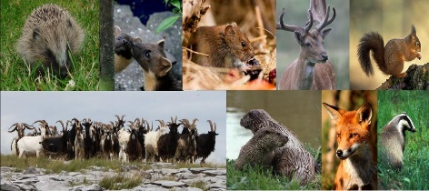  English animals  Kenyan flag  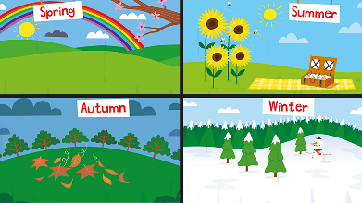  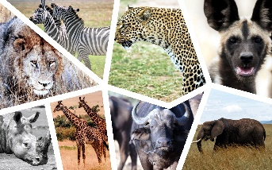  4 Seasons- Spring, Summer, Autumn and Winter.  Kenyan animals  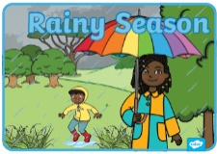  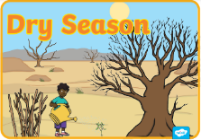  2 Seasons- dry and rainy.

Boarshaw Primary School – Geography Year 2
Topic: Where would you prefer to live, England or Kenya? |  | Year 2
End of unit assessment.
Question 1:  What are Kenya and the UK?  a) Continents  b) Countries  c) Towns  d) Cities  e) Don’t know |  |  | Question 4:  How are Manchester and Kenya similar?  a) They both have hills  b) They both have a beach  c) They both have a national park  d) They both have slum areas  e) Don’t know
Question 2:  What are Africa and Europe?  a) Continents  b) Countries  c) Towns  d) Cities  e) Don’t know |  |  | Question 5:  Which of these statements are false? (circle 2)  a) Manchester is a coastal city  b) Kenya has over 50 national parks  c) There are many museums in Manchester  d) Kenya is made up of several islands joined together  e) Don’t know
Question 3:  Which of these can I use to find where the UK and Kenya are? (circle 2)  a) A telescope  b) An atlas  c) A dictionary  d) An information book  e) Don’t know |  |  | Question 6:  How are Manchester and Kenya different? (circle 2)  a) Kenya is a city and Manchester is a village  b) Kenya has a national park and Manchester does not  c) Kenya has rhinos and lions but Manchester does not  d) Manchester is by the sea and Kenya is not  e) Don’t know

