Boarshaw Primary School – Science
Topic: Materials |  | Strand: Chemistry |  |  | Year 2
What should I already know? | Key Knowledge |  |  | Key Knowledge
- That an object is something you can see.  - All objects are made of materials.  - Materials have certain properties. | 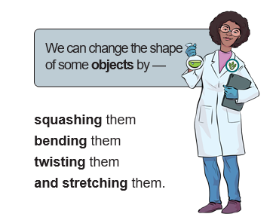 |  |  | 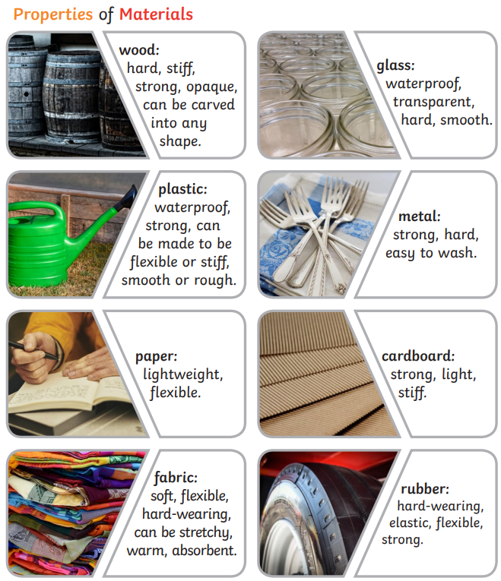
Key Knowledge and Vocabulary

