Year 4 - Class Newsletter
Autumn 2 2026
Dear Parents and Carers,

Reading: Children may take home two reading books and a library book. These can be changed regularly after completing comprehension style questions. Pupils should be reading at home daily to help increase their pace and fluency. Please ensure you sign or encourage your child to sign and date their reading record to show they have read at home/finished a book.
Homework: They will also receive handwriting practice which will have their weekly spelling words. The children will also be given a weekly comprehension to complete. Times tables rock stars is a high priority this year and we would like the children to complete 15 minutes worth of practice each night. We will also be providing the children with a Maths activity book. We will direct the children each week as to how many pages they should complete.
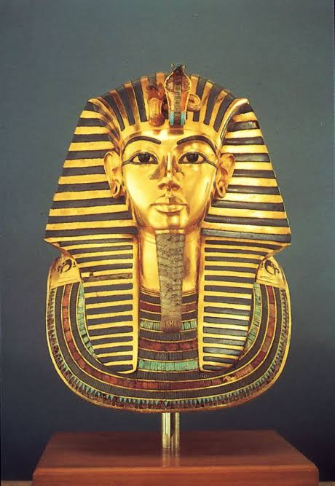
Please make sure you provide your child with the correct uniform for PE. Black shorts, pumps or trainers and a white t-shirt. A jumper and tracksuit may be needed for outdoor PE. Children are not allowed to wear any jewellery in PE, so please make sure your child removes any jewellery on the mornings of PE days unless they can remove it themselves. Girls with long hair must have it tied back.
Should you have any concerns or questions please let us know. You can contact us via the Class Dojo app.
 | Here is an overview of our learning across the curriculum this term.
English: | Persuasive advert – Visit Ancient Egypt  Biography : Mystique The Evil Fairy
Maths: | Number: Multiplication & Division
History: | Ancient Egypt
Science: | States of Matter
Computing: | Unpacking hardware and software  Animation
DT: | Textiles – Making an Egyptian Collar
RE: | Why are festivals important to religious communities?
PSHE: | My Happy Mind – Celebrate - Places
Spanish: | My local area, your area
Music: | Djembe drums / Ukulele

What are we learning?
During Autumn 2 the focus will be History and the children will be learning about Ancient Egypt. They will be learning where Egypt is located in the world and why is it a favourite holiday destination. Some of the questions they will be looking are:
- What is an archaeologist and how have they
helped us find out about the past?
- Who were the pharaohs and why were they very important?
- What have we learnt from Ancient Egyptian writing?
- What would you ask an Ancient Egyptian?
- Reflection: Were the Egyptians more advanced than we are?
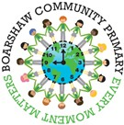

Weekly Timetable
Monday – P.E. Jellyfish / Starfish
Tuesday – Reading Plus and TTRS
Wednesday – Reading Plus and TTRS
Thursday TTRS. Homework handed out.
Friday – Spelling Test. Homework hand- ed in. Jellyfish and Starfish PE.
Please sign and return your child’s reading book and record on a daily basis.

