Boarshaw Primary School – Geography
LC: Where do the wheels on the bus go? |  | Geographical Skills and Fieldwork |  | Year 1
What should I already know? | What key knowledge will I know by the end of the unit?
That I live in the United Kingdom.  The United Kingdom is a country.  A country is a place where you live. | 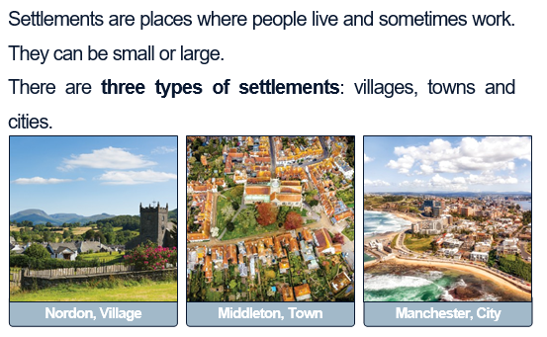  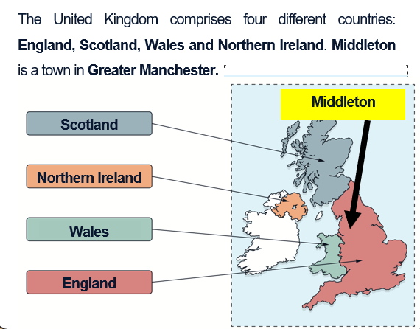 |  | 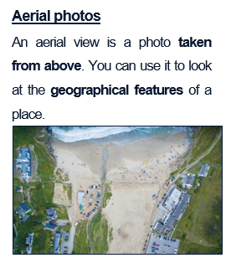  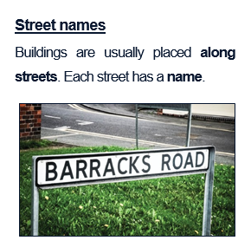
  Key Vocabulary
  Middleton | The town where we go to school.
  Postcode | Locates you to a street or place using letters and numbers.
  Town | A place where people live, shop and work which is larger than a village.
  Physical features | Natural things such as the river, which are part of the environment and not made by humans.
  Human features | Things such as houses, roads and bridges, which have been built by humans
Geographical skills and enquiry

To create and use maps.

To use aerial photographs to recognise landmarks.

To recognise human and physical geography.

Post Assessment – Geography – Geographical skills and fieldwork.
Learning Challenge: Where do the wheels on the bus go?
 | Post assessment |  | Post assessment
- What country do you live in? |  | - Can you find England on the map? | 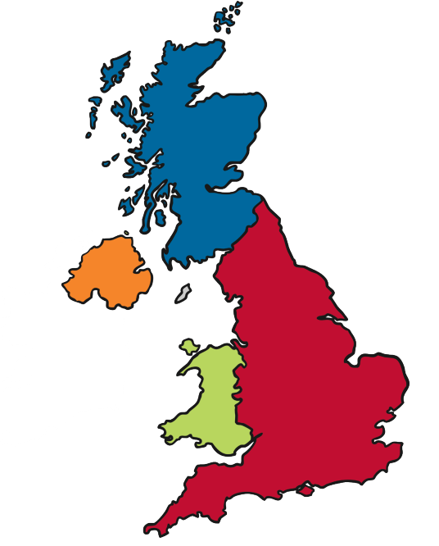
  England | Scotland
  Wales | Northern Island
- Which town do you live in? |  | - Can you find England on the map?
- Middleton is a city.  True of false? |  | - Label the map with the countries.
- What is your address? |  | - Label the map with the countries.

