Boarshaw Primary School – Science
Topic: Seasons | Strand: Physics |  |  | Year 1
What should I already know? |  | Key Knowledge
- The four seasons, Autumn, Winter, Spring, Summer,  - During autumn the leaves fall off the tress,  - In winter it is cold,  - In spring the leaves start to grow back,  - In summer the sun shines more and it becomes hotter. |  | 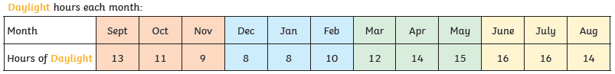  The daylight hours changes with each season:
Key Vocabulary |  | 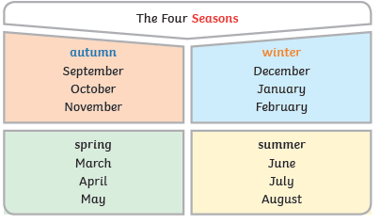 | 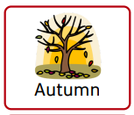  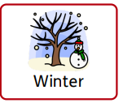  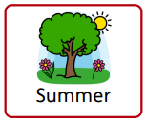  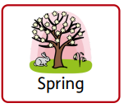
Weather – The weather is what is happening outside, e.g. rain, snow, sun.

Daylight – Daylight is when it is light outside.

Seasons – There are Autumn, Winter, Spring, Summer.

Night time – Night time is when it is dark outside.

Temperature – How cold or hot it feels.

