
Boarshaw Primary School
Child Protection and Safeguarding

If you have a concern about a child in the school, tell a member of staff below:

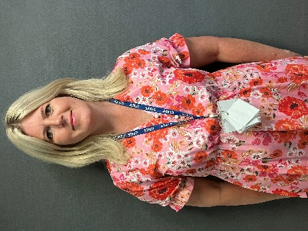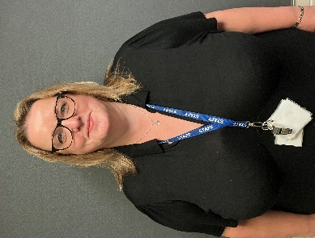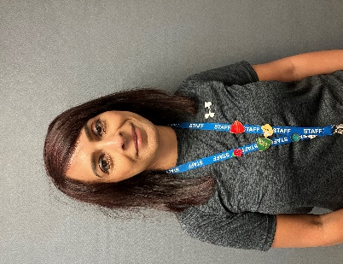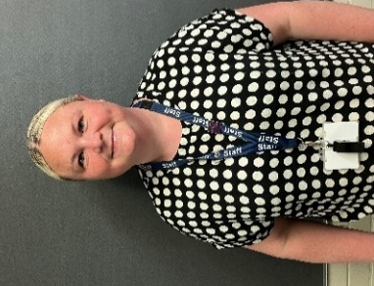
Children’s Social Care: 0300 303 0440

Copies of the child protection policies are available on the school website, the shared staff drive, on the safeguarding displays around school and from the school office.

Children’s Welfare Officer
Mandy Evans

DDSL
Sadia Riaz
DDSL
Jackie Harland

DSL
Abigail Facchin

