Reviewed on: | 18/7/23
Next review: | 18/7/24
Staff Responsibility: | Abigail Facchin
Linked policies: | SEND, Safeguarding, Intimate care policy, Medicine Policy, Inclusion Policy
Singed by chair: | L Vitler
Date: | 19/7/24

Boarshaw Community Primary School
SEN information report 2023

Introduction
At Boarshaw Community Primary School all members of staff work together to be inclusive, with the needs of pupils with Special Educational Needs (SEND) being met wherever possible. The school works alongside a range of other agencies to ensure that all pupils, regardless of their specific needs, make the best possible progress in school.

The Special Educational Needs and Disability Code of Practice makes it clear that all teachers are responsible and accountable for the progress of all learners in their class, including where they access support from teaching assistants or specialist staff.

Students who continue to face challenges in their learning, despite receiving high-quality teaching, are likely to need additional strategies, or different provision, in order to meet their needs. The SEND Code of Practice states that, for these learners, teachers are required to remove barriers to learning and put effective special educational provision in place through SEN support.
This SEN support takes the form of a four-part cycle (assess, plan, do, review). Through this cycle, actions are reviewed and refined as understanding of a student’s needs and the support required to help them secure good outcomes increases. This is known as the graduated approach.

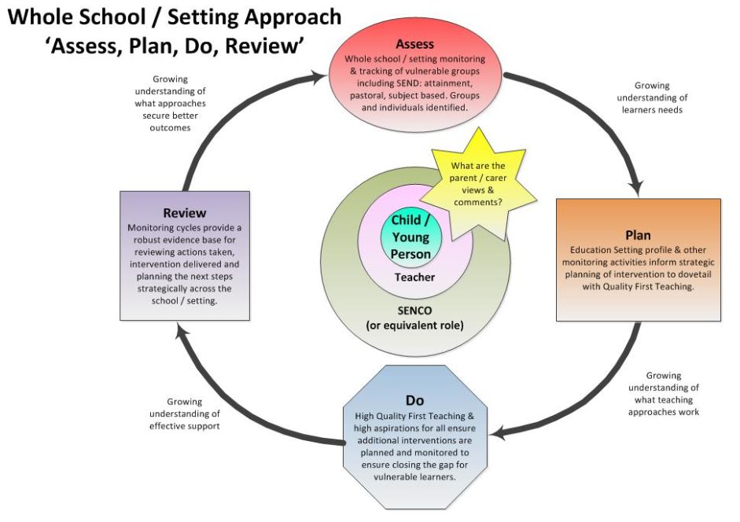

There are four types of SEND decided by The Department for Education:
- Communication and Interaction
- Cognition and Learning
- Social, Emotional and Mental Health
- Sensory and Physical.
If a child has SEND then their needs will fit into one or more of these categories.
How are the needs of children identified and assessed?
If a child is identified as having SEND their name will be added to the school’s SEND list and parents will be consulted with. We recognise that a child’s needs may change over time and therefore their name may be removed from the SEND list. If, however, further needs are identified in the future they may be added to the list again.

We identify and assess pupils with SEND as early and as thoroughly as possible using the revised SEND Code of Practice (2014). We aim to involve parents / carers and pupils in the identification and assessment of SEND. We value information from parents in enabling us to identify the needs of individuals and to support our assessments.
Members of staff in school work alongside other professionals from health and education in carrying out assessments to determine the educational needs and support for our children.
The progress of children with SEND is assessed and reviewed on a regular basis using methods appropriate to the individual. Individual Education Plans (IEPs) are written to reflect a child’s needs and the support they require to make progress. They are reviewed at least once a term and parents and pupils are invited to be involved in this process.
What should I do if I think my child has special educational needs?
- Speak to your child’s class teacher.
- Ask to discuss your concerns with the Special Education Needs Coordinator (SENDCo), Abigail Facchin. The SENDCo is responsible for coordinating the support provided for SEND children across the school.
- Make an appointment to Speak to the Head teacher, Jackie Harland.
What does Boarshaw Primary School provide for children with SEND?
- The school’s provision for SEND is defined as support which is additional to or different from that which is provided for all pupils.
- We meet the needs of all pupils with SEND, including those who are LAC, by offering appropriate and flexible provision, with efficient use of available resources.
- Pupils with SEND are, wherever possible, educated in an inclusive environment alongside their peers. We match levels of additional support to the wide variety of individual needs of our children.
- We have a Designated Unit for 12 children with SLCN.
- Some children with more severe and complex needs have an Education and Health Care (EHC) Plan. EHC plans are reviewed at least annually and involve pupils, parents and any other relevant agencies.
- We have a dedicated early help Teaching Assistant, who works directly with families and pupils who need extra support to develop their SEMH. This may involve referral to other agencies, such as #Thrive. We may also involve the families in EHA (Early Help assessment).
- We have a dedicated team of teachers and TA who work with pupils who are experiencing difficulties in school and at home. They are engaged in a nurture-based curriculum to help develop their SEMH needs.
- We have dedicated nurture provision in the school to help support pupils with SEND. This is run by a dedicated team of staff.
The Lagoon – allows pupils access to play based learning in small intervention groups
The Ocean – play based learning for KS1
The Light House– a nurture room for Y4/5/6 pupils.
- All Teachers and TAs have received attachment training to support pupils with SEMH.
- We use emotion coaching as a tool for all our learners.
- We use zones of regulation with all our pupils.
- We are an Autistic Champion school
- All teachers and TAs receive training about SEND.
- All pupils, including those with SEND are supported through our Anti- Bullying policy, with includes the use of class Bully Busters and pupil questionnaires. Teachers and TAs undertake specific training linked to SEND and bullying.
- Our corridor displays are based on inclusion and help to promote equality and understanding.

How will the school support my child?
- Class teachers are responsible for the learning of all children in their class. They are trained to teach children with a wide range of additional learning needs within the classroom using a variety of methods.
- Additional support is provided for all children by Teaching Assistants who are class based.
- Additional intervention may be used to meet a child’s needs.
- Class teachers are able to provide learning activities or materials for parents to support the needs of their child at home.
- All staff are trained to meet the various needs of children and updated on effective support strategies for individuals.
- School staff work with other professionals to meet children’s specific SEND.
- School will inform parents/carers of any concerns and aim to support the child by putting a Learning Adventure (individual targets for the child) into place. This is shared with the child and parents, and reviewed at least termly.
- We offer personalised support for children identified as SEND.
- We hold termly meetings with parents of children with an EHCP, as well as coffee mornings and support groups. Early help is also offered.

How is the curriculum matched to my child’s needs?
- Class teachers differentiate learning to meet the needs of all children in their class. Within the classroom children are grouped in various and flexible ways.
- Additional resources are used where necessary.
- Resources are adapted or adjusted to make them more accessible.
- Alternative activities or resources are provided for parents to support children at home where this is appropriate.
- We promote inclusive classrooms, where all pupils have access to resources that may support their learning. This may include coloured overlays, reading guides, fidget toys.
- We realise that some pupils will require a heavily differentiate curriculum which requires the expertise and support from colleagues in a different Year group or key Stage.

How are the governors involved?
- The SENDCo reports annually to the governors. This report does not refer to individuals and confidentiality is maintained at all times.
- One of the governors is responsible for SEND.
How accessible is the school environment?
- All learning areas in the school are on the ground floor and are accessible for wheelchair users or those with impaired mobility.
- There are two disabled toilets on site. One has a height adjusting bed with a shower. This room is used for changing pupils in line with the intimate care policy.
- The car park has designated bays for disabled parking, clearly marked in yellow paint.
How do we support your child with transitions between year groups and to and from other schools?
- If your child is joining us in Nursery or Reception our staff will liaise with previous placements and arrange meetings for parents before children start school in September.
- If your child is joining us from another school they will be able to visit our school prior to starting.
- If your child would benefit from a book/passport to support them when moving between year groups then one may be made.
- Information is passed onto new class teachers in advance and any Learning Adventures are shared with the new teacher.
- When moving to a new school, records including Learning Adventures and advice from other agencies are passed on.

What should I do if I am not happy with the provision provided for my child?
- In the first instance, you should speak to your child’s class teacher.
- Ask to make an appointment with the SENDCo.
SENDCO - Abigail Facchin
office@boarshawprimary.co.uk
0161 653 9536
- If you are still unhappy, follow the school complaints procedure. A copy can be found on the school website or a copy can be requested from the school office.
For more information about SEND at Boarshaw Community Primary School please refer to the SEND policy.

