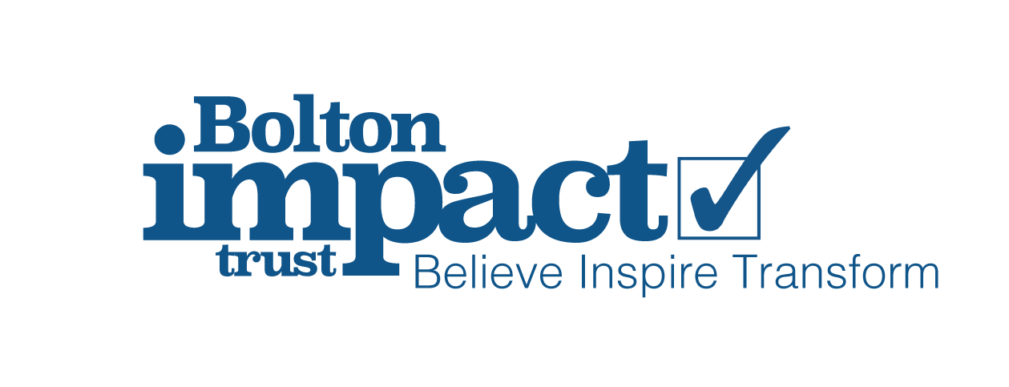

Bolton Impact Trust
Consent for using staff photos

At The Bolton Impact Trust we would like your consent in order to take and use your photo in the ways described below. If you’re not happy for us to do this, that’s no problem – we will accommodate your preferences. If you initially give consent and then wish to withdraw it at any time, please inform your academy in writing. This should be addressed to the Office Supervisor in your academy or team. Please be aware this consent will remain in force for the whole of your time at Bolton Impact Trust Photographs used on permanent displays and/or in marketing materials may be kept for a reasonable time after you have left trust.

Please tick the relevant box(es) below, sign and return this form to your academy/trust office.

I am happy for the school to use my photo in displays in the academy or trust
I am happy for the school to use my photo on the academy/trust website
I am happy for the school to use my photo in the academy/trust newsletter
I am happy for the school to use my photo in social media, including Twitter, Facebook and Instagram
I am happy for the school to share my photo for use in the media
I am happy for the school to film me teaching

I am NOT happy for the school to use my personal data for any of the above purposes

Why are we asking for your consent?

You may be aware that there are new data protection rules. To ensure we are meeting the new requirements, we need to seek your consent for some of the ways we use information about you.

We would appreciate you taking the time to give consent, as we really value being able to use the information in the ways listed above.

Staff Name: ______________________________________

Staff signature: ___________________________________

Date: ________________________________

