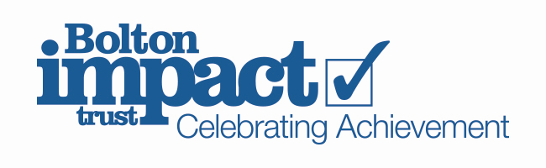

Dear Parent/Carers
I am writing to update you on the situation with the ‘Who’s in Charge’ programme.
Unfortunately, due to the Covid 19 restrictions and safety procedures I am currently unable to run the course as I have in the past.
I know some of you have been waiting for a review session, some of you were in the middle of a course and also others are waiting to start a course.
I am so sorry to find that we are in this position and those of you who know me well, know that I am always keen to run another course. Unfortunately at the moment I am unable to say when that will be.
I am sorry to inconvenience you all but know as soon as is possible I will put on another course.
In the meantime if you require support and/ or advice please speak to your child’s key worker about an individual referral.
Kind Regards
Elaine Lord

