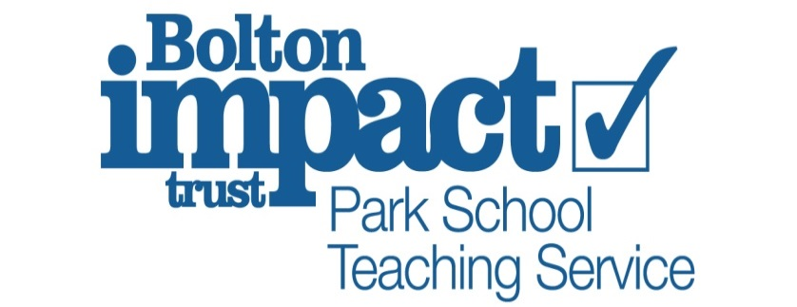

Dear Parents / Carers

RE: Trip to Chorley Little Theatre

We would like to offer our pupils the opportunity to participate in a trip to watch a private cinema screening of ‘The Greatest Showman’ at Chorley Little Theatre on Wednesday 23rd June 2021.
There is no cost for the trip as it is funded by ‘Youth Music’, using public funding from the National Lottery. The screening of the film is exclusively for Park School pupils and there will be no members of the public in the theatre. It is a large theatre that seats 230 people so there is adequate room for social distancing.

Pupils will arrive at school as normal and will travel in minibus taxis/taxis or staff cars to the theatre at approximately 9.30am. The film will start at 10.15am and lasts for 1 hour 46mins, with a 15-minute interval in the middle where pupils can have a break.
We will be returning to school at approximately 1pm. Normal lunch arrangements will apply.

Pupils who would prefer not to participate in the trip will still be able to access normal lessons on this day.

Could you please let us know whether your child will be joining us on our trip by completing and returning the slip below by Wednesday 16th June 2021.

Yours Faithfully

Mrs Banks

PLEASE DETACH AND RETURN
To be completed by Parent/Carer
I confirm that my child ……………………………………. will/will not be attending the trip to
Chorley Little Theatre for a private screening of The Greatest Showman.

Parent/Carer’s signature: ………………………………………. Date : …………………………
Emergency telephone contact number for Wednesday 23rd June. ……………………….

