Youth Challenge Primary is proud to be in partnership with Magic Breakfast, providing healthy breakfasts to our pupils so that they are settled and ready to learn.

Magic Breakfast provides Youth Challenge Primary with nutritious breakfast food to ensure children start their school day in the best possible way. Breakfast gives children the energy needed for the busy school morning, enabling them to focus on their lessons.

Here at Youth Challenge Primary we are committed to ensuring no child is too hungry to learn.

Youth Challenge Magic Breakfast Offer
All children will be offered breakfast when they arrive.

Yours sincerely

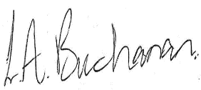

Louise Buchanan
Academy Lead
