

Spring term 2021

Journeys

Maths

Measure-Time

Tell and write the time from an analogue clock, including using Roman numerals from I to XII, and 12-hour and 24-hour clocks

Estimate and read time with increasing accuracy to the nearest minute; record and compare time in terms of seconds, minutes and hours.

Know the number of seconds in a minute and the number of days in each month, year and leap year

Geometry- position and direction

Describe positions on a 2-D grid as coordinates in the first quadrant

Describe movements between positions as translations of a given unit to the left/right and up/down

Plot specified points and draw sides to complete a given polygon.

English

Story / Descriptions

Expanded noun phrases

Simile metaphor alliteration

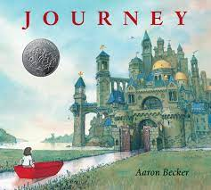

Our Wider Learning

Geography

Locate the world’s countries, using maps to focus on Europe (including the location of Russia) and North and South America,

Name and locate counties and cities of the United Kingdom, geographical regions and their identifying human and physical characteristics, key topographical features (including hills, mountains, coasts and rivers),

Identify the position and significance of latitude, longitude, Equator, Northern and Southern Hemisphere.

Cultural Capital

New Year

Martin Luther King Day

Children’s mental health

Chinese New Year

St David’s day

World Book day International day of happiness

Easter

PSHCE

Emotional intelligence

Worries- bag of worries,

Anger- inside out

Happiness- buckets

links with music, art

Music

Termly visit from the Bolton Music service

[](https://www.bing.com/images/search?q=twitter+symbol&id=9BF3AB6F4AE14BDCE98172199FB675DAE879AF41&FORM=IQFRBA)

Follow us @PrimaryYouth