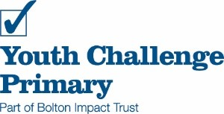

Spring term 2021

Journeys

Maths

Measure-Time

solve problems involving converting between units of time

Geometry- position and direction

Identify, describe and represent the position of a shape following a reflection or translation, using the appropriate language, and know that the shape has not changed

English

Story / Descriptions

Expanded noun phrases

Simile metaphor alliteration

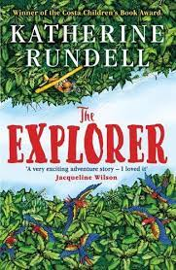

Our Wider Learning

Geography

Locate the world’s countries, using maps to focus on Europe (including the location of Russia) and North and South America,

Name and locate counties and cities of the United Kingdom, geographical regions and their identifying human and physical characteristics, key topographical features (including hills, mountains, coasts and rivers),

Identify the position and significance of latitude, longitude, Equator, Northern and Southern Hemisphere.

Cultural Capital

New Year

Martin Luther King Day

Children’s mental health

Chinese New Year

St David’s day

World Book day International day of happiness

Easter

PSHCE

Emotional intelligence

Worries- bag of worries,

Anger- inside out

Happiness- buckets

links with music, art

Music

Termly visit from the Bolton Music service

[](https://www.bing.com/images/search?q=twitter+symbol&id=9BF3AB6F4AE14BDCE98172199FB675DAE879AF41&FORM=IQFRBA)

Follow us @PrimaryYouth