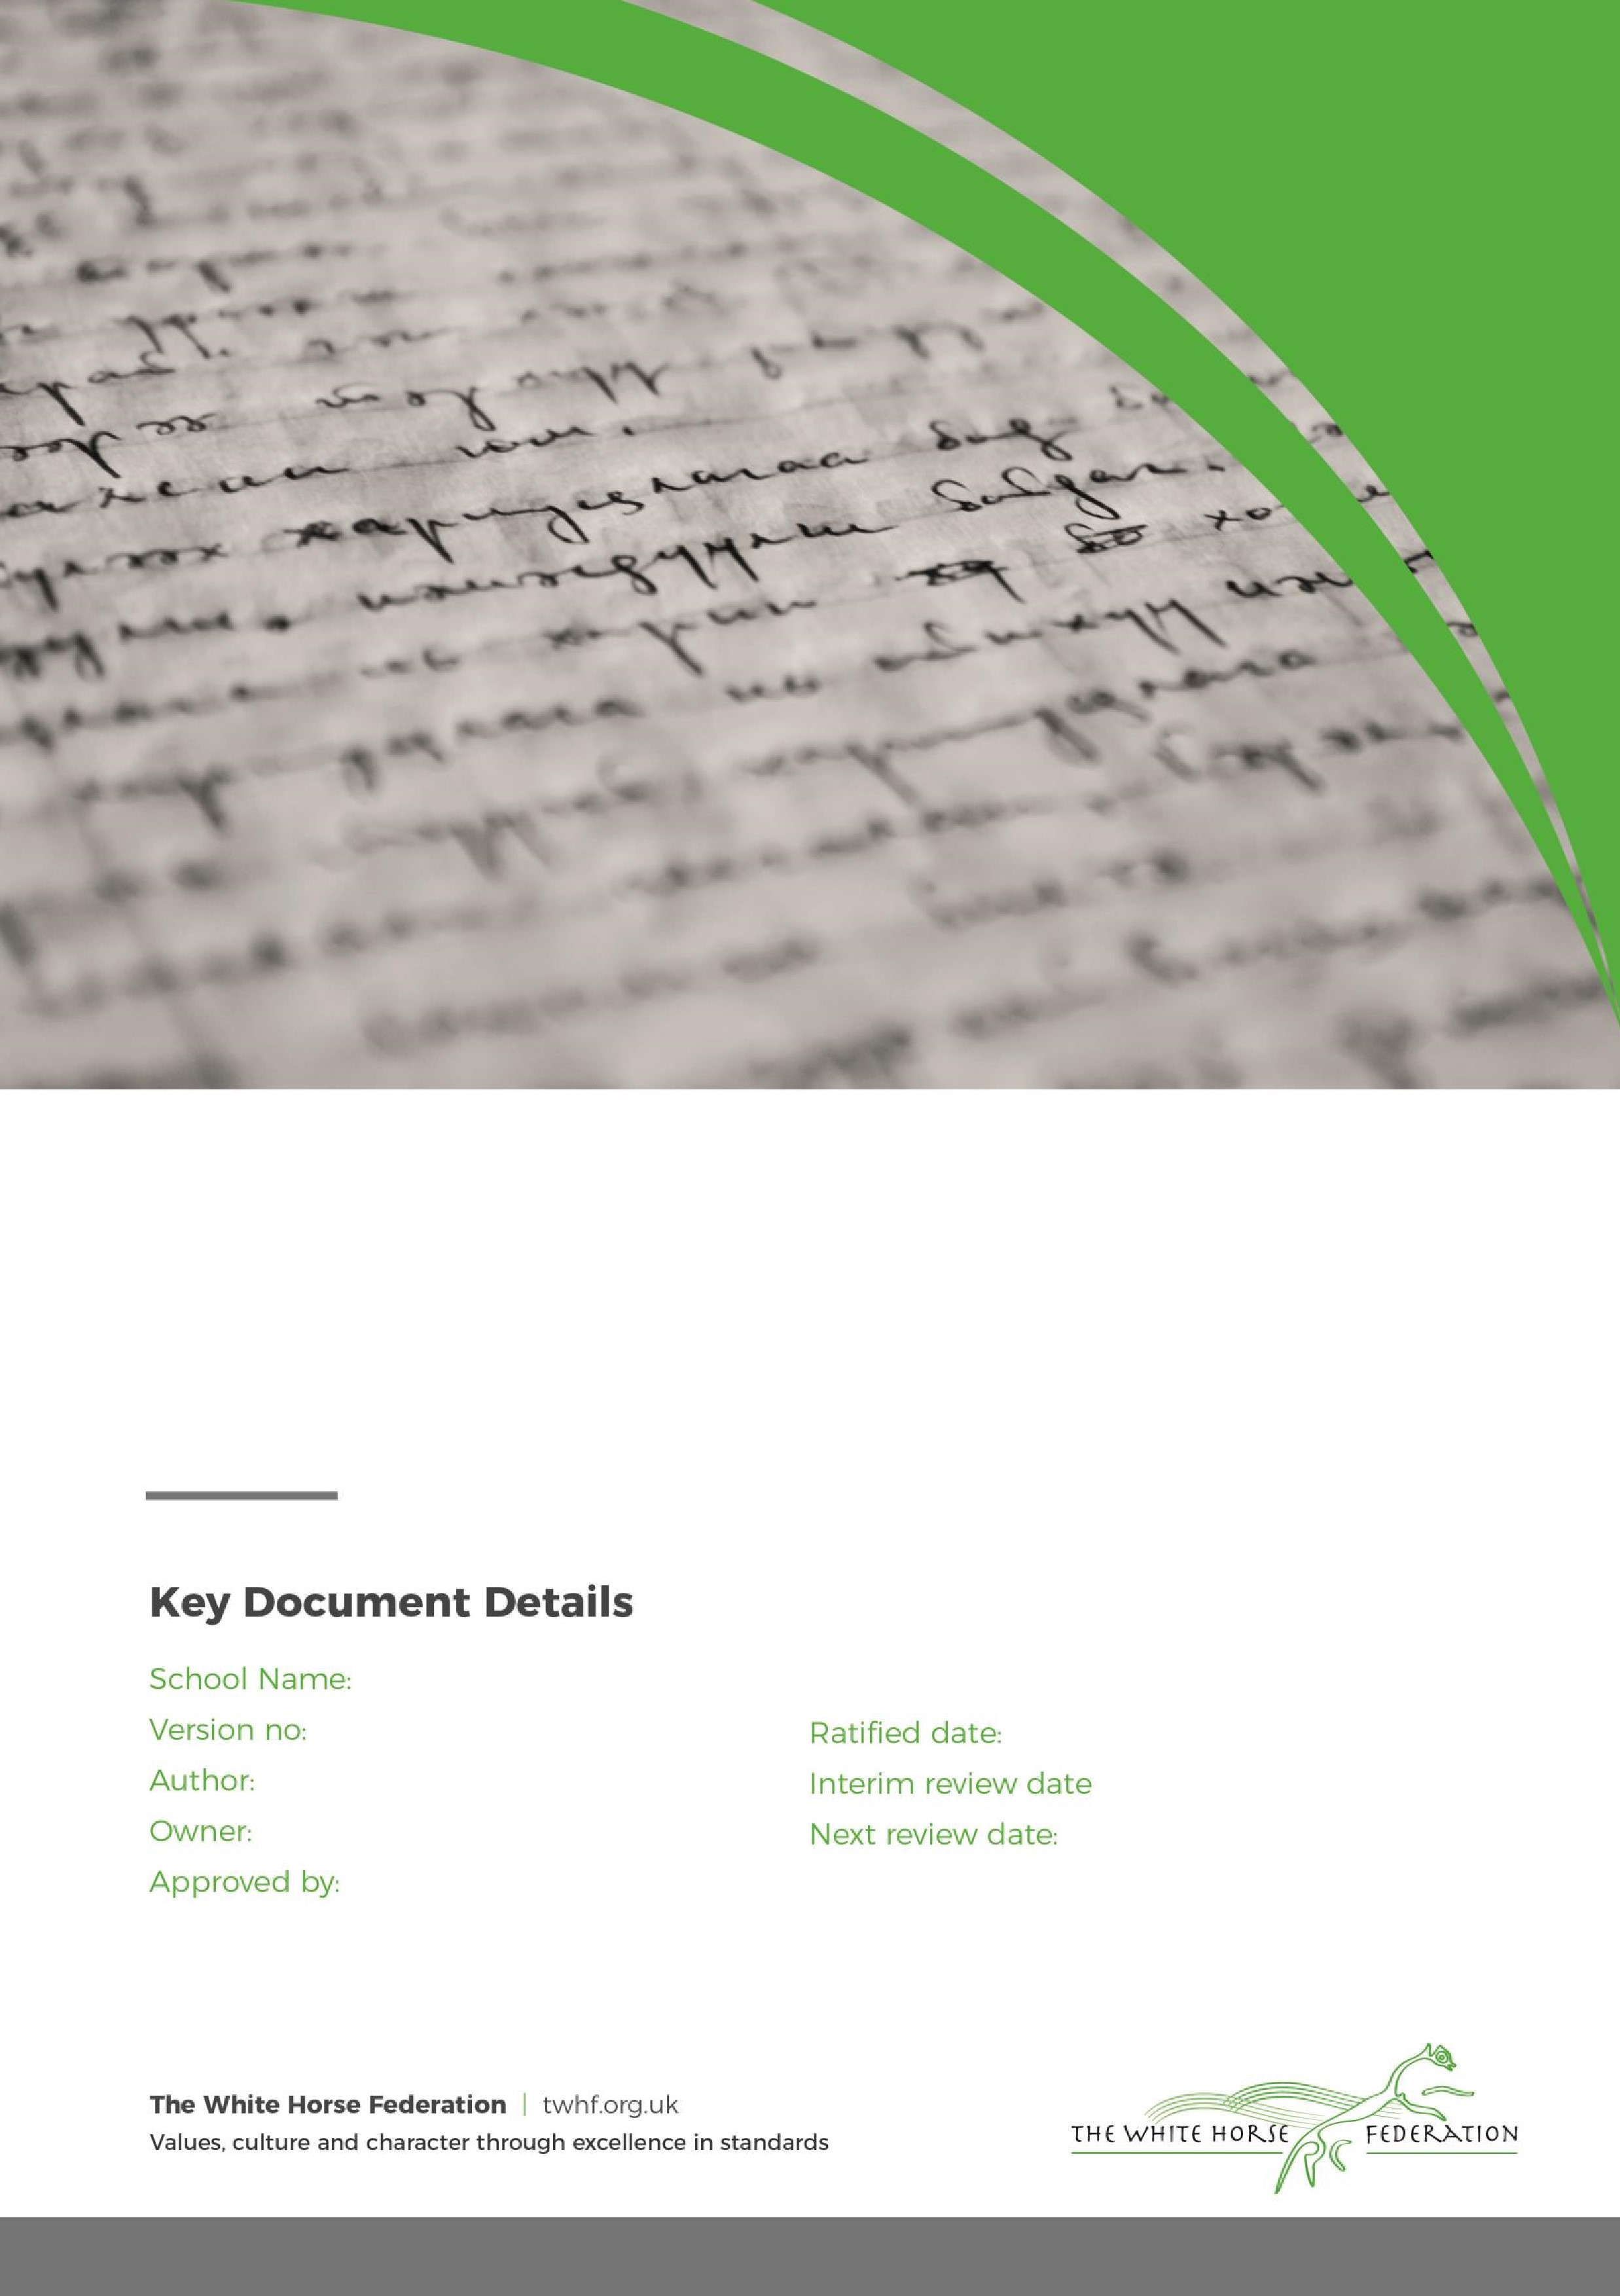

Special Education Needs (SEN)

Information Report

2

Rebecca Millard

Tim James

September 2025

September 2026

Bowerhill Primary School

April 2026

# **Dear Parents and Carers,**

The aim of this information report is to explain how we implement our SEND policy and how it works at Bowerhill. If you want to know more about our arrangements for supporting children with SEND you can find our SEND policy on the school website [Special Educational Needs and Disabilities Information | Bowerhill Primary School](https://www.bowerhill.wilts.sch.uk/about-us/school-information/send)

**Note:** If there are any terms we’ve used in this information report that you’re unsure of, you can look them up in the Glossary at the end of the report.

# **1. What types of SEN does the school provide for?**

At Bowerhill Primary School, we aim to provide an inclusive, broad and balanced curriculum for all children, including those with SEND (Special Educational Needs and/or Disability). We are a school where each child’s individuality is valued and where our aim is to inspire all children to realise and value their potential, using the 6 school values which are:

**Creativity Respect Resilience Responsibility Creativity Courage Understanding**

We have a range of systems in place for early identification of barriers to learning and participation and we set high expectations for all. Provision for children with SEN is a matter for the whole school. All teachers are teachers of children with SEN.

Our school provides for children with the following needs:

|  |  |
| --- | --- |
| **Area of need** | **Condition** |
| **Communication and interaction** | Children with Autism spectrum disorder |
| Children with a range of Speech and language difficulties |
| **Cognition and learning** | Children with moderate learning difficulties and specific learning difficulties including dyslexia and dyspraxia |
| **Social, emotional and mental health** | Children with Attention deficit hyperactive disorder (ADHD) or Attention deficit disorder (ADD) |
| Children experiencing specific anxieties |
| **Sensory and/or physical** | Children with hearing impairments |
| Children with visual impairment |

# **2. Which staff will support my child, and what training have they had?**

At Bowerhill Primary School provision for children with SEN is a matter for the whole school. All teachers are teachers of children with SEN and have the support of the SENCO to ensure good progress and attainment of all children.

All teachers are expected and committed to having a good understanding and awareness of SEND. This is achieved through on-going professional development and training. Through the school year, a number of staff training sessions are spent on SEND and new practices.

Teaching Assistants are employed to support the learning needs of all the children including targeted support for children with high needs to enable them to access a mainstream curriculum.

We also have a Pastoral team, established in September 2022. Mrs Millard is the Pastoral Lead. We have two trained Emotional Literacy Support Assistants (ELSA’s) Mr Jamie Stuart and Mrs Sam Brailey, who is also our Family Support Worker. ELSA is a national programme of staff training to support children and young people with Social, Emotional and Mental Health (SEMH) needs run by the Educational Psychology service. It supports practitioners in developing the emotional literacy and overall resiliency of vulnerable children and young people. Examples of things covered on the course are social skills, emotions, bereavement, social stories and therapeutic stories, anger management, self-esteem, counselling skills such as solution focus and friendship.

Staff have been trained in the Thrive Approach.The Thrive Approach offers a trauma-informed, [whole school](https://www.thriveapproach.com/services/whole-school-approach) approach to improving the mental health and wellbeing of children and young people. Mrs Brailey, Mr Stuart and Mrs Webber are fully trained Thrive practitioners. They have completed comprehensive training on the science behind behaviour and why children act the way they do. Licensed Practitioners have a wide range of skills to enable them to support children’s social and emotional development, build resilience and ensure they feel safe, supported and ready to learn.

Our SENCO is Rebecca Millard.

Mrs Millard has experience of working alongside others in this role and have worked as a class teacher, SENCo, and in school leadership roles in London and Wiltshire . She is a qualified teacher who completed a PGCE in Primary Education in 2002.

Mrs Millard began working towards the National Professional Qualification for SENCOs in November 2024 and will complete this in April 2026.

Mrs Millard is allocated 4 days a week, Monday to Thursday to manage SEN provision.

**Class teachers**

All of our teachers receive in-house SEN training, and are supported by the SENCO to meet the needs of children who have SEN.

Last academic year all staff received Thrive Whole School training.

Teaching assistants (TAs)

We have a team of 17 TAs, including a number of teaching assistants who are trained to deliver interventions such as SALT, ELSA and Rapid Catch Up.

External agencies and experts

Sometimes we need extra help to offer our children the support that they need. Whenever necessary we will work with external support services to meet the needs of our children with SEN and to support their families. These include:

* Speech and language therapists
* Wiltshire Specialist Special Educational Needs Service (SSENS)
* The White Horse federation SEN team (ASD/SLCN advisory teacher, Educational Psychologist, SEMH team)
* Educational psychologists
* Occupational therapists
* GPs or paediatricians
* School nurses
* Child and adolescent mental health services (CAMHS)
* Education welfare officers
* Social services and other LA-provided support services
* Voluntary sector organisations

# **3. What should I do if I think my child has SEN?**

Explain your school’s approach here. Insert details about how parents/carers can tell you that they think their child might need SEN support. Insert at what stages the child will be involved.

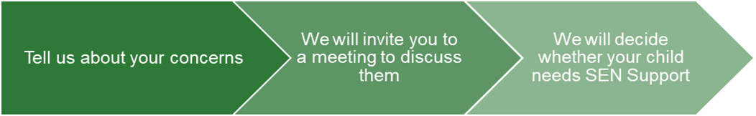

|  |  |  |
| --- | --- | --- |
| If you think your child might have SEN, the first person you should tell is your child’s teacher. You can do this by talking to them at the start or end of day, sending a message on Class Dojo or contacting them via the school office.  They will pass the message on to our SENCO, Rebecca Millard, who will be in touch to discuss your concerns.  You can also contact the SENCO  directly on 01225 700964 or at  [senco@bowerhill.wilts.sch.uk](mailto:senco@bowerhill.wilts.sch.uk) | We will meet with you to discuss your concerns and try to get a better understanding of what your child’s strengths and difficulties are.  Together we will decide what outcomes to seek for your child and agree on next steps.  We will make a note of what’s been discussed and add this to your child’s record. You will also be given a copy of this. | If we decide that your child needs SEN support, we will formally notify you in writing and your child will be added to the school’s SEND register. |

# 

# **4. How will the school know if my child needs SEN support?**

Working in partnership with teachers and parents, we identify and assess children with SEND as early as possible using the [SEND Code of Practice 2015](https://assets.publishing.service.gov.uk/media/5a7dcb85ed915d2ac884d995/SEND_Code_of_Practice_January_2015.pdf). We recognise that children make progress at different rates and not always in a linear pattern. With this in mind, children are identified as having SEND in a number of different ways. These could include:

* Transition conversations and information sharing from previous setting or school
* Children whose assessment data shows that they are working significantly below he expectations for their year group
* Conversations with, and concerns raised by parents/carers
* Concerns raised by class teacher, Teaching Assistants or anyone else who may work in school with your child

All the adults who work in school are aware of SEN and are on the lookout for any children who aren’t making the expected level of progress in their schoolwork or socially. If a teacher notices that a child is falling behind, they try to find out if the child has any gaps in their learning. If they can find a gap, they will give the child extra tuition to try to fill it. Children who don’t have SEN usually make progress quickly once the gap in their learning has been filled.

Creating this profile will include:

The SENCO observing the child in the classroom and in the playground to see what their strengths and difficulties are. They will have discussions with your child’s teacher/s, to see if there have been any issues with, or changes in, their progress, attainment or behaviour. They will also compare your child's progress and development with their peers and available national data.

The SENCO will ask for your opinion and speak to your child to get their input as well. They may also, where appropriate, ask for the opinion of external experts such as a speech and language therapist, an educational psychologist, or a paediatrician.

Based on all of this information, the SENCO will decide whether your child needs SEN support. You will be told the outcome of the decision in writing.

If your child does need SEN support, their name will be added to the school’s SEN register, and the SENCO will work with you to create a SEN support plan for them.

# **5. How will the school measure my child’s progress?**

There are robust systems in place for the SENCO to monitor the effectiveness of the school provision these include;

• Book scrutiny

• Pupil Progress meetings

• Lesson observations of all staff, including the quality of provision for SEND children

• Monitoring of planning

• Pupil profiles

* My Support Plans

• Annual reviews

• Review meetings with external professionals

* Subject leaders also monitor the delivery of their subject and the progress made.

We will follow the ‘graduated approach’ to meeting your child’s SEN needs.

The graduated approach is a 4-part cycle of **assess, plan, do, review**.

**Assess**

**If your child is not making the expected level of progress, we will make an assessment to find out what strengths and difficulties your child has.** **We will ask for you and your child’s input, as well as getting help from external professionals where necessary.**

**Review**

**We will assess how well the support we put in place helped the child to meet the outcomes we set. We will use our improved understanding of   
your child’s needs to improve the support we offer.**

**Do**

**We will put our plan into practice.**

**The class teacher, with the support of the SENCO, will be responsible for working with your child on a daily basis, and making sure the support we put in place is having the impact we intended.**

**Plan**

**In discussion with you and your child, we will decide what outcomes we are hoping to achieve. We will make a plan of the support we will offer your child to help them meet those outcomes. We will make a record of this and share it with you and all relevant school staff.**

As a part of the planning stage of the graduated approach, we will set outcomes that we want to see your child achieve.

Whenever we run an intervention with your child, we will assess them before the intervention begins. This is known as a ‘baseline assessment’. We do this so we can see how much impact the intervention has on your child’s progress. We will track your child’s progress towards the outcomes we set over time and improve our offer as we learn what your child responds to best.

This process will be continual. If the review shows a child has made progress, they may no longer need the additional provision made through SEN support. For others, the cycle will continue and the school's targets, strategies and provisions will be revisited and refined.

# **6. How will I be involved in decisions made about my child’s education?**

Class teachers hold two parent/carer Parents evening meetings during the year to discuss and share and achievements, progress, attendance, assessment outcomes and review individual targets.

In addition, parents with children on the SEN register will receive half termly updates using the graduated response, in the form of Pupil Profiles or My Support Plans. Parents of children who have an Education Healthcare Plan (EHCP) will also meet the SENCO and class teacher for an Annual Review of the provision set out by the EHCP.

These documents and meetings will

* Set clear outcomes for your child’s progress
* Review progress towards those outcomes
* Discuss the support we will put in place to help your child make that progress
* Identify what we will do, what we will ask you to do, and what we will ask your child to do
* The SENCO may also attend these meetings to provide extra support.

We value the opportunity to work closely with parents/carers as your views and aspirations for your child will be central to plans that are put in place. We know that you’re the expert when it comes to your child’s needs and aspirations. So we want to make sure you have a full understanding of how we’re trying to meet your child’s needs, so that you can provide insight into what you think would work best for your child. We also want to hear from you as much as possible so that we can build a better picture of how the SEN support we are providing is impacting your child outside of school.

If your child’s needs or aspirations change at any time, please let us know right away so we can keep our provision as relevant as possible.

After any discussion we will make a record of any outcomes, actions and support that have been agreed. This record will be shared with all relevant staff, and you will be given a copy.  If you have concerns that arise between these meetings, please contact your child’s class teacher either at the start or end of the day, by messaging on Class Dojo or via the office on 01225 700964.

# 

# **7. How will my child be involved in decisions made about their education?**

We value children’s views about how they learn best, what works for them and how they like to learn. All children will be supported to complete a One Page Profile which shares their views and aspirations and they will be invited (with your agreement) to review meetings as is appropriate for their age and developmental stage. We recognise that no 2 children are the same, so we will decide on a case-by-case basis, with your input.

**8. How will the school adapt its teaching for my child?**

Class teachers are responsible for teaching all children in a way that meets their needs. In line with the Code of Practice, there is an expectation that Quality First Teaching is the first response to meeting the needs of all children and that all children are entitled to a broad, balanced and responsive curriculum. Teachers plan the curriculum so that it is carefully differentiated to meet the needs of every child. The child is then able to learn at their own level and make the progress they need to make. Children learn in different ways and our teachers and TAs are skilled in catering for a range of learning styles. Multisensory approaches are often used and some children work on a personalised curriculum that is time bound and reviewed regularly.

Adaptive teaching to meet your children’s needs may include:

* Adapting our curriculum to make sure all children are able to access it, for example, by grouping, 1-to-1 work, adapting the teaching style or content of the lesson, etc.
* Adapting our teaching, for example, giving longer processing times, pre-teaching of key vocabulary, reading instructions aloud, etc.
* Adapting our resources and staffing
* Adapting seating arrangements and grouping in class eg groups, talk partners, mixed ability pairs etc
* Using recommended aids, such as laptops, coloured overlays, visual timetables, larger font

|  |  |  |
| --- | --- | --- |
| **Area of need** | **Condition** | **How we support these childs** |
| **Communication and interaction** | Autism spectrum disorder | Visual timetables  Social stories |
| Speech and language difficulties | Speech and language therapy |
| **Cognition and learning** | Specific learning difficulties, including dyslexia, dyspraxia and dyscalculia | Writing slope |
|
|
| Moderate learning difficulties |  |
| **Social, emotional and mental health** | ADHD, ADD | Quiet workstation  ASD strategies |
| Adverse childhood experiences and/or mental health issues | Nurture groups |
| **Sensory and/or physical** | Hearing impairment |  |
| Visual impairment | Limiting classroom displays |
| Multi-sensory impairment |  |
| Physical impairment |  |

These interventions are part of our contribution to Wiltshire Council’s local offer.

# **9. How will the school evaluate whether the support in place is helping my child?**

Provision for children with SEND is evaluated as part of the whole school improvement plan.

We will evaluate the effectiveness of provision for your child by:

* Reviewing their progress towards their goals each term
* Reviewing the impact of interventions after 6- 8 weeks
* Using child questionnaires
* Monitoring by the SENCO
* Holding an annual review (if they have an education, health and care (EHC) plans
* There are robust systems in place for the SENCO to monitor the effectiveness of the school provision these include:
* Book scrutiny
* Pupil Progress meetings
* Lesson observations of all staff, including the quality of provision for SEND children
* Monitoring of planning
* Pupil profiles
* My Support Plans
* Annual reviews
* Review meetings with external professionals
* Subject leaders monitor the delivery of their subject and the progress made.

# **10. How will the school resources be secured for my child?**

The school receives funding for children including children with Special Educational Needs and Disabilities. This funding for children with SEND covers up to £6000 of additional costs. In addition, the school can request additional funding to support higher needs pupils or children with Education Health Care Plans. The Senior Leadership Team and SENCo will discuss each child’s needs in detail and then ensure that school based provision meets the needs of each child as detailed on the EHCP.

It may be that your child’s needs mean we need to secure:

* Additional resources such as Extra equipment or facilities
* Additional adult support
* Additional learning support
* Further training for our staff
* Support from outside agencies (If this is the case, we will consult with external agencies to get recommendations on what will best help your child access their learning)

# **11. How will the school make sure my child is included in activities alongside children who don’t have SEND?**

Bowerhill Primary School is a fully inclusive school. We ensure that all children can benefit from everything that the school offers regardless of SEN or disability. Through carefully planned reasonable adjustments, all pupils are enabled to participate in all activities throughout the school day. The playground has a wide range of accessible equipment and quiet space for those children who need a quieter environment in which to socialise. All children are supported and encouraged to take part in sports day, school performances, special workshops and other events put on during and after the school day.

We have a carefully planned programme of extracurricular activities, including before and after school clubs, trips and overnight residential visits. Access to activities outside of the classroom/ school trips will be determined through a rigorous risk assessment process and school will work closely with parents and their child to enable successful participation.

# **12. How does the school make sure the admissions process is fair for children with SEN or a disability?**

# Wiltshire Council is the admissions authority for Bowerhill and we follow the county admissions policy for community schools. Our admissions policy can be found [here](https://www.bowerhill.wilts.sch.uk/about-us/admissions).

# **13. How does the school support children with disabilities?**

As a school we are committed, to and passionate about ensuring that children with physical or sensory disabilities and impairments are treated are not treated less favourably than others. It is part of our school values to ensure that all children regardless of need are treated with equity to ensure they can successfully access all aspects of school life

When a child has a particular need e.g. wheelchair access, use of auditory aids, adaptations for visual needs, the school makes reasonable adjustments to ensure that the barriers to learning or physical environment are addressed and the child’s needs are met. This will include seeking support from professionals such as occupational therapists, physiotherapists, hearing impairment service etc. These services are able to provide physical equipment to ensure all a child’s needs can be met in school.

Staff also receive training to manage medical conditions as and when needed. For example, administration of medications, EpiPens or supporting children with diabetes.

# **14. How will the school support my child’s mental health and emotional and social development?**

We are a fully inclusive school and all staff are passionate about the wellbeing of each child. We have a strong pastoral team who work together with the wider staff team to ensure the wellbeing of all children. Our school values encompass and encourage those we strive to inspire in the children. Our behaviour ladder sets out the expectations of behaviour and this is modelled and used throughout the school by all members of staff. Health, safety and wellbeing are also taught through lessons and assemblies. Continuous support, care and guidance in class and around school may also include:

* PSHE curriculum
* Fully inclusive school where every child matters
* Enrichment activities (clubs, activities, residential trips)
* Medical care plans/Intimate care plans
* Some staff are trained in Mental First Aid
* Some staff are trained Thrive practitioners and ELSAs who can offer social, emotional and mental health support to children
* Some staff are trained in positive physical intervention (Team Teach). Any physical intervention is recorded appropriately according to safeguarding and LA guidelines and is reported to parents. Physical intervention is a last resort in order to maintain the safety of a child and other around them. It is always deemed to be reasonable and proportionate to the circumstances they were intended to prevent. Childs with SEN are encouraged to be part of the school council

**15. What support will be available for my child as they transition between classes or settings, or in preparing for adulthood?**

Between years

To help children with SEND be prepared for a new school year we:

* Ask both the current teacher and the next year’s teacher to meet to discuss all children in the class and hand over strategies that have worked to support children with SEND.
* Schedule time with the incoming teacher towards the end of the summer term

Between schools

Transition meetings start between school and pre schools/nurseries prior to the children starting in Reception. Visits are made by the SENCO to support children with EHCPs in their transitions in to school. At these meetings we will check banding and funding, write any necessary plans and look at how best to deploy staff. There is a bespoke pathway for children coming into school, dependent on their need, recognising the strength of parental knowledge and the information they can share. We believe parental views are essential in this process. Children are invited to visit the school with their parents at least once before their start date.

If a child moves to or from another school, we will closely liaise with the transitioning school to ensure there is a sound knowledge of the child’s needs and attainment as well as sharing important documents securely.

**Between phases**

Our Year 6 children have a structured transition to Year 7. The SENCO meets with the receiving school’s SENCO and discusses the needs of the children. Paperwork is shared securely. We have several visits to the new school during the summer term. For children with SEND, arrangements are made between us and the secondary school about which children would benefit from extra transition sessions within a smaller group. For children with Education Healthcare Plans, the transitional review takes place in Year 5 and possible school options are discussed.

* Out Year 6 teachers will also prepare children for their transition to secondary school by:
* Practising with a secondary school timetable
* Learning how to get organised independently
* Plugging any gaps in knowledge

# **16. What support is in place for looked-after and previously looked-after children with SEN?**

Chris Light (Headteacher, DDSL) is the designated teacher for Looked After children. Mrs Light will work with Rebecca Millard, our SENCO, to make sure that all teachers understand how a looked-after or previously looked-after child’s circumstances and their SEN might interact, and what the implications are for teaching and learning.

Children who are looked-after or previously looked-after will be supported much in the same way as any other child who has SEND. However, looked-after children will also have a Personal Education Plan (PEP). We will make sure that the PEP and any SEN support plans or EHC plans are consistent and complement one another.

# **17. What should I do if I have a complaint about my child’s SEN support?**

We would always encourage parents/carers to firstly speak to your child’s class teacher regarding any concerns. It may be appropriate for our SENCO to join this conversation or a more formal meeting can be arranged to discuss any concerns. At all times, the staff will help to resolve a problem. If you feel this has not resolved your concerns, please refer to Mr Light, the Headteacher, and the school’s complaints policy. [The White Horse Federation Complaints Procedure](https://www.bowerhill.wilts.sch.uk/about-us/school-information/policies-procedures)

If you are not satisfied with the school’s response, you can escalate the complaint. In some circumstances, this right also applies to the child themselves.

To see a full explanation of suitable avenues for complaint, see pages 246 and 247 of the [SEN Code of Practice](https://www.gov.uk/government/publications/send-code-of-practice-0-to-25).

If you feel that our school discriminated against your child because of their SEND, you have the right to make a discrimination claim to the first-tier SEND tribunal. To find out how to make such a claim, you should visit: <https://www.gov.uk/complain-about-school/disability-discrimination>

You can make a claim about alleged discrimination regarding:

* Admission
* Exclusion
* Provision of education and associated services
* Making reasonable adjustments, including the provision of auxiliary aids and services

Before going to a SEND tribunal, you can go through processes called disagreement resolution or mediation, where you try to resolve your disagreement before it reaches the tribunal.

# **18. What support is available for me and my family?**

If you have questions about SEND, or are struggling to cope, please get in touch to let us know. We want to support you, your child and your family.

To see what support is available to you locally, have a look at Wiltshire Council’s local offer. Wiltshire Council publishes information about the local offer on their website: [Local Offer](https://localoffer.wiltshire.gov.uk/)

Our local special educational needs and disabilities information advice and support services (SENDIASS) organisations are:

[Wiltshire SENDIASS](https://family-action.org.uk/services/wiltshire-sendiass/)

Local charities that offer information and support to families of children with SEND are:

[Wiltshire Parent Carer Council](https://www.wiltshireparentcarercouncil.co.uk/en/Home_Page)

National charities that offer information and support to families of children with SEND are:

* [IPSEA](https://www.ipsea.org.uk/)
* [SEND family support](https://sendfs.co.uk/)
* [NSPCC](https://www.nspcc.org.uk/keeping-children-safe/support-for-parents/)
* [Family Action](https://www.family-action.org.uk/what-we-do/children-families/send/)
* [Special Needs Jungle](https://www.specialneedsjungle.com/)

# **19. Glossary**

* **Access arrangements** – special arrangements to allow children with SEND to access assessments or exams
* **Annual review** –an annual meeting to review the provision in a child’s EHC plan
* **Area of need** – the 4 areas of need describe different types of needs a child with SEND can have. The 4 areas are communication and interaction; cognition and learning; physical and/or sensory; and social, emotional and mental health needs.
* **CAMHS** – child and adolescent mental health services
* **Adapt** – when teachers adapt how they teach in response to a child’s needs
* **EHC needs assessment** – the needs assessment is the first step on the way to securing an EHC plan. The local authority will do an assessment to decide whether a child needs an EHC plan.
* **EHC plan** –an education, health and care plan is a legally-binding document that sets out a child’s needs and the provision that will be put in place to meet their needs.
* **First-tier tribunal/SEND tribunal** – a court where you can appeal against the local authority’s decisions about EHC needs assessments or plans and against discrimination by a school or local authority due to SEND
* **Graduated approach** – an approach to providing SEN support in which the school provides support in successive cycles of assessing the child’s needs, planning the provision, implementing the plan, and reviewing the impact of the action on the child
* **Intervention** – a short-term, targeted approach to teaching a child with a specific outcome in mind
* **Local offer** – information provided by the local authority which explains what services and support are on offer for children with SEN in the local area
* **Outcome** – target for improvement for children with SEND. These targets don't necessarily have to be related to academic attainment
* **Reasonable adjustments** – changes that the school must make to remove or reduce any disadvantages caused by a child’s disability
* **SENCO** – the special educational needs co-ordinator
* **SEN** – special educational needs
* **SEND** – special educational needs and disabilities
* **SEND Code of Practice** – the statutory guidance that schools must follow to support children with SEND
* **SEN information report** – a report that schools must publish on their website, that explains how the school supports children with SEN
* **SEN support** – special educational provision which meets the needs of children with SEN
* **Transition** – when a child moves between years, phases, schools or institutions or life stages