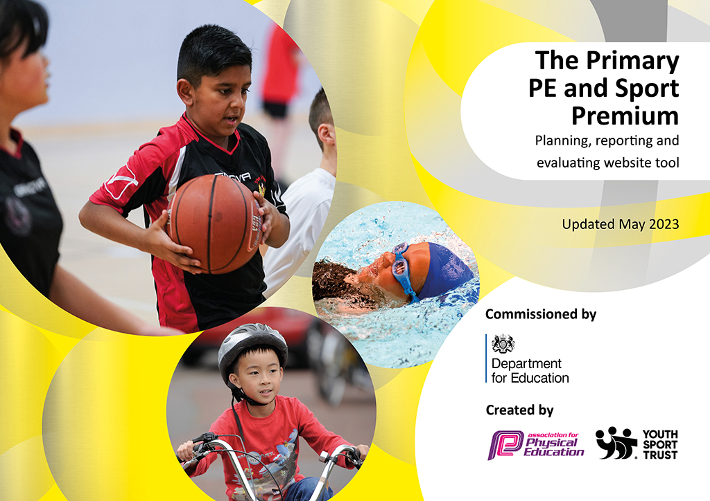
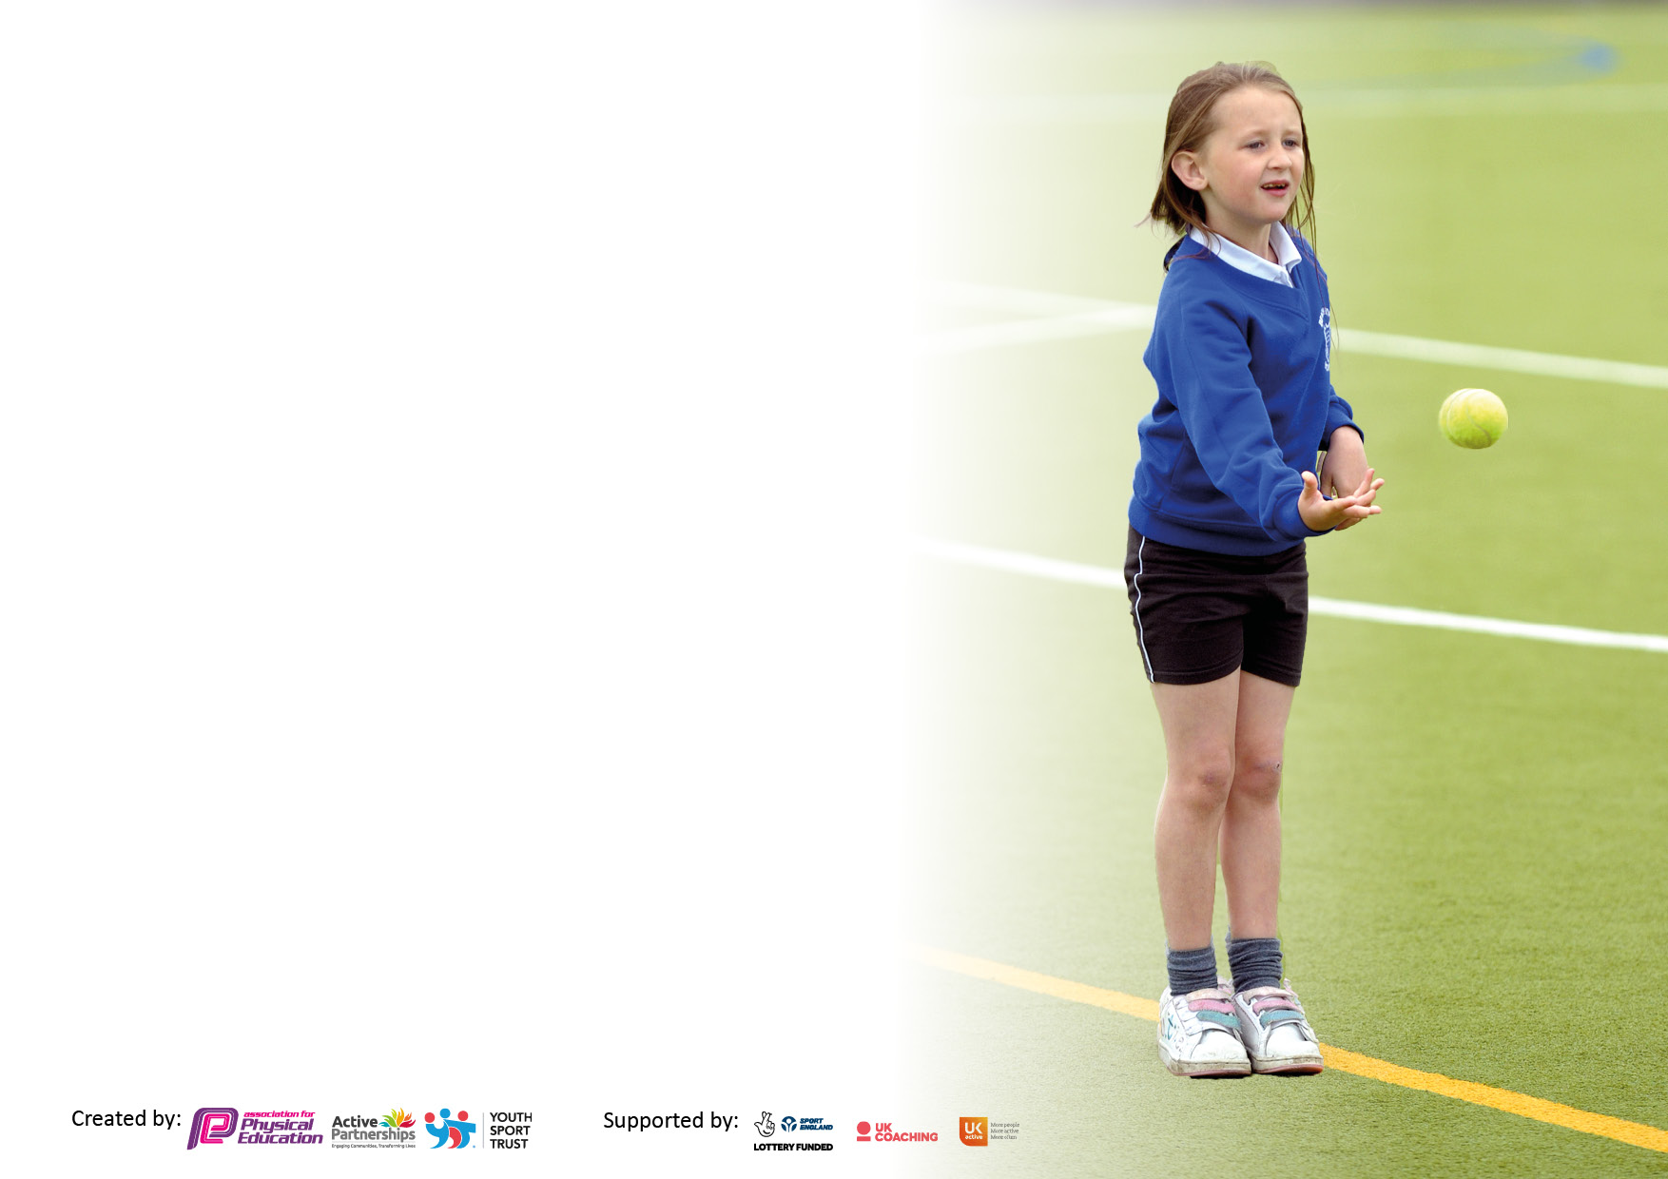

It is important that your grant is used effectively and based on school need. The Education Inspection Framework makes clear there will be a focus on ‘whether leaders and those responsible for governors all understand their respective roles and perform these in a way that enhances the effectiveness of the school’.

Under the Quality of Education Ofsted inspectors consider:
Intent - Curriculum design, coverage and appropriateness
Implementation - Curriculum delivery, Teaching (pedagogy) and Assessment
Impact - Attainment and progress

To assist schools with common transferable language this template has been developed to utilise the same three headings which should make your plans easily transferable between working documents.

Schools must use the funding to make additional and sustainable improvements to the quality of Physical Education, School Sport and Physical Activity (PESSPA) they offer. This means that you should use the Primary PE and sport premium to:

- Develop or add to the PESSPA activities that your school already offer
- Build capacity and capability within the school to ensure that improvements made now will benefit pupils joining the school in future years
- The Primary PE and sport premium should not be used to fund capital spend projects; the school’s budget should fund these.

Pleasevisitgov.ukfortherevisedDfEguidanceincludingthe5keyindicatorsacrosswhichschoolsshoulddemonstrate animprovement.Thisdocumentwillhelpyoutoreviewyourprovisionandtoreportyourspend.DfEencouragesschools to use this template as an effective way of meeting the reporting requirements of the Primary PE and Sport Premium.

We recommend you start by reflecting on the impact of current provision and reviewing the previous spend.

Schools are required to publish details of how they spend this funding, including any under-spend from 2021/2022, as well as on the impact it has on pupils’ PE and sport participation and attainment. All funding must be spent by 31st July 2023.

We recommend regularly updating the table and publishing it on your website throughout the year. This evidences your ongoing self-evaluation of how you are using the funding to secure maximum, sustainable impact. Final copy must be posted on your website by the end of the academic year and no later than the 31st July 2023. To see an example of how to complete the table please click HERE.

Details with regard to funding
Please complete the table below.

Total amount carried over from 2021/22 | £0
Total amount allocated for 2021/22 | £33,537
How much (if any) do you intend to carry over from this total fund into 2022/23? | £0
Total amount allocated for 2022/23 | £19,570
Total amount of funding for 2023/23. To be spent and reported on by 31st July 2023. | £ 19,112.48
Swimming Data
Please report on your Swimming Data below.

Meeting national curriculum requirements for swimming and water safety.

N.B. Complete this section to your best ability. For example you might have practised safe self-rescue techniques on dry land which you can then transfer to the pool when school swimming restarts.
Due to exceptional circumstances priority should be given to ensuring that pupils can perform safe self rescue even if they do not fully meet the first two requirements of the NC programme of study
What percentage of your current Year 6 cohort swim competently, confidently and proficiently over a distance of at least 25 metres?  N.B. Even though your pupils may swim in another year please report on their attainment on leaving primary school at the end of the summer term 2022.  Please see note above | 43/60
What percentage of your current Year 6 cohort use a range of strokes effectively [for example, front crawl, backstroke and breaststroke]?  Please see note above | 43/60
What percentage of your current Year 6 cohort perform safe self-rescue in different water-based situations? | 53/60
Schools can choose to use the Primary PE and sport premium to provide additional provision for swimming but this must be for activity over and above the national curriculum requirements. Have you used it in this way? | Yes

Action Plan and Budget Tracking
Capture your intended annual spend against the 5 key indicators. Clarify the success criteria and evidence of impact that you intend to measure to evaluate for pupils today and for the future.

Academic Year: 2022/23 | Total fund allocated: 20,060 | Date Updated:17/7/23
Key indicator 1: The engagement of all pupils in regular physical activity – Chief Medical Officers guidelines recommend that primary school pupils undertake at least 30 minutes of physical activity a day in school |  |  |  | Percentage of total allocation:
 |  |  |  | 19%
Intent | Implementation |  | Impact
Your school focus should be clear what you want the pupils to know and be able to do and about  what they need to learn and to  consolidate through practice: | Make sure your actions to achieve are linked to your intentions: | Funding allocated: | Evidence of impact: what do pupils now know and what can they now do? What has changed?: | Sustainability and suggested next steps:
Overall aim: All children to be able to swim 25m by the end of year 6,  Majority of children are able to swim 25m by the end of year 3.  Year 6 pupils will know basic lifesaving and water safety skills.  Engagement in physical exercise both during and after school will increase.  Increase the variety of sports being taught to pupils.  Wider range of activities during playtimes and lunchtimes. | Weekly swimming lessons taught for KS2 pupils with targeted top ups for year 4, 5 and 6.  Swimming coaches plan and prepare sessions to provide high quality teaching of swimming to all KS2 pupils.  Water safety sessions completed with all KS2 pupils by experienced coaches.  An increase in clubs and activities run by school staff and professional coaches.  Sports festival to build relationships with local clubs and increase the opportunities that children have to try new sports.  Independent clubs have begun running afterschool clubs at school.  Development of PE curriculum with wider variety of sports.  Use of professional coaches to teach different sports.  MDSA’s have worked with sports coaches to play simple games and activities.  SLT leading lunchtime games, including basketball. | £2270.40 on lessons for pupils in year 4, 5 and 6.  £2842.88 | Number of children able to swim 25m by the end of year 6: 43/60  Number of children able to swim 25m by the end of year 3: 18/60  Participation in clubs increased from 7% to 52% this year. This includes 62% of the children who obtain pupil premium funding.  Additional coaching provided to pupils including basketball, volleyball and taekwondo.  Trial of new schemes to improve variety of sports and activities.  Use of games organized by MDSA’s. | Only children in year 3 and 6 to attend swimming each year.  Increase participation in extra curricular activities to 75% of pupils.  Getset4pe invested in for increased variety of activities and sports.  CPD provided to increase understanding of PE planning and use of tools on Getset4pe.  Play leaders re-established.
Key indicator 2: The profile of PESSPA being raised across the school as a tool for whole school improvement |  |  |  | Percentage of total allocation:
 |  |  |  | 3%
Intent | Implementation |  | Impact
Your school focus should be clear what you want the pupils to know and be able to do and about  what they need to learn and to  consolidate through practice: | Make sure your actions to achieve are linked to your intentions: | Funding allocated: | Evidence of impact: what do pupils now know and what can they now do? What has changed?: | Sustainability and suggested next steps:
Subscription to Primary planning  www.thepehub.co.uk  Development of school sports clubs and opportunities to compete.  The raise the profile of PE and physical activity amongst the school. | Staff have access to high quality PE planning in multiple different sports and activities.  Encouragement of new clubs. Sign up to competitions with clear aims.  Target least active children and PPG pupils to take part in sports clubs. | £455  £0 | More competitions attended. A wide variety of children have attended including children with SEND and PP funding. | Movement to another PE scheme with a wider variety of activities and skills and a more user friendly interface.  Clear use of visual aids to make lessons clear and structured.  In September promote playground clubs that play leaders can run.  Begin running lunchtime clubs such as skipping to support pupils at lunchtimes and breaktimes.  Attend Play leaders training to set up and integrate a new team of play leaders.

Key indicator 3: Increased confidence, knowledge and skills of all staff in teaching PE and sport |  |  |  | Percentage of total allocation:
 |  |  |  | 50%
Intent | Implementation |  | Impact
Your school focus should be clear | Make sure your actions to | Funding | Evidence of impact: what do | Sustainability and suggested
what you want the pupils to know | achieve are linked to your | allocated: | pupils now know and what | next steps:
and be able to do and about | intentions: |  | can they now do? What has
what they need to learn and to |  |  | changed?:
consolidate through practice:
Sports Coach, (PH Sports)  Wiltshire School of Gymnastics (WSOG)  Dance CPD | To provide 2 weekly sessions with classes. This is high quality, specialized sports provision. Sports Coaches will be available during the day to support staff in teaching of PE and school sports where needed. Staff to develop teaching and learning skills and more accurate assessments. SEND children to be supported during sessions.  Each class from year 2-6 to partake in 5, 1-hour sessions at WSOG. Staff to shadow gymnastic coaches to build confidence and knowledge in teaching gymnastics.  Active Trowbridge to support with developing and choreographing a dance routine. | £5,685.75  £3750  £26.25 for CPD. £83.08 for class cover. | Staff have worked closely this PH sports. PH sports have set personal targets with staff to improve confidence in teaching a wider variety of sports. Teachers have improved in confidence and are able to teach using new skills learnt through CPD.  Staff have shadowed professional coaches and bring this into school gymnastics lessons. Confidence in teaching gymnastics have improved.  Attending and performing Bath Forum in front of an audience. | Clearer progression of skills and new assessment system being developed for next year. This will allow development to be tracked more clearly.  Continued partnership with WSOG.  To continue with dance clubs to perform again next year.
Key indicator 4: Broader experience of a range of sports and activities offered to all pupils |  |  |  | Percentage of total allocation:
 |  |  |  | 12%
Intent | Implementation |  | Impact
Your school focus should be clear | Make sure your actions to | Funding | Evidence of impact: what do | Sustainability and suggested
what you want the pupils to know | achieve are linked to your | allocated: | pupils now know and what | next steps:
and be able to do and about | intentions: |  | can they now do? What has
what they need to learn and to |  |  | changed?:
consolidate through practice:
Additional achievements:  Lunchtime sports provision with qualified sports coaches.  Increased after school sports clubs.  All children to partake in sports festival and receive specialist coaching in a variety of different sports.  Develop opportunities for pupils to access community sport in order to develop social skills, leadership and communication outside of school. | Make use of equipment available at school. Increase participation in all sports including PP and SEND pupils.  To make use of volleyball, basketball, rugby and other coaches to increase participation in competitive and non-competitive sports by choice.  All pupils from year 1 to 6 to attend a world class training facility to build aspirations and provide opportunities for all children including children with SEND and PP funding.  Children to experience a wider variety of sports and build interest.  Dynamo cricket visit by Wiltshire cricket for year 3-6. Year 2 attended all stars cricket at Melksham community campus.  Dance club provided to work up to authentic outcome.  Develop links with the community through a sports festival.  West Wilts dance festival attended by year 6 pupils.  Outside organisations work within school to provide expert coaching through after school clubs. | £2527  £154.60 on new resources.  £150 | 211/409 pupils have participated in a sport club including netball, cross country, athletics, dance, rugby, hockey, cricket, rounders, benchball and football.  Attending Bath Forum and performing in front of an audience.  Increase participation and confidence in pupils.  Representation of the school across the county including the Melksham area.  Wider variety of sports seen on site after school hours. | Continue to work with PH sports to provide appropriate extra-curricular activities.  Early communication to parents of upcoming extra-curricular activities.

Key indicator 5: Increased participation in competitive sport |  |  |  | Percentage of total allocation:
 |  |  |  | 16%
Intent | Implementation |  | Impact
Your school focus should be clear | Make sure your actions to | Funding | Evidence of impact: what do | Sustainability and suggested
what you want the pupils to know | achieve are linked to your | allocated: | pupils now know and what | next steps:
and be able to do and about | intentions: |  | can they now do? What has
what they need to learn and to |  |  | changed?:
consolidate through practice:
Working to ensure maximum uptake of our extra-curricular clubs to engage children in different sports.  Children to have opportunity to take part in competitive sports.  Netball matches with other schools.  Acorn Trust – School Games membership | Implementation of a variety of different activities and sports to meet a wider variety of interest.  Bath rugby coaches working with year 4 in spring term to increase participation in rugby with cross curricular links.  Football, netball, benchball, cross country, tag rugby teams created through clubs.  Begin to build relationships with schools in the local area to provide friendly sports matches. Targeting children who have not participated in competitive sports before. | £2527 PH sports cost.  £175 membership cost. | Football, tag rugby, benchball, cross country tournaments over the year in multiple year groups.  Individual friendly matches played in benchball and netball to allow a wider variety of children to participate.  Elite coaches have inspired pupils to partake in rugby. This has lead to increased participation in rugby clubs as well as competing at local events.  Significant increased in club participation in school and within the community.  Clubs from outside organisations keen to come and work with our children. | FOF football league.  Align clubs with upcoming sporting events over the year.  Focus and target children with SEND and attend appropriate events for these pupils.  Continue to work with other schools to provide friendly matches for pupils.

Signed off by
Head Teacher:
Date: | July 23
Subject Leader: | Ben Davies
Date:
Governor:
Date:

