
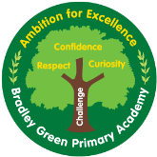
Geography Unit Plan – Year 1
What is in my local area?
Geography coverage NC | - use simple compass directions (North, South, East and West) and locational and directional language [for example, near and far; left and right], to describe the location of features and routes on a map  - use aerial photographs and plan perspectives to recognise landmarks and basic human and physical features; devise a simple map; and use and construct basic symbols in a key  - use simple fieldwork and observational skills to study the geography of their school and its grounds and the key human and physical features of its surrounding environment.
Links to previous learning | - This work will refer back to EYFS unit about our school community and local area
Links to future learning | - This will link to local area unit in Year 3
Misconceptions | - That everyone who attends Bradley Green lives in Hyde  - That everyone lives in the same type of house
Key knowledge | We live in England  We live in the north of England  There are many different parts of Hyde  School is in Newton which is one of the parts in Hyde  School is on Bradley Green Road  Maps have keys and symbols to help you to read them
Key vocabulary | terraced house – a row of 3 or more houses joined together  semi-detached house – this is 2 houses joined together  detached house – a house that is not joined to any other house  bungalow - a ground floor house with no stairs  flat/apartment - a set of rooms in a big building
Key diagrams | 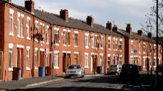  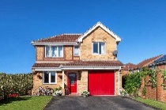  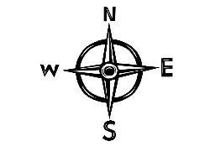  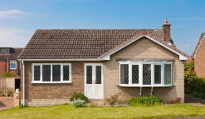  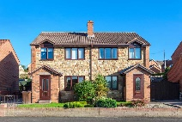  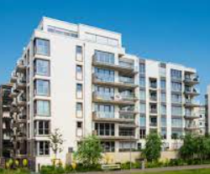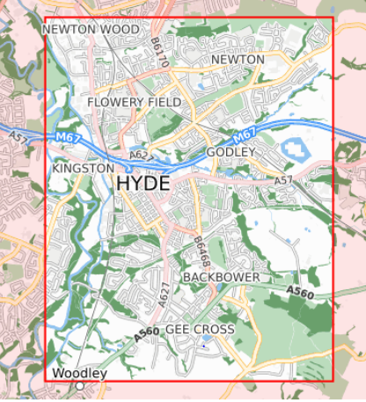
    What is my address? | Place knowledge retrieval  To name and locate the seven continents and Atlantic ocean on a map/globe.  Retrieval activity  Can you remember 4 compass points? Can you use your body to point to N, S, E and W? Can you remember they rhyme?  Can you draw the OS symbol for mountain?  Key knowledge  We live in England  We live in the north of England  Maps have keys and symbols to help you to read them  There are many different parts of Hyde  School is in Newton which is one of the parts in Hyde  Lesson plan  Show BBC Bitesize clip about maps https://www.bbc.co.uk/bitesize/topics/zqj3n9q/articles/zjd66v4  Maps can be paper and digital and you can use tools like compasses to help you find where you are going.  Prior to the lesson, have a list of children’s addresses.  You may want to do this as a whole class using IWB  Explain this is a digital map that is going to help us create a whole class map.  https://digimapforschools.edina.ac.uk/roam/map/schools  Type in school’s postcode and show children where we are located https://digimapforschools.edina.ac.uk/roam/map/schools  Select drawing tools  Marker  Teacher to place a balloon marker on School and to model how to mark a certain point.  Then can each child come and find their house? You may need to zoom in and out.  Can they add a marker to show where they live?  This needs to be saved and then added to working wall (I would say not in children’s books as it will have children’s street names of where they live).  Show a map of Hyde and show how there are many places within Hyde – Have they heard of any of these places?  Could you make a tally chart to show which places in Hyde and other areas such as Dukinfield where children live? Address the misconception that everyone who goes to Bradley Green lives in Hyde.
Teacher assessment |  | Still need more depth of learning | Shows strong understanding
Where is school? | Place knowledge retrieval  To name and locate the 4 parts that make up the UK  Retrieval activity  What is a map?  Can you name some of the places in Hyde?  Key knowledge  There are many different parts of Hyde  School is in Newton which is one of the parts in Hyde  School is on Bradley Green Road  Maps have keys and symbols to help you to read them  Lesson plan  Go onto Digimaps for Schools and add in school’s postcode and bring up the digital map.  Then press aerial photo on map selector and explain that this photograph has been taken from above. Zoom in and see if the children can find school and Bradley Green Road. What else can they see?  Show the map of Hyde and explain that school is on Bradley Green Road and it is in the Newton area of Hyde.  Use a saved and printed map from Digimaps. Using their knowledge of compass points and directional language, can children describe their route to school?
Teacher assessment |  | Still need more depth of learning | Shows strong understanding
  What is in my local area? | Place knowledge retrieval  Which is the largest continent?  Which is the smallest continent?  What is the capital city of England?  What is the capital city of Scotland?  Retrieval activity  What are physical features?  What are human features?  Key knowledge  There are many different parts of Hyde  School is in Newton which is one of the parts in Hyde  School is on Bradley Green Road  Lesson plan  Explain to the children that we are going to take part in fieldwork activities and explore Bradley Green Road. Fieldwork is when you go outside and find out more about a place.  The children turn left from school and walk along Bradley Green Road to Talbot Road.  Identify human features in the environment. Identify lampposts, post boxes, shops, houses, roads, road signs, double yellow lines, road markings, different types of houses, door numbers.  Draw an outline of the roads but ask the children to add on the features that they notice as a class. (houses, trees, street lamps, bins, street signs)  When they get back to class the children need to draw a map of their journey. Can they recall what they saw?
Teacher assessment |  | Still need more depth of learning | Shows strong understanding
Can you draw a map with symbols and a key? | Place knowledge retrieval  What is the capital city of Northern Ireland?  What is the capital city of Wales?  Can you name the seas that are in the UK?  Retrieval activity  What is fieldwork?  Key knowledge  Maps have keys and symbols to help you to read them  Lesson plan  Go onto Digimaps for Schools and add in school’s postcode and bring up the digital map. Then zoom out to show OS symbols, recall mountain symbol from UK unit.  Symbols  Show OS symbols of Sch for school, flag for golf course, cross for Church, PO for Post Office.  Then in groups, children to look at a paper OS map. Can they see any of the above symbols? There is a key on a map which tells you what the symbols mean.  Have a go at the symbols activity https://www.bbc.co.uk/bitesize/topics/zqj3n9q/articles/zjd66v4 to match the correct symbol to the correct place on the key.  Children to look at the map they drew last week. What is represented on their map?  Children to redraw their map to include a key and symbols to represent school, trees, houses, bin, lamp post. What symbol will they use for each one?
Teacher assessment |  | Still need more depth of learning | Shows strong understanding
  What is the common type of house near school? | Place knowledge retrieval  To name and locate the seven continents and Atlantic ocean on a map/globe.  Retrieval activity  What is an aerial photograph?  What is a key?  Key knowledge  terraced house – a row of 3 or more houses joined together  semi-detached house – this is 2 houses joined together  detached house – a house that is not joined to any other house  bungalow - a ground floor house with no stairs  flat/apartment - a set of rooms in a big building  Lesson plan  There are different types of houses that people live in. Address the misconception that everyone lives in the same type of house.  Use Twinkl powerpoint to show different homes – flats, terraced, semi-detached, detached, bungalow.  What type of house do they live in?  Go on a local area walk along Bradley Green Road to Talbot Road and complete some data collection on a tally chart.  On their return to school, the children need to present their information as a bar chart and identify the most common type of housing near school. What is the most common type of house near school?
Teacher assessment |  | Still need more depth of learning | Shows strong understanding

Common strengths | Common weaknesses | Notes for subject leader | Pupils who still need more depth of learning | Shows strong understanding

