

Geography Unit Plan – Year 3
What would you see in a coastal environment?
Geography coverage NC | - Describe and understand the key aspects of physical geography  - Describe and understand the key aspects of human geography  - Name and locate counties and cities of the United Kingdom, geographical regions and their identifying human and physical characteristics, key topographical features (including hills, mountains, coasts and rivers), and land-use patterns; and understand how some of these aspects have changed over time
Unit overview | This unit should study the coastal towns of the UK. They should plot these on a map and look at the distances. Which is our closest seaside town?  The children need to know that the landscape is continuously changing due to coastal erosion and look ways that this process can be slowed down. Link this to any current issues in the media.  The children need to study the positive and negative impacts of tourism on people and the environment.  They will also look at ways to stay safe on the beach and communicate this knowledge to others.  This work will link to the science unit on rocks in year 3.
Links to previous learning | Links to EYFS unit on Seaside, links to Science unit on rocks
Links to new learning | Links to tourism in Y4 and Y5
Misconceptions | That coasts and coastlines do not change
Key knowledge | The coastline of a country is forever changing due to coastal erosion  Coastal erosion cannot be stopped but we can do things to slow the process down like build seawalls and groynes  Tourism is good for places because it brings money and it gives local people jobs  Tourism can be bad for places because they can be overcrowded and this can lead to traffic jams, the jobs are seasonal, damage to the environment (Litter, habitat loss due to new buildings)
Key vocabulary | coastal erosion – where the sea wears away the land  cliff – a steep rock face  coastline – the area where the land meets the sea  seawalls – walls built with a steep face that are built along the coast  groyne – a structure built along the shoreline to interrupt the flow of water and sediment  tourists – visitors
Key diagrams | 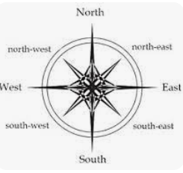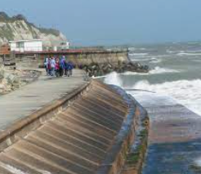  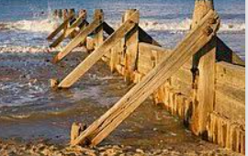
    Where are coastal towns? | Place knowledge retrieval  - New knowledge – to name and locate North American countries  Retrieval activity  - What is an OS symbol? Can you name and describe what some of the symbols look like?  Key knowledge  A coastal town is a town or village located on the coast  A coast is a place where land and sea meet  Lesson plan  Show map of coasts of UK https://www.bbc.co.uk/bitesize/topics/zttbcmn/articles/zk6fydm  Use an atlas to find New Brighton, Blackpool, Brighton, Whitby and St Andrews  Can you use compass points to describe their location?  Look for patterns. Where are they all? Why?  Use Digimaps to locate New Brighton https://digimapforschools.edina.ac.uk/roam/map/schools  What do you notice? What do you think the red, green and blue lines mean?  Red line is an a road  Green line is a primary road (dual carriage way)  Blue line is a motorway  You have to use transport to visit a coastal town  Can you see any OS symbols? Can you identify them?  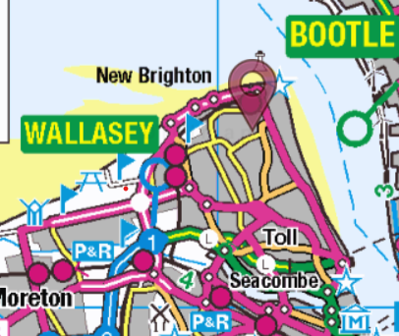
Teacher assessment | Still needs more depth of learning | Shows good understanding
  Why are coastal towns disappearing? | Place knowledge retrieval  To name and locate the 5 oceans  To name and locate North American countries  Retrieval activity  What is a coast? What is a coastal town? Can you name one?  Key knowledge  A coastal town is a town or village located on the coast  A coast is a place where land and sea meet  The coastline of a country is forever changing due to coastal erosion  Key vocabulary  Coastal erosion  Lesson plan  The children need to learn about and explain the physical process of coastal erosion – This work should link to your Science work on rocks. https://www.youtube.com/watch?v=zUh3WeilFN4  - They can then look at where in the UK there are coastal towns most at risk. Is there a pattern in the location? Why?  https://www.dailymail.co.uk/sciencetech/article-7702717/Shocking-map-shows-UK-coastal-towns-risk-wiped-20-years.html This link will then also take you to an interactive map which shows the places most at risk  - Look at news articles to bring this to life to see how peoples live are affected Norfolk July 2023 https://www.youtube.com/watch?v=0_IqKzOtFc8  - Clymping beach in Sussex https://www.youtube.com/watch?v=EENvJX2WQiE
Teacher assessment | Still needs more depth of learning | Shows good understanding
    Can we stop coastal eroison?  Will probably take 2 lessons | Place knowledge retrieval  New learning locate New Brighton, Blackpool, St, Anne’s, Isle of Wight, Cornwall, Scarborough, Brighton, Llandudno, Newquay, St Andrew’s, Morecambe, Ballycastle  Retrieval activity  How can weather affect coastal towns? What impact will that happen in the people that live there?  Key knowledge  The coastline of a country is forever changing due to coastal erosion  Coastal erosion cannot be stopped but we can do things to slow the process down like build seawalls and groynes  Key vocabulary  Seawalls  Groynes  Erosion  Lesson plan  - Address the misconception that coasts and coastlines do not change. They do due to erosion.  - Explain that we can’t stop this physical process but we can do things to try and slow it down  - https://www.youtube.com/watch?v=nujYG_b8lI8  - Look at the building of seawalls and groynes to slow the process of erosion.  - Lyme regis has a cobb cam on the cobb (sea wall) https://lovelymeregis.co.uk/webcam  - Explain how these 2 defences work and compare the two. Show Twinkl powerpoint pages 16-18
Teacher assessment | Still needs more depth of learning | Shows good understanding
Fieldwork trip to New Brighton | Key knowledge  Tourism is good for places because it brings money and it gives local people jobs  Tourism can be bad for places because they can be overcrowded and this can lead to traffic jams, the jobs are seasonal, damage to the environment (Litter, habitat loss due to new buildings)  Key vocabulary  Tourists  Lesson plan  Whilst at New Brighton look at physical and human features of a seaside (sea, sand, lighthouse, fort).  Look at the amount of people who are visiting New Brighton? It is a week day, is it a popular place for tourists?  Why might people visit New Brighton? Refer back to human and physical features  Whilst at New Brighton address if litter is a problem? Carry out a beach clean, what litter has been left on the beach? How might this affect the marine life and environment?  Please can you take photo’s so we can add this to Eco board and green flag application
Teacher assessment | Still needs more depth of learning | Shows good understanding
How do tourists impact on places?  Will probably take 2 lessons | Place knowledge retrieval  To name and locate the seven continents  Retrieval activity  What is a seawall? What is a groyne?  Key knowledge  Tourism is good for places because it brings money and it gives local people jobs  Tourism can be bad for places because they can be overcrowded and this can lead to traffic jams, the jobs are seasonal, damage to the environment (Litter, habitat loss due to new buildings)  Key vocabulary  Tourists  Lesson plan  - Watch clip comparing Giant’s causeway to Blackpool https://www.bbc.co.uk/bitesize/topics/zttbcmn/articles/zk6fydm#z7y3g7h4  - Look at Blackpool as a case study. What makes it a popular place for tourists? Identify some physical and human features using Ariel photographs and Digimaps https://digimapforschools.edina.ac.uk/roam/map/schools  - https://www.twinkl.co.uk/resource/t3-g-80-can-you-spot-blackpool-powerpoint  - Look at the positive and negative impacts of tourism on people and the environment.  - Was New Brighton popular for tourists? What attracts people to visit there?
Teacher assessment | Still needs more depth of learning | Shows good understanding
Would you like to live by the coast? | Place knowledge retrieval  Locate New Brighton, Blackpool, St, Anne’s, Isle of Wight, Cornwall, Scarborough, Brighton, Llandudno, Newquay, St Andrew’s, Morecambe, Ballycastle  Retrieval activity  How do tourists impact on a coastal town?  Lesson plan  - Children reflect upon their learning in this unit to answer the question with reasons why. Children to create a video or poster to answer the question.
Teacher assessment | Still needs more depth of learning | Shows good understanding

