Key Information
Lightening and static electricity are examples of electricity occurring naturally, but for us to use electricity to power appliances, we need to make it.

Coal, oil and natural gases are fossil fuels which, when burnt, produce heat, which can be used to generate electricity.
Electricity can be generated from wind power used to turn windmills and hydroelectric power from water used in dams. The suns rays can be converted into electricity by solar panels.
Many everyday appliances rely on electricity for them to work. Some appliances need to be plugged into a socket (mains electricity) and others may have a battery to make them work.

Electricity can only flow around a complete circuit that has no gaps. There must be wires connected to the positive and negative end of the power supply/ battery.

Switches can be used to open or close a circuit. When off, a switch breaks the circuit to stop the flow of electrons. When the switch is on, the circuit is complete and the electrons are able to flow around the circuit.

Mains electricity- power stations send an electric charge through wires to transformers and pylons. Then, underground wires carry the electricity into our homes via wires in the walls and through our plug sockets.

Battery electricity- Batteries store chemicals which produce and electric current. Eventually, even re-chargeable batteries will stop producing an electric current.
A conductor of electricity is a material that is made up of free electrons, which can be made to move in one direction, creating an electric current. Metals are good conductors. Electrical insulators have no free electrons and so no electric current can be made. Wood, plastic and glass are good insulators.

Vocabulary
Electricity - The flow of an electric current or charge through a material.

Generate- To make or produce.

Renewable- A source of electricity that will not run out. These include solar, nuclear, geothermal, hydro and wind.

Non-renewable- This source of energy will eventually run out and so will no longer be able to be be used to make electricity.
These include fossil fuels- coal, oil and natural gas.

Appliances- A piece of equipment or device designed to perform a particular job, such as washing machine or mobile phone.

Battery- A device that stores electrical energy as a chemical.

Circuit- A pathway that electricity can flow around. It includes wires, a power supply and may include bulbs, switches or buzzers.

Electrons- Small particles with an electric charge.

Key Diagrams
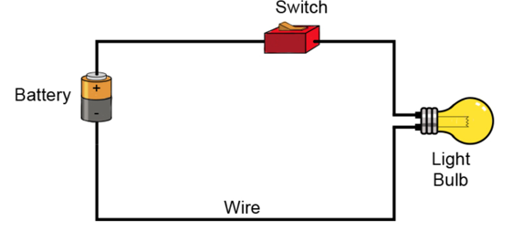
This is a simple circuit diagram

Many household appliances use electricity, which ones do you have in your homes?

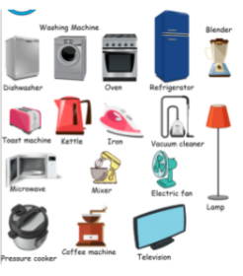
Many household appliances require electricity to work – which appliances do you have in your homes?

