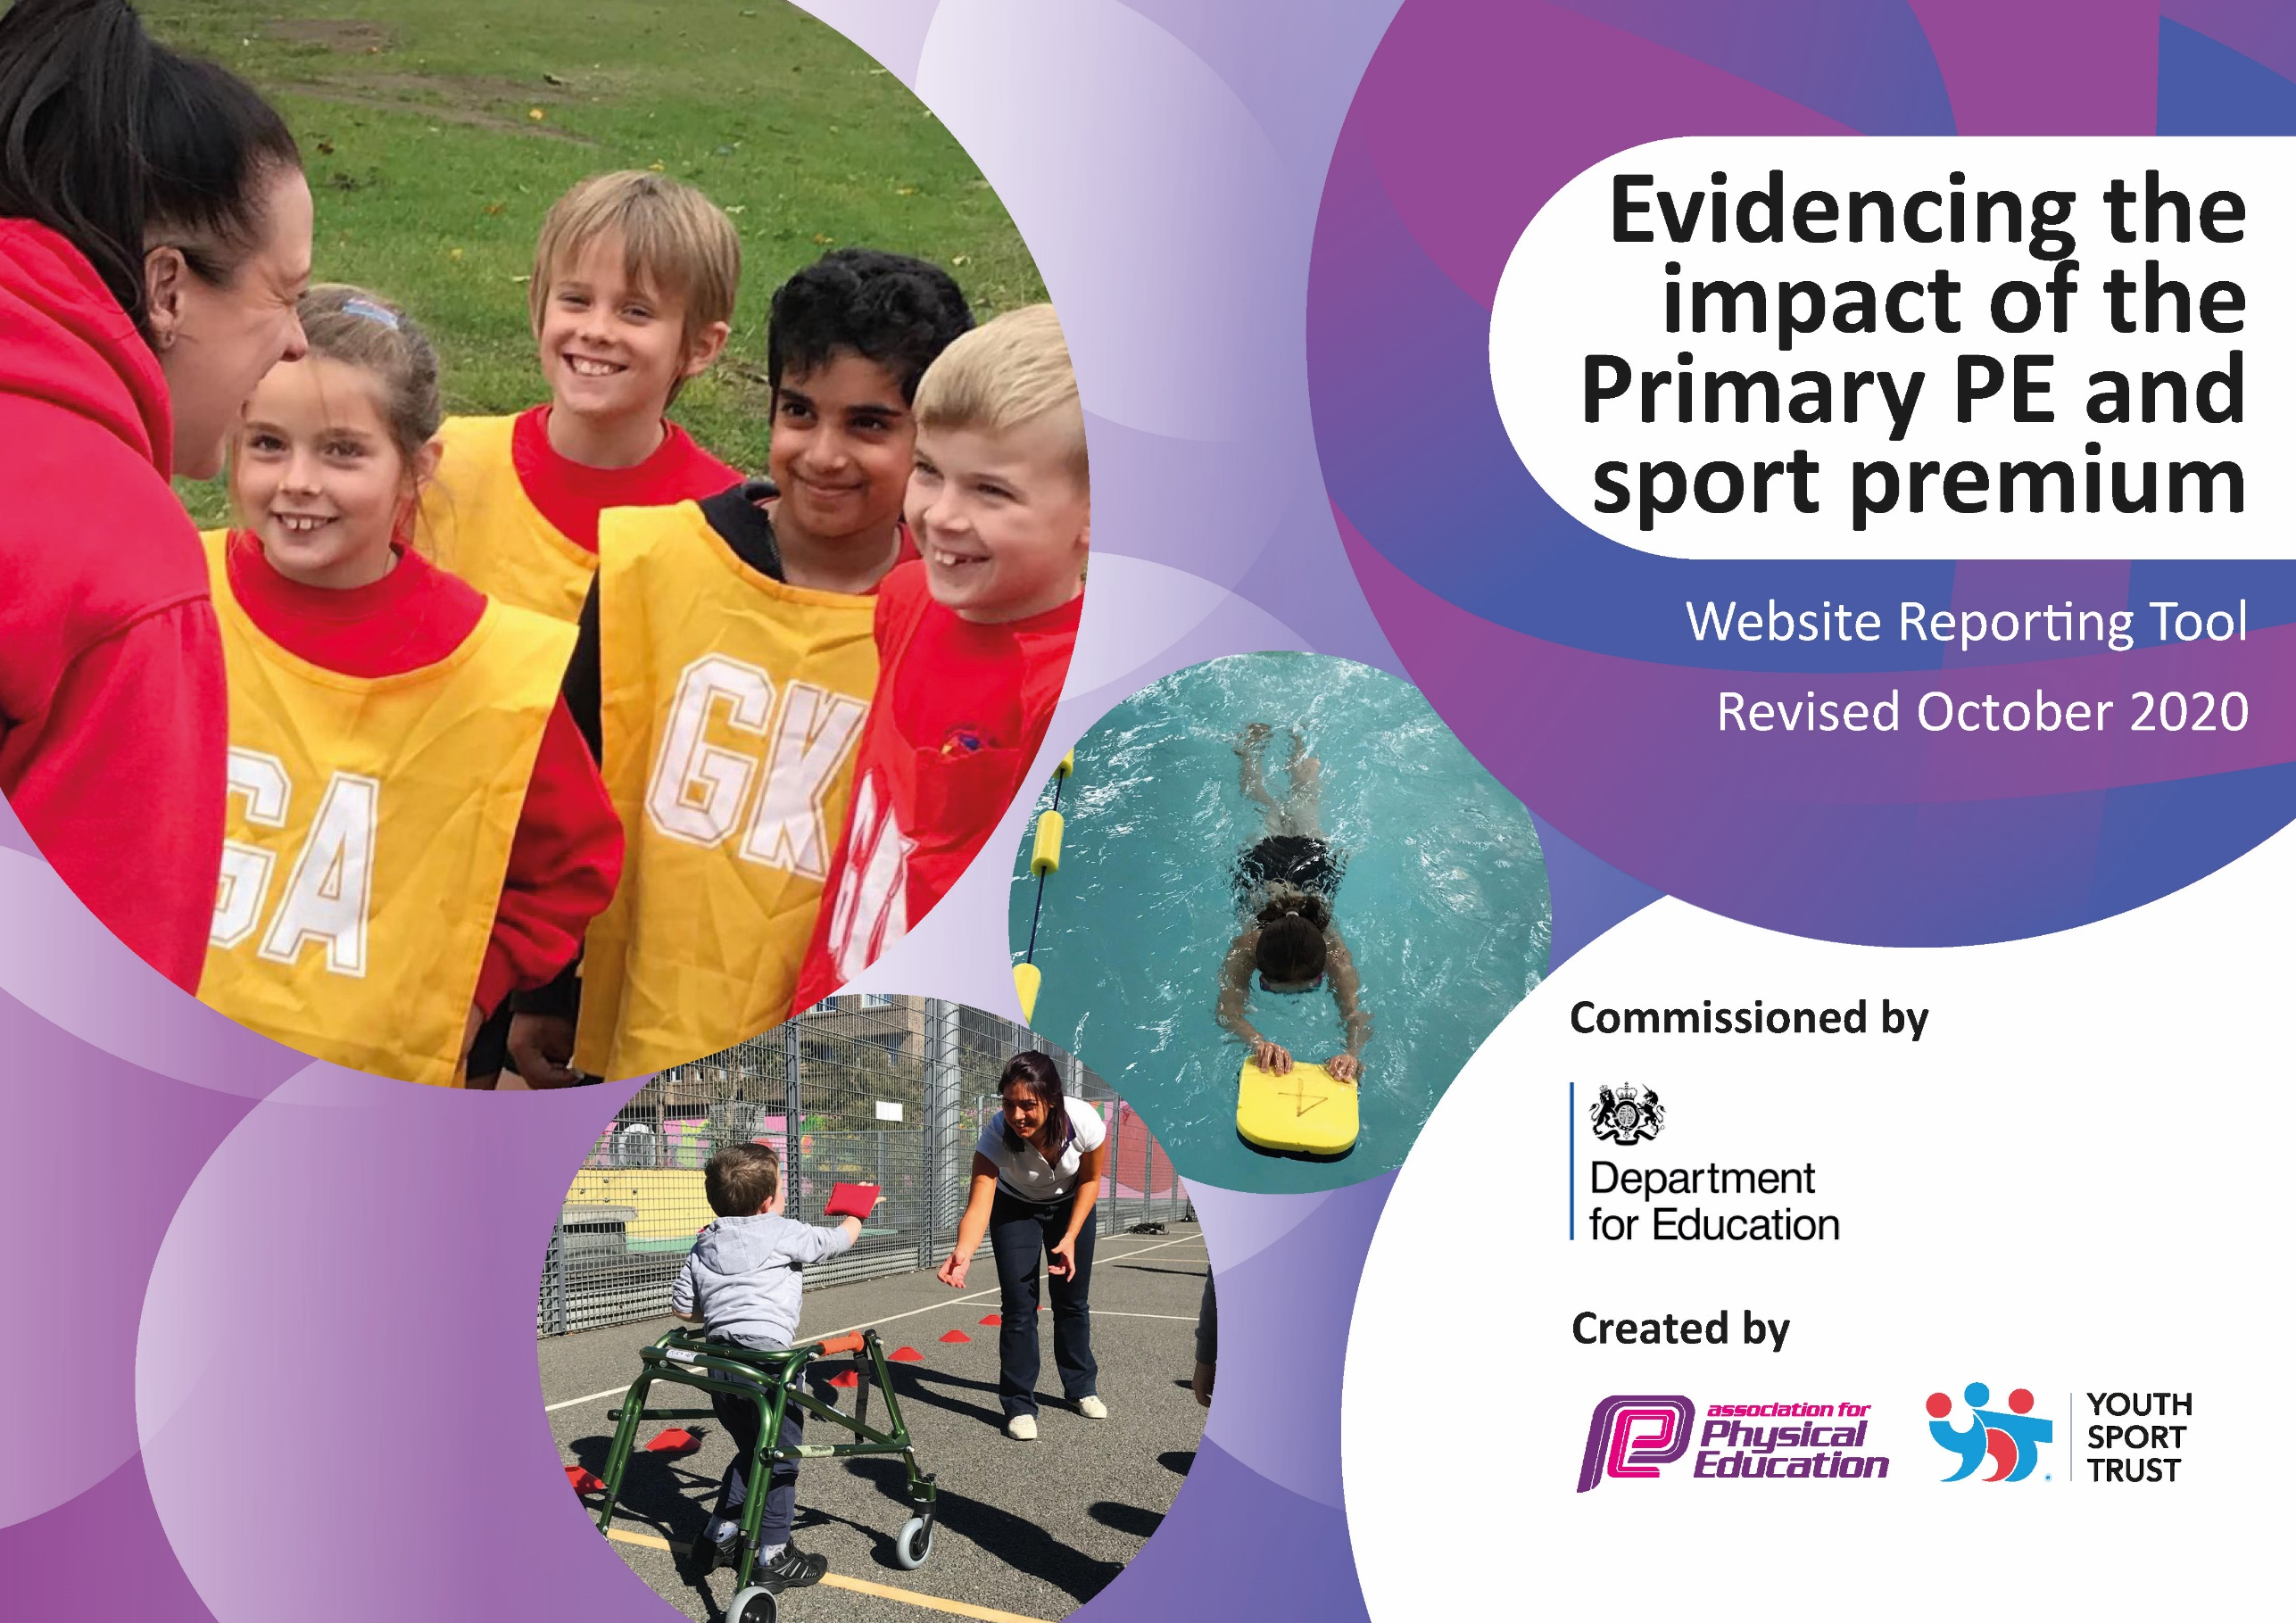
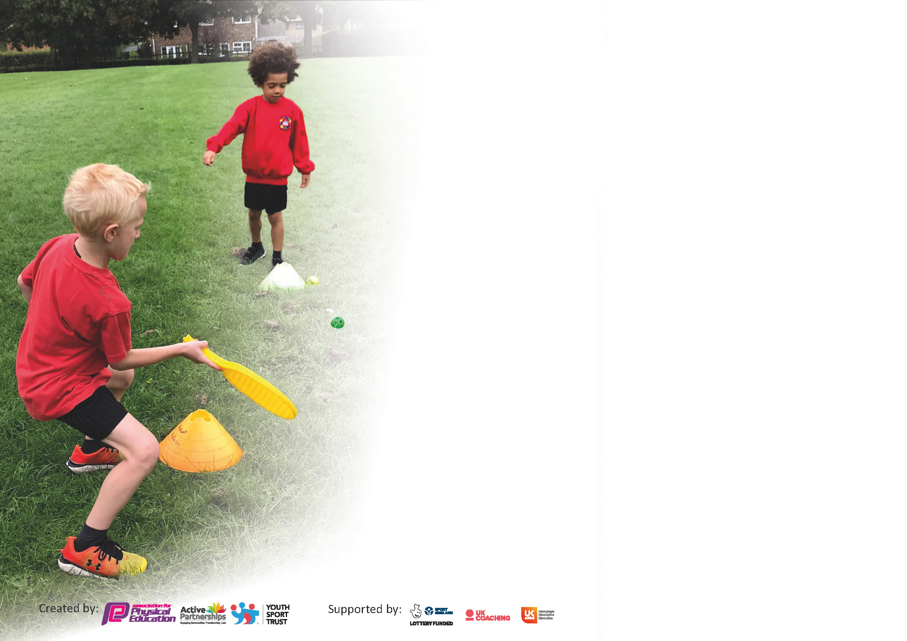

It is important that your grant is used effectively and based on school need. The Education Inspection Framework (Ofsted 2019 p64) makes clear there will be a focus on ‘whether leaders and those responsible for governors all understand their respective roles and perform these in a way that enhances the effectiveness of the school’.

Under the Quality of Education criteria (p41) inspectors consider the extent to which schools can articulate their curriculum (INTENT), construct their curriculum (IMPLEMENTATION) and demonstrate the outcomes which result (IMPACT).

To assist schools with common transferable language this template has been developed to utilise the same three headings which should make your plans easily transferable between working documents.

Schools must use the funding to make additional and sustainable improvements to the quality of Physical Education, School Sport and Physical Activity (PESSPA) they offer. This means that you should use
the Primary PE and sport premium to:

- Develop or add to the PESSPA activities that your school already offer
- Build capacity and capability within the school to ensure that improvements made now will benefit pupils joining the school in future years

Please visit gov.uk for the revised DfE guidance including the 5 key indicators across which schools should demonstrate an improvement. This document will help you to review your
provision and to report your spend. DfE encourages schools to use this template as an effective way of meeting the reporting requirements of the Primary PE and sport premium.

We recommend you start by reflecting on the impact of current provision and reviewing the previous spend.

Schools are required to publish details of how they spend this funding as well as on the impact it has on pupils’ PE and sport participation and attainment by the end of the summer term or by 31st July 2021 at the latest.

** In the case of any under-spend from 2019/20 which has been carried over this must be used and published by 31st March 2021.

We recommend regularly updating the table and publishing it on your website throughout the year. This evidences your ongoing self-evaluation of how you are using the funding to secure maximum, sustainable impact. Final copy must
be posted on your website by the end of the academic year and no later than the 31st July 2021. To see an example of how to complete the table please click HERE.
Created by: Supported by:

Bradley Green Primary Academy
Sport Premium Funding 2020-21

During the school year of 2020-21 the school will have received £17,700 to improve the quality of sport, health and PE provision at Bradley Green Primary Academy. Our aim is to create a culture that encourages all children to be active and have positive attitudes towards sport, physical activity and healthy lifestyles.

The funding will develop the delivery of PE, sport and health awareness in school, which includes:
1. The engagement of all pupils in regular physical activity – kick-starting healthy, active lifestyles
2. The profile of PE and sport being raised across the school as a tool for whole school improvement
3. Increased confidence, knowledge and skills of all staff in teaching PE and sport
4. Broader experience of a range of sports and activities offered to all pupils
5. Increased participation in competitive sport
6. Improve the general health and mental well-being of children in school
Sustainability & Monitoring
We will monitor the Sports Premium Funding in conjunction with the Sainsbury’s School Games Mark, so we can evaluate and assess the impact that this funding is having across the school. In addition, the Sports Leader in Bradley Green will perform recurring checks on the impact of the Sports Premium Action Plan. In achieving the aims set forward here and with reference to the Sainsbury’s School Games Mark, Bradley Green Primary Academy will have a sustainable and effective sports programme.

Please note: Although there has been considerable disruption in 2020 it is important that you publish details on your website of how you spend the funding - this is a legal requirement.
Support for review and reflection - considering the 5 key indicators from DfE, what development needs are a priority for your setting and your pupils now and why? Use the space below to reflect on previous spend and key achievements and areas for development.

N.B. In this section you should refer to any adjustments you might have made due to Covid-19 and how these will influence further improvement.
Key achievements to date until July 2020: | Areas for further improvement and baseline evidence of need:
- Online sports video to encourage pupil participation in sports during lockdown  - Investment in equipment to ensure that each school bubble has adequate, high-quality resources without the need to share with other classrooms. | - Ensuring the competitive sport is continued during COVID-19  - Ensuring that PE is continued and 2 hours per week is written in to the weekly timetable  - Ensuring that the underspend is spent on a project that will benefit the widest reach of students

Did you carry forward an underspend from 2019-20 academic year into the current academic year? YES Delete as applicable

If YES you must complete the following section
If NO, the following section is not applicable to you

If any funding from the academic year 2019/20 has been carried over you MUST complete the following section. Any carried over funding MUST be spent by 31 March 2021.
Academic Year: September 2020 to March 2021 | Total fund carried over: £8000 | Date Updated:
What Key indicator(s) are you going to focus on? |  |  |  | Total Carry Over Funding:
 |  |  |  | £8000
Intent | Implementation |  | Impact
Your school focus should be clear how you want to impact on your pupils.  Improve the participation in an active lifestyle, improving children’s coordination, balance, strength, stamina and agility from EYFS to Year 6.  Children’s overall balance and stamina is relatively low in school and the opportunity for group sport has diminished. A activity whereby children can participate individually will ensure that children are still active. | Make sure your actions to achieve are linked to your intentions:  Create a Trim Trail | Carry over funding allocated:  £8000 | Evidence of impact: How can you measure the impact on your pupils; you may have focussed on the difference that PE, SS & PA have made to pupils re-engagement with school. What has changed?  Are children engaged with the Trim Trail? Do they use the balance, strength, and agility apparatus? | Sustainability and suggested next steps and how does this link with the key indicators on which you are focussing this academic year?  Could the Trim Trail be developed with additional ‘sections’ – i.e. more balance/ climbing, etc. if and where required.

Meeting national curriculum requirements for swimming and water safety.

N.B Complete this section to your best ability. For example you might have practised safe self-rescue techniques on dry land.
What percentage of your current Year 6 cohort swim competently, confidently and proficiently over a distance of at least 25 metres?  N.B. Even though your pupils may swim in another year please report on their attainment on leaving primary school at the end of the summer term 2020. | UNKNOWN YET
What percentage of your current Year 6 cohort use a range of strokes effectively [for example, front crawl, backstroke and breaststroke]? | UNKNOWN YET
What percentage of your current Year 6 cohort perform safe self-rescue in different water-based situations? | UNKNOWN YET
Schools can choose to use the Primary PE and sport premium to provide additional provision for swimming but this must be for activity over and above the national curriculum requirements. Have you used it in this way? | YES

Action Plan and Budget Tracking
Capture your intended annual spend against the 5 key indicators. Clarify the success criteria and evidence of impact that you intend to measure to evaluate for pupils today and for the future.

Academic Year: 2020/21 | Total fund allocated: £ | Date Updated:
Key indicator 1: The engagement of all pupils in regular physical activity – Chief Medical Officers guidelines recommend that primary school pupils undertake at least 30 minutes of physical activity a day in school |  |  |  | Percentage of total allocation:
 |  |  |  | %
Intent | Implementation |  | Impact
Your school focus should be clear what you want the pupils to know and be able to do and about  what they need to learn and to  consolidate through practice: | Make sure your actions to achieve are linked to your intentions: | Funding allocated:  £2000 | Evidence of impact: what do pupils now know and what can they now do? What has changed?: | Sustainability and suggested next steps:
High quality equipment enabling PE lessons to be well resourced to increase participation | Children are fully participating and engaged throughout lessons without the need to wait for equipment | £2000 | Children are engaged and have enough equipment | Ensure that equipment is used, maintained and replenished when required.  Staff and Pupil Voice
Key indicator 2: The profile of PESSPA being raised across the school as a tool for whole school improvement |  |  |  | Percentage of total allocation:
 |  |  |  | %
Intent | Implementation |  | Impact
Your school focus should be clear what you want the pupils to know and be able to do and about  what they need to learn and to  consolidate through practice: | Make sure your actions to achieve are linked to your intentions: | Funding allocated:  £3300 | Evidence of impact: what do pupils now know and what can they now do? What has changed?: | Sustainability and suggested next steps:
Tameside SSP affiliation fees  Sports Ambassadors  Balance Bikes in EYFS | Ensuring that PLT is up to date with current sports guidance, attends Virtual Subjects meetings  Resources, badges, and time is allocated for training and meetings for PLT and Sports Ambassadors  Ensuring that the youngest children have access to high quality provision to enable them to develop their balance, stamina and fitness from an early age. | £1500  £500  £1300 | Sports Ambassadors are pro-active in organising events to encourage a healthy lifestyle and fitness in school  Children are engaging and using the bikes | Ensure meeting and guidance is followed up upon  Sports Ambassadors are given time to perform their tasks to increase participation in school  Ensure that the bikes and used and maintained in EYFS

Key indicator 3: Increased confidence, knowledge and skills of all staff in teaching PE and sport |  |  |  | Percentage of total allocation:
 |  |  |  | %
Intent | Implementation |  | Impact
Your school focus should be clear | Make sure your actions to | Funding | Evidence of impact: what do | Sustainability and suggested
what you want the pupils to know | achieve are linked to your | allocated: | pupils now know and what | next steps:
and be able to do and about | intentions: | £9500 | can they now do? What has
what they need to learn and to |  |  | changed?:
consolidate through practice:
PE Primary Passport  Primary Sports Coaching | Staff have access to high quality lesson planning and have the opportunity to use PE Primary Passport as CPD using their videos and explanations  Staff CDP (teacher/ TA) delivering PE lessons with a qualified Sports Coach. Sports Coach to have dialogue with PLT in reference to planning and requirements of lessons and PE provision across school | £500  £9000 | Planning is being followed in lessons  Planning is being followed  Pupil Voice for engagement  Staff Voice for confidence | Ensure that planning is being followed by using Pupil Voice and recording evidence via videos/ photographs  Ensure that staff feel confident in delivering PE lessons
Key indicator 4: Broader experience of a range of sports and activities offered to all pupils |  |  |  | Percentage of total allocation:
 |  |  |  | %
Intent | Implementation |  | Impact
Your school focus should be clear | Make sure your actions to | Funding | Evidence of impact: what do | Sustainability and suggested
what you want the pupils to know | achieve are linked to your | allocated: £3100 | pupils now know and what | next steps:
and be able to do and about | intentions: |  | can they now do? What has
what they need to learn and to |  |  | changed?:
consolidate through practice:
Investment in inclusive equipment and training for staff to ensure that all children can participate in PE lessons  Additional Swimming lessons and transportation | Children and staff have access to inclusive PE equipment to modify lessons to enable participation  Booster lessons for those children who don’t meet the requirements of National Curriculum swimming levels | £500  £2600 | Pupil Voice with children  Active Tameside Swimming Data | Ensure equipment is used and maintained and that training is given where needed.  Ensure that children are targeted for additional swimming lessons.

Key indicator 5: Increased participation in competitive sport |  |  |  | Percentage of total allocation:
 |  |  |  | %
Intent | Implementation |  | Impact
Your school focus should be clear | Make sure your actions to | Funding | Evidence of impact: what do | Sustainability and suggested
what you want the pupils to know | achieve are linked to your | allocated: | pupils now know and what | next steps:
and be able to do and about | intentions: | £300 | can they now do? What has
what they need to learn and to |  |  | changed?:
consolidate through practice:
Sports Day  Inter-Class Challenges | Medals, stickers, certificated for Sports Days  Trophy and certificates for participants | £200  £100 | Children are active engaged in competitive sports  Children are active engaged in competitive sports | Sports Ambassadors to lead the running/ organisation of inter-class competitions

Signed off by
Head Teacher:
Date:
Subject Leader:
Date:
Governor:
Date:

