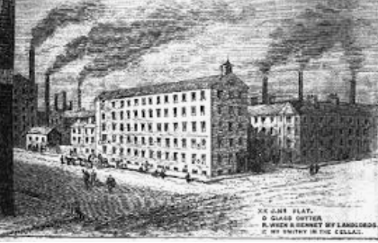
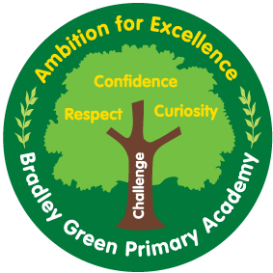
Year 4 Newsletter – Spring 1st half term.
How you can help
MATHS This half term we begin developing our knowledge of multiplication and division and area. There will also be a big focus on the learning of times table and division facts. We will be using TT Rock stars which will be happening daily, this will help the children to rapidly recall their times table and division facts. The children will have a daily times table test in Year 4 please help them to practice the times table they are working on.
ENGLISH Our We will be reading a beautiful picture book by Helen Ward about an old man who dreams of changing the view from his window. . In lessons, we will develop both our reading and writing skills. The children will also have handwriting and spelling and grammar lessons throughout the week.
PE. Please ensure children come dressed in their PE kit on PE days. This term PE day will be on Mondays and Wednesdays. If your child cannot take part, please send a note or dojo message.
HOMEWORK –homework will be set weekly on Monday and needs to be returned the following Monday. They will each receive a piece of English and Maths homework. Some children may choose to use lunchtimes throughout the week to complete this in school. Please make sure your books are brought in on time as we mark together.
HOME READING BOOKS/FREE READERS –Please return your books when you have read them, we will aim to change them as soon as we can. For the time being we will not be using reading records so please notify us on dojo if you want to let us know anything about their reading or the books. Please aim to read at home at least 4 times per week.
CLASS DOJO Please ensure you are registered on class dojo, it enables us to keep in contact and share important notices and updates.

Welcome back I hope you all had a lovely Christmas break! I cannot believe we are in 2021, I wish all of you a very happy new year. I can’t wait to hear about your Christmas news and start off this new year with lots of new topics and exciting things to learn.
This term …
This half term our topic has a history focus. Our enquiry question is ‘Why did the industrial revolution thrive in Manchester?’ We will be considering Manchester in the 18th century and the changes that happened in Manchester during this time, we will be considering how the location of Manchester was so important to the developments of the time.
In design and technology, we will be examining bridges and beginning to design our own.

In ICT, we will developing our knowledge of iPad; the children will be developing their skills so that they can create book trailers.

Our science topic is ‘Which animals and plants live in our local area?’ In this topic, we will be finding out about animal habitats and different kinds of living things.

PE this half term will focus on the sport basketball.

Please feel free to get in touch if you have any questions or wish to discuss anything with me. The dojo account is a brilliant tool to send messages, so please feel free to use it to send messages into school. I am looking forward to sending lots of positive messages home about brilliant work. In the case of individual isolation, work will be uploaded to children’s portfolios daily.

Useful websites:
www.sumdog.com
www.classdojo.com
https://ttrockstars.com/
https://www.oxfordowl.co.uk/

