Year 1 Newsletter Autumn 1 2020
Follow us on twitter at: @Y1Bradley

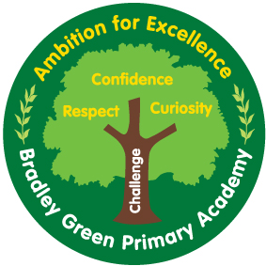

How you can help:
Reading
Reading books will be sent home regularly and this is a key focus for all children.
Every child that reads and returns their book will receive 3 dojo points and be able to move their ‘reading rocket’ across the chart. For every 20 books read, children will receive a prize!

HOMEWORK
Homework will consist of Phonics and Maths – linked to the work we are doing in school. This will be sent home on Tuesday and needs to be back in school by the following Monday. Children are expected to present their homework neatly.

Sumdog - Please encourage your child to log onto Sumdog regularly. Here you will find game based learning for both Maths and English.
Your child’s log on details can be found on the front of their reading record and Homework books.

The warmest of welcomes to Year 1. We have lots to look forward to this half term and I am excited to have the opportunity to support and guide your children as they progress through Year 1.

This term …
History
We will be learning about the Gunpowder Plot. We will be finding out about why the Gunpowder Plot occurred, who was involved, how it was stopped, and why we still celebrate Bonfire Night.
Further information regarding what will be covered in our lessons can be found on the Knowledge Organiser attached.
English
We will start with a whole school text ‘We Are Here’ before moving onto reading ‘ How to Find Gold’ – a story about a little girl and a crocodile who go searching for treasure!
Our focus author for the term is Oliver Jeffers.
Maths
We will be focusing on place value, addition, and subtraction within 10.
Science
Throughout the school year we will be investigating seasonal changes. Why the weather changes and what weather is typically associated with each season.
We will also be looking at materials, including why certain materials are chosen to make certain objects.
Further information regarding what will be covered in our lessons can be found on the Knowledge Organiser attached.
Computing
We will be looking at how to stay safe on line and to be a good digital citizen.
Art
We will be looking at the work of Kandinsky and exploring colour through the use of paint.

Snack
Children have regular access to a water fountain within the classroom, in addition to receiving a piece of fruit daily.
Uniform
To reduce the likelihood of your child losing their clothing. Please make sure that every piece of your child’s school uniform is clearly labelled.
Remember that children should come in full PE kit on PE days.
Children should only wear lace up shoes if they are able to tie them without assistance.

Useful websites:

https://twitter.com/BradleyGreenPA

http://www.bradleygreen.org.uk/

PE – PE will take place on Wednesday and Friday mornings. Please ensure that your child arrives to school wearing full PE kit. Please remember no earrings on PE days.

