Key Information
Ring of fire | An area around the Pacific Ocean with lots of earthquakes ad volcanoes
Earthquakes | When tectonic plates slip and slide under and passed each other the ground shakes violently
Volcanoes | Pressure from inside the earth builds up an magma is forced out of the Earth as lava
Tsunami | These happen with earthquakes happen at sea. The shockwaves produce huge tsunami waves.
Most recorded earthquakes | The most recorded earthquakes are in Japan.
Mount Vesuvius | This is a volcano in Italy.
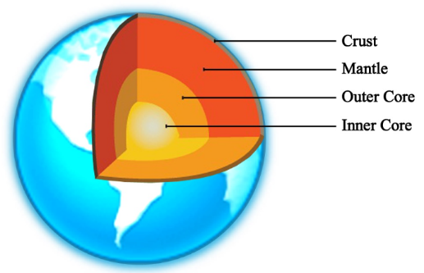
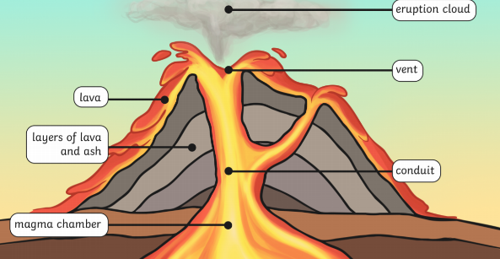
Key Diagrams
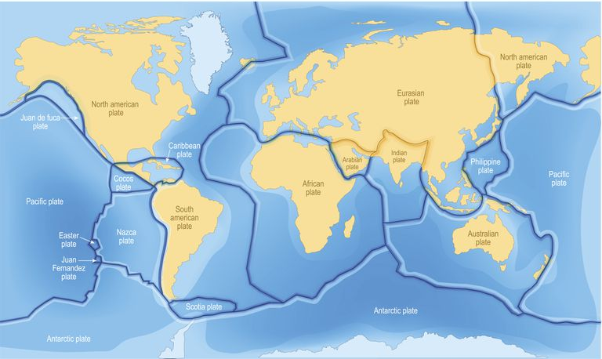
Tectonic plates

Vocabulary
Richter scale | a scale used to measure the strength of an earthquake
Tectonic plates | huge slabs of rock that make up the earth’s crust
Plate boundaries | the edges of tectonic plates
Mantle | the mantle lies between the crust and the core. It contains magma
Outer core | this is a liquid layer above the inner core and below the mantle.
Inner core | this is at the centre of the earth and is made of solid metal.
Crust | this is the solid shell of the planet made of rocks
Lava | this is molten rock that has erupted form volcano
Vent | openings in the crust where lava escapes
Magma chamber | a large pool of liquid rock below the earth’s surface
Magma | semi-fluid rock below the earth’s surface with comes lava when it erupts
Conduit | the path way through the heart of a volcano where the magma flows from beneath the surface
Eruption | when magma is released from a volcano
Epicentre | the point on the earth’s surface directly above the focus of an earthquake
Active volcano | it has had a recent eruption and is likely to erupt again.
Dormant volcano | these have erupted before but a long time ago and are likely to erupt again.
Extinct volcano | it has not erupted for 10,000 years and is not expected to erupt again.

