Year 6 Newsletter Spring 1 2021

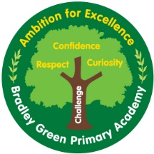

How you can help
MATHS –You can access www.sumdog.com for fun ways to practice basic maths.
https://ttrockstars.com/ is a fun, online timestable game that children can complete at home and in school.

HOMEWORK – Homework goes home on Tuesday and needs to be back in school the following Monday.
Homework will take the form of arithmetic practice for maths.
For English homework, children will be required to complete a SPaG mini-test this term.
We will go through the answers to homework on Monday afternoon, so it is vital that your child completes their homework. If not then they will have to complete it during Monday lunchtime.

READING – Children have reading books in school / at home and many are reading and changing them regularly. Children can be reading in addition to this – whether it’s their reading book from home, newspapers, comics or magazines. All reading is good reading!
Maths
Year 6 will be multiplying and dividing a range of numbers including decimals. Year 6 will also be learning about percentages this half term.
English
The text we will be looking at this term is a book linked to our Antarctic topic called ‘Shackleton’s Journey. We will be writing job applications, diary entries and newspaper reports as part of this learning.
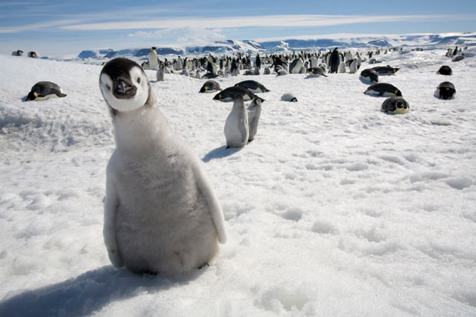
Topic
Our topic this term is ‘Antarctica’. We will be learning about the geography of the continent as well as the history and wildlife. We will be linking our art with topic this term and creating zoological drawings of the wildlife found in polar regions.
Science
In science, Year 6 will be studying classification of living organisms. They will creating and using keys to determine the species of different plans, animals and living organisms, in Antarctica and around the world.
PE
PE is on a Monday afternoon and swimming will be on Thursday afternoon. Children will be learning gymnastics and learning how to land and jump safely. Please make sure that children arrive to school in their PE kit
French
Children will be learning about where they live and describing towns in French this half term.
Computing
In Computing, children will be learning all about Excel spreadsheets and how to create formulas, tables, charts and graphs.

Class Twitter - @Y6BradleyGreen

