Year 6 Newsletter Spring 2 2020

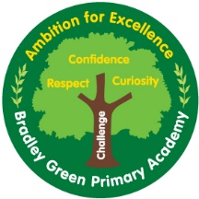

How you can help
MATHS –You can access www.sumdog.com for fun ways to practice basic maths.
https://ttrockstars.com/ is a fun, online timestable game that children can complete at home and in school.

HOMEWORK – Homework goes home on Tuesday and needs to be back in school the following Monday.
Homework will take the form of arithmetic practice for maths.
For English homework, children will be required to complete a SPaG mini-test this term.
We will go through the answers to homework on Monday afternoon, so it is vital that your child completes their homework. If not then they will have to complete it during Monday lunchtime.

READING – Children have reading books in school / at home and many are reading and changing them regularly. Children can be reading in addition to this – whether it’s their reading book from home, newspapers, comics or magazines. All reading is good reading!
Readtheory.org – children have logins for this online reading program and it is worth encouraging them to compete in, especially if you find that your child is a reluctant reader at home.
Maths
Year 6 will be looking at measurements, area perimeter and shape this half term. Towards the end of the half-term Year 6 will revisit some of their previous learning in preparation for their SATs.
English
The text we will be looking at this term is Stormbreaker by Anthony Horowitz. Year 6 will be producing diary entries and persuasive adverts for gadgets that they will design.
Topic
We will be continuing our topic ‘Antarctica’. We will be learning about the geography of the continent as well as the history and wildlife. We will be looking at climate change and the effects that this will have on Antarctica.
Science
In science, Year 6 will be studying “Evolution and Inheritance”. Year 6 will be learning about where all life and humans came from, including the work of Charles Darwin. Year 6 will also be looking at what features they have inherited from their family.
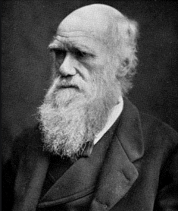
PE
PE is on a Monday afternoon and a Friday afternoon. Children are allowed to bring in jogging bottoms to wear during PE lessons due to it being colder this time of year. However, please make sure that children have their shorts/ t-shirts in case PE is indoors.
SATS meeting
On Friday 28th February, afterschool, I will be hosting a SATs meeting, going through important dates and information, as well as answering any questions that you may have.

