..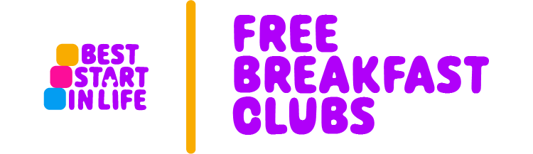 

Bradley Breakfast Club
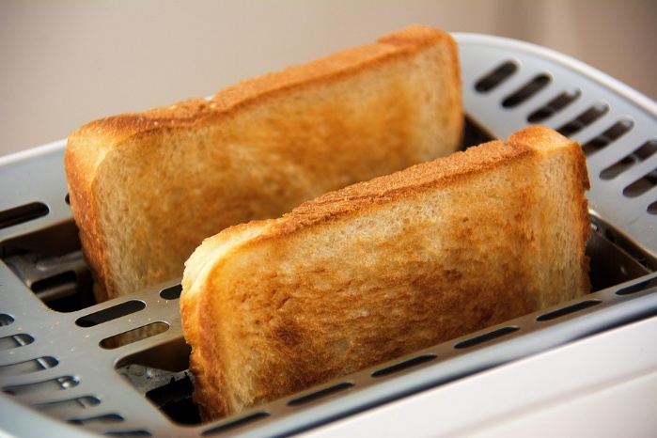

We are proud to announce that Bradley Primary School has been selected to offer a Free, Government funded Breakfast Club to all our families.
The Breakfast Club will be run by our school staff, in the hall, every day.
The club is open to all pupils from Reception to Year 6. We offer a range of healthy breakfasts including cereals, fresh fruit, yoghurt, toast and drinks.
Breakfast Club starts at 8am.
Please book places through the office.

