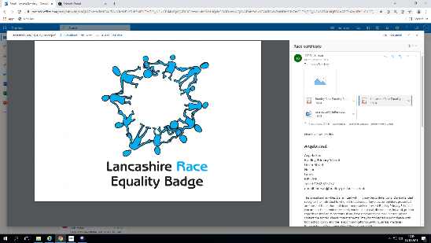

Head Teacher:

Mrs S. Taylor

Deputy Head/SENDCo:

Mrs H. Southern

Bradley Primary School

Dover Street,

Nelson,

Lancs

BB9 7RF

(T) 01282 615772

Email: bursar@bradley-pri.lancs.sch.uk

Website: https://www.bradleyprimaryschool.org/

|  |
| --- |
| **What is the SEND information report?** |
| The Special Education Needs (Information) Regulations (September 2015) outline that the governing body of every school must prepare a report, which is made available on its website, which outlines:  • The kinds of special educational needs for which provision is made at the school.  • Information in relation to schools policies for the identification and assessment of pupils with special educational needs.  • Information about the schools policies for making provision for pupils with special educational needs. |

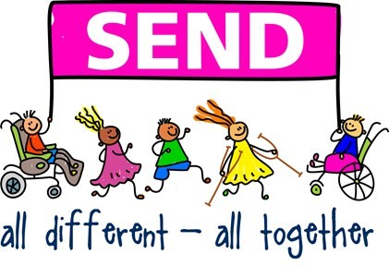

|  |
| --- |
| **What kind of special educational needs do we provide for?** |
| Bradley Primary School is a mainstream school so does not specialise in any area of special educational need or disability. However, we recognise the ‘uniqueness’ of every child and we are committed to working together with all members of our school community in order to ensure achievement for all our children. We strive to create an inclusive culture in our school and we aim to be responsive to the diversity of children’s backgrounds, interests, experience, knowledge and skills. We understand that every child with special educational needs is an individual, but generally special educational needs can be grouped into four areas:   |  |  | | --- | --- | | **Communication and Interaction**  Speech, language and Communication Needs  Autistic Spectrum Disorder (ASD)  Children with these needs may have difficulties with their speech and language or may experience conditions such as an Autistic Spectrum Disorder (ASD) | **Cognition And Learning Difficulties**  Specific Learning Difficulties (SPLD) - Dyslexia, Dyscalculia  Moderate Learning Difficulties (MLD)  Severe Learning Difficulties (SLD)  Profound and Multiple Learning Difficulties (PMLD)  Children with these needs may learn at a slower pace than their peers and may have difficulty acquiring basic skills | | **Social, Emotional and Mental Health Needs**  Depression  Attention Deficit Hyperactivity Disorder (ADD, ADHD)  Eating Disorders  Anxiety Disorders  Mental Health Issues  Social Disorders  Children with these needs may have difficulties socially, or with managing their behaviour | **Sensory and/or Physical Needs**  Visual Impairment (VI)  Hearing Impairment (HI)  Multi-Sensory Impairment (MSI)  Physical Disability (PD)  Children with these needs may have an impairment relating to their sight, hearing or another physical difficulty |   We currently have pupils who experience difficulties in each of these areas, including some who experience more than one form of special educational need. The type of provision offered very much depends on the strengths and needs of the child in question. |

|  |
| --- |
| **Who is the SENDCo and how can parents contact them?** |
| The school’s SENDCo is Mrs H. Southern and she holds the National SENDCo Award.  Mrs Southern can be contacted by telephoning the school office on: 01282 615772.  Mrs R. Tahir is our SEND Governor. |

|  |
| --- |
| **Definition of Special Educational Needs and Disabilities** |
| The SEND Code of Practice (2015) states that a child or young person has a special educational need (SEN) or disability if they have a learning difficulty or disability, which calls for special educational provision to be made for him or her.  A child of compulsory school age or a young person has a learning difficulty or disability if he or she:  • Has a significantly greater difficulty in learning than the majority of others of the same age  • Has a disability, which prevents or hinders him or her from making use of educational facilities of a kind generally provided for others of the same age in mainstream schools.  Factors which are NOT SEND but may affect a child’s progress and attainment are taken into consideration and adaptations are made accordingly. These may include:  • A disability under the Equality Act 2010 – all reasonable adjustments will be made in order that they can access the full curriculum  • Attendance and Punctuality  • Health and Welfare  • English as an Additional Language (EAL)  • Being in receipt of Pupil Premium Grant  • Being a Child Looked After (CLA)  • Being a child of Serviceman / woman  Persistent disruptive or withdrawn behaviour does not necessarily mean that a young person has SEND. Any concerns over a pupil’s behaviour will be investigated on the premise that the behaviour is an underlying response to a need. This may be a learning difficulty or another factor as noted above. School staff will endeavour to recognise and quickly identify the reasons for the behaviour and take all reasonable steps to address the root cause. |

**What should I do if I think my child has special educational needs or disability (SEND)?**

|  |
| --- |
|  |
| If you have any concerns about your child’s needs, these should be discussed with your child’s class teacher, initially.  If you continue to be concerned that your child is not making progress you may speak to: SENDCo: Mrs H. Southern, Head teacher: Mrs S. Taylor,  Pupil Support Manager: Mrs R. Ishfaq Office Telephone Number: **01282 615772**  * Teachers are responsible for the initial identification of a pupil’s special needs through observation of classroom practice and on-going assessment. * Teachers organise the timetable, class grouping and all available resources so that the pupil receives all possible support to reach the targets. * Teachers will inform the SENCO of any concerns about a child and together with the SENCO will facilitate the necessary intervention. This means your child will get some support in a small group or 1:1 to help them catch up. |

**How does the school know if children need**

**extra help?**

|  |
| --- |
|  |
| The identification of SEND is built into the overall approach to monitoring the progress and development of all pupils. All children are assessed regularly and progress is tracked and monitored as detailed within our Teaching and Learning Policy.  Any pupils who are falling significantly outside of the range of expected academic achievement, have social or emotional difficulties, are vulnerable or have specific diagnosed needs will be monitored.  If your child’s class teacher has concerns, they will contact you to discuss this further. They will ask if you can provide any information relating to their concerns. The class teacher will suggest strategies they will use within school to support your child. We then employ a ‘graduated response’  Your child will be assessed as to the severity of their need and the appropriate provision will be put in place.  Bradley Primary School Graduated Response |

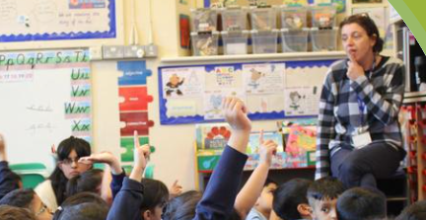

Mrs Southern is our SENCDO, but she also loves to teach.

|  |
| --- |
| **What provision is there for children with SEND?**  **What is our approach to teaching children with SEND?**  **How is the decision made about type and how much support my child will receive?**  **How do we adapt the curriculum and learning environment for children with SEND?**  **?** |
| The curriculum at Bradley Primary School is designed to meet the needs of all our pupils and the appropriateness of its intent is regularly reviewed. The staff at Bradley, make reasonable adjustments to their teaching to accommodate the needs of individual children. Some of these are listed in the table below.  As described in the ‘Graduated Response’ above, we also offer ‘intervention’ groups, which are  run by either a teacher or teaching assistant and take place in the classroom or in sessions outside of whole class learning. These are tailored to the needs of an individual or small group of children. Staff ensure that although children may be participating in these groups, they still have access to a broad and balanced curriculum along with their peers. If your child is still struggling to progress, we have links with many different external agencies and specialists from whom we can seek further advice.   |  |  |  | | --- | --- | --- | | Quality teaching strategies which apply to all 4 categories of SEND | Intervention groups we can offer | Specialist support we can access | | Providing extra processing time  Repeated, simple instructions  Extra time for tasks  Concrete and visual aids  Differentiation  Grouping by ability and mixed ability  Visual prompts on displays e.g. vocabulary  Clear routines  Meeting a range of learning styles  Everyday assistive devices e.g. pencil grips, writing slopes  Flexibility in timetabling  Teaching assistant support  Range of learning environments  Access to ICT e.g. tablets | Pre-Teaching  Post-Teaching  Same day catch up sessions  Magical Spelling  WELLCOMM speech and Language interventions  Red Rose Phonics Interventions  Fine-Motor Workshops  Lego Therapy  Handwriting Workshops  Pupil Support Manager 1:1 Sessions  Precision Teaching  Attention Autism  Nurture Group | Specialist Teachers  Visual and Hearing Specialist Teachers  Speech and Language Service  Occupational Therapy  Action for AD  SEND services  British Dyslexia Association  Educational Psychologists  School Nurse Team |   The support provided consists of a four–part process: Assess - Plan - Do - Review  Assess: The Class Teacher’s assessment and experience of working with the pupil, details of previous progress and attainment, comparisons with peers and national data, specific assessment tasks and tests as well as the views of parents and pupils is used to identify needs. Advice may also come from external support services. The attainment of children who are working significantly behind age expectations is tracked using the PIVAT’s system and this feeds into planning their next steps.  Plan: Information gathered is then used to develop interventions and adaptions to the environment and to the curriculum, which aim to provide the best impact on a child’s development. Again, advice from outside agencies and specialist services, the educational psychologist, behaviour support, the school nurse and speech and language therapists may be accessed. Class Teachers work alongside the SENDCo to plan the most appropriate strategies and interventions.  Do: Interventions may involve group or one-to-one teaching both in class and away from the main teaching on specific learning objectives. It may also involve use of different equipment or the adaption of the curriculum. The curriculum may be adapted through scaffolding activities, differentiation, using prompts and adapted resources and by support from teachers and teaching assistants. Children who have a special need will have the targets and strategies they are working on recorded on an Individual Education Plan (IEP).  Review: IEP’s are reviewed termly and the children are involved in discussions about their targets including how well they are progressing and what they need to do as a “next step”. Adjustments can be made to the targets when necessary to suit rate of progress.  The SENDCo reviews intervention work termly with class teachers and teaching assistants, using teacher assessments, observations and SEND Pupil Progress Meetings. Children with SEND are also carefully monitored at termly progress meetings with the head teacher.  For children with an Education, Health and Care Plan (EHCP), an annual review (6 monthly for under 5s) will be carried out by the school in conjunction with the LEA. Parents and external agencies are strongly encouraged to attend. |

**What else do we do to make the school safe and accessible?**

|  |
| --- |
|  |
| School staff are on duty on the school playground from 8:40am. All children are supervised as they leave school to ensure safe handover. In EYFS, a child can only be collected by a named adult; these details are collected at the beginning of the Autumn term. However, if someone other than a named adult is collecting the children, school must be informed in advance.  Bradley School is an old building and has many levels, however we do have wheelchair access into both KS1 and KS2. Careful thought is taken as to which classroom may best suit a child’s needs. A disabled toilet is available to both staff and pupils. Furniture is modern and is at suitable height for the age group of children. We can arrange the provision of specially adapted furniture through our links with occupational therapy. The school also has a range of ICT, including class sets of Ipads, which can be utilised by children with SEN in order to access apps appropriate to their needs. |

|  |
| --- |
| **How are children with SEND enabled to take part in all the activities available in school?** |
| We provide a range of extra- curricular activities, which are offered on a rota system. They include such things as choir, netball, sports clubs and library club. We also have before school breakfast club. Children with SEN can access all of these activities. Teachers will discuss your child’s needs before planning a school trip to ensure that your child can partake alongside the other children. If a child needs support at break-times, then support will be given. We have a named adult who supervises our more vulnerable children whilst having their lunch and a safe play area for them. |

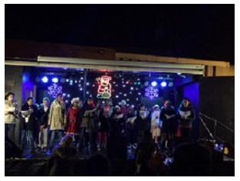

I like to go to choir because I love to sing. It is the best thing I do.

|  |
| --- |
| **How do we support children with medical difficulties or emotional and social difficulties?** |
| At Bradley Primary School, we wish to create a happy, secure environment in which the education of each child can flourish. Children are taught to value one another and to care for the health safety and wellbeing of others. We believe that high standards of learning depend upon the children having high standards of self-discipline and respect for adults, their peers and their environment.  We have a Family Support Officer working within school who is able to support the family and child in the school setting. Our Pupil Support Manager works alongside children who have emotional and social development needs helping them to engage in their learning. She is also always available to listen to the views of the children. Our Pupil Support Manager is also responsible for all children in school with medical difficulties and will meet with parents to put a care plan into place.  Some SEND children may require a behaviour plan to be put in place to keep them and staff safe. This will be discussed with parents and strategies to support difficult behaviour agreed together. |

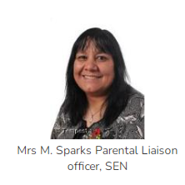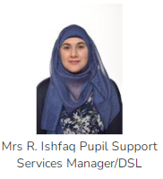

**How do we deal with bullying and make sure children with SEND can tell us if they are having a problem?**

|  |
| --- |
|  |
| * All children are taught about bullying, friendships and staying safe through a combination of age-appropriate PHSE lessons, weekly whole-school assemblies, Bradley School Values and British Values. * Children are encouraged to speak to members of staff on duty if they are worried during playtimes. * Additionally, all staff are made aware of vulnerable children and, if appropriate, a key worker may be allocated to a specific child. * Online safety is taught, in an age appropriate manner, throughout the school, recognising the potential dangers and issues on the Internet. * Any bullying incident is dealt with in accordance with the school’s anti-bullying policy and behaviour policy, which is available on the website and on request from the Head teacher. * In accordance with legislation, the school has Designated Senior Leaders (DSL) to deal with issues related to Child Protection and Safeguarding. * All staff receive regular Safeguarding and Child Protection awareness training. |

**How are staff trained and kept up to date?**

**If we need more expert advice, what do we do?**

|  |
| --- |
|  |
| Each year the SENCO audits the needs of all staff in school. This highlights areas of expertise and areas where staff require training to support children and young people with SEN. The SENCO will then arrange courses and inset.  As mentioned above, we can also access advice from;   * Specialist Teachers * Visual and Hearing Specialist Teachers * Speech and Language Service * Occupational Therapy * Action for AD * SEND services * British Dyslexia Association * Educational Psychologists * School Nurse Team |

**How do we involve and help parents of children with special educational needs or disabilities?**

|  |
| --- |
|  |
| Parents can help support the school and their child by:   * Providing support for the discipline within the school and for the teacher’s role * Being realistic about their child’s abilities and offering encouragement and praise * Participating in discussions concerning their child’s progress and attainments * Ensuring early contact with school to discuss matters which affect a child’s happiness, progress and behaviour * Ensuring their child attends all appointments and school is informed of outcomes * Giving due importance to homework, hearing reading and assisting in the learning of tables and spellings * Ensuring children attend school in good health, regularly and punctually * Supporting school organised events * Helping their child to value theirs and the school’s possessions * Encouraging outside interests to develop the whole child   Bradley School strives to keep parents involved and informed through:   * Our SEND section on the school website, which is regularly updated * Weekly newsletters sent out by e-mail and also uploaded into the school’s website * Three parents’ evenings a year and one annual report. * There are annual open days for prospective and current parents. * In addition, for children who are on the Special Educational Needs record and have an Individual Education Plan (IEP) parents are invited to discuss these with the class teacher and / or SENDCo. * For children with EHCP’s, parents are invited to contribute to and attend their yearly review * Staff are available to help complete any forms or paperwork, if necessary, including translation for those with English as an additional need. Parents / guardians are welcome to ask for support as necessary. * Each year group also has a bi-lingual member of staff to offer further support * When children begin in their new class, a welcome meeting is held for the parents / guardians, this is to introduce new members of staff and to discuss what to expect in the year to come. * Teachers and other key staff who may support your child, are available to see parents in a morning or at the end of the day via the office or playground. |

|  |
| --- |
| **How do we involve and consult with the children about their education?** |
| All school staff work together to ensure that the views of all our children with SEND are heard. When a child is placed on our SEND register, they will have an informal chat with their class teacher or the SENDCo and fill in a one-page profile.    We also run a Listening Ear Service in school where children can request time to talk with an adult about any issues they may be having. Our pupil support manager and our family support officer are always available for 1:1 sessions with any child who may need to talk. |

|  |
| --- |
| **How will school prepare and support your child to join the school, transfer to a new setting or to the next stage of education?** |
| We understand how important it is for children to be well supported when moving from nursery to primary school, between key stage one and key stage two and particularly, from primary school to secondary school.  Our Special Educational Needs and Disabilities Coordinator (SENDCo) attends meetings at local nurseries, along with our Early Years staff to ensure we gain as much information as possible about our new pupils, in order to put appropriate provision in place.  Our SENDCo also contacts the SENDCo’s at our link secondary schools to ensure that the information we have gathered throughout your child’s time at primary school is passed on.  We can also arrange additional visits to help your child become familiar with new staff and surroundings. We are also happy to arrange transition meetings additional to those already organised by the secondary schools. Furthermore, our teachers, pupil support manager and family support officer organise transition support between key stages within school. |

|  |
| --- |
| **What is the Local Authority Local Offer?** |
| You can also look at The Lancashire Authority Local Offer, is a website containing guidance and opportunities for parents of children with special educational needs. This can be found at  [www.lancashire.gov.uk/children-education-families/special-educational-needs-and-disabilities](http://www.lancashire.gov.uk/children-education-families/special-educational-needs-and-disabilities) |

|  |
| --- |
| **What do I do if I have a concern or complaint about the provision for my child?** |
| If you are unhappy with the way your child is being treated, or any of our actions or lack of action, please feel able to tell us your concern. We know it can be difficult to question what a school is doing, but if you do not tell us what is worrying you, we cannot explain our actions or put things right. Our support and respect for you and your child will not lessen in any way.  In order to deal with your concern or complaint in the quickest and most straightforward way, we ask that you:  a) Firstly, contact the class teacher via the school office  b) Secondly, if you have concerns which cannot be addressed by the class teacher, then please contact the Head teacher or SENDCo via the school office |