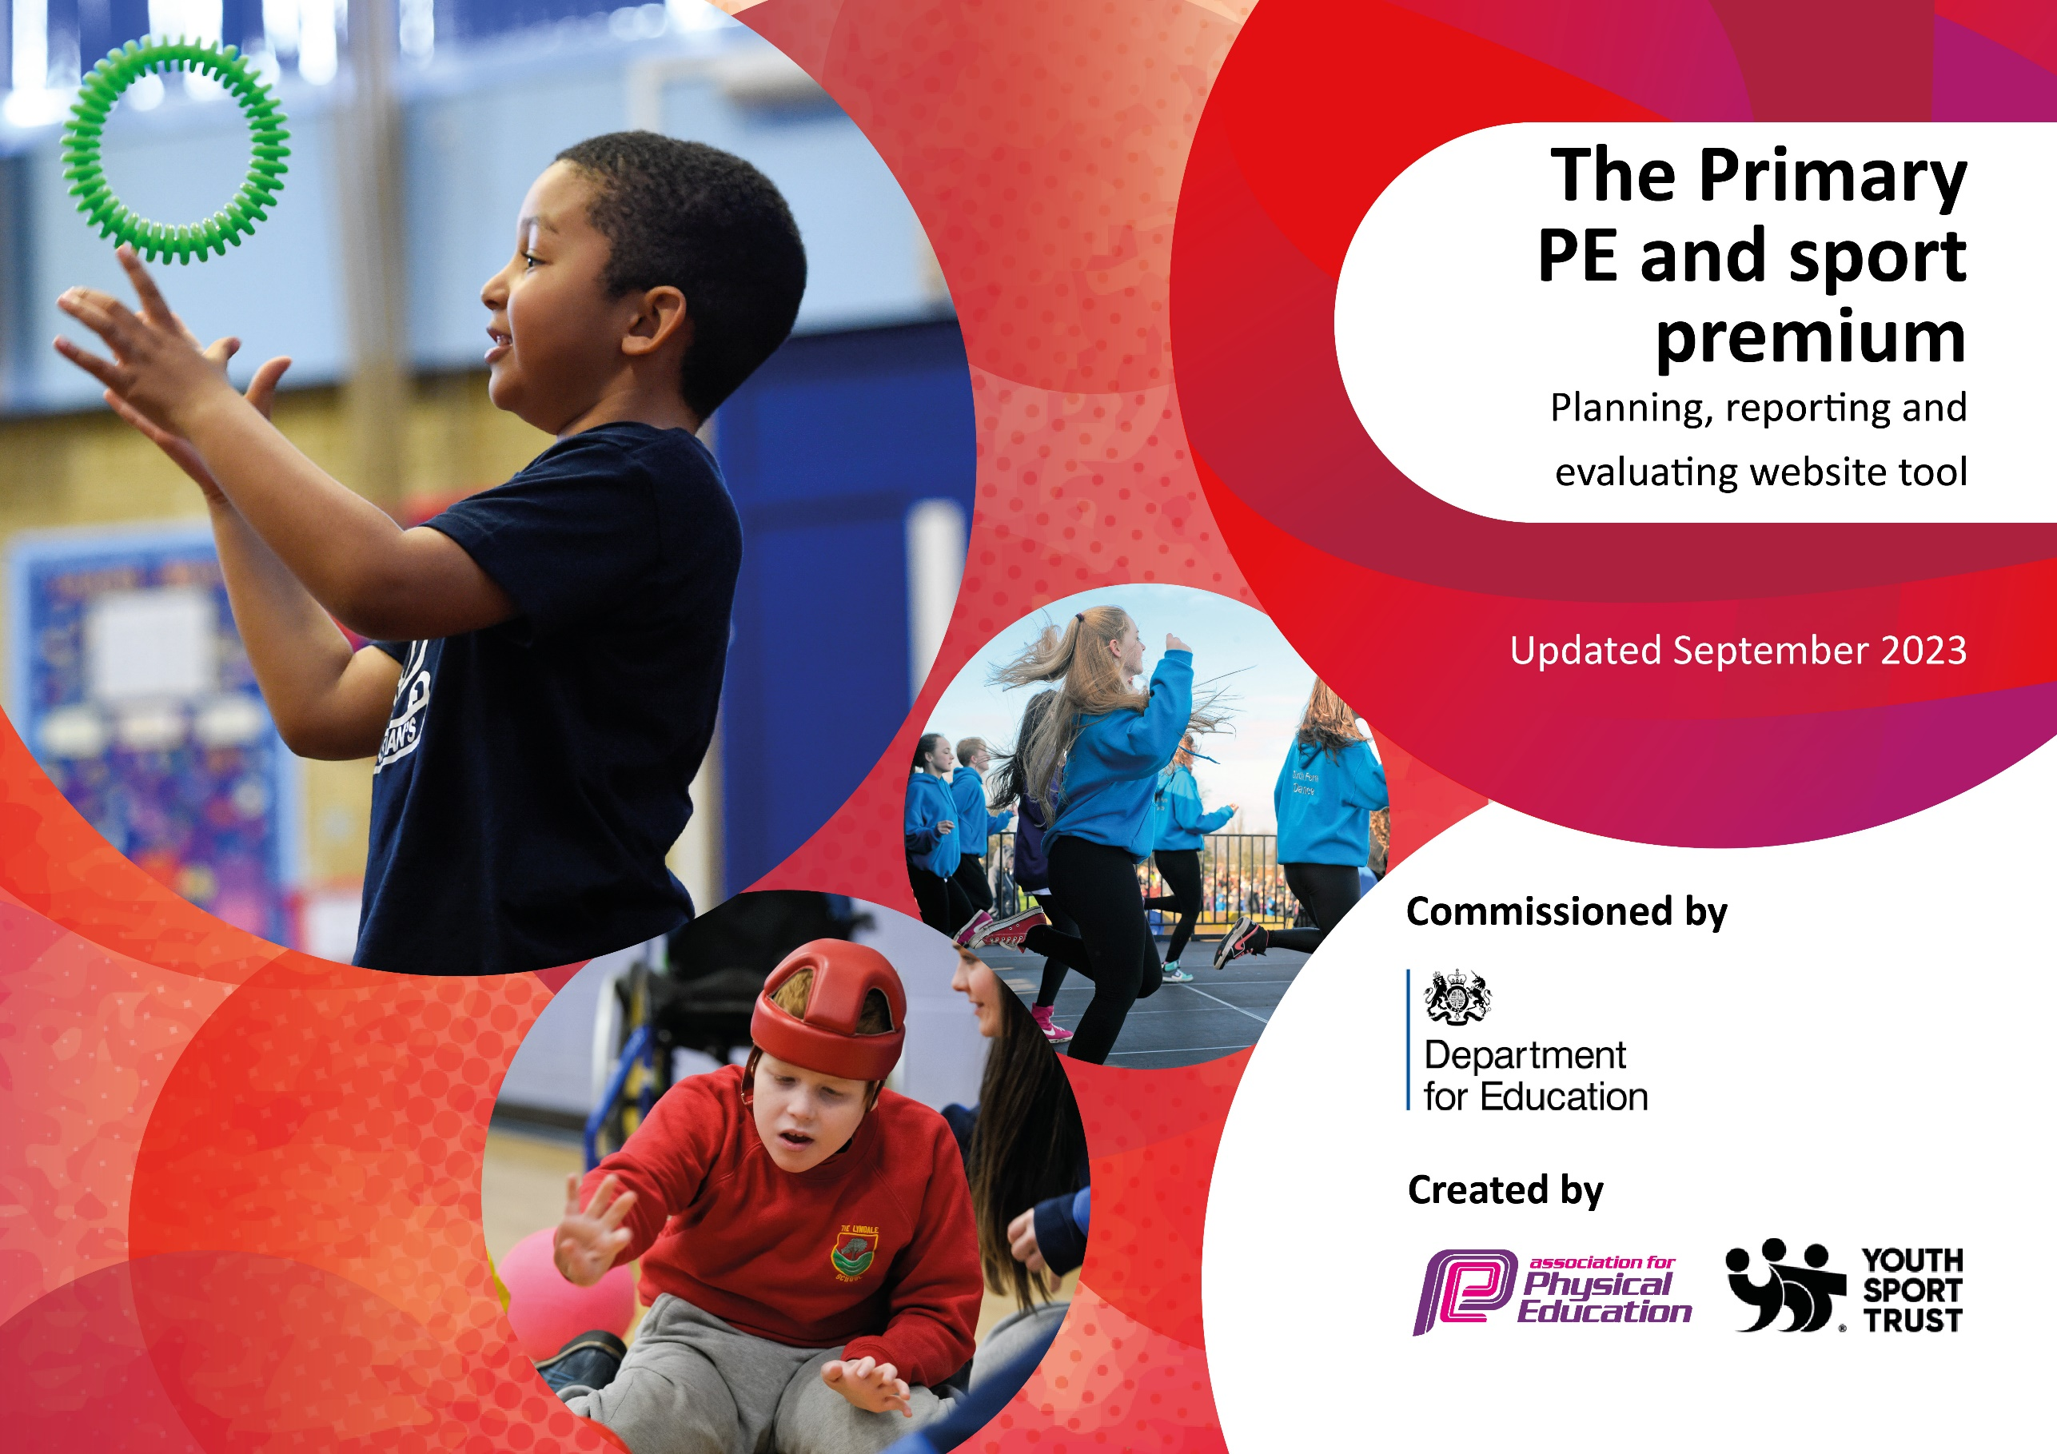

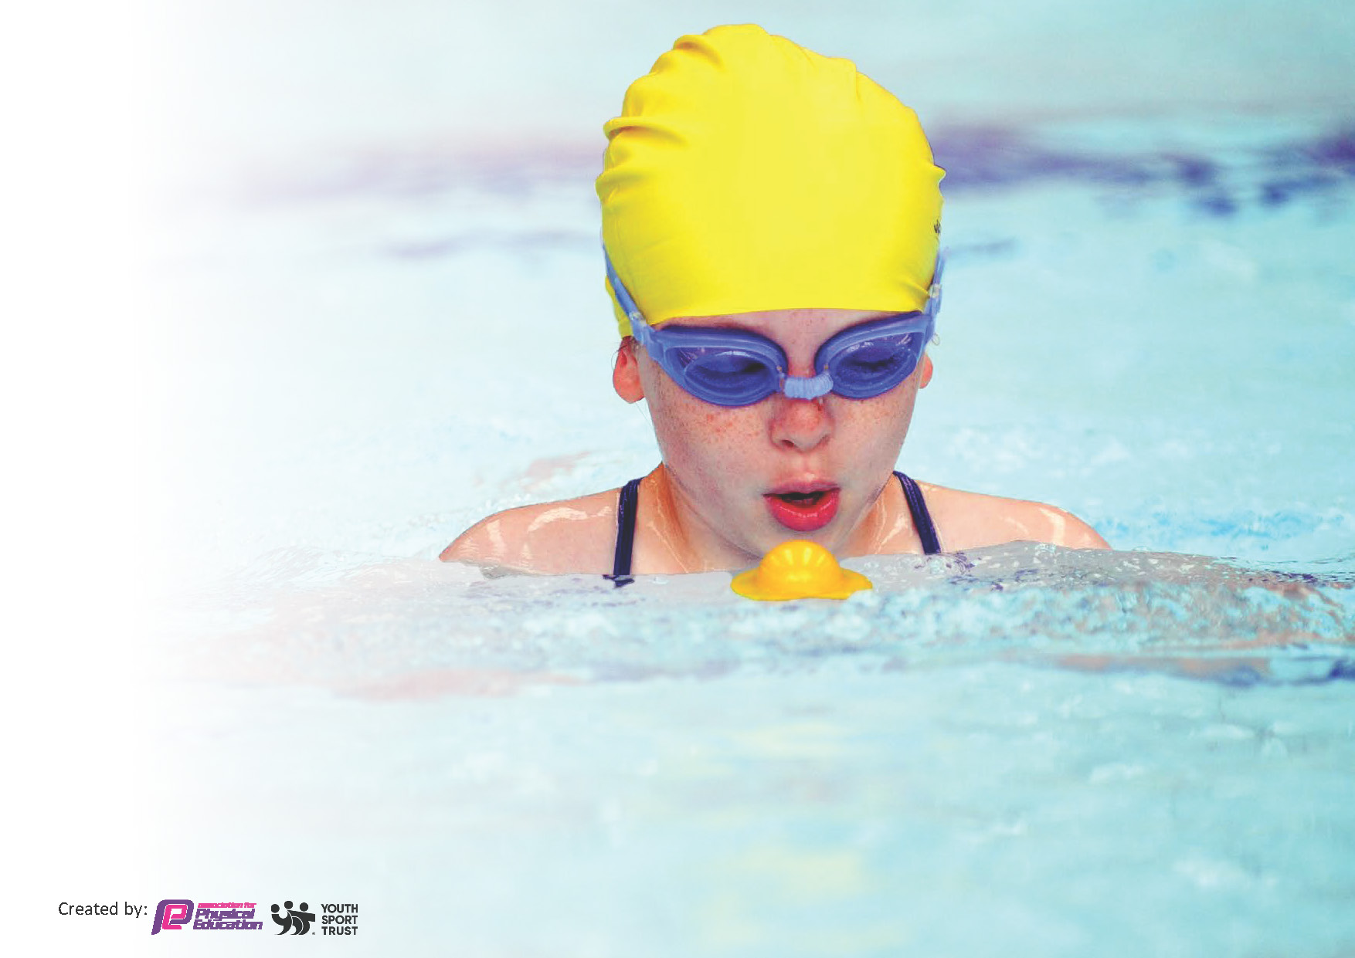
This template can be used for multiple purposes:
by:
- It enables schools to effectively plan their use of the Primary PE and sport premium
- It helps schools to meet the requirements (as set out in guidance) to publish information on their Primary PE and sport premium
- It will be an effective document to support Ofsted inspections enabling schools to evidence progress in Physical Education (PE) and evidence swimming attainment, which forms part of the PE National Curriculum. We would recommend schools consider
the Intent, Implementation and Impact of any spend, as examined within the Education Inspection Framework.

It is important that your grant is used effectively and based on school need.

Schools must use the funding to make additional and sustainable
improvements to the quality of the PE, School Sport and Physical Activity (PESSPA)
they offer. This means that you should use the Primary PE and sport premium to:

- Build capacity and capability within the school to ensure that improvements made now will benefit pupils joining the school in future years
- Develop or add to the PESSPA activities that your school already offers.

The Primary PE and sport premium should not be used to fund capital spend projects; the school’s core budget should fund these. Further detail on capital expenditure can be found in the updated Primary PE and sport premium guidance.

The Primary PE and sport premium guidance, outlines 5 key priorities that funding should be used towards. It is not

necessary that spending has to meet all the key priorities, you should select the priorities that you aim to use any funding towards.

Although completing this template is not a requirement for schools, schools are required to publish details of how they spend this funding. Schools must also outline what the impact this funding has had on pupils’ PE and sport participation and attainment and how any spending will be sustainable in the future. All funding must be spent by 31st July 2024.

The Department for Education has worked closely with the Association for Physical Education (afPE) and the Youth Sport Trust (YST) to develop this template and encourages schools to use it. This template is an effective way of meeting the reporting requirements of the Primary PE and sport premium.
Review of last year’s spend and key achievements (2024/2025)

We recommend you start by reflecting on the impact of current provision and reviewing your previous spend.

Activity/Action | Impact | Comments
- Invested in OPAL play  - CPD for staff  - Range of after school clubs offered  - Provided opportunities to watch professional sportspeople (Lancashire Cricket, WSL Manchester Derby) | - Increased activity levels during lunch times  - Staff more confident in teaching PE  - Rounders, Cricket, Dance, Dodgeball, Football. Children are enthused by these sports.  - Girls are much more excited about sports. Cultural capital increased and passion for the sports ignited. | A lot of work and effort has gone into provided enrichment opportunities for our pupils. Attitudes towards sports are much improved and we have seen an increase in positive attitudes of girls in particular (KS2).

Key priorities and Planning
This planning template will allow schools to accurately plan their spending.

Action – what are you planning to do | Who does this action impact? | Key indicator to meet | Impacts and how sustainability will be achieved? | Cost linked to the action
Take part in a variety of types of physical activities across the week.  To provide 30 Year 5 children with the opportunity to experience outdoor adventurous activities  Replenishing PE stocks to ensure high quality equipment is available | Staff on duty at playtime to play games and promote physical activities.  Children understand the importance of being active and exercising regularly.  Children who have limited life experiences due to circumstances are given the opportunity to experience adventurous activities including developing their knowledge of water safety.  Staff and children have access to the correct amount of appropriate resources | Key indicator 2 -The engagement of all pupils in regular physical activity  Key indicator 4: Broader experience of a range of sports and activities offered to all pupils.  Key indicator 4: Broader experience of a range of sports and activities offered to all pupils.  Key indicator 2: increasing engagement of all pupils in regular physical activity and sport  Key indicator 3: raising the profile of PE and sport across the school, to support whole school improvement  Key indicator 4: Broader experience of a range of sports and activities offered to all pupils. | More pupils meeting their daily physical activity goal, more pupils encouraged to take part in PE and Sport Activities.  More pupils having access to a wider variety of opportunities.  More pupils meeting their daily physical activity goal, more pupils encouraged to take part in PE and Sport Activities. | £1000 costs for additional resources to support active playtime sessions and staff CPD.  £2,190 for supporting pupils to access an adventurous outdoor residential.  £2,500

CPD for teachers.  Implement PE life Skills Award  Enable teachers to provide active lessons, by using Cross-Curricular Orienteering. | Staff who have moved to a new year group and ECTs  All learners will develop skills to help them in PE and everyday life – including embedding the values of fairness and communication  This will impact all learners, enabling them to participate in active learning. All teachers will have access to pre-planned age related lessons for a variety of subjects. | Key Indicator 1: Increased confidence, knowledge, and skills of all staff in teaching PE and sport.  Key indicator 5: Increased participation in competitive sport.  Key indicator 2: increasing engagement of all pupils in regular physical activity and sport  Key indicator 3: raising the profile of PE and sport across the school, to support whole school improvement  Key indicator 2 -The engagement of all pupils in regular physical activity | Teachers are more confident to deliver effective PE supporting pupils to undertake extra activities inside and outside of school, including assessing water safety and swimming and as a result improved pupil’s attainment in PE.  All children will learn the value of sharing, to learn the rules of a game and feel able to communicate with other learners - not just in PE, but during all other aspects of school.  All year groups will use the new scheme to build the confidence of both the children and the teachers. New orienteering skills will be taught in PE lessons. | £5000 for 5 teachers to undertake CPD.  £349 for the programme  £1000 for resources and staff training  £2,500

Key achievements 2024-2025
This template will be completed at the end of the academic year and will showcase the key achievements schools have made with their Primary PE and sport premium spending.

Activity/Action | Impact | Comments
- Invested in OPAL play  - CPD for staff  - Range of after school clubs offered  - Provided opportunities to watch professional sportspeople (Lancashire Cricket, WSL Manchester Derby)  - Children have been offered additional Outdoor And Adventurous activities through a subsidy off a Year 5 visit to PGL, Winmarleigh.  - Focus on getting girls into sport. | - Increased activity levels during lunch times  - Staff more confident in teaching PE  - MMA, Dance, Boxing, Football. Children are enthused by these sports.  - Girls are much more excited about sports. Cultural capital increased and passion for the sports ignited.  - Year 5 children were able to participate in activities that were new to them and that wouldn’t otherwise have an opportunity to experience.  - Girls were offered the opportunity to compete in sport, on a level playing field with other girls of the same age. | A lot of work and effort has gone into provided enrichment opportunities for our pupils. Attitudes towards sports are much improved and we have seen an increase in positive attitudes of girls in particular (KS2).

Swimming Data
Meeting National Curriculum requirements for swimming and water safety.
Priority should always be given to ensuring that pupils can perform safe self-rescue even if they do not fully meet the first two requirements of the National Curriculum programme of study

Question | Stats: | Further context  Relative to local challenges
What percentage of your current Year 6 cohort can swim competently, confidently and proficiently over a distance of at least 25 metres? | 50%
What percentage of your current Year 6 cohort can use a range of strokes effectively [for example, front crawl, backstroke, and breaststroke]? | 50%

What percentage of your current Year 6 cohort are able to perform safe self-rescue in different water-based situations? | 50% | Although only 15% of children passed the safe self-rescue in Year 4, they were able to describe in detail what they would do to perform a safe self-rescue. The Ofsted Advisor, during our recent visit, noted how knowledgeable our children were on this topic and noted it as a particular strength.
If your schools swimming data is below national expectation, you can choose to use the Primary PE and sport premium to provide additional top-up sessions for those pupils that did not meet National Curriculum  requirements after the completion of core lessons. Have you done this? | No | However, our children are encouraged to swim locally, with school giving out free swimming vouchers before each school holiday.
Have you provided CPD to improve the knowledge and confidence of staff to be able to teach swimming and water safety? | No

Signed off by:

Head Teacher: | Sharon Taylor
Subject Leader or the individual responsible for the Primary PE and sport premium: | Peter Connor (PE subject leader)
Governor: | R. Tahir
Date: | 20/07/25

#

- increasing all staff’s confidence, knowledge and skills in teaching PE and sport
- increasing engagement of all pupils in regular physical activity and sport
- raising the profile of PE and sport across the school, to support whole school improvement
- offer a broader and more equal experience of a range of sports and physical activities to all pupils
- increase participation in competitive sport

